TRIBHUVAN UNIVERSITY

INSTITUTE OF ENGINEERING

THAPATHALI CAMPUS



**A LAB REPORT ON**

CPU Scheduling Algorithms

**SUBMITTED BY**

Sushovan Shakya

THA075BEI046

**SUBMITTED TO**

Department of Electronics and Computer Engineering

26th August, 2021

**CPU SCHEDULING ALGORITHM**

**Objective**

* To implement FCFS algorithm
* To implement SJF algorithm

**Theory**

**First Come First Serve (FCFS) Algorithm**

It is the simplest CPU scheduling algorithm. The FCFS scheduling algorithm is non-preemptive i.e. once the CPU has been allocated to a process, that process keeps the CPU until it releases the CPU, either by terminating or by requesting I/O. In this technique, the process that requests the CPU first is allocated the CPU first i.e. when a process enters the ready queue, its PCB is linked onto the tail of the queue. When the CPU is free, it is allocated to the process at the head of the queue. The running process is then removed from the queue.

The average waiting time under this technique is often quite long.

**Source Code**

#include <stdio.h>

#include <unistd.h>

#include <stdlib.h>

// FCFS Algorithm

struct fcfs {

int process;

int burst;

int arrival;

int turnaround;

int waiting;

};

typedef struct fcfs FCFS;

// Selection sort

void sort(FCFS arr[], int n) {

int i, j, min_idx;

FCFS temp;

for(i = 0; i < n - 1; ++i) {

min_idx = i;

for(j = i+1; j < n; ++j) {

if(arr[j].arrival < arr[min_idx].arrival)

min_idx = j;

}

// Swapping

temp = arr[min_idx];

arr[min_idx] = arr[i];

arr[i] = temp;

}

}

int main() {

int n, temp = 0, AvTAT = 0, AvWT = 0;

int *tct;

FCFS *arr;

printf("Enter number of processes: ");

scanf("%d", &n);

// Creating arrays

arr = (FCFS*)malloc(n * sizeof(FCFS));

tct = (int*)malloc(n * sizeof(int));

for(int i = 0; i < n; ++i) {

arr[i].process = i;

printf("Enter the process %d data\n", arr[i].process);

printf("Enter CPU Burst: ");

scanf("%d", &(arr[i].burst));

printf("Enter the arrival time: ");

scanf("%d", &(arr[i].arrival));

}

// Sorting processes based on arrival time

sort(arr, n);

// Calculation of turnaround time, waiting time and completion time

printf ("Process\t\tBurst Time\tArrival Time\tCompletion Time\tTurn Around Time\tWaiting Time\n");

for(int i = 0; i < n; ++i) {

if(i >= 1 && arr[i].arrival > tct[i-1]) {

tct[i] = temp + arr[i].burst + (arr[i].arrival - tct[i-1]);

temp = tct[i];

}

else {

tct[i] = temp + arr[i].burst;

temp = tct[i];

}

arr[i].turnaround = tct[i] - arr[i].arrival;

arr[i].waiting = arr[i].turnaround - arr[i].burst;

AvTAT = AvTAT + arr[i].turnaround;

AvWT = AvWT + arr[i].waiting;

printf ("%5d\t%15d\t\t%9d\t%12d\t%12d\t%12d\n",

arr[i].process, arr[i].burst, arr[i].arrival, tct[i], arr[i].turnaround, arr[i].waiting

);

}

printf ("Average Turn Around Time: %f ms\nAverage Waiting Time: %f ms\n", (float)AvTAT / n, (float)AvWT / n);

free(arr);

free(tct);

return 0;

}

**Output**

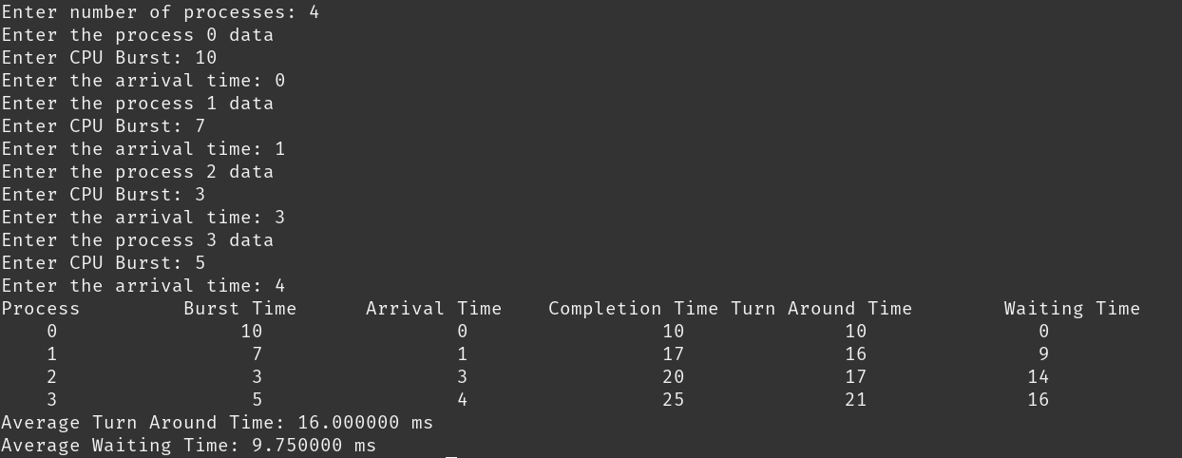

**Shortest Job First (SJF) Scheduling Algorithm**

This technique is associated with the length of the next CPU burst of a  
process. When the CPU is available, it is assigned to the process that has the  
smallest next CPU burst. If the next bursts of two processes are the same,  
FCFS scheduling is used. The SJF algorithm is optimal i.e. it gives the  
minimum average waiting time for a given set of processes. The real difficulty  
with this algorithm is knowing the length of the next CPU request.

**Source Code**

#include <stdio.h>

#include <stdlib.h>

// SJF Scheduling

struct sjf {

int process;

int burst;

int arrival;

int turnaround;

int waiting;

};

typedef struct sjf SJF;

// Selection sort

void sort(SJF arr[], int n) {

int min_idx;

SJF temp;

for(int i = 0; i < n-1; ++i) {

min_idx = i;

for(int j = i+1; j < n; ++j) {

if(arr[j].arrival < arr[min_idx].arrival) {

min_idx = j;

}

}

// Swapping

temp = arr[min_idx];

arr[min_idx] = arr[i];

arr[i] = temp;

}

}

int main() {

int i, j, n, TCT, count_process = 0, count = 0, minBurst, pos;

float AvTAT = 0.0, AvWT = 0.0;

SJF *arr;

printf ("Enter the number of processes: ");

scanf ("%d", &n);

arr = (SJF*)malloc(n*sizeof(SJF));

// Entering data of the processes

printf ("Enter the data of processes\n");

for (i = 0; i < n; i++)

{

arr[i].process = i + 1;

printf("Enter the burst time of process %d: ", arr[i].process);

scanf ("%d", &(arr[i].burst));

printf ("Enter the arrival time of process %d: ", arr[i].process);

scanf ("%d", &(arr[i].arrival));

}

// SJF Algorithm starts here

sort (arr, n);

printf ("PROCESS\tARRIVAL TIME\tBURST TIME\n");

for(int i = 0; i < n; i++) {

printf (

"%3d\t%5d\t\t%5d\n",

arr[i].process, arr[i].arrival, arr[i].burst

);

}

TCT = arr[0].turnaround = arr[0].burst;

arr[0].waiting = arr[0].turnaround - arr[0].burst;

arr[0].arrival = -1;

sort(arr, n);

count_process = 1;

while(count_process < n) {

minBurst = 999;

count = 0;

i = count_process;

while(TCT >= arr[i].arrival && i < n) {

++count;

++i;

}

for(j = i - count; count != 0 && j < n; ++j, --count) {

if(arr[j].burst < minBurst) {

minBurst = arr[j].burst;

pos = j;

}

}

TCT = TCT + arr[pos].burst;

arr[pos].turnaround = TCT - arr[pos].arrival;

arr[pos].waiting = arr[pos].turnaround - arr[pos].burst;

arr[pos].arrival = -1;

sort(arr, n);

++count_process;

}

printf("Process\tTAT\tWT\n");

for(i = 0; i < n; ++i) {

printf(

"%2d\t%2d\t%2d\n",

arr[i].process, arr[i].turnaround, arr[i].waiting

);

}

for(i = 0; i < n; ++i) {

AvTAT = AvTAT + arr[i].turnaround;

AvWT = AvWT + arr[i].waiting;

}

printf(

"Average TAT: %.2f\nAverage WT: %.2f\n",

AvTAT / n, AvWT / n

);

free(arr);

return 0;

}

**Output**

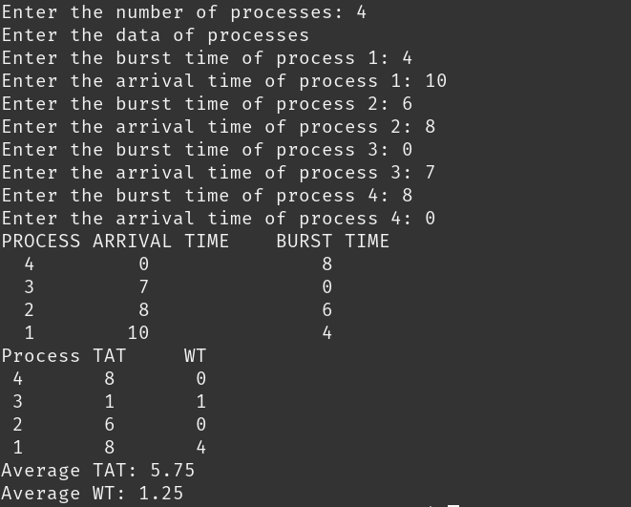

**Discussion and Conclusion**

In this section of the lab, we implemented various CPU scheduling algorithms. We calculated the average turnaround time and average waiting time of the given process using the scheduling algorithm. We observed output for different inputs and understood about FCFS and Shortest Job First Scheduling algorithm.

Thus, some CPU scheduling algorithms were implemented.