TRIBHUVAN UNIVERSITY

INSTITUTE OF ENGINEERING

THAPATHALI CAMPUS



**A LAB REPORT ON**

Inter Process Communication

**SUBMITTED BY**

Sushovan Shakya

THA075BEI046

**SUBMITTED TO**

Department of Electronics and Computer Engineering

26th August, 2021

**INTER PROCESS COMMUNICATION**

**OBJECTIVE**

* To understand IPC concepts.

**THEORY**

IPC stands for inter-process communication. Let us assume there are two processes running in the memory, a child process and a parent process. The requirement is such that the parent has to wait till a key is pressed from within the child and the parent has to exit.

**pipe()**

The pipe system call accept a pointer to an integer (actually an array of two integers). The integer (pfd[0]) can be used to read using the read call and the second (pfd[0]) can be used for writing using write call.

**SOURCES CODES**

**Program 1**

#include <stdio.h>

#include <unistd.h>

#include <stdlib.h>

int exflag = 0;

void main()

{

char c;

if(!fork())

{

printf("press a key:");

scanf("%c", &c);

exflag = 1;

exit(0);

}

else

{

while(!exflag);

printf("i got the character");

exit(0);

}

}

**Output**



**Modified Code**

#include <stdio.h>

#include <unistd.h>

#include <sys/wait.h>

#include <stdlib.h>

#include <errno.h>

int main()

{

int fd[2];

pipe(fd);

char c;

int exflag=0;

if(!fork()) {

close(fd[0]);

printf("press a key: ");

scanf("%c",&c);

exflag=1;

write(fd[1], &exflag, sizeof(int));

close(fd[1]);

exit(0);

}

else {

close(fd[1]);

int y;

read(fd[0], &y,sizeof(int));

close(fd[0]);

while(!y);

printf("i got the character\n");

}

}

**Output**

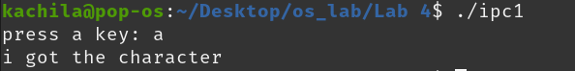

**RESULT**

Here a character is passed between the main and the child process. This is  
achieved by using the pipe() function call. The child process allows the user to  
enter a character and the main process displays a string on receiving the  
character.

**Program 2**

#include <unistd.h>

#include <stdlib.h>

#include <stdio.h>

void main()

{

int pfd[2];

if(pipe(pfd)<0)

{

perror("pipe");

exit(1);

}

if(!fork())

{

char data;

printf("I'm child\n");

printf("press any key to exit: ");

scanf("%c", &data);

write(pfd[1], &data, 1);

printf("child exiting...\n\n");

}

else

{

char data;

read(pfd[0], &data, 1);

printf("I'm parent\n");

printf("received %c from child\n", data);

printf("parent exiting...\n");

exit(0);

}

}

**Output**

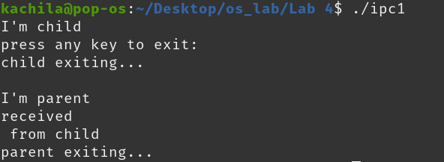

**RESULT**

pipe () system call is used to communicate between processes. The child  
process allows the user to enter a character which is written on a file and read in  
the main process from the file through the use of pipe () system call. The child  
process terminates on getting a character from the user and the parent process  
terminates when it receives a character from the child process.

**Program 3**

#include <unistd.h>

#include <stdlib.h>

#include <stdio.h>

#define MSGSZ 16

int main() {

char *msg1 = ("hello one");

char *msg2 = ("hello two");

char *msg3 = ("hello three");

char inbuf[MSGSZ];

int p[2];

pipe(p);

write(p[1], msg1, MSGSZ);

write(p[1], msg2, MSGSZ);

write(p[1], msg3, MSGSZ);

for(int j = 0; j < 3; ++j) {

read(p[0], inbuf, MSGSZ);

printf("%s\n", inbuf);

}

exit(0);

return 0;

}

**Output**

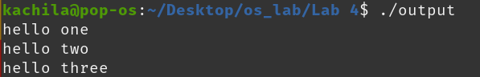

**RESULT**

Three messages are written to a file from the child process and read from the  
main process and displayed. This communication is made possible by a pipe()  
call which connects two processes. Similar results are achieved on writing from  
the parent process and reading from the child process. This can be done by  
exchanging statements of if and else.

**Program 4**

#include <unistd.h>

#include <stdlib.h>

#include <stdio.h>

int main() {

int p[2], pid;

pipe(p);

pid = fork();

if(pid == 0)

printf("in the child p[0] is %d p[1] is %d\n", p[0], p[1]);

else

printf("in the parent p[0] is %d p[1] is %d\n", p[0], p[1]);

return 0;

}

**Output**

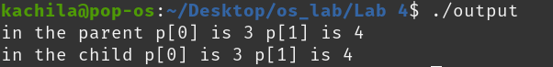

**RESULT**

The values of the file descriptors of the both processes are displayed.

**Program 5**

#include <unistd.h>

#include <stdlib.h>

#include <stdio.h>

#define msgsz 16

int main() {

char *msg = "hello!";

char inbuf[msgsz];

int p[2], pid, j;

pipe(p);

pid = fork();

if(pid > 0) {

close(p[0]);

write(p[1], msg, msgsz);

}

if(pid == 0) {

close(p[1]);

read(p[0], inbuf, msgsz);

printf("%s\n", inbuf);

}

exit(0);

return 0;

}

**Output**



**RESULT**

Message is written to a file in the main process and read in the child process  
and displayed. If the message is read from the file descriptor already closed then  
the message cannot be read and will not be displayed. Message cannot be read  
from or written to a file descriptor already closed.

**CONCLUSION**

In this section of lab, we learned about pipe () function and other parts of  
interprocess communication. We implemented some programs and saw examples  
of interprocess communications.