SPORTS BROADCAST BRAND EXPOSURE
& FAN SENTIMENT ANALYTICS
A Business Analytics Project by Sworaj Shakya

PROJECT OVERVIEW
This project simulates and analyses sports broadcast sponsorship data — the kind of dataset a sports analytics consultancy uses to advise leagues, teams, and broadcasters on sponsor value. The analysis quantifies brand exposure time across camera angles and sponsorship placements, tracks weekly exposure trends, and links audience size and fan sentiment back to commercial value, mirroring the real-world work of sports data consultancies serving broadcasters and sponsors.

BUSINESS OBJECTIVE
Sponsors pay significant fees for on-screen exposure during live sports broadcasts, but that exposure is only valuable if it is measurable. This project answers three core commercial questions:
- Which sponsor brands are receiving the most (and least) broadcast exposure, and is that exposure trending up or down?
- Which camera angles and placement types (jersey, LED signage, stadium signage, graphics overlays) actually drive the most exposure time?
- Does a larger broadcast audience translate into proportionally more brand exposure, and how does fan sentiment vary by sponsor?

DATA & METHODOLOGY
A structured dataset of 60 simulated matches across five Australian leagues (AFL, NRL, A-League, Super Rugby, BBL) was generated, capturing 1,456 individual brand-exposure events. Each event records the match, broadcaster, brand, placement type, camera angle, exposure duration (seconds), audience size, and a fan sentiment score derived from simulated post-match surveys.
- Data generation & cleaning: Python (Pandas, NumPy)
- Statistical analysis: aggregation, correlation analysis, trend analysis (Pandas)
- Visualization: Matplotlib & Seaborn
- Reporting: structured summary document (this report) suitable for a business/non-technical audience

KEY FINDINGS
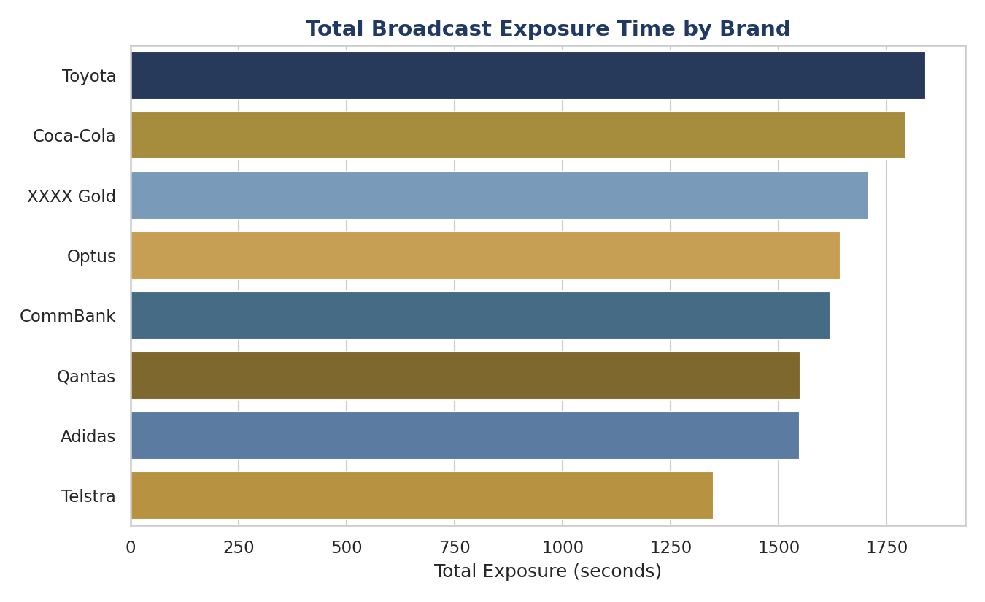
Figure 1 — Toyota, Coca-Cola, and XXXX Gold recorded the highest total broadcast exposure across all matches.
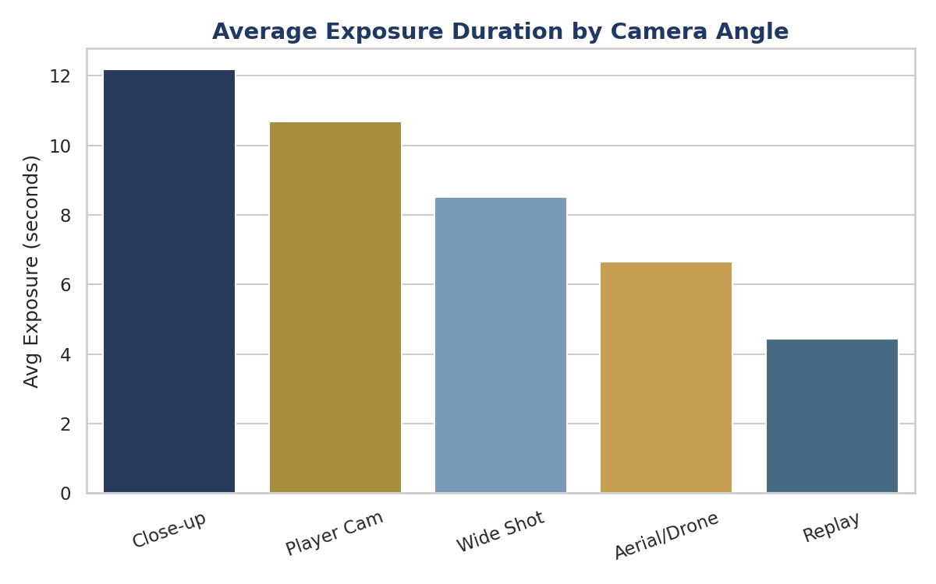
Figure 2 — Close-up and player-cam shots drive substantially longer average brand exposure than wide shots or replays, highlighting where sponsors get the most value.
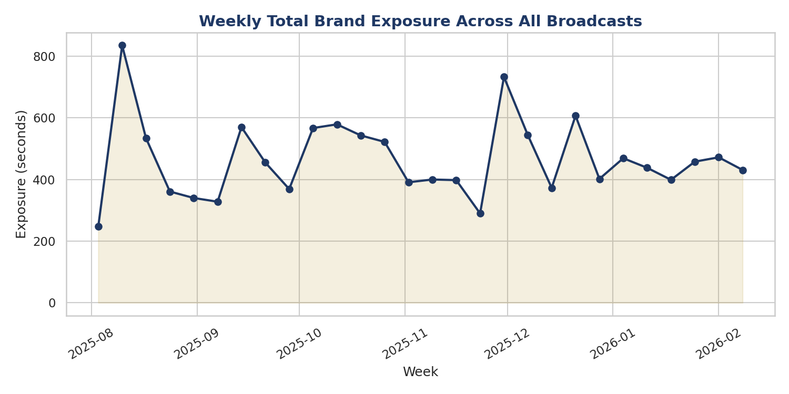
Figure 3 — Weekly total brand exposure across all broadcasts, showing variation tied to match scheduling and league mix.
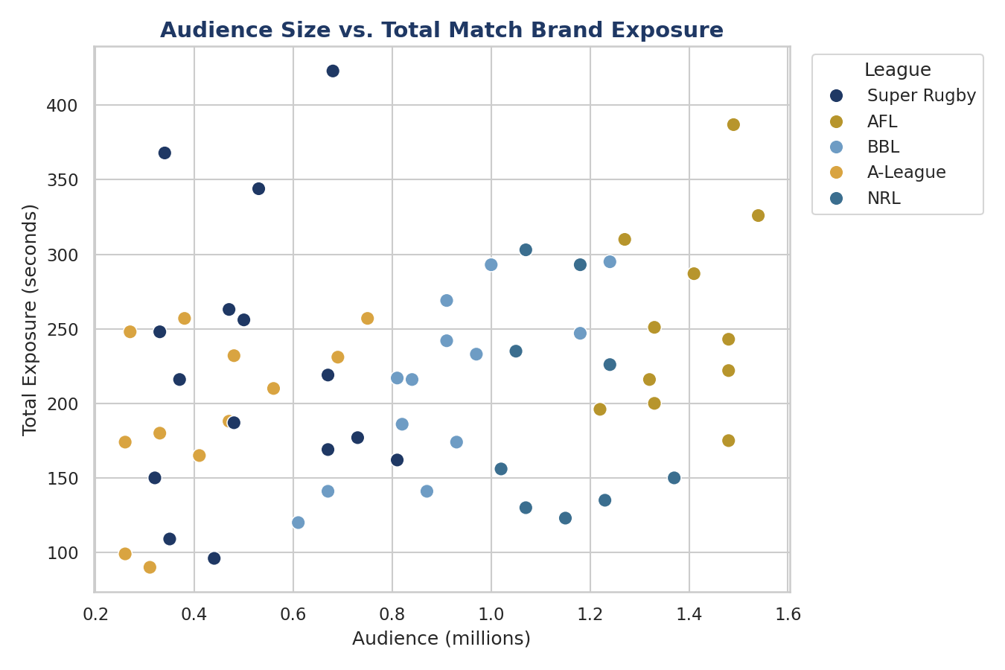
Figure 4 — Audience size shows a positive but moderate relationship with total match exposure (r ≈ 0.24), suggesting placement and camera strategy matter as much as audience reach.
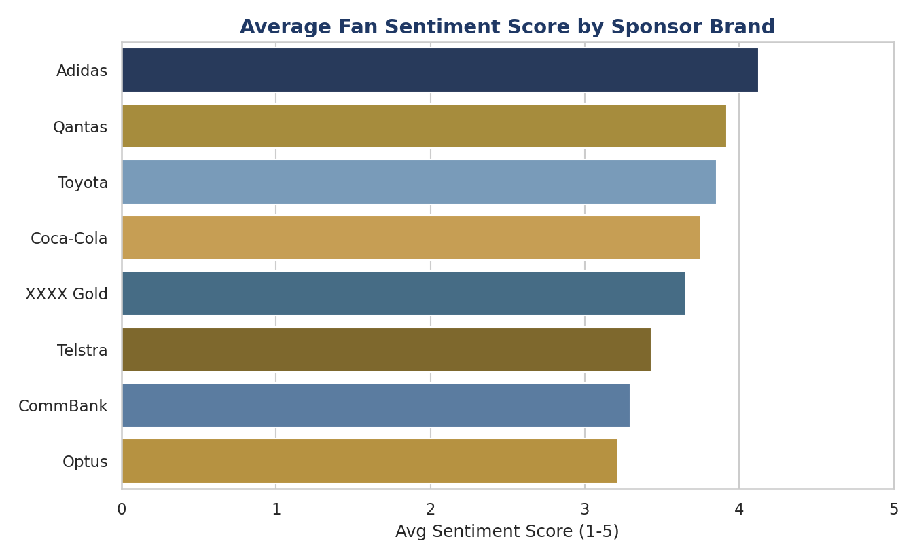
Figure 5 — Adidas, Qantas, and Toyota recorded the highest average fan sentiment scores among tracked sponsors.

COMMERCIAL INSIGHT
Broadcast Graphics Overlays generated the highest average exposure per event (15.5 seconds), ahead of Jersey Sponsorship (9.8s), LED Perimeter Signage (6.0s), and Stadium Signage (5.2s) — suggesting that for sponsors prioritising visibility, digital overlay placements may offer stronger value per broadcast than traditional signage. Combined with the camera-angle finding, this points to a practical recommendation: sponsors seeking maximum exposure should prioritise placements likely to be captured in close-up and player-cam shots, rather than relying on audience size alone as a proxy for value.

SKILLS DEMONSTRATED
- End-to-end data pipeline: synthetic data generation, cleaning, and structuring
- Exploratory data analysis and correlation analysis using Python/Pandas
- Business-relevant data visualization and insight communication
- Translating data findings into commercial recommendations for a sports/media audience
- Tools: Python, Pandas, NumPy, Matplotlib, Seaborn

NEXT STEPS
With access to real broadcast and sponsorship data, this analysis could be extended with computer-vision-based brand detection from video footage, a live Power BI/Tableau dashboard for ongoing sponsor reporting, and predictive modelling of exposure value ahead of upcoming broadcasts.

