**Night Entry Portal**

**Project Requirements-**

**Functional Requirements :**

**Maintaining the night entry portal requires some function, they are-**

1. **Hosteller’s Account creation**

**•Details like name, email ,phone No. ,course ,roll no. , gender ,password has to be filled by the student.**

**•Hosteller needs to click on the sign in after mentioning the above details.**

**2. Log In-**

**•Hosteller is required to enter into his/her account.**

**•Now the hosteller needs to click on the QR generate button which would generate QR code for the student**

**•Now the QR code will be scanned by the respective warden and a confirmation sms will be sent to the registered Mobile No.**

**•If the hosteller forgets his/her password then he can click on forget password so that a mail can be sent to his/her email address provided, to reset the password.**

**3. Scanning the QR code-**

**•The warden needs to open the scanner, scan the QR code.**

**•The date and time of the scanned QR code will be recorded in the database along with basic details.**

**4. Database-**

**As soon as the account is created all the details entered by the hostellers will be entered in the HOSTELLER table in the database**

**When the user is trying to log into his/her account, his credentials would be validated as per the details provided at the time of account creation.**

**The date and time of the scanned QR by the warden would be collected and stored in the RECORD table along with his/her roll no.**

**SMS would be sent to the hosteller’s registered mobile no. after successful entry being made into the RECORD table.**

**Daily report would be generated which would show who all have made their entry into the register.**

**5. Admin’s right-**

** Hosteller’s detail like roll no. ,mobile no could be changed only by requesting the admin.**

**Interface Requirements :**

GUI:

GUI1:

Initial GUI asks for user credentials consisting of various buttons–

•Email and password to login for users already having an account, with a service to change password in case forgotten via email, ,it directs users to GUI 3.

•For new users we provide an option to create new account ,it directs users to GUI 2.

GUI2: it consists of various buttons such as :

• Name

• Email

• phone number

• course

• stream

• gender

• roll number

• password(with check constraint)

• confirm

GUI3: For QR generation , contains meaningful buttons.

**HARDWARE INTERFACE:**

Responsive website can be embedded on desktop, ipad, mobile phone

**SOFTWARE INTERFACE:**

FRONTEND: html, css, bootstrap

BACKEND: mysql version 5.6, python(framework django)

**SOFTWARE TOOLS:**

Text Editors: Atom, VS code

**DEPLOYMENT:**

End user’s System Configuration:

Operating System: Android, iOS

Processor: Any version of Snapdragon 865+

*Mobiles must have in-built scanners.

1. **Data Flow Diagrams:**
   1. **0 Level :**

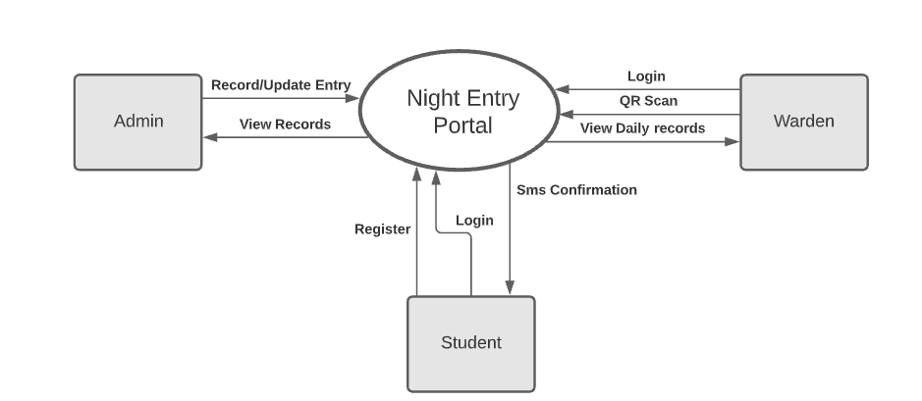

Fig 4.1 Zero level Diagram

* 1. **1 Level :**

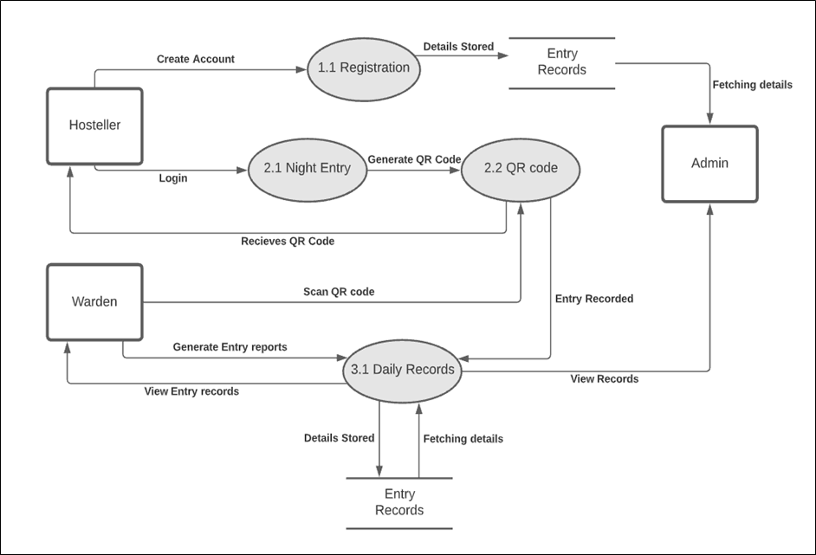

Fig 4.2 First Level Diagram

* 1. **2 Level :**

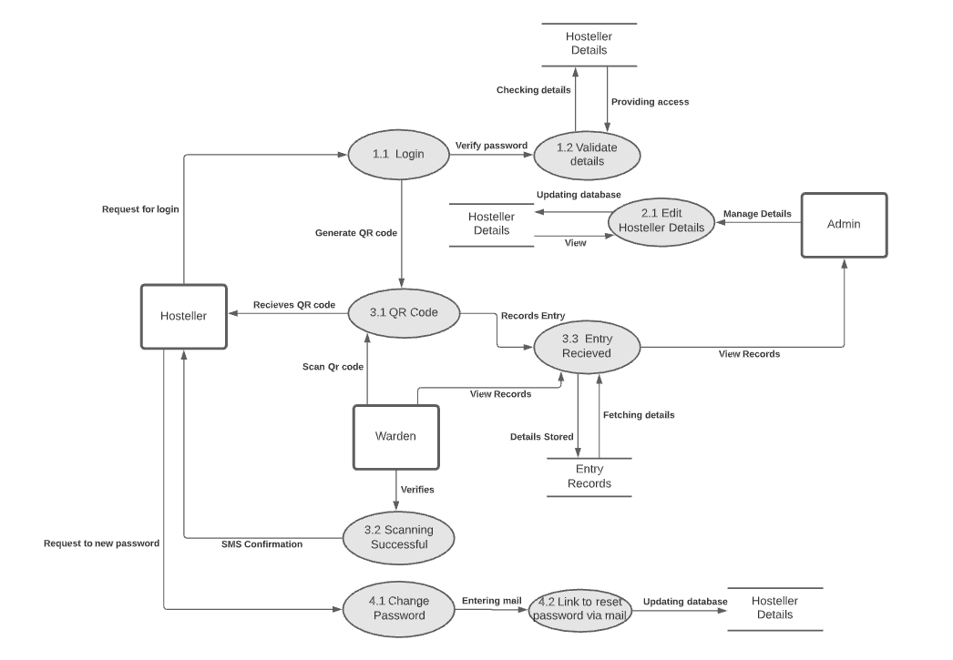

Fig 4.3 Second Level Diagram

1. **Data Dictionary**

**5.1. Data stored**

**Warden Table:**

|  |  |  |  |  |  |
| --- | --- | --- | --- | --- | --- |
| Field Name | Type | Data Format | Key | Description | Example |
| Email | varchar(50) | abc@domain | Primary | Email id of warden | Xyz@google.com |
| Password | varchar(30) | ****** |  | Should be atleast 6 characters long.It can be alpha-numeric. | Hello1@200 |
| Name | varchar(256) | xyz |  | Name of warden | pushpa |
| gender | varchar(10) | M/F |  | Gender of warden | Male |

Table 5.1.1 Warden Table

**Record Table:**

|  |  |  |  |  |  |
| --- | --- | --- | --- | --- | --- |
| Field Name | Type | Data Format | Key | Description | Example |
| id | int |  | Primary | Unique entry id | 3487 |
| fname | varchar(255) |  |  | Stores first name of student. | samridhi |
| lname | varchar(255) |  |  | Stores last name of student. | garg |
| roll_no | varchar(255) | 101916*** |  | Roll number of student. | 101916086 |
| phone | varchar(255) | 123-456-789 |  | Contact number of student. | 8748923456 |
| student_email | varchar(255) | Xyc@thapar.edu |  | Institute email of student. | sgarg@thapar.edu |
| date_of_entry | date | mm/dd/yyyy |  | Date at the time of entry. | May 27,2021 |
| time_of_entry | time(6) | hh:mm:ss |  | Time at which entry is being made. | 17:44:00 |
| warden_name | varchar(256) |  |  | Name of warden. | pushpa |
| Warden_email | varchar(50) | abc@domain |  | Email id of warden | Xyz@google.com |

Table 5.1.2 Record Table

**Hosteller Table**-

Table 5.1.3. Hosteller Table

|  |  |  |  |  |  |  |  |
| --- | --- | --- | --- | --- | --- | --- | --- |
| FIELD | TYPE | NULL | KEY | DEFAULT | DATA FORMAT | DESCRIPTION | EXAMPLE |
| Id | Int | No | Pri | NULL |  | Unique id given to each registered user at their time of registration | 1,2,45,66………… |
| Username | Varchar(255) | No | Uni | NULL |  | Username consisting of alphabets, numbers and various characters filled by registered user | Snm3456, pplo9864@....... |
| Roll_no | Varchar(20) | No |  | NULL |  | It is the number assigned by the organization to its students | 2345, 897868…. |
| First_name | Varchar(255) | No |  | NULL |  | First name of user | John,mary….. |
| Last_name | Varchar(255) | No |  | NULL |  | Last name of user | Dgfa, bhfg… |
| Email | Varchar(255) | No | Uni | NULL | abc@thapar.edu | Thapar Email of user | Dsghh7_be@thapar.edu.... |
| Phone | Varchar(255) | No |  | NULL | 123-456-7878 | Phone number of each user | 7465876790…… |
| Gender | Varchar(255) | No |  | NULL |  | Male or female category of the user | Male or female |
| Course | Varchar(255) | No |  | NULL |  | Course opted by the user | Copc, cose, ele… |
| Password | Varchar(20) | No |  | NULL |  | Password to secure his/her account by the user | 5647#34vdgfs…. |
| Confirm  password | Varchar(20) | No |  | NULL |  | Same password to be repeated | 5647#34vdgfs…. |
| Qr_code | Varchar(100) | No |  | NULL |  | unique qr code of user | - |
| Warden_id  _id | Int | Yes | uni | NULL | Foreign key | Takes reference from warden | 5,89,2….. |

**5.2. Data Structure ( based on dfd )**

**Warden:**

|  |  |  |
| --- | --- | --- |
| Data flow | Data structure | Description |
| Login | email ID+ password | To do successful login, user has to enter correct email ID and password. |
| QR scan | warden ID+ Time + Date | At the time of scanning, warden’s ID , current date and time is recorded. |
| View daily records | Hosteller’s name(i.e. first name + last name)+ time + date | Hosteller’s first name,last name,date of entry and time of entry can be seen in daily records. |
| QR scan | warden ID + Time of entry + Date of entry | At the time of scanning, warden’s ID , current date and time is recorded. |
| Generate Entry report | QR scan+ Hosteller’s name (first name + last name) + Hosteller’s roll number | Hosteller’s data collected at the time scanning the QR is entered into the record table. |
| View Entry records | Generate Entry report | The report generated i.e. is the record table is displayed. |

Table 5.2.1

**Hosteller:**

|  |  |  |
| --- | --- | --- |
| Data flow | Data structure | Description |
| Login | email ID + password | To do successful login, user has to enter correct email ID and password. |
| Register | email ID + phone number + roll number+ Student name(i.e. first name + last name)+ password + confirm password | User has to enter his/her details in order to get himself/herself registered at the portal. |
| Email confirmation | Date + time of entry + username | A confirmation mail is send to the student confirming his/her time of entry and date of entry. |
| Generate QR | Student’s unique ID | QR code is generated using user’s unique ID. |
| Receives QR code | QR code | QR generated using unique ID displayed at hosteller’s screen |
| Request for Login | username + password | To do successful login, user has to enter correct email ID and password. |
| Request to new password | Student’s email ID | To reset password, user has to provide their registered email ID. |
| Updating database | New password | old password replaced with new password. |

Table 5.2.2

1. **Use Case**

**6.1 Use Case Diagram**

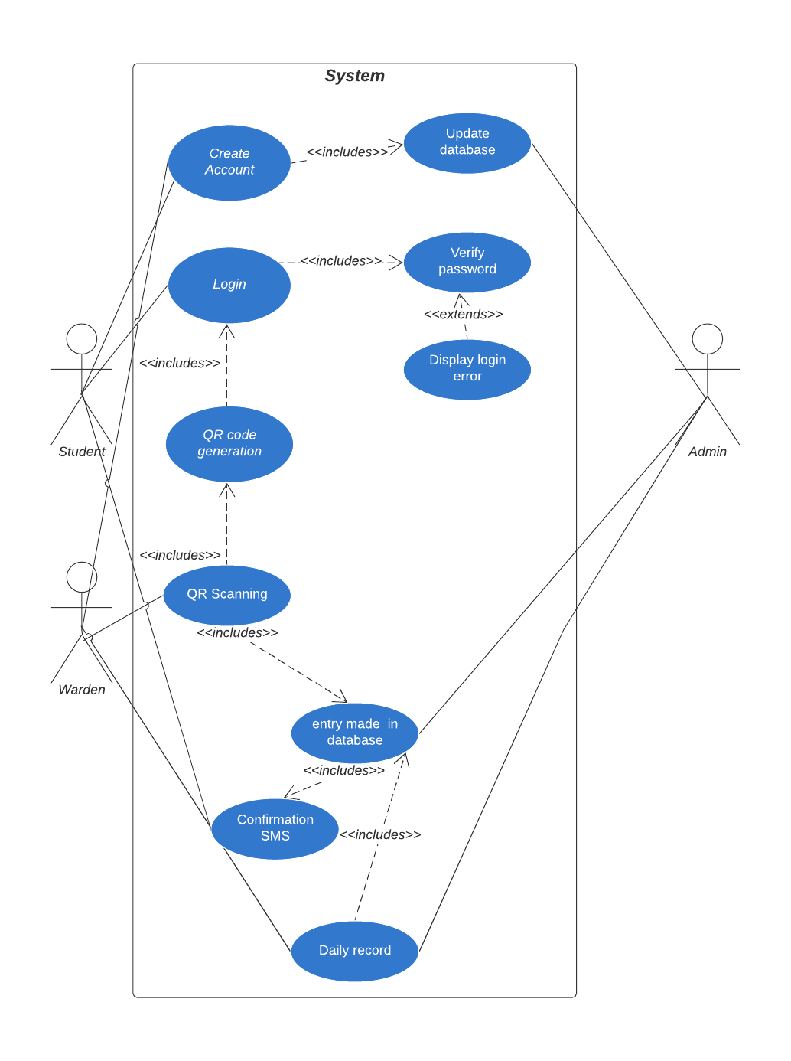

Fig 6.1. Use Case Diagram

**6.2 Use Case Template:**

1.

|  |  |
| --- | --- |
| 1. Use Case Title | QR Code Generation |
| 1. Abbreviated Title | QR Code Generation |
| 1. Use Case Id | 3 |
| 1. Actors:   Primary actor:  Secondary actor: | Hosteller  Warden |
| 1. Description | With this, hosteller will be able to generate a QR code with the help of which he will be able to make his night entry. |
| * 1. Pre-Conditions | Hosteller must be logged in. |
| 5.2 Task Sequence | 1. Generate QR button will be displayed on the screen.  2. Upon clicking the button, hosteller’s QR code will be displayed on the screen. |
| 5.3 Post Conditions | Hosteller should log out after the entry is confirmed.  Hosteller must show the confirmation mail to warden. |

2.

|  |  |
| --- | --- |
| 1. Use Case Title | QR Code Scanning |
| 1. Abbreviated Title | QR Scanning |
| 1. Use Case Id | 4 |
| 1. Actors:   Primary actor:  Secondary actor: | Warden  Hosteller |
| 1. Description | With this, Warden will be able to scan the QR code shown by the hosteller at the time of entry making. |
| * 1. Pre-Conditions | Warden must be logged in. |
| 5.2 Task Sequence | 1. Scan QR button will be displayed on the screen.  2. Upon clicking the button, student’s QR code could be scanned. |
| 5.3 Post Conditions | After scanning of the QR code , the warden should ask the hosteller to show the mail received by him/her for verification purposes. |

1. **Sequence Diagram**

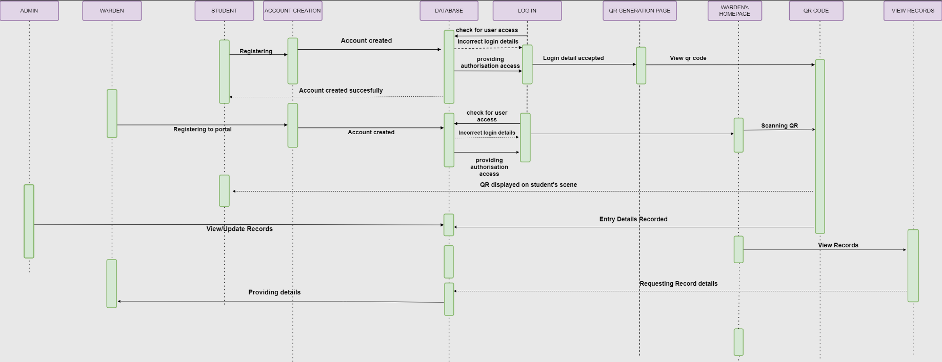

Fig 7. Sequence Diagram

1. **State Diagram**

**8.1 For Hosteller:**

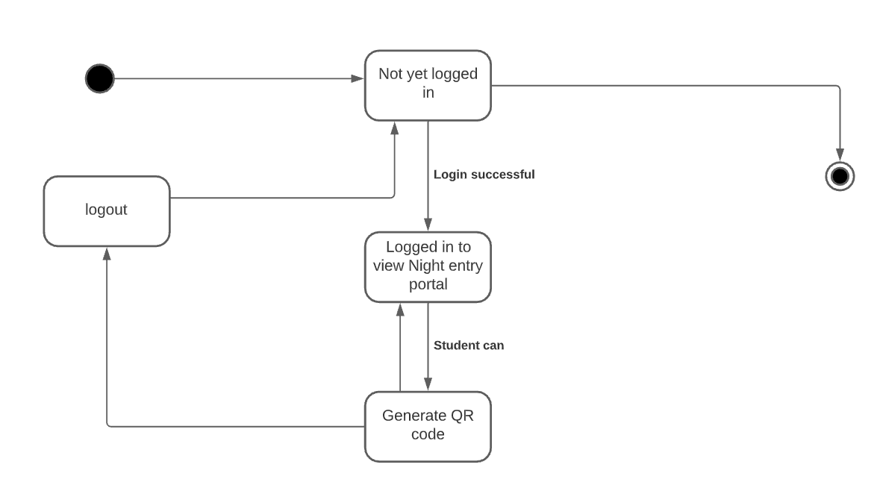

**Fig 8.1. State Diagram for Hosteller**

**8.2 For Warden**

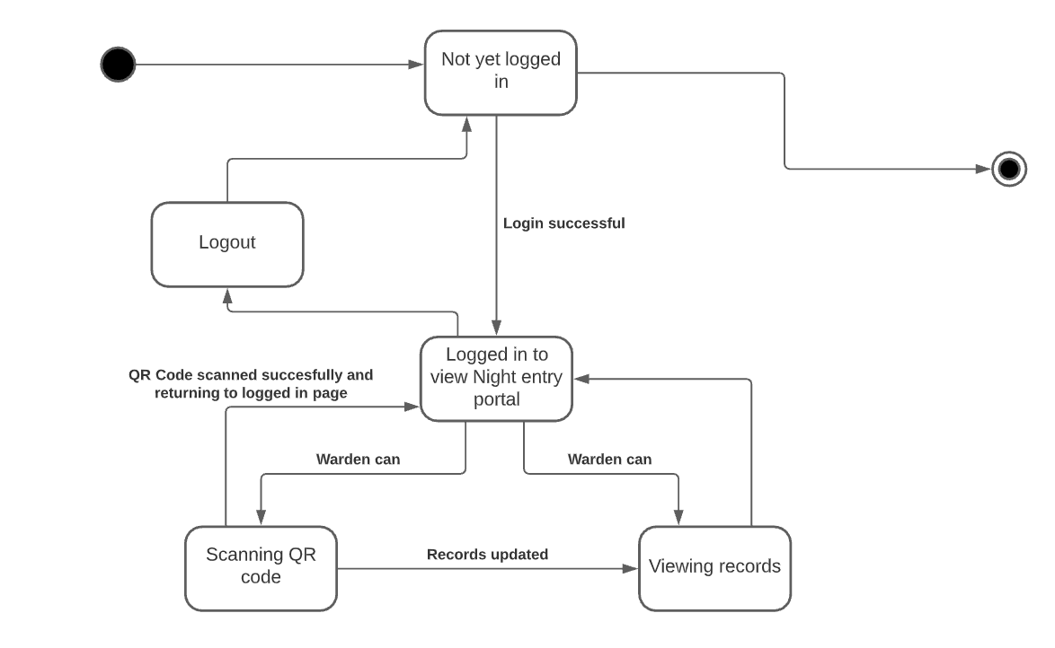

**Fig 8.2. State Diagram for Warden**

1. **Activity Diagram**
   1. **For Hosteller**

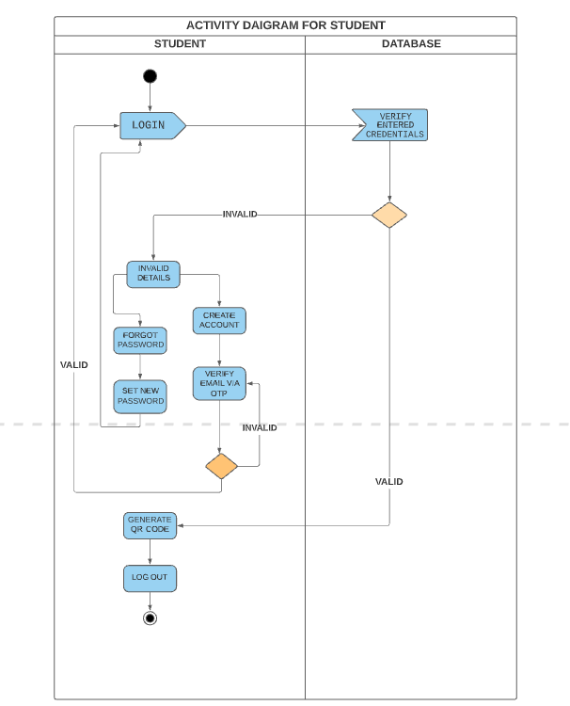

Fig 9.2. Activity Diagram for Hosteller

* 1. **For Warden**

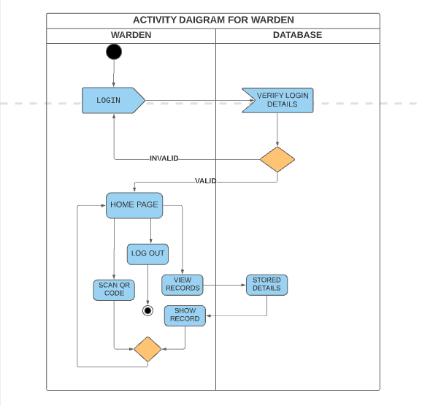

Fig 9.3. Activity Diagram for Warden

1. **Structural Diagram**
   1. **Class Diagram**

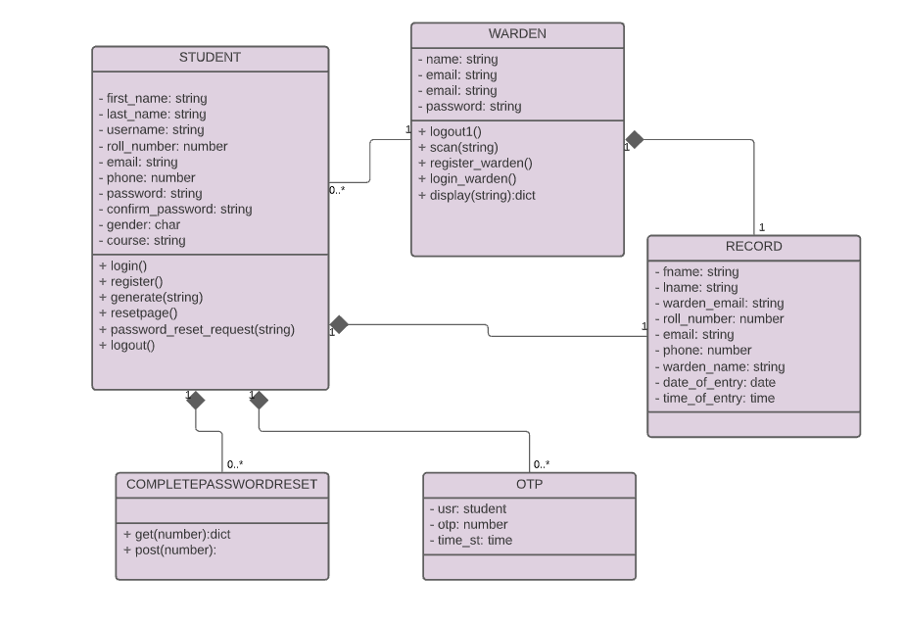

Fig 10.1. Class Diagram

* 1. **Component Diagram**

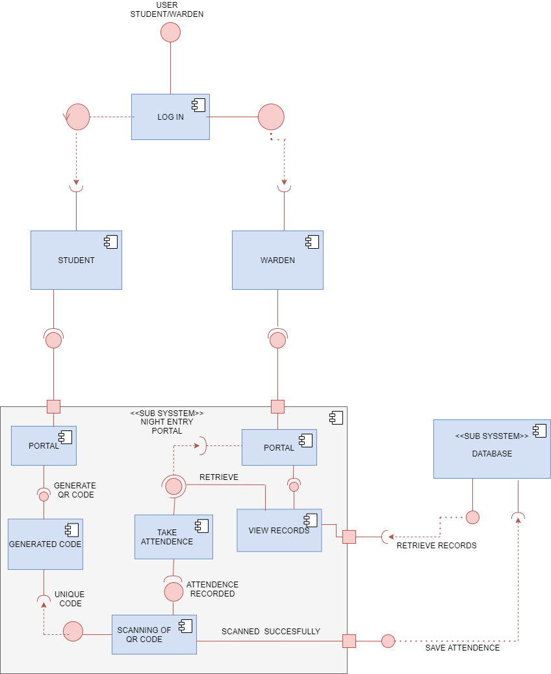

Fig 10.2. Component diagram

* 1. **Deployment Diagram**

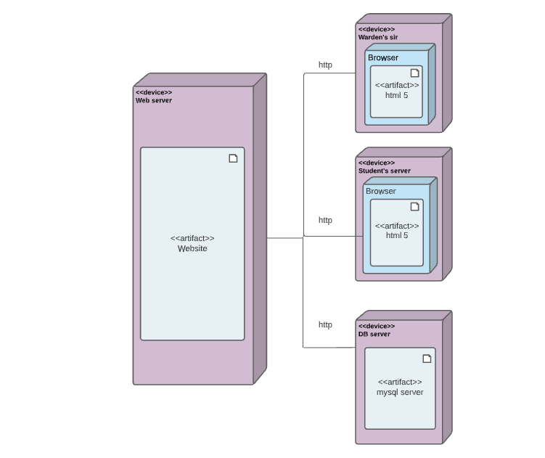

Fig 10.3. Deployment Diagram

1. **Project Diagram**

**11.1. Test Case Report**

|  |  |  |
| --- | --- | --- |
| **Behaviour** | **Expected** | **Pass/Fail** |
| Trying to access a page without logging into his/her account | System should show prompt that the user is logged out | Pass |
| Invalid credentials to login | System should show error message | Pass |
| Valid credentials to login | System should redirect to authenticated page | Pass |
| Registering with invalid email(not thapar email) | System should prompt domain error | Pass |
| Entry confirmation | Email will be sent with date and time of entry mentioned | Pass |
| Email confirmation via otp | Student must get an otp to verify entered email before logging in for entry | Pass |
| Forgot password | Student will get a link via email to reset his/her password | Pass |
| QR code scan with auto closing dialog | System should close the dialog after scanning QR code | Pass |
| Scan by wrong warden | Prompt error in case opposite gender warden tries to make entry | Pass |
| No duplicate entries | Prompt in case student tries to make more than one entry on single day | Pass |
| View records | Warden will be able to view records | Pass |
| View students not made entry | Warden will be able to view students who not made an entry | Pass |
| Display records of specific warden | Female warden will see her records and male his | Pass |
| Empty fields | Neither warden nor student allowed to register or login with incomplete details | Pass |
| Unique qr code | Student cannot make entry of another student | Pass |
| logout | After logging out student or warden will not be able to enter previous session | Pass |
| responsive | Flexible web app operating on all possible sizes of screen(small..big..medium) | Pass |

Table 11.1. Test Case Report

**11.2. UID**

**Appendix A.2- Architecture Style**

Late night entry portal follows the Layered Architecture Style since there are a number of different layers that are defined with each layer performing a well-defined set of operations. Each layer will do some operations that become closer to machine instruction set progressively

The various layers in web-page are as follows-

**USER INTERACTION LAYER-** This is the layer that interacts with users through screens, forms, menus, reports, etc. It is the most visible layer of the application. It deﬁnes how the application looks.

**FUNCTIONALITY LAYER-** This is the layer that presents the functions, methods, and procedures of the system based on the business rules layer. It determines how the pull-down menus work, how the buttons work, and how the system navigates through screens.

**●Application core layer:** This server contains the main programs, code deﬁnitions, and basic functions of the application. Programmers work in this layer most of the time.

**●Database layer:** This layer contains the tables, indexes, and data managed by the application. Searches and insert/delete/update operations are executed here.

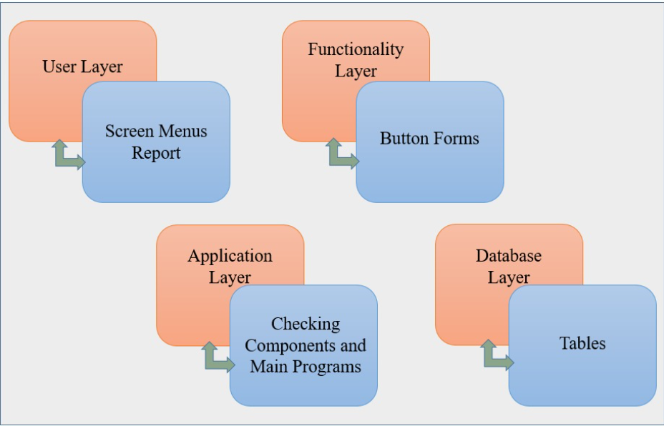

Fig A.2. Layers in a Web-page