* + 1. **Hosteller view web application( mobile view )**

a)

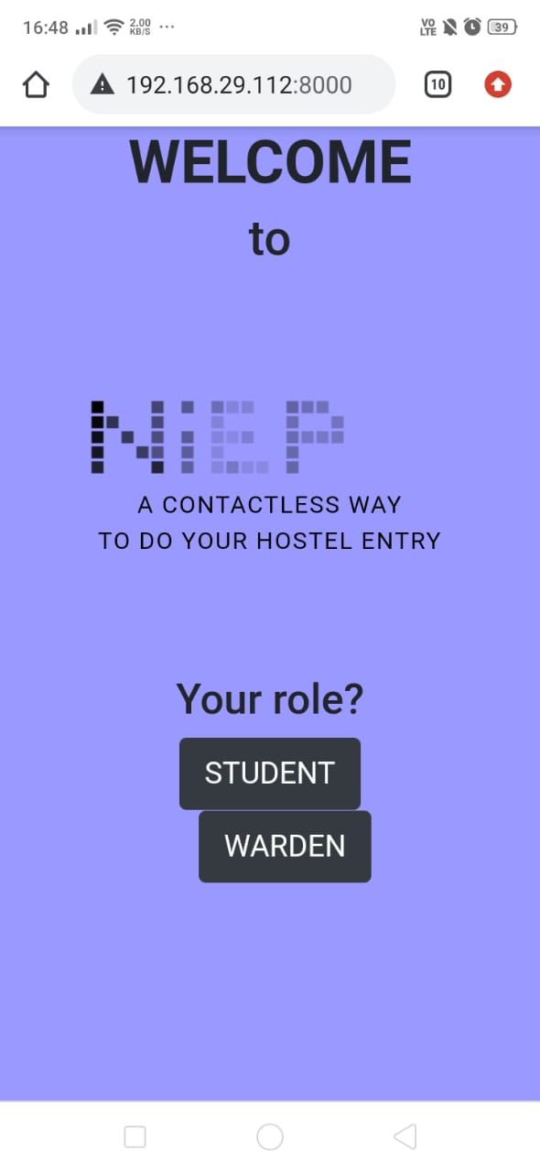

Fig a. Home page

b)

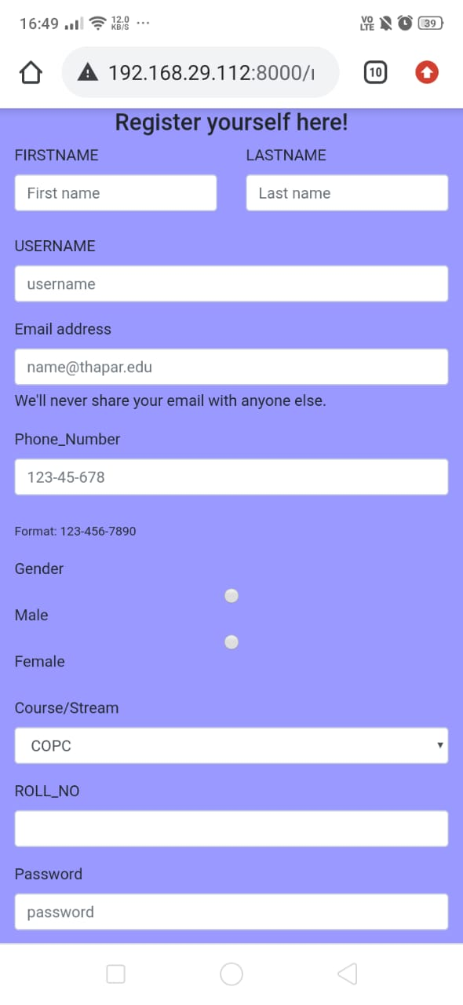

Fig b. Registration Page

c)

c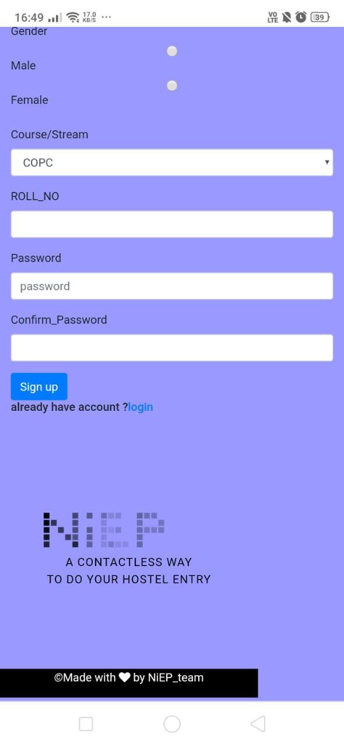

Fig c. Registration page for students (continued)

d)

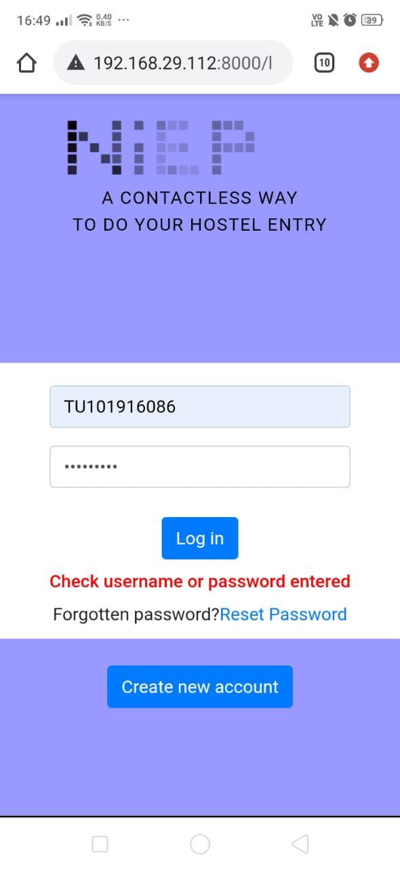

Fig d. Invalid login attempt

e)

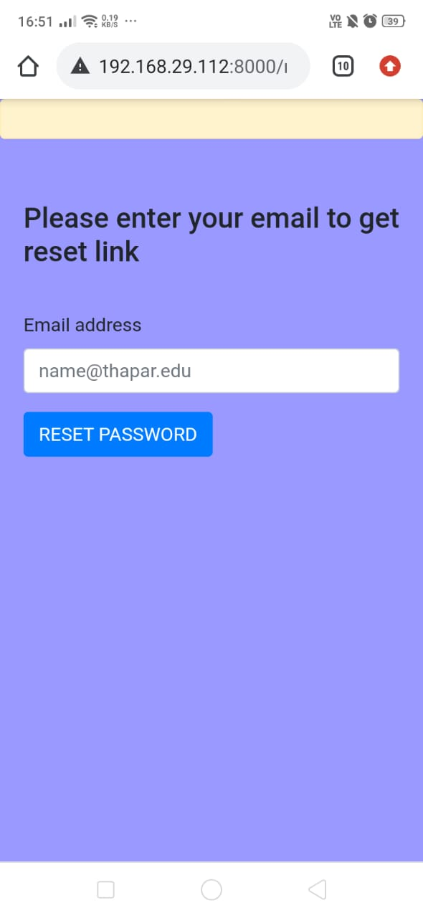

Fig e. Forgot Password

f)

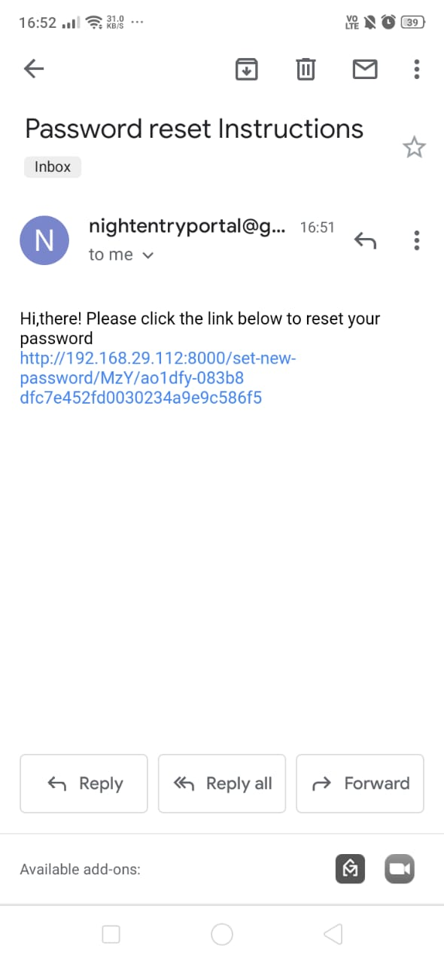

Fig f. Link to reset password via email

g)

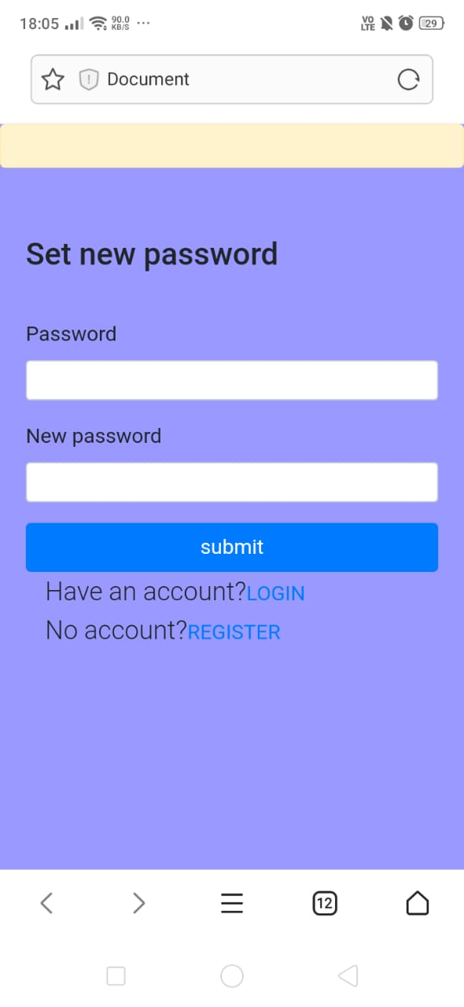

Fig g. Password reset page

h)

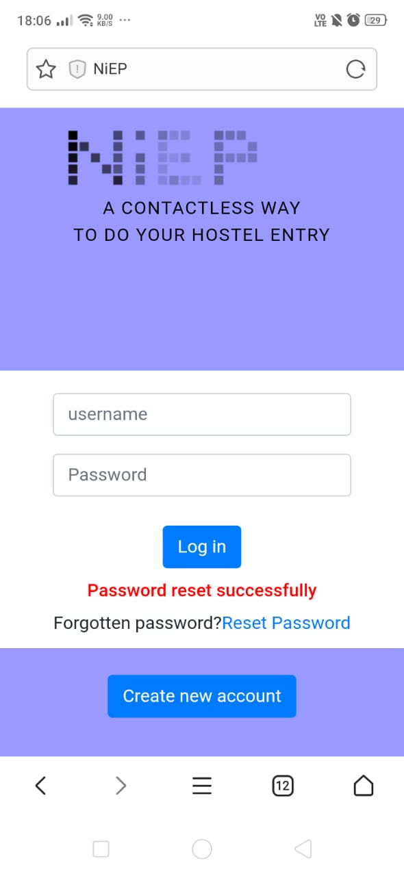

Fig h. Password Reset Successfully

i)

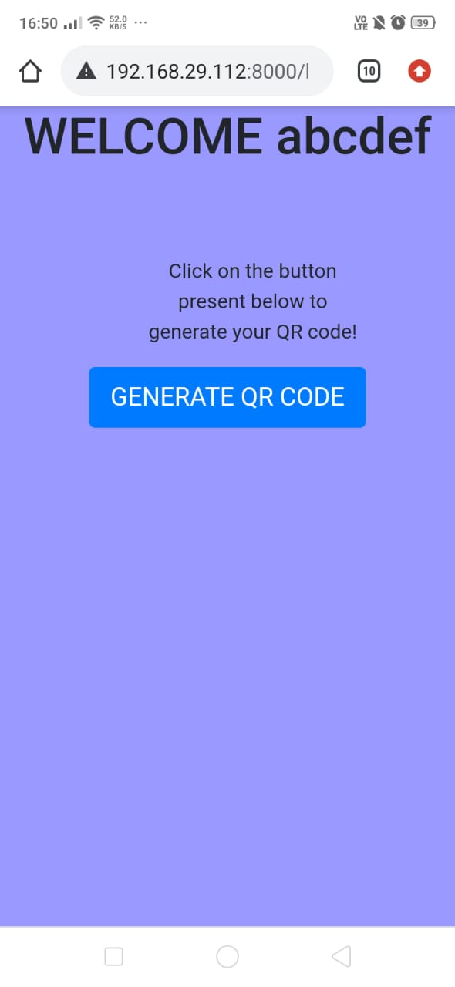

Fig I. Successful Logged In

j)

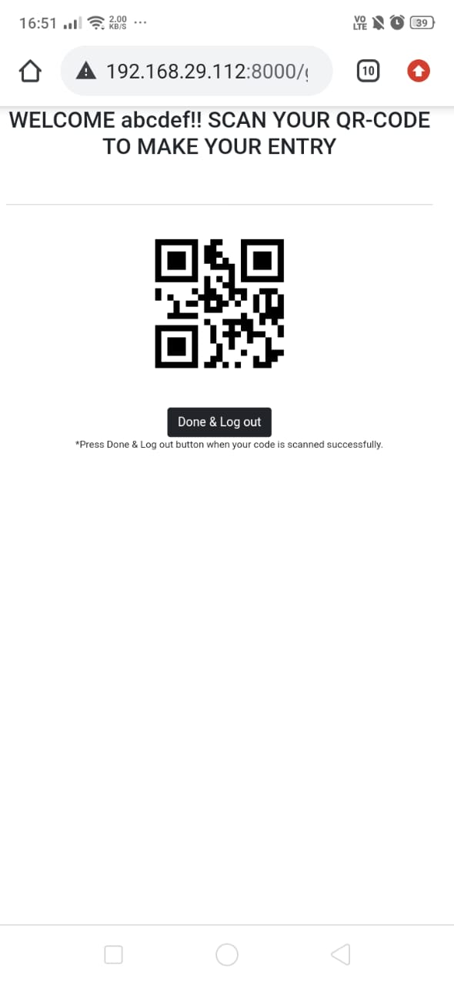

Fig j. Display QR

k)

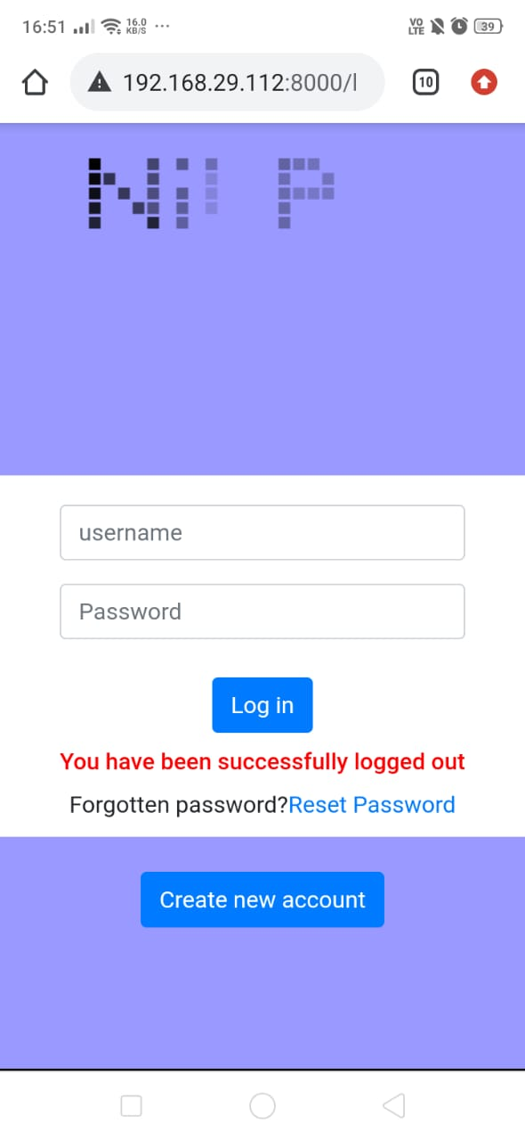

Fig k. Successfully Logged Out

l)

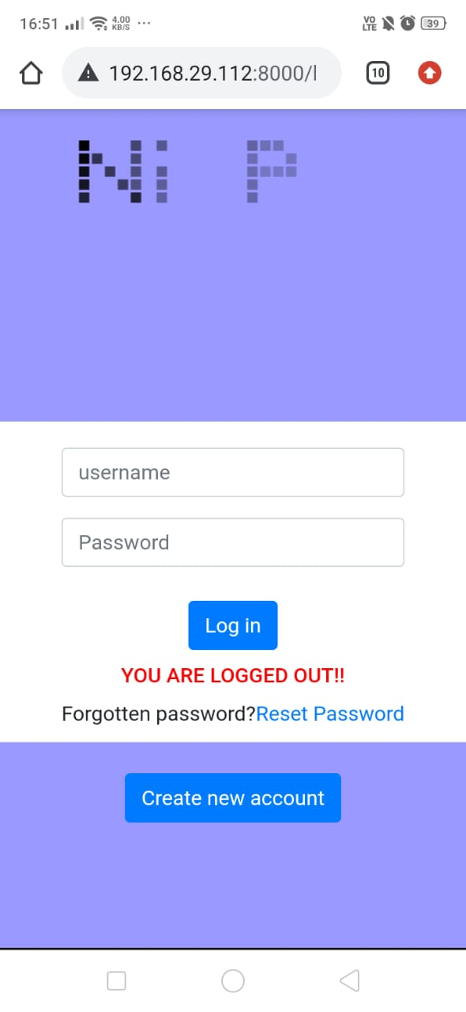

Fig l. Current session ended for user

m)

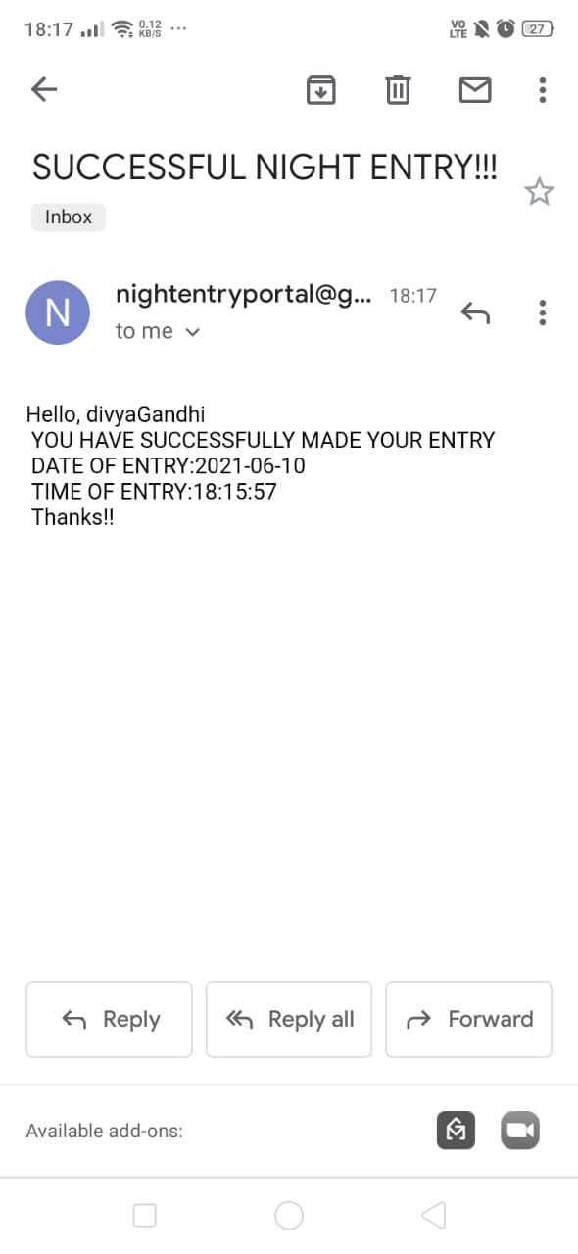

Fig m. Entry confirmed

* + 1. **Warden view web application(Desktop view)-**

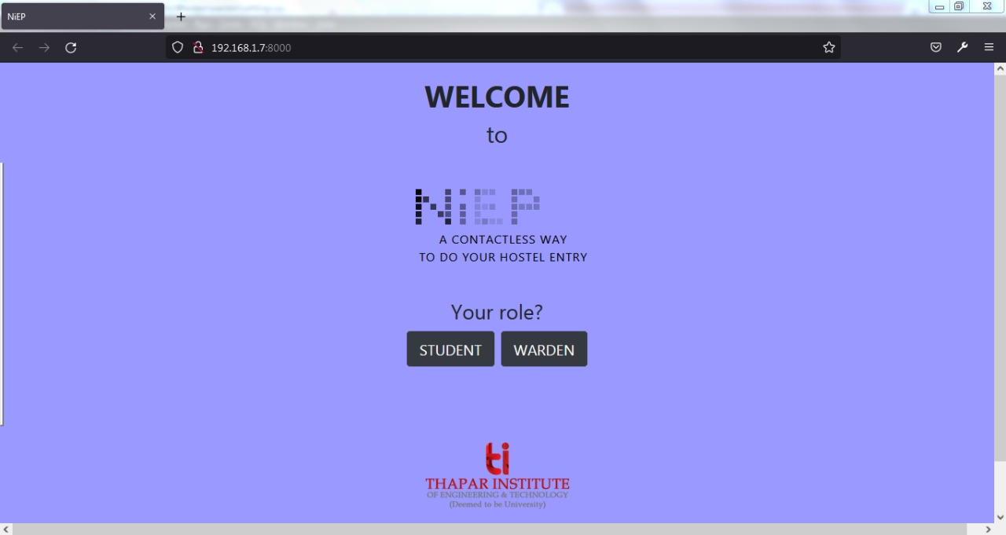

Fig a. Start page

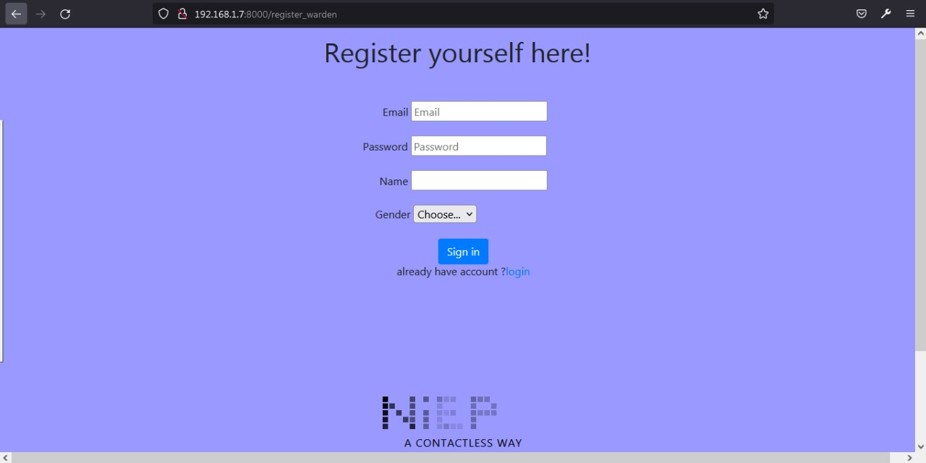

Fig b. Registration page

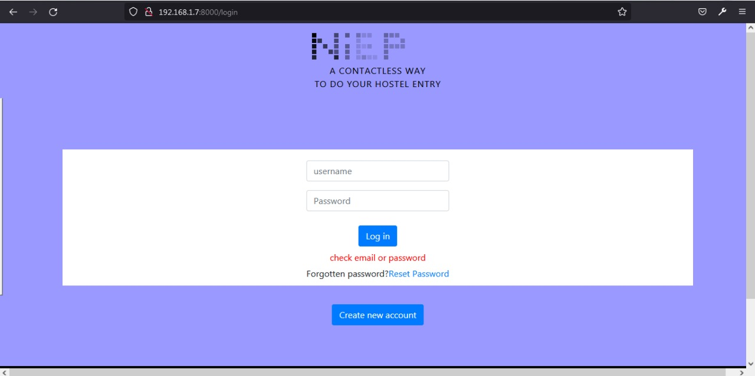

Fig c. Invalid login attempt

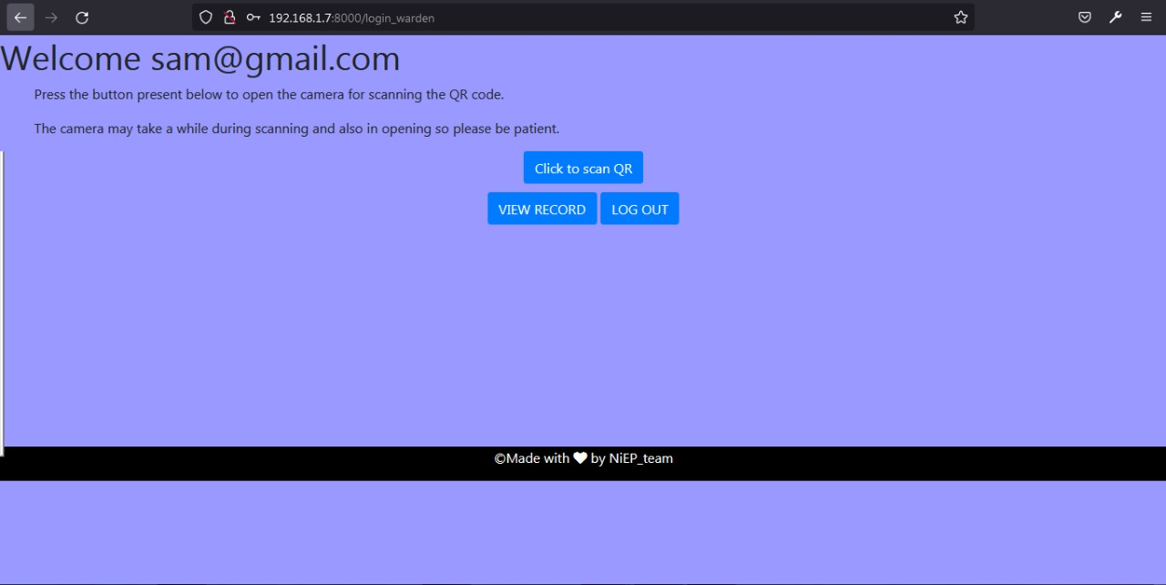

Fig d - Warden’s page after successful login

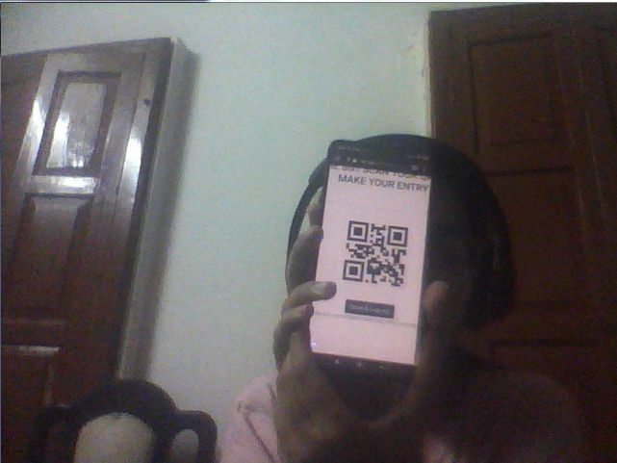

Fig e. Camera scanning the QR

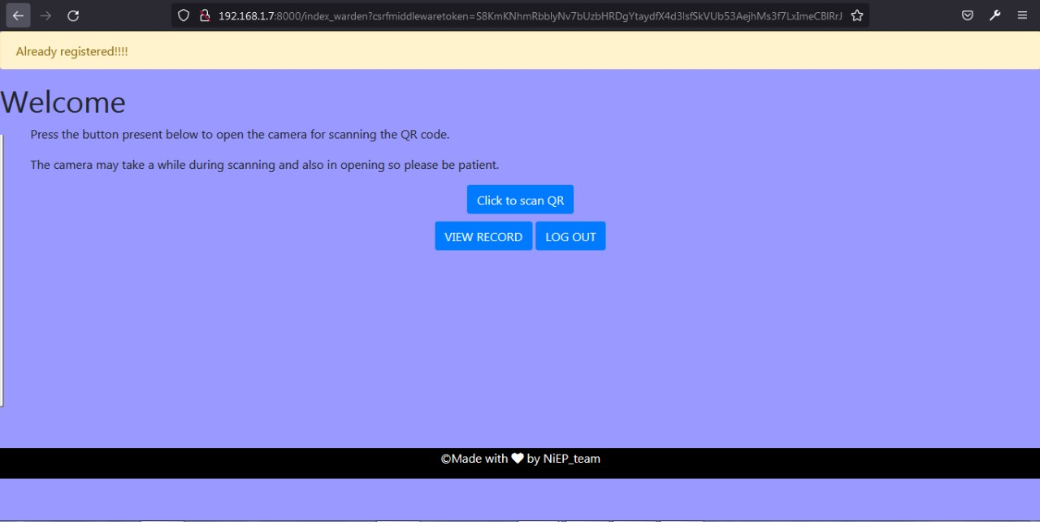

Fig f. If the student has already made the entry for the day

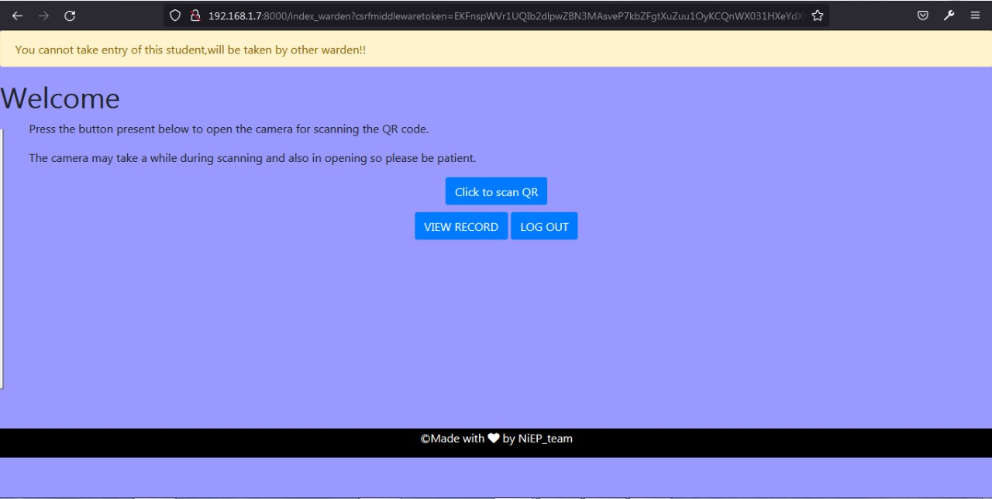

Fig g - If a warden of opposite gender tries to make an entry then error will be shown



Fig h - Camera scanning the QR

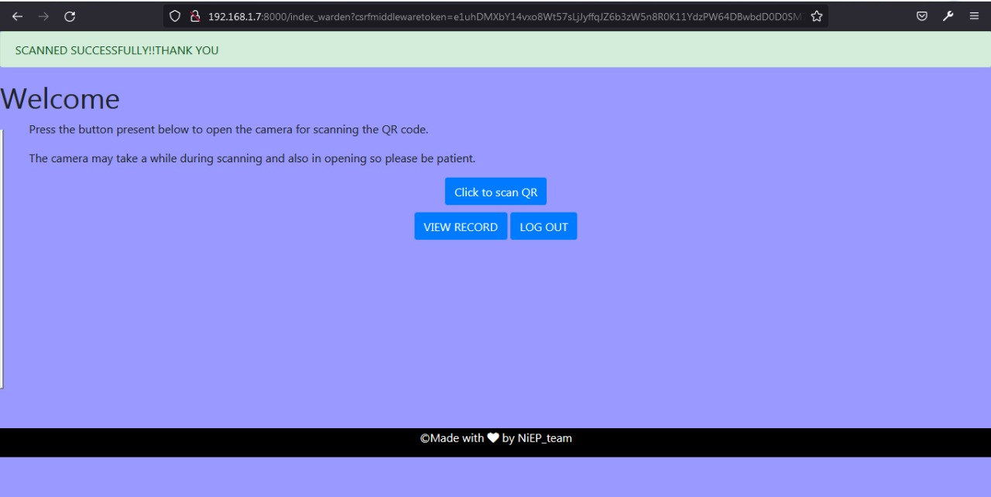

Fig I. Successful Entry Made

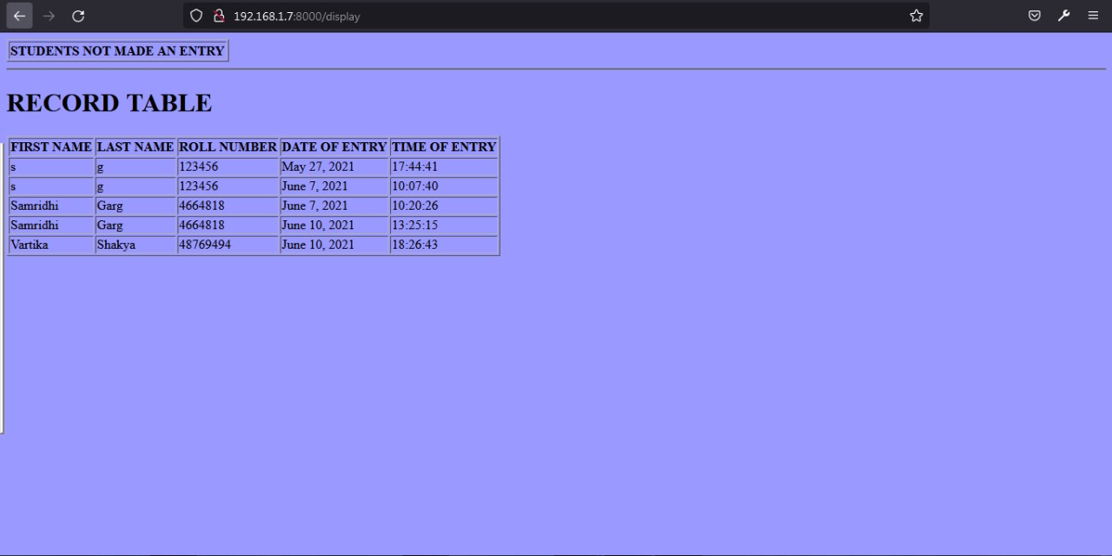

Fig j. Display of records entered

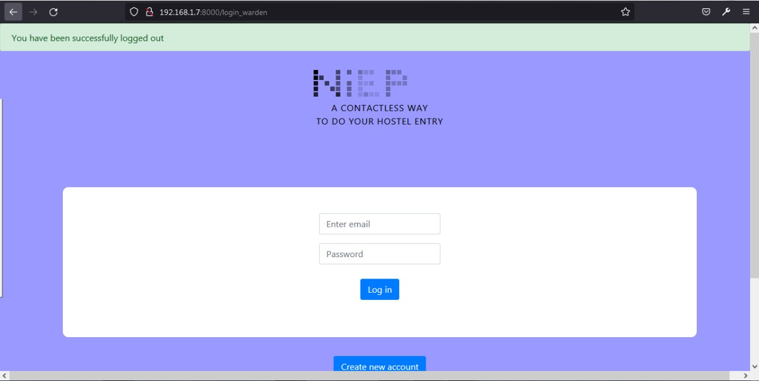

Fig k. Logged out successfully