Videos showing dataset collection for rock ,paper and scissors:

1.For rock:

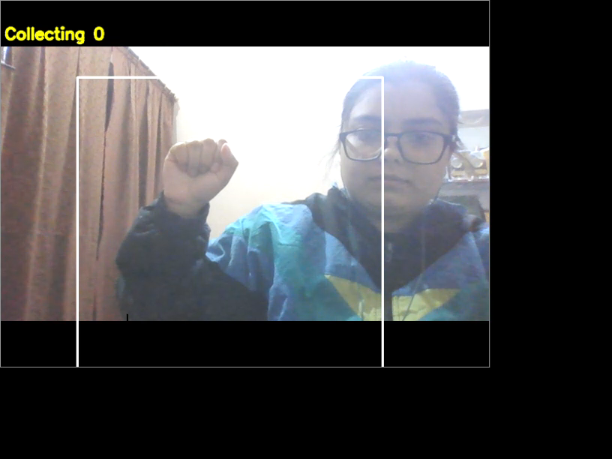

While recording images we tried to make as many variations as possible, like try to do zooming, translation, rotation, slight deformation of hands, etc.

2.For paper:

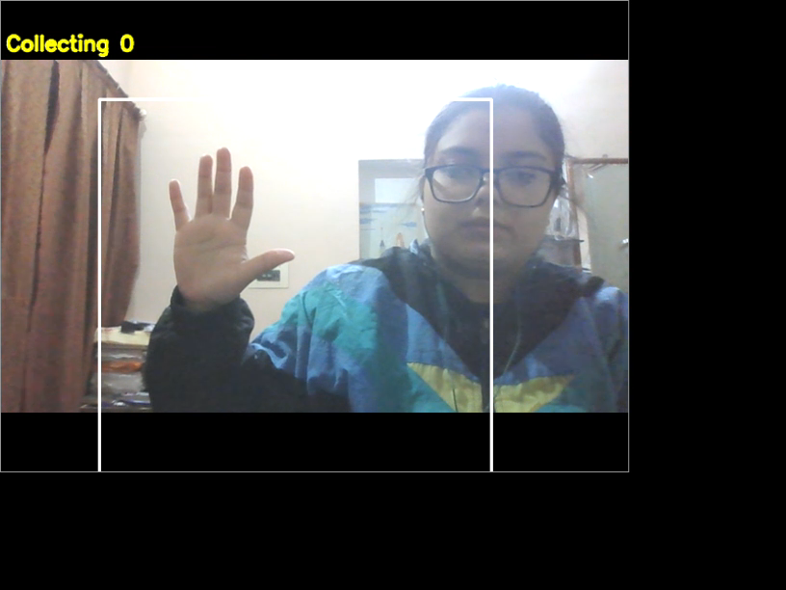

**Training Our Model**

* Now we will load the images from the directory and make sure no hidden files get in our way.
* Now we compile the model, we will be using the Adam Optimizer with a reasonable learning rate. Since it’s a multi-class problem with one hot encoded value we will be using a **categorical_crossentropy**loss and the only metric we care about right now is**accuracy.**
* 