### A

Project Report

On

**Protectoe**

Submitted in partial fulfillment of the Requirements for the award of the Degree of

## MASTERS OF SCIENCE (INFORMATION TECHNOLOGY)

By

# SHALINI SURYAPRAKASH GOUND

Masters of Science Part II (Information Technology)

### Under The Esteemed Guidance

Of

**PROF. AKSHAY RIDLAN**



DEPARTMENT OF INFORMATION TECHNOLOGY

*(Affiliated to University of Mumbai)*

GURU NANAK COLLEGE OF ARTS, SCIENCE AND COMMERCE

G.T.B NAGAR, MUMBAI: 400037 (2022 - 2023)

#### GURU NANAK COLLEGE OF ARTS, SCIENCE AND COMMERCE

***(Affiliated to University of Mumbai)***

**MUMBAI-MAHARASHTRA-400037**

#### DEPARTMENT OF INFORMATION TECHNOLOGY



**CERTIFICATE**

This is to certify that the project entitled, "**Protectoe**", is bonafide work of **MS. Shalini Suryaprakash Gound** bearing Seat. No: **3269662** submitted in partial fulfilment of the requirements for the award of degree of Master OF SCIENCE in INFORMATION TECHNOLOGY from University of Mumbai.

**Internal Guide Coordinator**

**External Examiner**

**Date: College Seal**

**ACKNOWLEDGEMENT**

We thank the almighty for giving us the courage and perseverance in completing the project. This project itself is an acknowledgement for all those who have given us their heart felt co-operation in making it a grand success.

We would like to express our deep gratitude to our honorable Principal Mrs. **Pushpinder Bhatia** for giving us an opportunity to study and pursue a career in Information Technology.

I would like to express my appreciation to our Head of the department **Mrs. Harpreet kaur** and my project guide **Prof. Akshay Ridlan** for her valuable and constructive suggestions during the planning and development of this project work.

Last but not least, we would like to express our deep sense and earnest thanks to our dear parents for their moral support, strength and help for everything.

## TABLE OF CONTENTS

ABSTRACT 6

1. INTRODUCTION 7
   1. INTRODUCTION 7
   2. OBJECTIVES & SCOPE 7
   3. PURPOSE AND SCOPE 8
      1. PURPOSE 8
      2. SCOPE 8
2. SYSTEM ANALYSIS 9
   1. IDENTIFICATION OF NEED 9
   2. PRELIMINARY INVESTIGATION 9
   3. FEASIBILITY STUDY 9
      1. EXISTING SYSTEM 9
      2. PROPOSED SYSTEM 10
      3. TECHNICAL FEASIBILITY STUDY 10
      4. ECONOMICAL FEASIBILITY STUDY 10
      5. LEGAL FEASIBILITY STUDY 10
      6. OPERATIONAL FEASIBILITY STUDY 10
   4. PROJECT PLANNING 11
   5. PROJECT SCHEDULING 11

2.6. SOFTWARE SPECIFICATION 13

2.6.1 FUNCTIONAL REQUIREMENTS 13

2.6.2 NON-FUNCTIONAL REQUIREMENTS 13

2.7 COST BENEFIT ANALYSIS 14

1. REVIEW OF LITERATURE 15
2. DESIGN 16
3. EVALUATION 22
4. RESULTS 26
5. CONCLUSION & SUGGESTIONS 27
6. BIBLIOGRAPHY 28

## LIST OF FIGURES

**Figure 1 Gantt Chart 11**

**Figure 2 Pert Chart 12**

**Figure 3 Project Flow 17**

**Figure 4 Use Case Diagram 18**

**Figure 5 Activity Diagram 19**

**Figure 6 Class Diagram 20**

**Figure 7 Sequence Diagram 21**

## LIST OF TABLES

**Table 1 Project Planning 11**

**Table 2 EAF for Protectoe 14**

**Table 3 Training Dataset……………..…..…..…....…..……………………………………….…….….23**

# PROTECTOE

### ABSTRACT

There are various type of fungus in nails, some are very serious and some are normal. Serious one will last for so long, as a consequence we need to remove the entire nail of a finger as well as the cost to treat this kind of fungus is high. In the healthcare domain, early stage disease diagnosis is very important aspect which plays an important role during the identification of the cause of a disease.

There are different parts of human body is analyzed to predict disease at the early stage of disease diagnosis by observing symptoms with respect to color or pattern or other features. With the help of this software we can detect what type of disease is present on nail and take action accordingly at early stage.

The proposed software guides user to take decision in nail disease identification. The input to the proposed software application is person nail symptom. The system will process the data and use the model to identify the infection. Here, first training set data is prepared using the different symptoms of nail disease. With this application the user can make decisions easily and can prevent there nail from getting lost.

1. **INTRODUCTION**

**1.1 INTRODUCTION**

Protectoe help user to get the nail disease information from anywhere, without visiting the doctor instantly. This application will save user time and money to some extent also, user can cure the nail as early as possible.

This application is also capable of predicting type of nail infection and its risk level so that user can take action accordingly. User need to provide the symptom to know the type of nail infection and if they want to check the level of risk to know how much risk is there if they delay for any medication to save nail.

If the risk level is low they can follow some treatment to stop nail infection from getting spread all over the nail. If the risk level is high, user need to visit doctor immediately and get the surgery done if required as per doctor suggestion.

**1.2 OBJECTIVES & SCOPE**

The following are the objectives of Protectoe:

* To predict the type of nail infection from anywhere.
* To identify the risk level of nail disease.
* To give information on types of nail disease.
* To identify the type of treatment to go-through for identified nail disease.
* To know which doctor user can visit for there treatment.
* Protectoe can help us to achieve all our goals to predict nail infection and treatment that can cure the nail disease, so that user can regain their healthy and beautiful nail.

**1.3 PURPOSE AND SCOPE**

**1.3.1 PURPOSE**

The purpose of this application is to save human nail. Nails protect the sensitive tips of fingers and toes. We don't need our nails to survive, but they do support the tips of our fingers and toes, protect them from injury, and help us pick up small objects. Without them, we'd have a hard time scratching an itch or untying a knot.

Around 10% of the adult population suffers from nail fungus infection Human not much took care of nail but when it catch nail infection and if not much taken care, it can spread to all over the nail and at last it need surgery to treat the infection People don’t visit doctor for such a small issue and hence can lead to loss of entire nail.

To avoid such issue and lose of our beautiful nail they can use this software to protect nail at early stage.

**1.3.2 SCOPE**

* To make simple User interface which can help users to identify the type of nail infection from anywhere
* To reduce the risk of loosing finger or toe nail.
* To make the nail disease identification easier
* To check the type of doctor to visit.
* To get a good understanding of nail infection.
* This application also provide the health tips for good health.

1. **SYSTEM ANALYSIS**

**2.1 IDENTIFICATION OF NEED**

The hard surface of your nails helps to protect the tips of your fingers and toes. And your fingernails make it easier to scratch an itch or remove a dog hair from your sweater. Nails themselves are made of keratin.Toenail fungus is a common infection of the toenails. Also known as onychomycosis, it can cause the toenail to discolor and thicken. As it is contagious, it often starts in one toenail and spreads to several others. As a result, people may consider home remedies to treat toenail fungus. However, home remedies are often not effective. While they may help suppress mild cases, they are unlikely to prevent infections. Instead, people may consider trying certain remedies alongside prescription antifungal treatments. This kind of issue stay for long time.

**2.2 Preliminary Investigation**

Hardware resources would require for using Protectoe as follow:

* Computer Embedded with Minimum 8gb of RAM on top of the hardware any operating system supporting latest version of python, Browser, Jupiter notebook for Testing the functionality. If user wants to compare huge datasets than may require of Larger RAM for fast computation.

**2.3 FEASIBILITY STUDY**

**2.3.1 EXISTING SYSTEM**

There are different ways of disease diagnosis such as through various tests (blood test etc..) and symptom’s available on various parts of body guides toward disease diagnosis patient should wait for the report to analyse the problem. People need to visit doctor for consultation then they need to go for a treatment to some other doctor for surgery/treatment for identified infection.

**2.3.2 PROPOSED SYSTEM**

The main objective of this system design to provide an application for use in healthcare domain this is advantages in terms of cost and time. The proposed system will take nail symptom as an input and will perform some processing on input details then finally it will predict probable type of nail infection, this system can be used by people who wants to know the type of infection without visiting doctor at first place.

Protectoe will guide people whether to take medication or must visit particular doctor for surgery or any other treatment.

**2.3.3 Technical Feasibility Study**

Various Cloud Platform are available that supports python and different python libraries like pandas, NumPy, flask, sklearn etc. To accomplish the tasks, local system is selected but we can use Google Colab cloud platform.

**2.3.4 Economical Feasibility Study**

Cloud platform (Google Colab) available to use its free and give good resource to run the application. If local system has 8 Gb RAM than Local system is best suited.

**2.3.5 Legal Feasibility Study**

All the documents are available for Python and for its libraries that are used in Protectoe. These libraries get frequent updates and release.

**2.3.6 Operational Feasibility Study**

Protectoe able to provide you better solution to identify the type of nail infection and its risk. It works on any operating system that have Python Installed.

**2.4 Project Planning**

|  |  |  |  |  |
| --- | --- | --- | --- | --- |
| **SR** | **TASK NAME** | **Duration** | **Start Time** | **End Time** |
| **System Analysis** | Identification of need | 10 | 10-Oct | 20-Oct |
| Preliminary Investigation | 14 | 21-Oct | 04-Nov |
| Feasibility study | 15 | 01-Nov | 16-Nov |
| Software Requirement Specification | 14 | 28-Oct | 11-Nov |
| **Review of Literature** | Paper Study | 20 | 10-Nov | 30-Nov |
| **Design & Coding** | Different source and sink Research & Implementation | 59 | 10-Jan | 10-Mar |
| **Testing** | Unit Testing | 14 | 11-Mar | 25-Mar |
| **Deployment** | Application GUI | 30 | 20-Mar | 19-Apr |

Table 1. Project Planning

**2.5 Project Scheduling**

**Gantt Chart**

Figure 1. Gantt Chart

**PERT CHART**

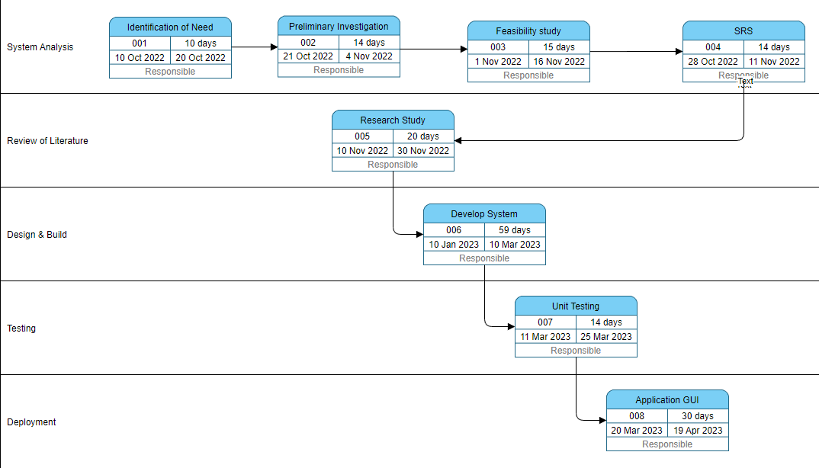

Figure 2. Pert Chart

**2.6. SOFTWARE SPECIFICATION**

**2.6.1 FUNCTIONAL REQUIREMENTS**

Protectoe is purely associated as a Nail disease identification. The nail features such as color, shape and texture used to predict diseases.  Different classification techniques such as SVM classifier, KNN classifier, ANN classification used to classify the nail disease prediction. K-Nearest Neighbor samples are classified based on the class of their nearest neighbor from the training instances, distance metric is calculated each time. Store all training data to classify new points. Choose K using cross validation

Protectoe uses KNN algorithm to ensure the type of nail infection identified successfully. It provide the output based on nearest matching symptom and the information stored in data set file by using KNN model.

**2.6.2 NON-FUNCTIONAL REQUIREMENTS**

**2.6.2.1 PERFORMANCE**

Protectoe is a application where users can identify the nail disease easily without visiting doctor’s clinic. This application is purely based on the Python, Flask and HTML web framework. The overall performance of the system depends on the system configuration. It works on the web and provides the predicted nail disease and risk associated with that.

**2.6.2.2 SCALABILITY**

This Product is scalable and can be used in different operating systems which supports python and other libraries. This application can run of any browser. For further enhancement there will be more strategies and methods implemented in the future to get more in Protectoe.

**2.6.2.3 SECURITY**

The security part of this system depends on the config file encryption and cryptography can also be implemented into the system depends on the security of the users.

**2.7 Cost benefit analysis**

The Characteristics and level for the estimation of Protectoe training:

|  |  |
| --- | --- |
| **Characteristics** | **Level** |
|  |  |
| Complexity | high |
| Runtime Performance Constraint | Nominal |
| Domain Experience | high |
| Programming Capability | high |
| Memory Constraint | Nominal |
| Use of Software tools | low |

Table 2. EAF for Protectoe

Effort Adjustment factor of Protectoe = (1 * 1.15 * 1 * 0.91 * 0.95 * 1 * 1.10) = 1.1

Effort for Protectoe = (3.0 (0.4) ^ 1.12) * Effort Adjustment factor of Protectoe Tool

= 1.2 Person Month

Project Duration = 2.7 Calendar Months

Staffing = 1 person

**3. REVIEW OF LITERATURE**

Many people don’t focus on nail. As a result, they ignore visiting doctor for such small issue. These small issues become big if they don’t take into consideration at early stage, Hence start to spread all over the nail and sometime loss of the beautiful nail. Nail fungus is a common infection of the nail. It begins as a white or yellow-brown spot under the tip of your fingernail or toenail. As the fungal infection goes deeper, the nail may discolor, thicken and crumble at the edge. Nail fungus can affect several nails.

If your condition is mild and not bothering you, you may not need treatment. If your nail fungus is painful and has caused thickened nails, self-care steps and medications may help. But even if treatment is successful, nail fungus often comes back.The most prevalent predisposing risk factor for developing onychomycosis is advanced age. It is obvious that people are still bothered by their fungal toenail infections and are determined to get rid of them. Unfortunately, this is easier said than done.

To successfully cure toenail onychomycosis requires long treatment duration that may extend to a full year. Even then, complete cure, defined as clinical cure (implying nail clearing) plus mythological cure (both negative microscopy and dermatophyte culture), is often unattainable With the help of Protectoe, they can avoid such issue and get the information at home and take necessary action cost-effectively.

1. **DESIGN**

Protectoe is simple to use. User need to follow the link and they can get the home page where they can get various options to do.We are taking symptom from user and the model predict the type of nail infection based on training data. Also, Protectoe can give the risk level based on user input. This application provide the health tips and disease,doctor information as well.

If user want to visit the doctor for particular disease they can book an appointment by clicking on the link.

**User interface :**

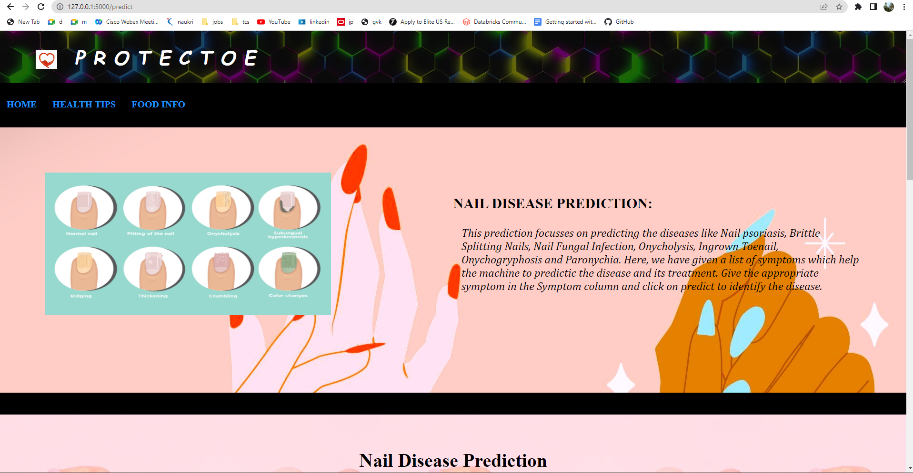

**DATA FLOW DIAGRAM**

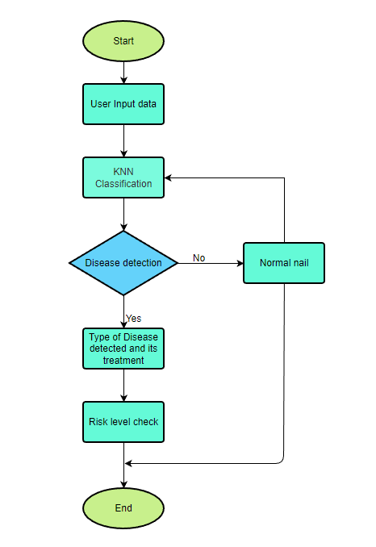

Figure 3. Project flow

**UML Diagram:**

**Use Case Diagram**

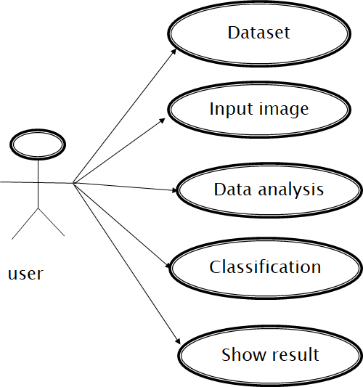

**Activity Diagram:**

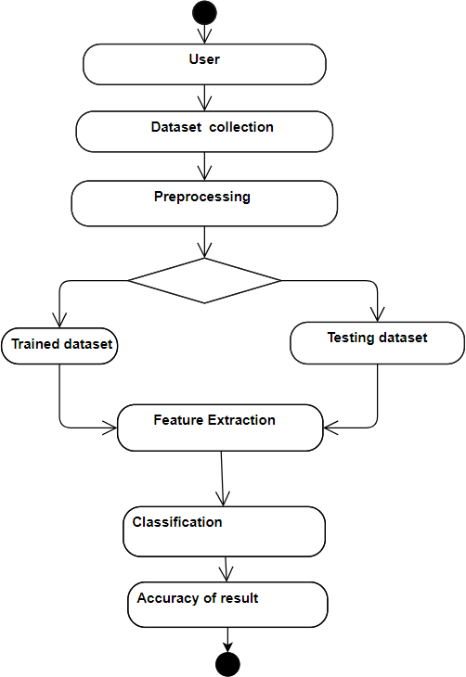

**Class Diagram**

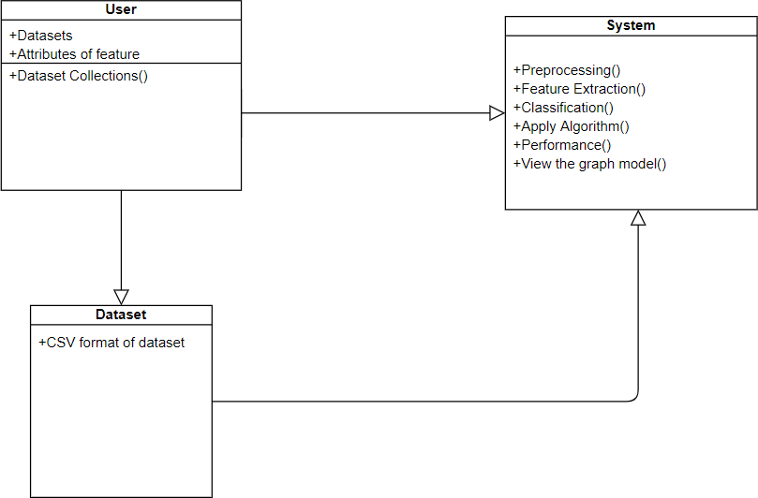

**Sequence Diagram:**

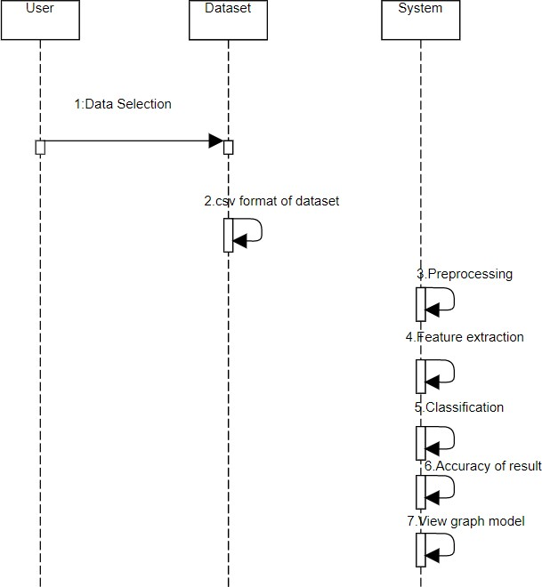

1. **EVALUATION**

Training Data:

|  |  |  |  |  |
| --- | --- | --- | --- | --- |
| SYMPTOM 1 | SYMPTOM 2 | SYMPTOM 3 | DISEASE | TREATMENT |
| Crumbling Nail | Pitting | Change in color,Blood under the nails | Nail psoriasis | Strong Corticosteroids,injection of Corticosteroids and laser treatment |
| Crumbling Nail | Change in color,Blood under the nails | Pitting | Nail psoriasis | Strong Corticosteroids,injection of Corticosteroids and laser treatment |
| Crumbling Nail | Pitting | The nail separates from the bed | Nail psoriasis | Strong Corticosteroids,injection of Corticosteroids and laser treatment |
| Pitting | Crumbling Nail | Change in color,Blood under the nails | Nail psoriasis | Strong Corticosteroids,injection of Corticosteroids and laser treatment |
| Pitting | Change in color,Blood under the nails | Crumbling Nail | Nail psoriasis | Strong Corticosteroids,injection of Corticosteroids and laser treatment |
| Pitting | Crumbling Nail | The nail separates from the bed | Nail psoriasis | Strong Corticosteroids,injection of Corticosteroids and laser treatment |
| Change in color,Blood under the nails | Crumbling Nail | Pitting | Nail psoriasis | Strong Corticosteroids,injection of Corticosteroids and laser treatment |
| Change in color,Blood under the nails | Pitting | Crumbling Nail | Nail psoriasis | Strong Corticosteroids,injection of Corticosteroids and laser treatment |
| Change in color,Blood under the nails | Crumbling Nail | The nail separates from the bed | Nail psoriasis | Strong Corticosteroids,injection of Corticosteroids and laser treatment |
| The nail separates from the bed | Pitting | Crumbling Nail | Nail psoriasis | Strong Corticosteroids,injection of Corticosteroids and laser treatment |
| The nail separates from the bed | Crumbling Nail | Pitting | Nail psoriasis | Strong Corticosteroids,injection of Corticosteroids and laser treatment |
| The nail separates from the bed | Change in color,Blood under the nails | Crumbling Nail | Nail psoriasis | Strong Corticosteroids,injection of Corticosteroids and laser treatment |
| Nail breaks easily | Drying the nails | Typically affects only finger nail | Brittle Splitting Nails | Moisturizer |
| Nail breaks easily | Affects both finger nail and toe nail | Typically affects only finger nail | Brittle Splitting Nails | Moisturizer |
| Nail breaks easily | Affects both finger nail and toe nail | Drying the nails | Brittle Splitting Nails | Moisturizer |
| Affects both finger nail and toe nail | Nail breaks easily | Drying the nails | Brittle Splitting Nails | Moisturizer |
| Affects both finger nail and toe nail | Drying the nails | Nail breaks easily | Brittle Splitting Nails | Moisturizer |
| Affects both finger nail and toe nail | Nail breaks easily | Typically affects only finger nail | Brittle Splitting Nails | Moisturizer |
| Drying the nails | Affects both finger nail and toe nail | Nail breaks easily | Brittle Splitting Nails | Moisturizer |
| Drying the nails | Nail breaks easily | Affects both finger nail and toe nail | Brittle Splitting Nails | Moisturizer |
| Drying the nails | Affects both finger nail and toe nail | Typically affects only finger nail | Brittle Splitting Nails | Moisturizer |
| Typically affects only finger nail | Affects both finger nail and toe nail | Nail breaks easily | Brittle Splitting Nails | Moisturizer |
| Typically affects only finger nail | Nail breaks easily | Affects both finger nail and toe nail | Brittle Splitting Nails | Moisturizer |
| Typically affects only finger nail | Affects both finger nail and toe nail | Drying the nails | Brittle Splitting Nails | Moisturizer |
| Thick Nail | Discolored nail that are brown,yellow,white | Fragile and cracked nail | Nail Fungal Infection | Antifungal Medication |
| Thick Nail | Fragile and cracked nail | Discolored nail that are brown,yellow,white | Nail Fungal Infection | Antifungal Medication |
| Discolored nail that are brown,yellow,white | Fragile and cracked nail | Thick Nail | Nail Fungal Infection | Antifungal Medication |
| The nail separates from the bed | Discoloration of nail yellow,green or opaque | Nail pitting,Nail thickening | Onycholysis | Treating psoriasis with oral |
| The nail separates from the bed | Nail pitting,Nail thickening | Discoloration of nail yellow,green or opaque | Onycholysis | Treating psoriasis with oral |
| The nail separates from the bed | Discoloration of nail yellow,green or opaque | Bending of nail edges | Onycholysis | Treating psoriasis with oral |
| Discoloration of nail yellow,green or opaque | The nail separates from the bed | Nail pitting,Nail thickening | Onycholysis | Treating psoriasis with oral |
| Discoloration of nail yellow,green or opaque | Nail pitting,Nail thickening | The nail separates from the bed | Onycholysis | Treating psoriasis with oral |
| Discoloration of nail yellow,green or opaque | The nail separates from the bed | Bending of nail edges | Onycholysis | Treating psoriasis with oral |
| Nail pitting,Nail thickening | The nail separates from the bed | Discoloration of nail yellow,green or opaque | Onycholysis | Treating psoriasis with oral |
| Nail pitting,Nail thickening | Discoloration of nail yellow,green or opaque | The nail separates from the bed | Onycholysis | Treating psoriasis with oral |
| Bending of nail edges | Discoloration of nail yellow,green or opaque | The nail separates from the bed | Onycholysis | Treating psoriasis with oral |
| Bending of nail edges | The nail separates from the bed | Discoloration of nail yellow,green or opaque | Onycholysis | Treating psoriasis with oral |
| Bending of nail edges | Nail pitting,Nail thickening | Discoloration of nail yellow,green or opaque | Onycholysis | Treating psoriasis with oral |
| Swelling,Tenderness | Redness,soreness | Pus | Ingrown Toenail | Surgery |
| Swelling,Tenderness | Pus | Redness,soreness | Ingrown Toenail | Surgery |
| Redness,soreness | Pus | Swelling,Tenderness | Ingrown Toenail | Surgery |
| Circulation issues | Genetics,Injury | Ichthyosis | Onychogryphosis | Podiatrist or Dermatologist |
| Ichthyosis | Genetics,Injury | Circulation issues | Onychogryphosis | Podiatrist or Dermatologist |
| Swelling | Pain,redness | Fever and gland pain | Paronychia | Tropical or oral antibiotics,corticosteroids |
| Swelling | Fever and gland pain | Pain,redness | Paronychia | Tropical or oral antibiotics,corticosteroids |
| Yellow pus | Pain,redness | Swelling | Paronychia | Tropical or oral antibiotics,corticosteroids |

Protectoe uses kNN Algorithm to predict nail Disease.

The kNN algorithm is a supervised machine learning model. That means it predicts a target variable using one or multiple independent variables.

There are multiple ways of evaluating models, but the most common one is the train-test split. When using a train-test split for model evaluation, you split the dataset into two parts:

1. Training data is used to fit the model. For kNN, this means that the training data will be used as neighbors.
2. Test data is used to evaluate the model. It means that you’ll make predictions of each of the disease in the test data and compare those results to the known true disease.

You can split the data into training and test sets in Python using [scikit-learn’s built-in train_test_split()](https://realpython.com/train-test-split-python-data/). Also, We can use Matplotlib to see the graphical representation of the best matched data.

1. **RESULTS**

The result will be the nail disease prediction based on symptoms provided by user. Also they can get risk level and accuracy of prediction.User can take necessary decision based on result and take necessary step to stop the infection and save the nail from getting into worst condition.

In addition, User can book an appointment with the doctor and may visit the clinic.

User can also get various details like disease information, Healthy food information, Healthy tips.

1. **CONCLUSION & SUGGESTIONS**

**8.1. Conclusion**

Protectoe is used to predict the type of nail infection from anywhere and to identify the risk level of nail disease. It can also give information on types of nail disease.It provide the type of treatment to go-through for identified nail disease and which doctor you can visit for there treatment.Protectoe can help us to achieve all our goals to predict nail infection and treatment that can cure the nail disease ,so that user can regain their healthy and beautiful nail.

It needs a little more analysis and research to identify accurate information on the type of nail infection, for a human being, it may be difficult and challenging to handle so much data and study it. Protectoe can help to reduce the efforts for effective results.Secondly, It will create a better environment for the people and will help them to identify and save their nail.

**8.2 Future Work**

For the future of this product, I will be implementing and researching about more methods and strategies to get the disease identification and risk level information more helpful and powerful.

More methodology, approaches and result oriented methods will be added.

Combine different prediction model for more accuracy and can include more number of disease prediction. All other disease prediction and other strong research will be done to make prediction easier and helpful.

1. **BIBLIOGRAPHY**

<https://www.healthline.com/health/fungal-nail-infection>

<https://www.medicalnewstoday.com/articles/151952#_noHeaderPrefixedContent>

<https://www.betterhealth.vic.gov.au/health/conditionsandtreatments/nails-fingernail-and-toenail-problems>

<https://www.webmd.com/skin-problems-and-treatments/fungal-nail-infections>

<https://www.cdc.gov/fungal/nail-infections.html>

<https://www.mayoclinic.org/diseases-conditions/nail-fungus/symptoms-causes/syc-20353294><https://www.practo.com/mumbai/doctors-for-nail-diseases-treatment>

<https://www.lybrate.com/mumbai/treatment-for-nail-infection>

<https://www.news-medical.net/health/Types-of-Nail-Disease.aspx>

<https://ieeexplore.ieee.org/document/8334747>

* 1. **REFERENCES**

Gold LFS and Rosen T. “Onychomycosis: Diagnosis, treatment, and prevention strategies.” Dermatology News (A CME/CE certified supplement). March 2016:2-15.\

.

Verma S and Heffernan MP. “Onychomycosis.” In: Wolff K, Goldsmith LA, et al. Fitzpatrick’s Dermatology in General Medicine (seventh edition). McGraw Hill Medical, New York, 2008: 1817-20.

[Dtsch Arztebl Int.](https://www.ncbi.nlm.nih.gov/pmc/articles/PMC5527843/) 2016 Jul; 113(29-30): 509–518.

Published online 2016 Jul 25. doi: [10.3238/arztebl.2016.0509](https://doi.org/10.3238/arztebl.2016.0509" \t "https://www.ncbi.nlm.nih.gov/pmc/articles/PMC5527843/_blank)

Continuing Medical Education

Nijhawan Rahul, Verma Rose, Ayushi, Bhushan Shashank, Dua Rajat and Ankush Mittal, An Integrated Deep Learning Framework Approach for Nail Disease Identification, 13th International Conference on Signal-Image Technology & Internet-Based Systems (SITIS), 2017

Lean Karlo Tolentino, Renz Marion Aragon, Winnie Rose Tibayan, Angelie Alvisor, Pauline Grace Palisoc and Geralyn Terte, Detection of Circulatory Diseases Through Fingernails Using Artificial Neural Network, Journal of Telecommunication, Electronic and Computer Engineering, e-ISSN: 2289-8131 Vol. 10 No. 1-4,pp. 181-188, 2018