**Hive Class 4 Assignment**

**(11-09-2022)**

1. Downloaded vechile sales data

=> https://github.com/shashank-mishra219/Hive-Class/blob/main/sales_order_data.csv

2. Store raw data into hdfs location

=> /tmp/hive_class/sales_order_data.csv

3. Create a internal hive table "sales_order_csv" which will store csv data sales_order_csv .. make sure to skip header row while creating table

=> Database name:- hive_class_assignment

|  |
| --- |
| create table sales_order_csv |
|  | ( |
|  | ORDERNUMBER int, |
|  | QUANTITYORDERED int, |
|  | PRICEEACH float, |
|  | ORDERLINENUMBER int, |
|  | SALES float, |
|  | STATUS string, |
|  | QTR_ID int, |
|  | MONTH_ID int, |
|  | YEAR_ID int, |
|  | PRODUCTLINE string, |
|  | MSRP int, |
|  | PRODUCTCODE string, |
|  | PHONE string, |
|  | CITY string, |
|  | STATE string, |
|  | POSTALCODE string, |
|  | COUNTRY string, |
|  | TERRITORY string, |
|  | CONTACTLASTNAME string, |
|  | CONTACTFIRSTNAME string, |
|  | DEALSIZE string |
|  | ) |
|  | row format delimited |
|  | fields terminated by ',' |
|  | tblproperties("skip.header.line.count"="1"); |
|  |  |

4. Load data from hdfs path into "sales_order_csv"

=> load data local inpath 'file:///tmp/hive_class/sales_order_data.csv' into table sales_order_csv;

5. Create an internal hive table which will store data in ORC format "sales_order_orc"

|  |
| --- |
| create table sales_order_orc |
|  | ( |
|  | ORDERNUMBER int, |
|  | QUANTITYORDERED int, |
|  | PRICEEACH float, |
|  | ORDERLINENUMBER int, |
|  | SALES float, |
|  | STATUS string, |
|  | QTR_ID int, |
|  | MONTH_ID int, |
|  | YEAR_ID int, |
|  | PRODUCTLINE string, |
|  | MSRP int, |
|  | PRODUCTCODE string, |
|  | PHONE string, |
|  | CITY string, |
|  | STATE string, |
|  | POSTALCODE string, |
|  | COUNTRY string, |
|  | TERRITORY string, |
|  | CONTACTLASTNAME string, |
|  | CONTACTFIRSTNAME string, |
|  | DEALSIZE string |
|  | ) |
|  | stored as orc; |

6. Load data from "sales_order_csv" into "sales_order_orc"

=> from sales_order_csv insert overwrite table sales_order_orc select *;

**Perform below mentioned queries on "sales_order_orc" table :**

**a. Calculate total sales per year**

=> Select year_id, sum(sales) as total_sales from sales_order_orc group by year_id;

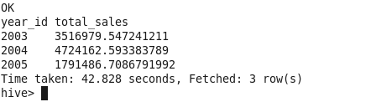

**b. Find a product for which maximum orders were placed**

=> Select max(productline) as max_order_product from sales_order_orc where status='Shipped';

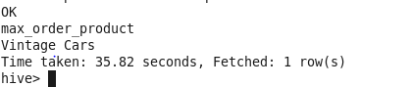

**c. Calculate the total sales for each quarter**

=> Select qtr_id, sum(sales) as total_sales from sales_order_orc group by qtr_id;

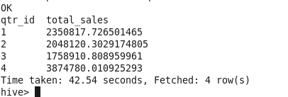

**d. In which quarter sales was minimum**

=> Select qtr_id, min(sales) as min_sales from sales_order_orc group by qtr_id order by min_sales asc limit 1;

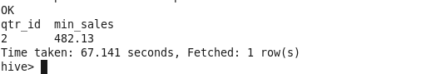

**e. In which country sales was maximum and in which country sales was minimum**

=> Select country, max(sales) as max_sales from sales_order_orc group by country order by max_sales desc limit 1;



=> Select country, min(sales) as min_sales from sales_order_orc group by country order by min_sales asc limit 1;

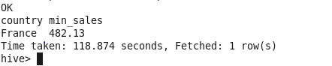

**f. Calculate quarterly sales for each city**

=> Select 'Quarterly' as qtr_id, sum(sales) as sales, city from sales_order_orc group by city;

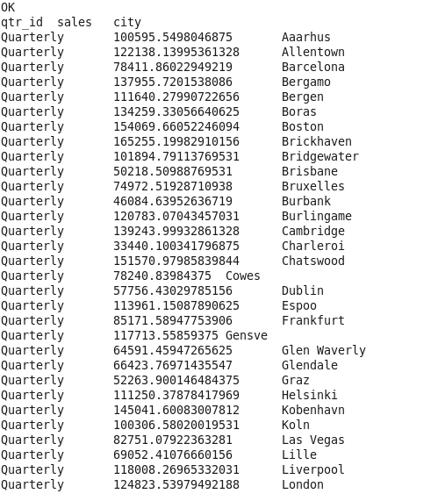

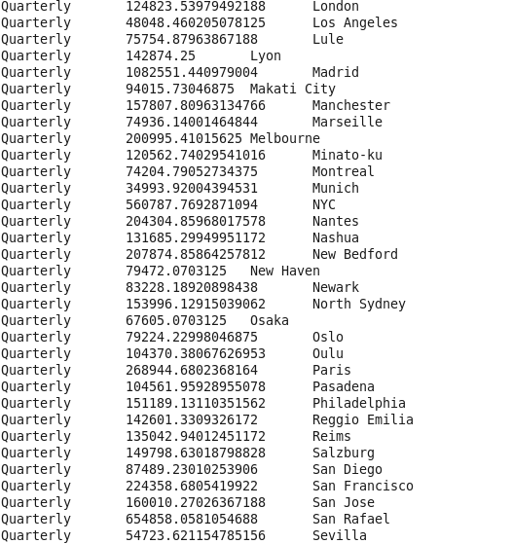

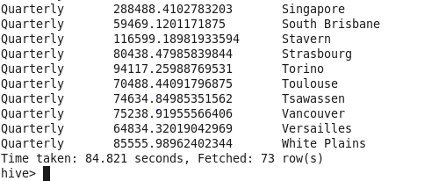

h. Find a month for each year in which maximum number of quantities were sold

**h. Find a month for each year in which maximum number of quantities were sold**

=> Select month_id as MONTH, year_id, max(quantityordered) as max_sold_quantities from sales_order_orc where status='Shipped' group by year_id, month_id;

