Natural Win

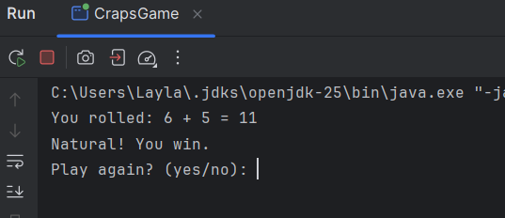

Point Scenario

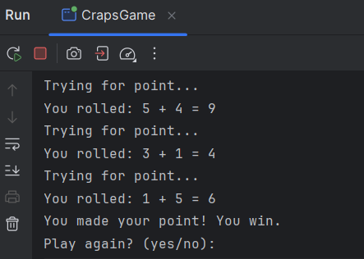

Craps out

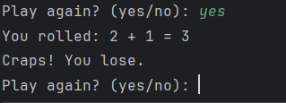

<https://github.com/shalasla/IT1090---Programming-I/tree/master/Ass_01_craps/src>