Methods Test Runs:

Program 01:

Program 02:

Program 03:

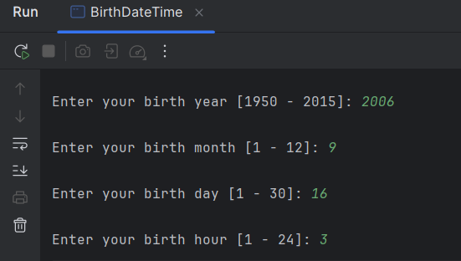

Program 04:

Program 05:

Program 06:

Program 07:

<https://github.com/shalasla/IT1090---Programming-I/tree/master/Lab_08_GetMethodical/src>