Marketing Analytics: Sentiment & ROI Strategic Report

1. Executive Summary
This report provides a comprehensive analysis of marketing performance by integrating financial metrics (ROAS) with customer psychological states (Sentiment). The objective is to identify the most effective channels for sustainable growth and brand loyalty.

2. Analytical Methodology
Data was processed from 300 customer interactions. Sentiment was extracted using a proprietary keyword-based NLP model, while ROI was calculated based on the ratio between total purchase value and advertising expenditure.

3. Visual Data Insights

3.1 Return on Ad Spend (ROAS) per Channel
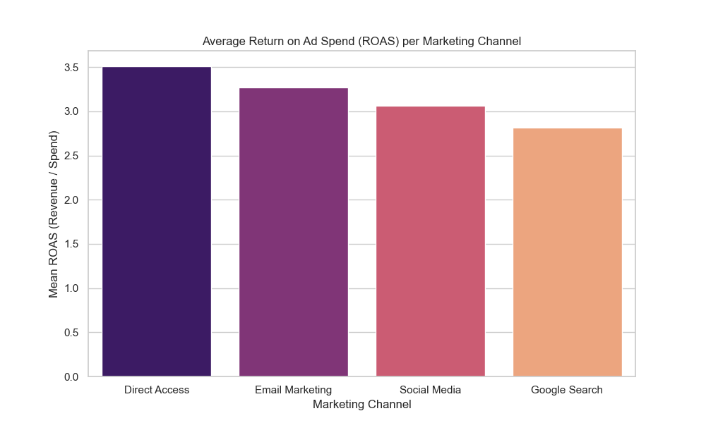
Figure 1: This chart highlights the financial efficiency of each marketing channel, allowing for data-driven budget reallocation.

3.2 Customer Sentiment Breakdown
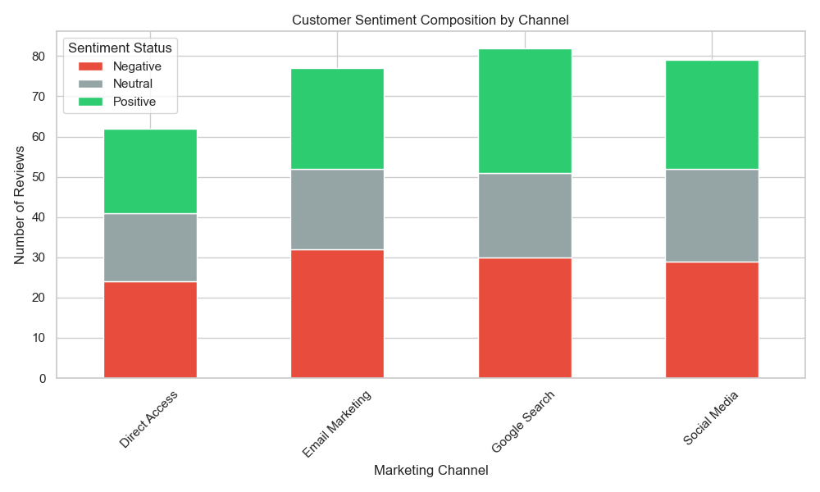
Figure 2: A breakdown of customer emotions per channel. This metric identifies potential brand risks where high sales might coincide with negative feedback.

4. Strategic Recommendations
1. Scale budgets for channels showing high Positive Sentiment and ROAS.
2. Audit the 'Negative' sentiment clusters to improve product descriptions or support.
3. Transition towards a humanized marketing model that prioritizes long-term brand equity.

