1. Introduction

a. Problem Statement
Working on post reconstruction images. Each image is a slice of a reconstructed volume along the Z-direction. Have to develop a visualization software which will take these image stack and as input and will produce fully functional UI based interactive volume visualization.

b. Use case and Features

- This software is used to visualize 3D computed tomography data. (Tomography is imaging by sections or sectioning, through the use of any kind of penetrating wave.)
- The visualization and quantitative analysis of differently absorbing phases/ surfaces.
- To check for microporosities, cracks, precipitates or grains in a specimen.
- These visualized objects can be rotated, sliced, clipped and saved as image.
- This software also features a histogram of value populations above the main visualization widget. This is used to show where values were most numerous, and give researchers a general feel for the data. We also have added the opacity function editor. So along with displaying the histogram and the current color map you can interactively edit opacity function, and see the results in the active visualization window.
- This software also provides an option of applyig different color maps. One can also change the color resolution of the color map for a perticular range of gray values.
- Slices of the object can be obtained using the plane widget which can be rotated, moved and scale in any angle and direction. The same plane can be used to clip the object too.
- Clipping can also be done using a clipping box.

c. Input Data
Reconstructed image stack obtained by computed tomography is the input for this software.
The reconstruction of an image from the acquired data is an inverse problem. Often, it is not possible to exactly solve the inverse problem directly. In this case, a direct algorithm has to approximate the solution, which might cause visible reconstruction artifacts in the image. Iterative algorithms approach the correct solution using multiple iteration steps, which allows to obtain a better reconstruction at the cost of a higher computation time.

d. Volume Rendering

Volume rendering is a set of techniques used to display a 2D projection of a 3D discretely sampled data set, typically a 3D scalar field. A typical 3D data set is a group of 2D slice images acquired by a for example CT, MRI, or MicroCT scanner. Usually these are acquired in a regular pattern (e.g., one slice every millimeter) and usually have a regular number of image pixels in a regular pattern. This is an example of a regular volumetric grid, with each volume element, or voxel represented by a single value that is obtained by sampling the immediate area surrounding the voxel.
To render a 2D projection of the 3D data set, one first needs to define a camera in space relative to the volume. Also, one needs to define the opacity and color of every voxel. This is usually defined using an RGBA (for red, green, blue, alpha) transfer function that defines the RGBA value for every possible voxel value.
For example, a volume may be viewed by extracting isosurfaces (surfaces of equal values) from the volume and rendering them as polygonal meshes or by rendering the volume directly as a block of data. The marching cubes algorithm is a common technique for extracting an isosurface from volume data. Direct volume rendering is a computationally intensive task that may be performed in several ways.

e. Design Pattrens

In software engineering, a design pattern is a general repeatable solution to a commonly occurring problem in software design. A design pattern isn't a finished design that can be transformed directly into code. It is a description or template for how to solve a problem that can be used in many different situations.

Uses of Design Patterns
Design patterns can speed up the development process by providing tested, proven development paradigms. Effective software design requires considering issues that may not become visible until later in the implementation. Reusing design patterns helps to prevent subtle issues that can cause major problems and improves code readability for coders and architects familiar with the patterns.
Often, people only understand how to apply certain software design techniques to certain problems. These techniques are difficult to apply to a broader range of problems. Design patterns provide general solutions, documented in a format that doesn't require specifics tied to a particular problem.
In addition, patterns allow developers to communicate using well-known, well understood names for software interactions. Common design patterns can be improved over time, making them more robust than ad-hoc designs.
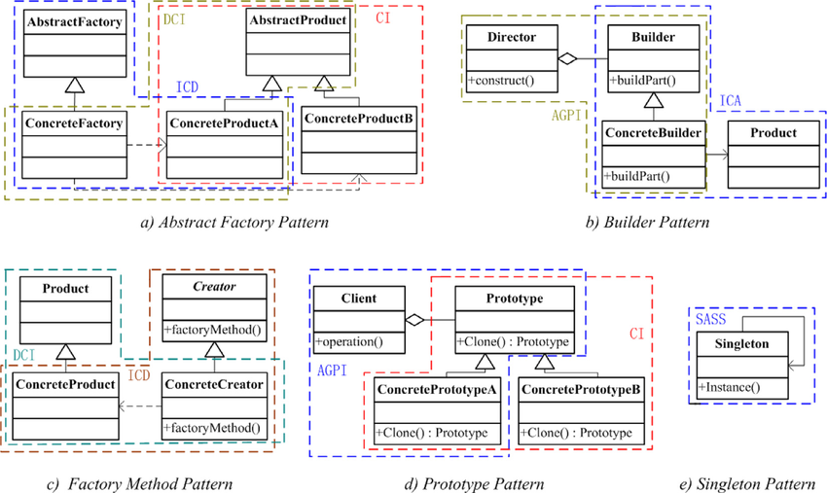

Sigleton Pattern
Singleton pattern is one of the simplest design patterns in Java. This type of design pattern comes under creational pattern as this pattern provides one of the best ways to create an object.In software engineering, the singleton pattern is a software design pattern that restricts the instantiation of a class to one "single" instance. This is useful when exactly one object is needed to coordinate actions across the system. The term comes from the mathematical concept of a singleton.
The singleton design pattern solves problems like:
- How can it be ensured that a class has only one instance?
- How can the sole instance of a class be accessed easily?
- How can a class control its instantiation?
- How can the number of instances of a class be restricted?

f.Color Spaces
The color spaces present are-

a.RGB :-
The RGB color model is an additive color model in which red, green and blue light are added together in various ways to reproduce a broad array of colors. The name of the model comes from the initials of the three additive primary color red, green, and blue.
The main purpose of the RGB color model is for the sensing, representation and display of images in electronic systems, such as televisions and computers, though it has also been used in conventional photography. Before the electronic age, the RGB color model already had a solid theory behind it, based in human perception of colors.

b. CMYK :-
CMYK is a subtractive color model, used in color printing, and is also used to describe the printing process itself. CMYK refers to the four inks used in some color printing: cyan, magenta, yellow, and key.
The CMYK model works by partially or entirely masking colors on a lighter, usually white, background. The ink reduces the light that would otherwise be reflected. Such a model is called subtractive because inks "subtract" the colors red, green and blue from white light. White light minus red leaves cyan, white light minus green leaves magenta, and white light minus blue leaves yellow.

c. HSL and HSV :-
HSL and HSV are both cylindrical geometries, with hue, their angular dimension, starting at the red primary at 0°, passing through the green primary at 120° and the blue primary at 240°, and then wrapping back to red at 360°. In each geometry, the central vertical axis comprises the neutral, achromatic, or gray colors, ranging from black at lightness 0 or value 0, the bottom, to white at lightness 1 or value 1, the top.

d. YcBcr :-
YcBcr is a family of color spaces used as a part of the color image pipeline in video and digital photography systems. Y′ is the luma component and CB and CR are the blue-difference and red-difference chroma components. Y′ (with prime) is distinguished from Y, which is luminance, meaning that light intensity is nonlinearly encoded based on gamma corrected RGB primaries. Y′CbCr color spaces are defined by a mathematical coordinate transformation from an associated RGB color space. If the underlying RGB color space is absolute, the Y′CbCr color space is an absolute color space as well; conversely, if the RGB space is ill-defined, so is Y′CbCr.

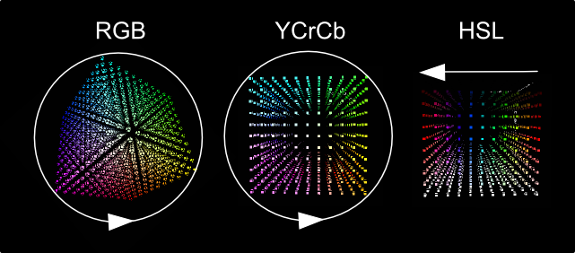

g.Software Architecture
Software architecture refers to the high level structures of a software system and the discipline of creating such structures and systems. Each structure comprises software elements, relations among them, and properties of both elements and relations.The architecture of a software system is a metaphor, analogous to the architecture of a building.It functions as a blueprint for the system and the developing project, laying out the tasks necessary to be executed by the design teams.
Software architecture is about making fundamental structural choices which are costly to change once implemented. Software architecture choices include specific structural options from possibilities in the design of software. For example, the systems that controlled the space shuttle launch vehicle had the requirement of being very fast and very reliable. Therefore, an appropriate real-time computing language would need to be chosen. Additionally, to satisfy the need for reliability the choice could be made to have multiple redundant and independently produced copies of the program, and to run these copies on independent hardware while cross-checking results.
Documenting software architecture facilitates communication between stakeholders, captures early decisions about the high-level design, and allows reuse of design components between projects.
Software architecture exhibits the following characteristics:
Multitude of stakeholders: software systems have to cater to a variety of stakeholders such as business managers, owners, users, and operators. These stakeholders all have their own concerns with respect to the system. Balancing these concerns and demonstrating how they are addressed is part of designing the system. This implies that architecture involves dealing with a broad variety of concerns and stakeholders, and has a multidisciplinary nature.
Separation of concerns: the established way for architects to reduce complexity is to separate the concerns that drive the design. Architecture documentation shows that all stakeholder concerns are addressed by modeling and describing the architecture from separate points of view associated with the various stakeholder concerns. These separate descriptions are called architectural views .
Quality-driven: classic software design approaches (e.g. Jackson Structured Programming) were driven by required functionality and the flow of data through the system, but the current insight is that the architecture of a software system is more closely related to its quality attributes such as fault-tolerance, backward compatibility, extensibility, reliability, maintainability, availability, security, usability, and other such –ilities. Stakeholder concerns often translate into requirements on these quality attributes, which are variously called non-functional requirements, extra-functional requirements, behavioral requirements, or quality attribute requirements.
Recurring styles: like building architecture, the software architecture discipline has developed standard ways to address recurring concerns. These "standard ways" are called by various names at various levels of abstraction. Common terms for recurring solutions are architectural style.
Conceptual integrity: a term introduced by Fred Brooks in The Mythical Man-Month to denote the idea that the architecture of a software system represents an overall vision of what it should do and how it should do it. This vision should be separated from its implementation. The architect assumes the role of "keeper of the vision", making sure that additions to the system are in line with the architecture, hence preserving conceptual integrity.
Cognitive constraints: an observation first made in a 1967 paper by computer programmer Melvin Conway that organizations which design systems are constrained to produce designs which are copies of the communication structures of these organizations. As with conceptual integrity, it was Fred Brooks who introduced it to a wider audience when he cited the paper and the idea in his elegant classic The Mythical Man-Month, calling it "Conway's Law."

h. SOLID Principle

In object-oriented computer programming, SOLID is a mnemonic acronym for five design principles intended to make software designs more understandable, flexible and maintainable.
The principles are a subset of many principles promoted by American software engineer and instructor Robert C. Martin. Though they apply to any object-oriented design, the SOLID principles can also form a core philosophy for methodologies such as agile development or adaptive software development.[3] The theory of SOLID principles was introduced by Martin in his 2000 paper Design Principles and Design Patterns, although the SOLID acronym was introduced later by Michael Feathers.

Single responsibility principle
A class should have only a single responsibility, that is, only changes to one part of the software's specification should be able to affect the specification of the class.
Open–closed principle
"Software entities should be open for extension, but closed for modification."
Liskov substitution principle
"Objects in a program should be replaceable with instances of their subtypes without altering the correctness of that program." See also design by contract.
Interface segregation principle
"Many client-specific interfaces are better than one general-purpose interface."
Dependency inversion principle
One should "depend upon abstractions, [not] concretions."

2. Framework and Libraries

Programming language used for coding this software is python. It is because of the simplicity of python, availability of good libraries for achieving your task, ease of using them, good community of users using them.
Python version: Python 2.7.12

a. VTK

VTK version: 5.10.1
The Visualization Toolkit (VTK) is an open-source, freely available software system for 3D computer graphics, image processing, and visualization. It consists of a C++ class library and several interpreted interface layers including Tcl/Tk, Java, and Python. VTK supports a wide variety of visualization algorithms including scalar, vector, tensor, texture, and volumetric methods, as well as advanced modeling techniques such as implicit modeling, polygon reduction, mesh smoothing, cutting, contouring, and Delaunay triangulation.
VTK has an extensive information visualization framework and a suite of 3D interaction widgets. The toolkit supports parallel processing and integrates with various databases on GUI toolkits such as Qt and Tk.
VTK is cross-platform and runs on Linux, Windows, Mac, and Unix platforms. VTK is part of Kitware’s collection of commercially supported open-source platforms for software development.
VTK applications are largely constructed by connecting vtkAlgorithms together. Each algorithm ( or filter) inspects the dataset or datasets it is given and produces some derived data for the algorithm (or algorithms) connected to it. The connected set of filters forms a data-flow network. VTK uses reference counting heavily to eliminate redundant memory consumption and timestamps in the demand-driven network to eliminate redundant computation. Algorithms are strongly type-checked to enforce compatible filter connectivity.

b. PyQt

Qt version: 4.8.7
PyQt is widely used for developing graphical interfaces that can be run on various operating systems. It’s one of the most popular GUI choices for Python programming.
PyQt brings together the Qt C++ cross-platform application framework and the cross-platform interpreted language Python.
Qt also includes Qt Designer, a graphical user interface designer. PyQt is able to generate Python code from Qt Designer. It is also possible to add new GUI controls written in Python to Qt Designer.
Python is a simple but powerful object-orientated language. Its simplicity makes it easy to learn, but its power means that large and complex applications can be created. Its interpreted nature means that Python programmers are very productive because there is no edit/compile/link/run development cycle.
PyQt combines all the advantages of Qt and Python. A programmer has all the power of Qt, but is able to exploit it with the simplicity of Python.

c. Matplotlib
Matplotlib is a plotting library for the Python programming language and its numerical mathematics extension NumPy. It provides an object-oriented API for embedding plots into applications using general-purpose GUI toolkits like Tkinter, wxPython, Qt, or GTK+.
Matplotlib has many predefined color maps which are used in this software.
Also for plotting the histogram and the opacity function matplotlib’s functions are used.
Matplotlib can be used to create histograms. A histogram shows the frequency on the vertical axis and the horizontal axis is another dimension. Usually it has bins, where every bin has a minimum and maximum value. Each bin also has a frequency between x and infinite.

d.NumPy
NumPy is a general-purpose array-processing package. It provides a high-performance multidimensional array object, and tools for working with these arrays.
It is the fundamental package for scientific computing with Python. It contains various features including these important ones:
- A powerful N-dimensional array object
- Sophisticated (broadcasting) functions
- Tools for integrating C/C++ and Fortran code
- Useful linear algebra, Fourier transform, and random number capabilities

Study of VTK(visualization tool kit )

a. About VTK
VTK was initially conceived as a scientific data visualization system. In general data visualization includes the whole process of transforming data into sensory input, typically images, but also includes tactile, auditory, and other forms. The data forms not only consist of geometric and topological constructs, including such abstractions as meshes or complex spatial decompositions, but attributes to the core structure such as scalars (e.g., temperature or pressure), vectors (e.g., velocity), tensors (e.g., stress and strain) plus rendering attributes such as surface normals and texture coordinate.
Data representing spatial-temporal information is generally considered part of scientific visualization. However there are more abstract data forms such as marketing demographics, web pages, documents and other information that can only be represented through abstract (i.e., non-spatial temporal) relationships such as unstructured documents, tables, graphs, and trees. These abstract data are typically addressed by methods from information visualization. With the help of the community, VTK is now capable of both scientific and information visualization.
As a visualization system, the role of VTK is to take data in these forms and ultimately transform them into forms comprehensible by the human sensory apparatus. Thus one of the core requirements of VTK is its ability to create data flow pipelines that are capable of ingesting, processing, representing and ultimately rendering data. Hence the toolkit is necessarily architected as a flexible system and its design reflects this on many levels. For example, VTK is purposely designed as a toolkit with many interchangeable components that can be combined to process a wide variety of data.

b. Architectural Features
There are high-level concepts that have significant impact on developing and using the system. One of these is VTK's hybrid wrapper facility. This facility automatically generates language bindings to Python, Java, and Tcl from VTK's C++ implementation, hence was feasible for developing AnuTom using python. This hybrid compiled/interpreted environment combines the best of both worlds: high performance compute-intensive algorithms and flexibility when prototyping or developing applications. In fact this approach to multi-language computing has found favor with many in the scientific computing community and they often use VTK as a template for developing their own software.
In terms of software process, VTK has adopted CMake to control the build; CDash/CTest for testing; and CPack for cross-platform deployment. VTK can be compiled on almost any computer including supercomputers which are often notoriously primitive development environments. In addition, web pages, wiki, mailing lists (user and developer), documentation generation facilities (i.e., Doxygen) and a bug tracker (Mantis) round out the development tools.

c. Basic objects

In the Visualization Toolkit there are seven basic objects that we use to render a scene:

1. vtkRenderWindow — manages a window on the display device, one or more renderers draw into an instance of vtkRenderWindow .
2. vtkRenderer — coordinates the rendering process involving lights, cameras, and actors.
3. vtkLight — a source of light to illuminate the scene.
4. vtkCamera — defines the view position, focal point, and other viewing properties of the scene.
5. vtkActor — represents an object rendered in the scene, including its properties and position in the world coordinate system. ( Note: vtkActor is a subclass of vtkProp. vtkProp is a more general form of actor that includes annotation and 2D drawing classes.)
6. vtkProperty — defines the appearance properties of an actor including color, transparency, and lighting properties such as specular and diffuse. Also representational properties like wireframe and solid surface.
7. vtkMapper — the geometric representation for an actor. More than one actor may refer to the same mapper.

d. VTK Pipeline

VTK consists of several major subsystems. Probably the subsystem most associated with visualization packages is the data flow/pipeline architecture. In concept, the pipeline architecture consists of three basic classes of objects: objects to represent data (the vtkDataObjects discussed above), objects to process, transform, filter or map data objects from one form into another (vtkAlgorithm); and objects to execute a pipeline (vtkExecutive) which controls a connected graph of interleaved data and process objects (i.e., the pipeline).

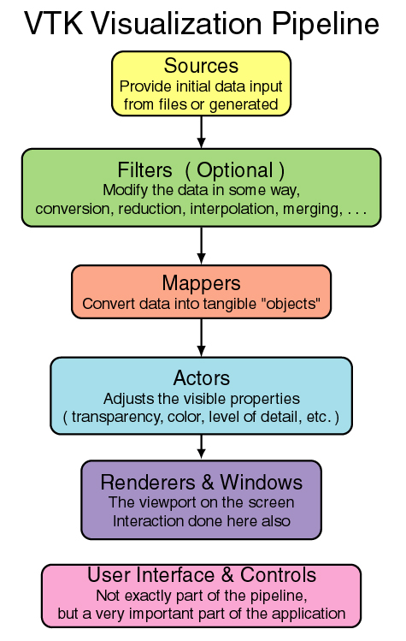

General Architecture of the VTK Pipeline. The central structure of the Visualization Toolkit is a pipeline of data, from a source of information to an image rendered on the screen.In general the data pipeline is "fired" by requesting the window to render, because the window then requests all of its inputs to update their outputs.

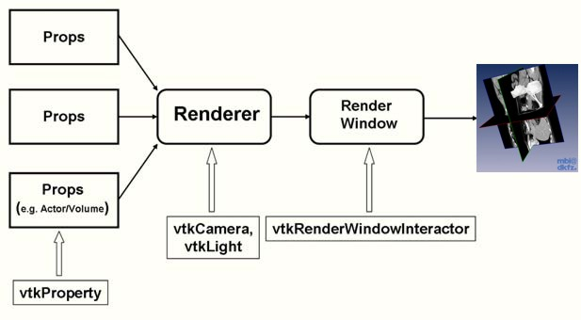

While conceptually simple, actually implementing the pipeline architecture is challenging. One reason is that the representation of data can be complex. For example, some datasets consist of hierarchies or grouping of data, so executing across the data requires non-trivial iteration or recursion. To compound matters, parallel processing (whether using shared-memory or scalable, distributed approaches) require partitioning data into pieces, where pieces may be required to overlap in order to consistently compute boundary information such as derivatives.
The algorithm objects also introduce their own special complexity. Some algorithms may take multiple inputs and/or produce multiple outputs of different types. Some can operate locally on data (e.g., compute the center of a cell) while others require global information, for example to compute a histogram. In all cases, the algorithms treat their inputs as immutable, algorithms only read their input in order to produce their output. This is because data may be available as input to multiple algorithms, and it is not a good idea for one algorithm to trample on the input of another.
Finally the executive can be complicated depending on the particulars of the execution strategy. In some cases we may wish to cache intermediate results between filters. This minimizes the amount of recomputation that must be performed if something in the pipeline changes. On the other hand, visualization data sets can be huge, in which case we may wish to release data when it is no longer needed for computation. Finally, there are complex execution strategies, such as multi-resolution processing of data, which require the pipeline to operate in iterative fashion.

e. Types of Datasets

Five datasets are implemented in VTK : vtkPolyData , vtkImageData , vtkStructuredGrid , vtkRectilinearGrid , and vtkUnstructuredGrid
1. Polygonal Data
These primitives also are frequently generated or consumed by computational geometry and visualization algorithms. In the Visualization Toolkit , we call this collection of graphics primitives polygonal data . The polygonal dataset consists of vertices, polyvertices, lines, polylines, polygons, and triangle strips. The topology and geometry of polygonal data is unstructured, and the cells that compose that dataset vary in topological dimension. The polygonal dataset forms a bridge between data, algorithms, and high-speed computer graphics.

2. Image Data
An image dataset is a collection of points and cells arranged on a regular, rectangular lattice. The rows, columns, and planes of the lattice are parallel to the global x-y-z coordinate system. If the points and cells are arranged on a plane (i.e., two-dimensional) the dataset is referred to as a pixmap, bitmap, or image. If the points and cells are arranged as stacked planes (i.e., three-dimensional) the dataset is referred to as a volume. Keep in mind that the term image data refers to images, volumes, or one-dimensional point arrays collectively. Structured points was the terminology used in earlier versions of VTK.

3. Rectilinear Grid
The rectilinear grid dataset is a collection of points and cells arranged on a regular lattice. The rows, columns, and planes of the lattice are parallel to the global x-y-z coordinate system. While the topology of the dataset is regular, the geometry is only partially regular. That is, the points are aligned along the coordinate axis, but the spacing between points may vary.

4. Structured Grid
A structured grid is a dataset with regular topology and irregular geometry. The grid may be warped into any configuration in which the cells do not overlap or self-intersect. The topology of the structured grid is represented implicitly by specifying a 3-vector geometry dimensions . The n x n y n z is explicitly represented by maintaining an array of point coordinates. The composing cells of a structured grid are quadrilaterals (2D) or hexahedron (3D). Like image data, the structured grid has a natural coordinate system that allows us to refer to a particular point or cell using topological i-j-k coordinates.

5. Unstructured Grid
The most general form of dataset is the unstructured grid. Both the topology and geometry are completely unstructured. Any cell type can be combined in arbitrary combinations in an unstructured grid. Hence the topology of the cells ranges from 0D (vertex, polyvertex) to 3D (tetrahedron, hexahedron, voxel). In the Visualization Toolkit any dataset type can be expressed as an unstructured grid. We typically use unstructured grids to represent data only when absolutely necessary, because this dataset type requires the most memory and computational resources to represent and operate on.

4. Code Documentation

Files :

a. Driver.py

This class manages calls to different class methods (/ utilities) as and when required and serves as a central module. This class should be called in order to run the entire software. It takes the UI from MainWindowUi class.

The external libraries and classes that it imports are:
- Project Classes : LoadStack, MainWindowUi, Renderer, CutObj, HistogramWidget,QrangeSlider,RecDialogUi,RenderConfiguration,LoadStackDialogUi
- QtCore,QtGui from PyQt4
- matplotlib
- numpy
- vtk_to_numpy from vtk.util.numpy_support
- sys, os, time
- threading
- json
- Normalize from matplotlib.colors
- pyqtSlot,SIGNAL,SLOT
#no mention about the variables used
Methods :
__init__(self)
It initializes and setups the UI and connects all the buttons to their respective callback functions for the action event. And sets the initial state of the buttons (some are disabled).
openLoadStackDialog(self)
It calls the function showDialog() from LoadStack class. It displays the dialog box to take the information of input image stack. After the user press ‘OK’, an internal call is made to the renderVolume() function of Renderer class which renders the output object.
renderV(self)
It calls the renderVolume() of Renderer class. Changes the states of buttons (enables/disables) and also gives internal call to function that plots histogram and alpha function.
cutObj(self)
Adds the plane of Plane widget as a clipping plane to the volume by calling cut() function of CutObj class.
toggleOutline(self)
Changes the visibility of the outline actor.
togglePlane(self)
On / Off the Plane widget. Also accordingly changes the visibility of slice. And enables / disables the option of setting the slice resolution.
toggleClippingBox(self)
On / Off the box widget. This use for clipping the volume.
toggleVolume(self)
Changes the visibility of rendered volume.
toggleSlice(self)
Changes the visibility of the contour actor, which displays the slice of the volume captured by plane widget.
toggleAlignedPlane(self)
On / Off the ImagePlaneWidget widget. By default aligns the plane to Z axis and sets the state of buttons and slider accordingly.
alignPlaneToX(self)
Aligns the ImagePlaneWidget to X axis. Sets the range (minimum and maximum) of slider according to the values of Data extent taken from the reader. Sets the default value of slider to the center index of the Data extent and places the plane at the center of the object in X axis.
alignPlaneToY(self)
Aligns the ImagePlaneWidget to Y axis. Sets the range (minimum and maximum) of slider according to the values of Data extent taken from the reader. Sets the default value of slider to the center index of the Data extent and places the plane at the center of the object in Y axis.
alignPlaneToZ(self)
Aligns the ImagePlaneWidget to Z axis. Sets the range (minimum and maximum) of slider according to the values of Data extent taken from the reader. Sets the default value of slider to the center index of the Data extent and places the plane at the center of the object in Z axis.
valueChangeSlider(self)
Takes the new value of the slider set by the user and sets it as the new position of the plane in the object. Called when slider is moved.
changeColorMap(self)
Gives call to HistogramWidget class’s showDialogBox() function which displays a dialog box asking the new color map to choose and set the color resolution if nedded.
takeSnapshot(self)
Asks for the path to select for saving the snapshot and calls the snapshot() from Renderer class.
plot(self)
Adds a subplot to the figure of histogram widget and calls the plotHist() and plotAlphaFunc() from HistogramWidget class to plot the histogram of image stack.
setSliceResolution(self)
Sets the resolution of the slice of the volume obtained from the plane widget.
addPoint(self)
Adds a point to the alpha function and also to the alpha function ploted over the histogram.
removePoint(self)
Removes a point from the alpha function and also from the alpha function ploted over the histogram.
createTable(self)
Creates a table from the values present in the dictionary alphaFuncPoints. Creates it in sorted order.
changeBGColor(self)
Displays a color picker and changes background color of render window to the color selected by the user.
record(self)
Records the interaction with the object in form of image sequence. It actually takes multiple snapshots at the given frame rate. It cretaes a new thread for it because the MainWindow should remain active inorder to do interaction with rendered object.
task1(self, fname, nImg, sTime)
This is the task carried out by the thread. It clicks multiple snapshot (takes nImg images, each image after sTime(sleep time))(calculated from frame rate and time of recording taken from text boxes) and saves it with file name prefix fname.
resetCamera(self)
This function allign the camera at perticular location.
retriveTableWidgetValues(self)
This function retrives the values of the intensity and opacity key pair present in the table widget.
getRangeFromSlider(self)
This function is to retive the range of the slider everytime the value gets changed.
toggleColorMasking(self)
This function is to change the mode and display a particular color map(the range of which is set by the range slider) of the rendered volume.
After the toggle radiobutton is set as checked a vtgkpiecewise function of six points(at - start , rmin(min value set by rangeSlider) , rmin+1,rmax-1,rmax(max value set by rangeSlider),end) is created , due to which a new hoistogram is created and the above vtkpiecewise function is plotted.
Untoggling the radiobutton the rangeslider freezes and the old hiostogram is again plotted.

rangeSliderOperations(self)
This function is called by the PyQt signals endValueChanged and the startvalueChanged. It gets the values from the getRangeFromSlider function.
getIntensityOpacityFromUi(self)
In this function values from the lineEdit_2 and lineEdit_3 of the MainWindowUi class are retrived . This function was basically created to maintain the SRP(single responsibility principle) of the addPoint function.
onclick(self,event)
This function is to make the addPoint fiunctionality of the histogram interactive. User just have to click on the histogram and a point will be created there.
openVTKObj(self)
The prestored image files(with their properties intact) w are loaded with the help of this function . The values are retrieved from a json file.
saveVtkConfiguration(self , loadedDataInfo)
The set configuration that is the rendered volume along with its intensity and opacity values is dumped into a flie , which later on is retrieved and rendered by the openVTKObj function.
Some important variables:
flag_stackRendered
This keeps a check on whether the stack is rendered or not. Initially seted to False, turns True only when volme is rendered atleast once. This helps in deciding whether or not to make a call to a perticular function that makes some changes in the volume.
alphaFuncPoints
This is a dictionary which stores the alpha function points that is in form of gray value as key and the corresponding opacity as value. This helps in maintaining the table in a sorted way.
cMin and cMax
This stores the min and max of the range of color map resolution set by the user. (variables with same name exist in Renderer class, those are the original values of minimum and maximum gray values, combination of these two is used in order to plot the alpha function)

alphaChannelFunc1
This variable is to access the vtkpiecewise function .

b. Renderer.py
This class will take the information of the image stack(such as it's path, number of images,etc.) from the RenderConfiguration object or the vtkObject (pickle) and pass it to the VTK pipeline. Volume’s default properties and functions(color and alpha) are defined here. Volume will be mapped, rendered and the output will be given to the render window of vtkWidget. All the other widgets like plane widget for clipping and slicing, box widget for clipping box and snapshot are defined here.
It imports :
- vtk
- HistogramWidget

Methods :
readImgStack(self, loadedDataInfo)
This function fetches the information of the image stack from RenderConfiguration object and reads it using the TiffReader of vtk. It also sets the cMin and cMax depending on whether the image is 8 bit or 16 bit.
renderVolume(self, vtkWidget)
This function is like heart of whole software. It actually handles the entire VTK pipeline. Creates color function and alpha function. Sets it to the volume mapper and also takes the output from reader as input to volume mapper. Creates the volume. Creates outline actor, plane widget, slice, box widget and the axes actor. Handles the interaction events of plane widget and box widget for slicing and clipping purpose. Gives all this output to vtkWidget of the MainWindowUi.
renderBlank(self,vtkWidget)
When the driver program loads ,this function is called, which just sets the background and renders no object
snapshot(self,fname)
This funtion is used to take the snapshot of whatever is in the camera view of render window and saves it with the fname

c. HistogramWidget.py
This class takes care of the histogram widget. It provides function to apply color maps to the rendererd volume and also the histogram. It also plots the alpha function over the histogram.
It imports :
- matplotlib.pyplot, matplotlib.colors
- QtGui,QtCorefrom PyQt4
- numpy
- Ui_Dialog from ColorMapDialogUi
- sys

Methods :
showDialogBox(self, driver)
It initializes the dialog with the UI designed in ColourMapDialogUi which asks user to chose color map from the combo-box and enter the color resolution if required.
accept(self)
This function is called when the ‘OK’ button of dialog box is pressed. It sets the new cMin and cMax of the Driver class depending on the color resolution range entered by user. It sets the new color map to the color transfer function of Renderer class and also plots a new histogram with the new color map.
plotHist(self, driver, cName, cMin, cMax)
It plots a histogram of all the gray values (taken from the vtkTIFFReader outpput, which is converted into numpy array) using the matplotlib functions. Also color for every patch is set using the color map.
plotAlphaFunc(self, func, ax, canvas, cMin, cMax)
It plots the opacity function over the histogram using the twin axis and the interpolated values directly from the piecewise function.
setColorMap(self, cFunc, cName, cMin, cMax)
Sets the color map to the color transfer function of Renderer class according to the color map name and color resolution range (cMin - cMax).

d. LoadStack.py
This class takes the input from the user ,i.e, details about the image stack to loaded. It provides all this info to the Renderer.
Where the data is automatically inserted into the respective fields.
The initial problem was that whenever a directory path was set we had to manually set the image prefix,offset value and the number of images.
Therefore, the task was to automatically fetch the those valuse and when the accept button was clicked those values should be passed to the renderer.

It imports :
- QtGui,QtCore from PyQt4
- vtk
- sys, os ,glob
- Ui_LoadDialog from LoadStackDialogUi
- RenderConfiguration from RenderConfiguration
Methods :
showDialog(self)
It initializes the dialog box with the UI designed in LoadStackDialogUi. Buttons are connected to their corresponding callback functions for the action events.
setDirPath(self)
Opens a File Dialog box to browse and locate the path of directory from where the input image stack will be loaded.
Calls the setFileImages function within itself and directory path along with Driver class object is passed as parameter while calling the function.
setFileImages
This method is called in the setDirPath() function . This method is actually responsible in extracting the filename offset number and image prefix , hence making the module automative .
accept(self)
This method is called when "Ok" is clicked. It assigns the values entered by the user in the text box to the class variables. It also calls the renderV() of Driver class in order to start the rendering of the input image stack.
getExtent(self)
This method reads the first image and returns a tuple having info about the extents of the image.
getDigits(self)
It return the length of this offset as the number of digits in file name. This helps the SetFilePattern() in the PRenderer to read the files having specific digit pattern (/ format specifier) in the file name.

e. CutObj.py
This class will cut (/actually clip by adding a clipping plane) the rendered object based on the plane position of PlaneWidget. Calling the plane widget is necessary before calling the cut() method of this class.(which has been taken care of in the logic of Driver class)
Method :
cut(self,pRenderer)
Adds the current plane of the plane widget as the clipping plane to the volume mapper.

f. MainWindowUi.py
This UI class setups the UI for the Driver as the Main Window using setupUi(self, MainWindow) method. It has a Grid Layout. Contains the Histogram Widget, table to modify the alpha function, vtk widget and a frame which has many options for interacting with the rendered object.
It Imports :
- QtCore, QtGui from PyQt4
- QVTKRenderWindowInteractor from vtk.qt4.QVTKRenderWindowInteractor
- FigureCanvasQTAgg, NavigationToolbar2QT from matplotlib.backends.backend_qt4agg
- Figure from matplotlib.figure
- qrangeslider

g. LoadStackDialogUi.py
This UI class setups UI for the dialog box which asks for the details about the input image stack. Information like the stack’s directory, file name prefix, offset value, number of images to load and the data spacing is asked from the user.
Imports QtCore, QtGui from PyQt4

h. ColorMapDialogUi
UI design for the dialog box which asks for the new color map to select from the combo-box and also if the user want to change the color resolution range, it provides text boxes to enter the range.
Imports QtCore, QtGui from PyQt4

i.LogDriver
This file contains two nested classes so as to create a singleton design pattern and a singleton object .This class is created to maintain a log file of the software which will be updated throught the while software is running.The timestamp and action performed are dumped into a single log file.
Currently it updates about the instance being created(new and old) and Image being loaded.
classes-
Logger
methods
__new__(cls)
__Logger
methods
__init__(self)
To instalize the member variable action (But this function is throwing an error if we do so hence only print statement is given )
log(self,action)
reads the time from the machine and action from the function which calls the log function and dumps the information along with the timestamp into a log file.
j.qrangeslider1
The QRangeSlider class implements a horizontal range slider widget.
Methods
- __init__ (self, QWidget parent = None)
- bool drawValues (self)
- int end (self)
- (int, int) getRange (self)
- int max (self)
- int min (self)
- int start (self)
- setBackgroundStyle (self, QString styleSheet)
- setDrawValues (self, bool draw)
- setEnd (self, int end)
- setStart (self, int start)
- setRange (self, int start, int end)
- setSpanStyle (self, QString styleSheet)
Signals
- endValueChanged (int)
- maxValueChanged (int)
- minValueChanged (int)
- startValueChanged (int)

k.RenderConfiguration
This file contains two nested classes so as to create a singleton design pattern and a singleton object .The singleton object is required to store and retrieve the properties of the volume at any given point of time while running the software.
It imports -
      - Logger from LogDriver
      - JSON

5. Mapping of UI items

a. MainWindowUi
Name | Text | Callback function
pushButton | Load Image Stack | openLoadStackDialog
pushButton_2 | Clip (*using plane widget) | cutObj
pushButton_3 | Set | setSliceResolution
pushButton_4 | Change Color Map | changeColorMap
pushButton_5 | Snapshot | takeSnapshot
pushButton_7 | Record | record
pushButton_8 | Remove | removePoint
pushButton_9 | Add | addPoint
pushButton_10 | Reset Volume | renderV
pushButton_11 | X | alignPlaneToX
pushButton_12 | Change BG Color | changeBGColor
pushButton_13 | Reset Camera | resetCamera
pushButton_14 | Y | alignPlaneToY
pushButton_15 | Z | alignPlaneToY
saveImage_pushButton | Save Image | saveVtkConfiguration
loadImage_pushButton | Load Image | openVTKObj
radioButton | Outline | toggleOutline
radioButton_2 | Plane Widget | togglePlane
radioButton_3 | Clipping Box | toggleClippingBox
radioButton_4 | Volume Visibility | toggleVolume
radioButton_5 | Slice Visibility | toggleSlice
radioButton_6 | Aligned Plane Widget | toggleAlignedPlane
radioButton_hist | Change Mode | toggleColorMasking
lineEdit | 300 | *For slice resolution
lineEdit_2 |  | *For intensity value of alpha function
lineEdit_3 |  | *For opacityvalue of alpha function
lineEdit_4 | 10 | * Time of recording
lineEdit_5 | 16 | *Frame rate
horizontalSlider | *for positioning image plane widget | valueChangeSlider
rs(rangeSlider) | For taking range as input | QrangeSlider class

b. LoadStackDialogUi

Name | Text | Callback function
buttonBox | Contains two standard buttons:
buttonBox | Ok button | accept  (*overridden method)
buttonBox | Cancel button | reject  (*of parent Dialog class)
browse_button | Browse | setDirPath
path_lineEdit |  | * directory path
image_prefix_lineEdit |  | * file prefix
offset_lineEdit |  | * offset
num_of_image_lineEdit |  | * Number of images
x_lineEdit |  | * Data spacing for x
y_lineEdit |  | * Data spacing for y
z_lineEdit |  | * Data spacing for z

c. ColorMapDialogUi

Name | Text | Callback function
buttonBox | Contains two standard buttons:
buttonBox | Ok button | accept  (*overridden method)
buttonBox | Cancel button | reject  (*of parent Dialog class)
radioButton | Set color resolution range : | enableSettingRange
lineEdit | 0 (default) | * cMin (for color resolution range)
lineEdit_2 | 65535 | * cMax
comboBox | * names of all color maps

6. Problems faced and Future Scope

- Getting the Data extent without asking to user
In the LoadStack class created a function that reads the first file, gets the x and y data extent and number of images is the z extent.
Earlier the user had to enter the values into the LoadStackDialogBox. The problem has hence been resolved and now user has to just click the directly and other details will be automatically updated.
- Data Spacing
Not sure about what values to pass as x, y and z data spacing. So for now its upto user to set spacing at the time of loading the input.
- Image name having specific format of digit pattern
There was a problem if the image stack have a perticular number of digits in file name (like some may have 3 digits Img_000, Img_001.. or some may be normal like Img_0,Img_1,..) now its a normal human tendency that one will follow this pattern while giving the offset (means if image name has the digit pattern as Img_000,Img_001 so one will write the offset as "000"). Assuming this we return the length of this offset as the number of digits in file name. This helps the SetFilePattern() in the PRenderer to read the files having such specific digit pattern in the file name.
- Unable to use same plane for Clipping and Slicing
For clipping the vtkMapper (AddClippingPlane()) takes the input object of vtkPlane class (obtained from planeWidget.GetPlane()).
To display the slice we use a vtkActor which takes the input as a vtkPolyData (which can not be obtained from vtkPlane), so for now two planes are created, one of vtkPlane (used for clipping) and other vtkPolyData (which takes input from planeWidget.GetPolyData() which is then passed to the vtkActor) used for slicing.
- Segmentation fault whenever ‘Reset Volume’ was pressed.
If we are interacting with the volume using any widget (plane, clipping box, image plane), if we press the ‘Reset Volume’ button with any of those widget ON it gave Segmentation fault.
So created a flag ‘flag_stackRendererd’ to have check whether the stack is rendered at least once. If rendered, then if turns OFF all the widgets first and then the call to render volume to default is given.

- Maintaining sorted order of alpha function point in Qtable
Qtable don’t allow to store values in form of key-value pair. If given sort function it sorts only one collumn and not the corresponding row.
So created a dictionary, which maintains the alpha value function points. This is then used to display the points in correct order in the table and also removes duplicacy issue.
- Change in alpha function plot after changing the color map resolution range
Used two variables cMin and cMax. One being variables of Renderer class that store original range of grey values. Other, variables of Driver class which changes according to the range entered by the user. Then all the values other than in the range are made zero in alpha function.
- Main window turns inactive while recording
While taking the multiple snapshot the main window was turining inactive and interaction with the object was not possible. So, created a different thread and assigned it the task of taking snapshots. This made the main window to remain active as the loop for taking snapshot was running in different thread.
- Unable to display status of recording
The main window GUI running in main thread doesn’t allow any other GUI to be created in other thread. It is giving an error “QPixmap: It is not safe to use pixmaps outside the GUI thread”. Tried this for QProgressBar and also for QDialogBox/MessageBox but didn’t worked.
- X-Y-Z plot in different render window
Wanted to display the different projection of the object in the 3 planes (X-Y, Y-Z, X-Z). But, unable to get the surface poly data of the plane widget in 2D form, the slice displayed in the different render window was actually the projection of that slice with respect to the camera view.
- Interactive histogram
Make the histogram plot more interactive.Our software is capable enough to add the points to the alpha function by just clicking on the line but the user cannot delete those points just by clicking on them.

OUTPUT:-

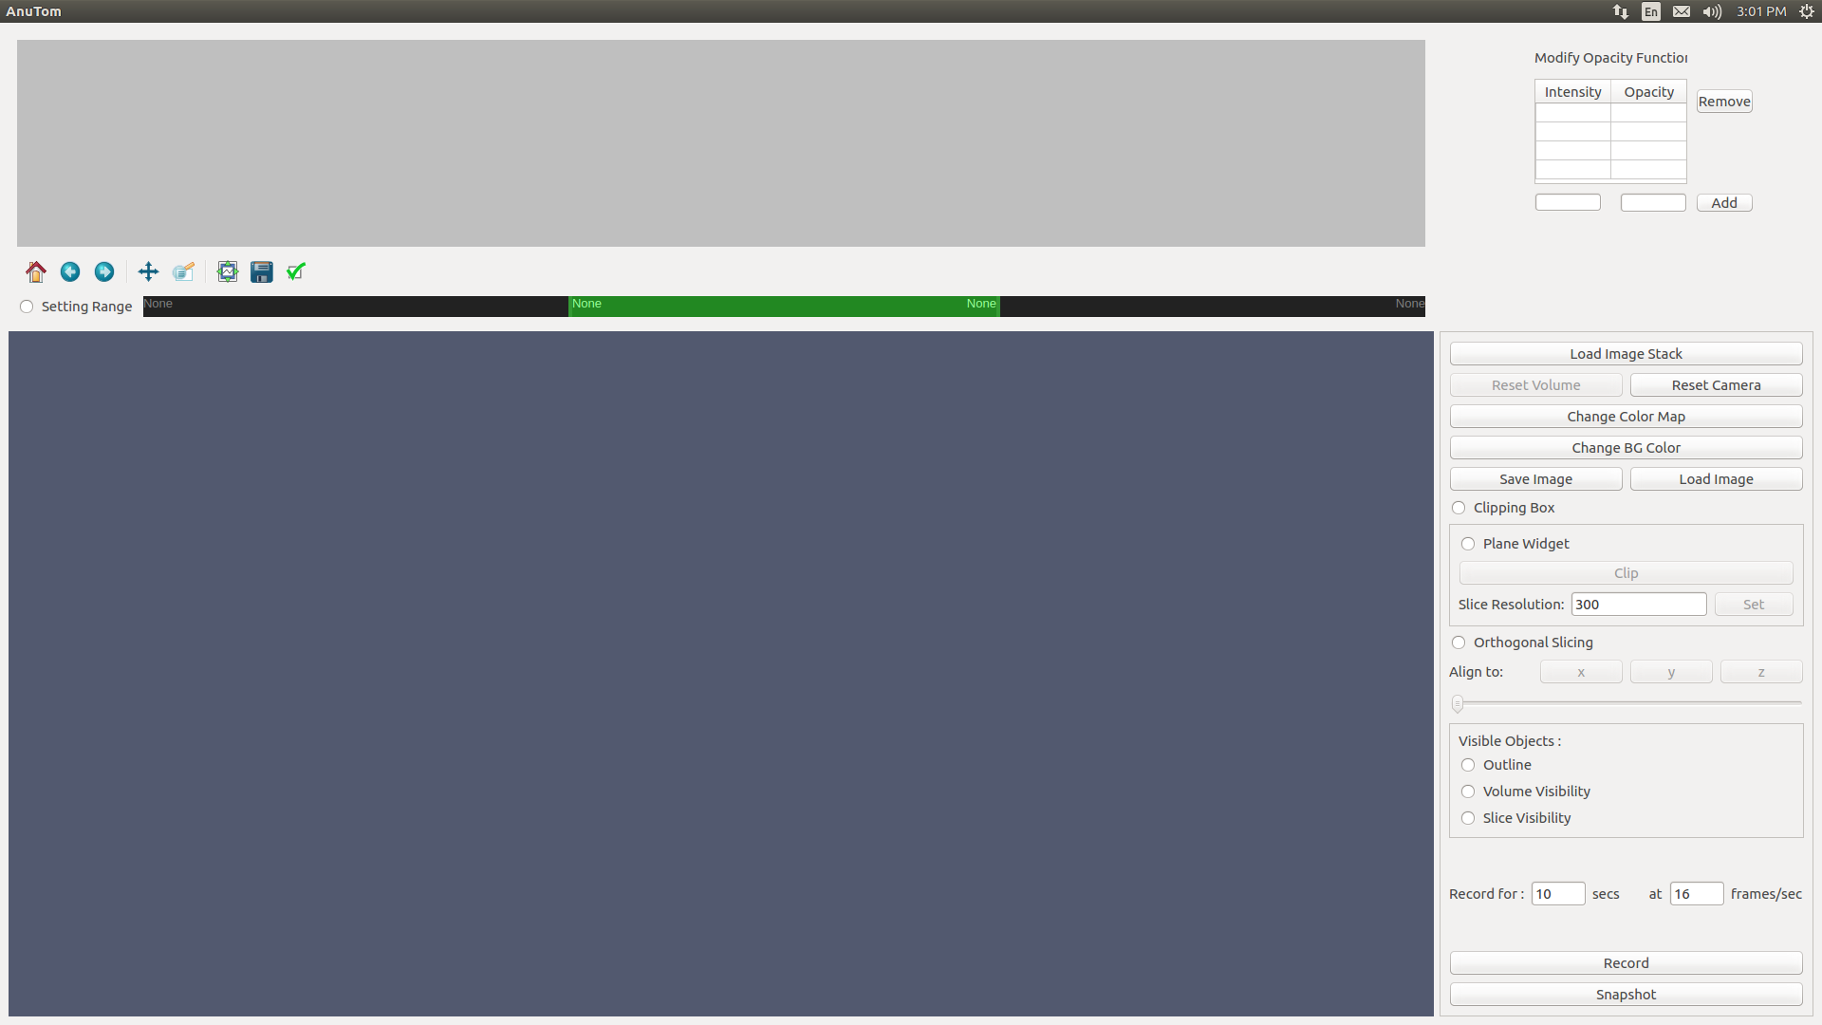

INITIAL WINDOW

LOADSTACK WINDOW

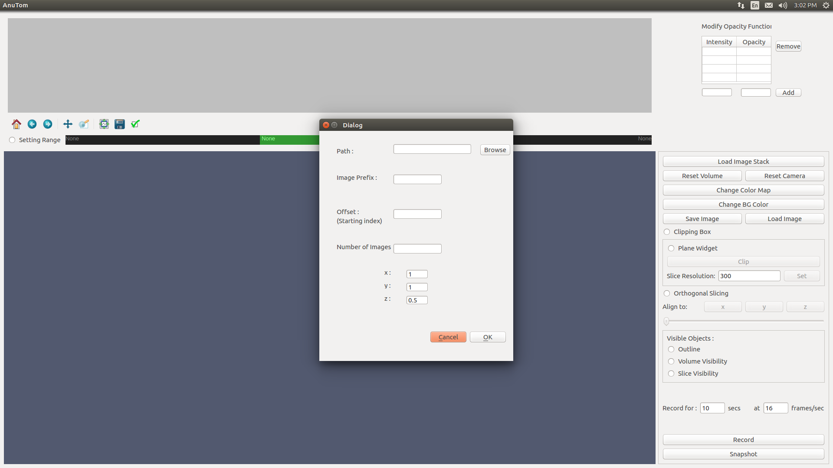

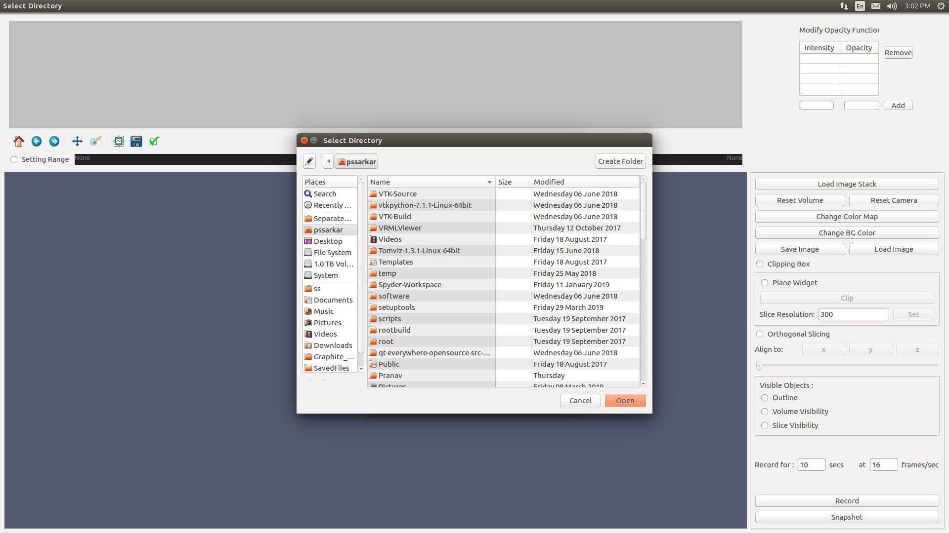

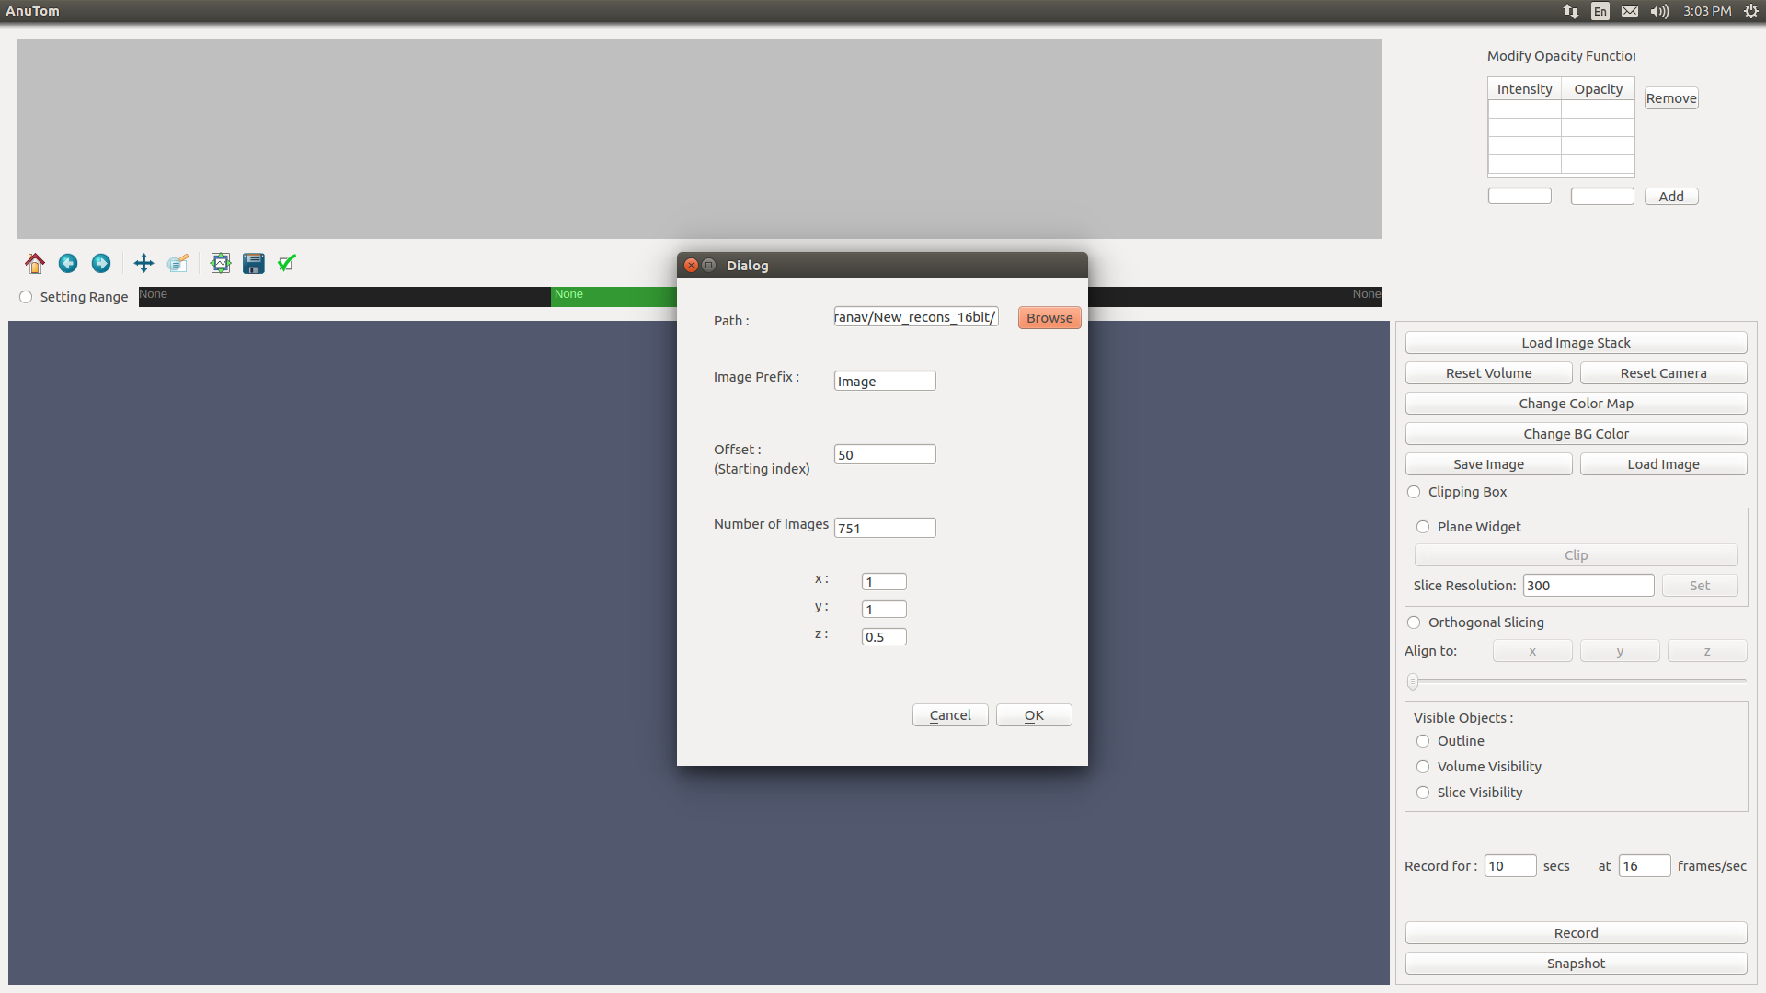

RENDER WINDOW

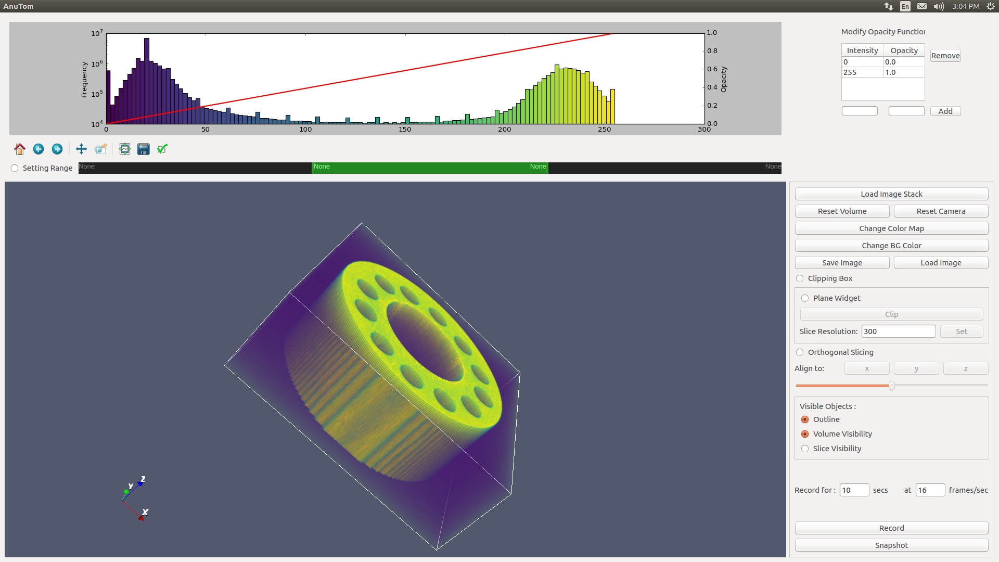

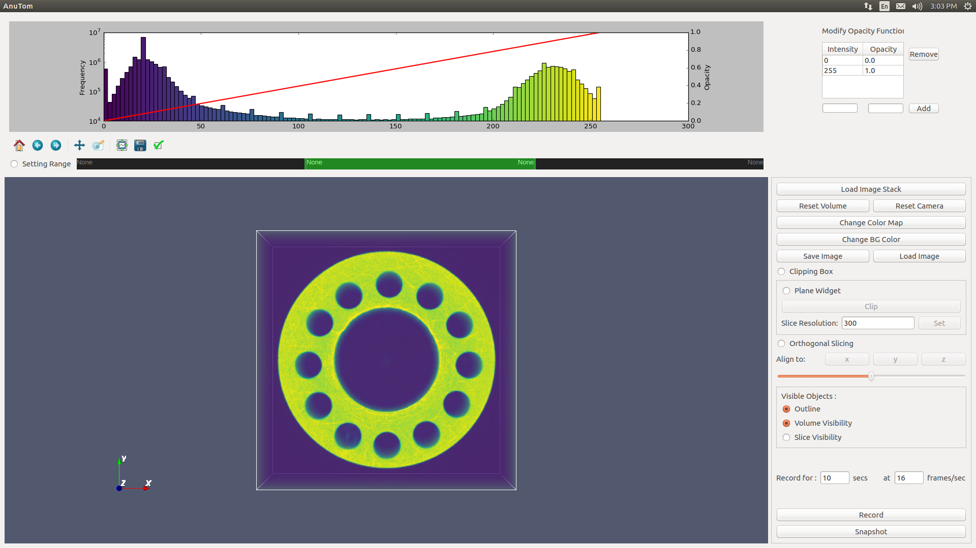
SAVE VTK CONFIGURATION

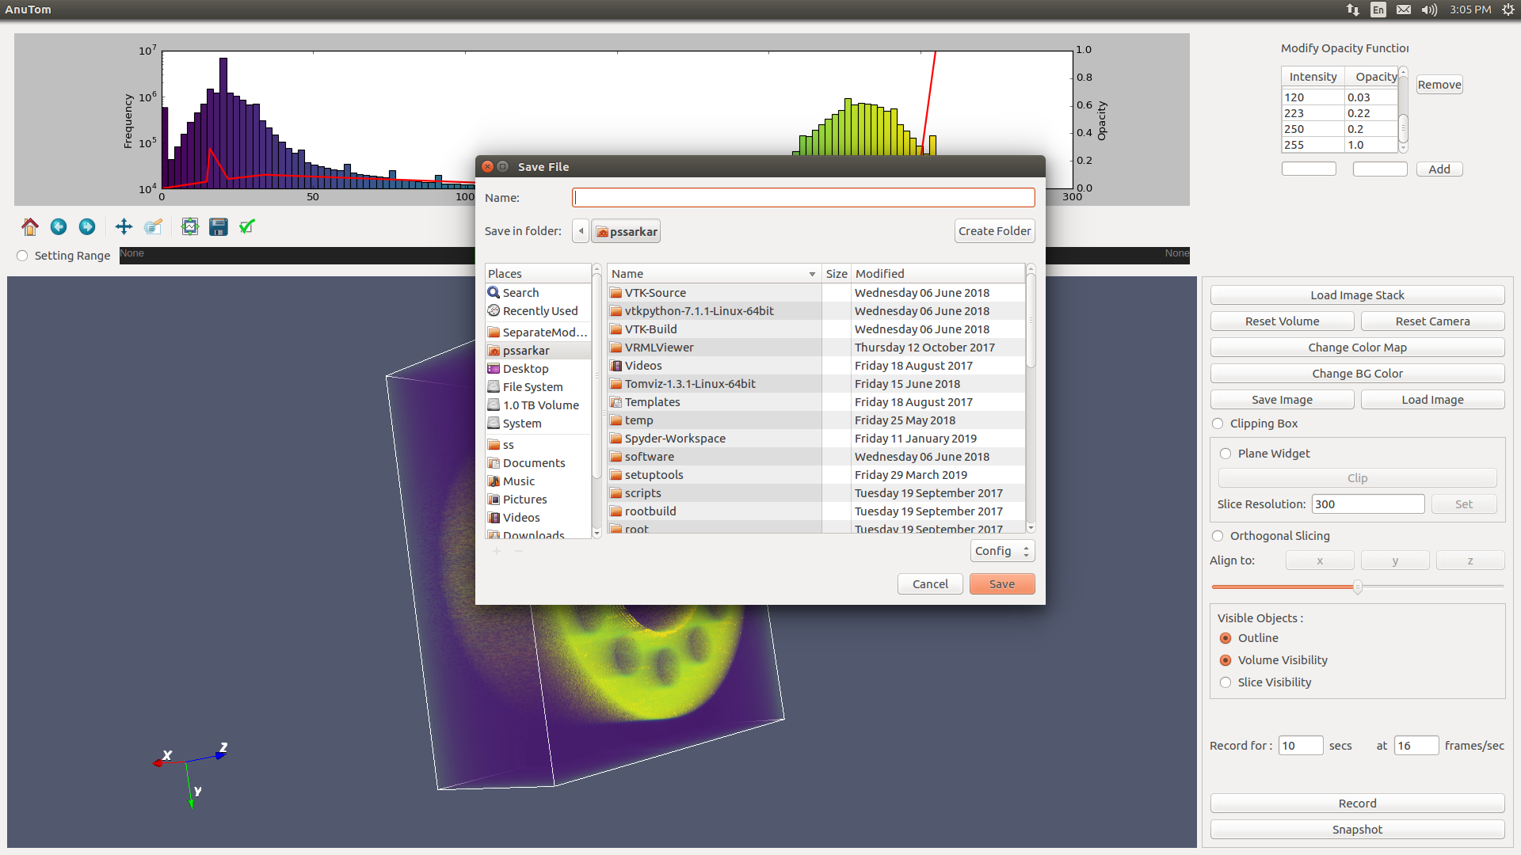

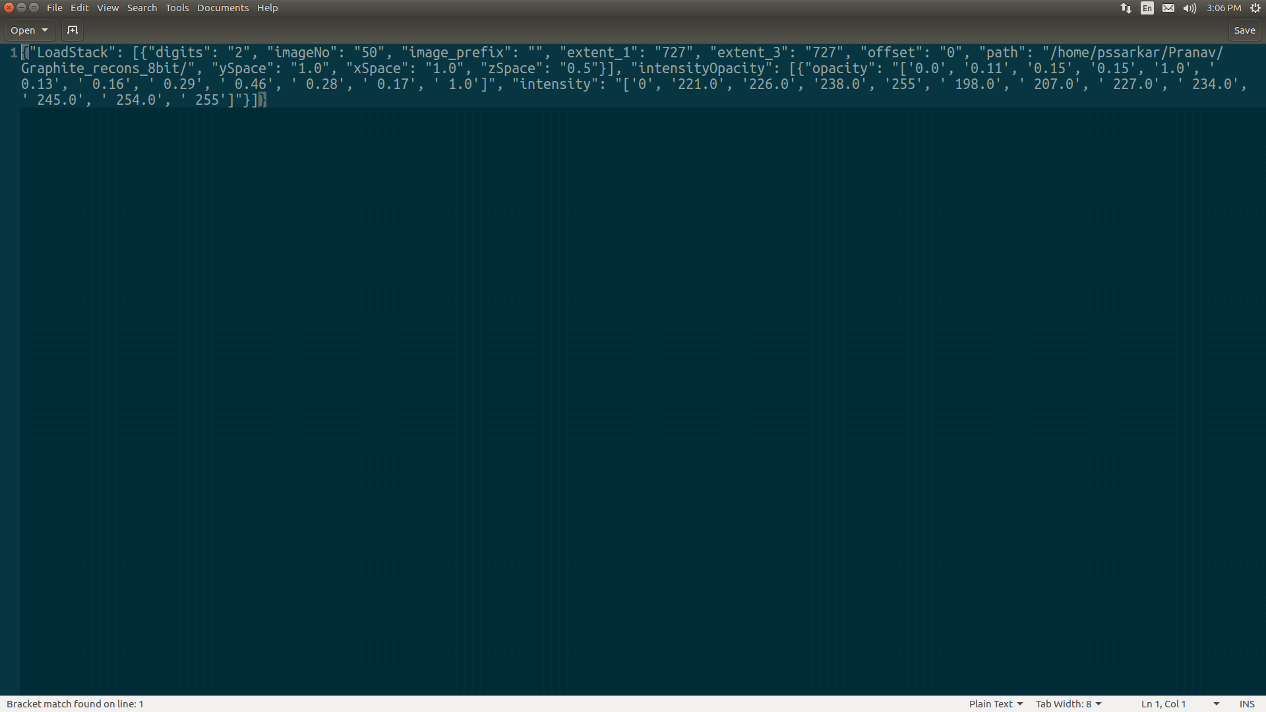

LOAD VTK OBJECT

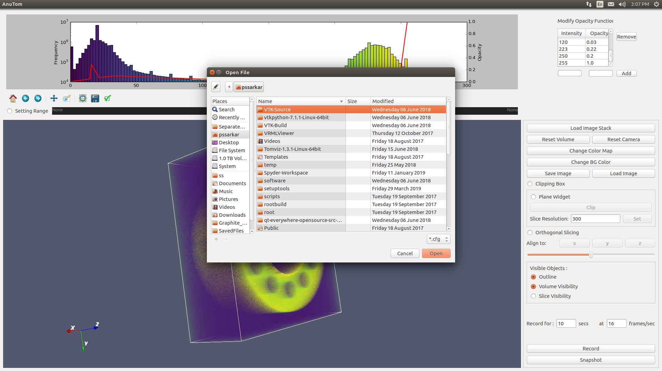

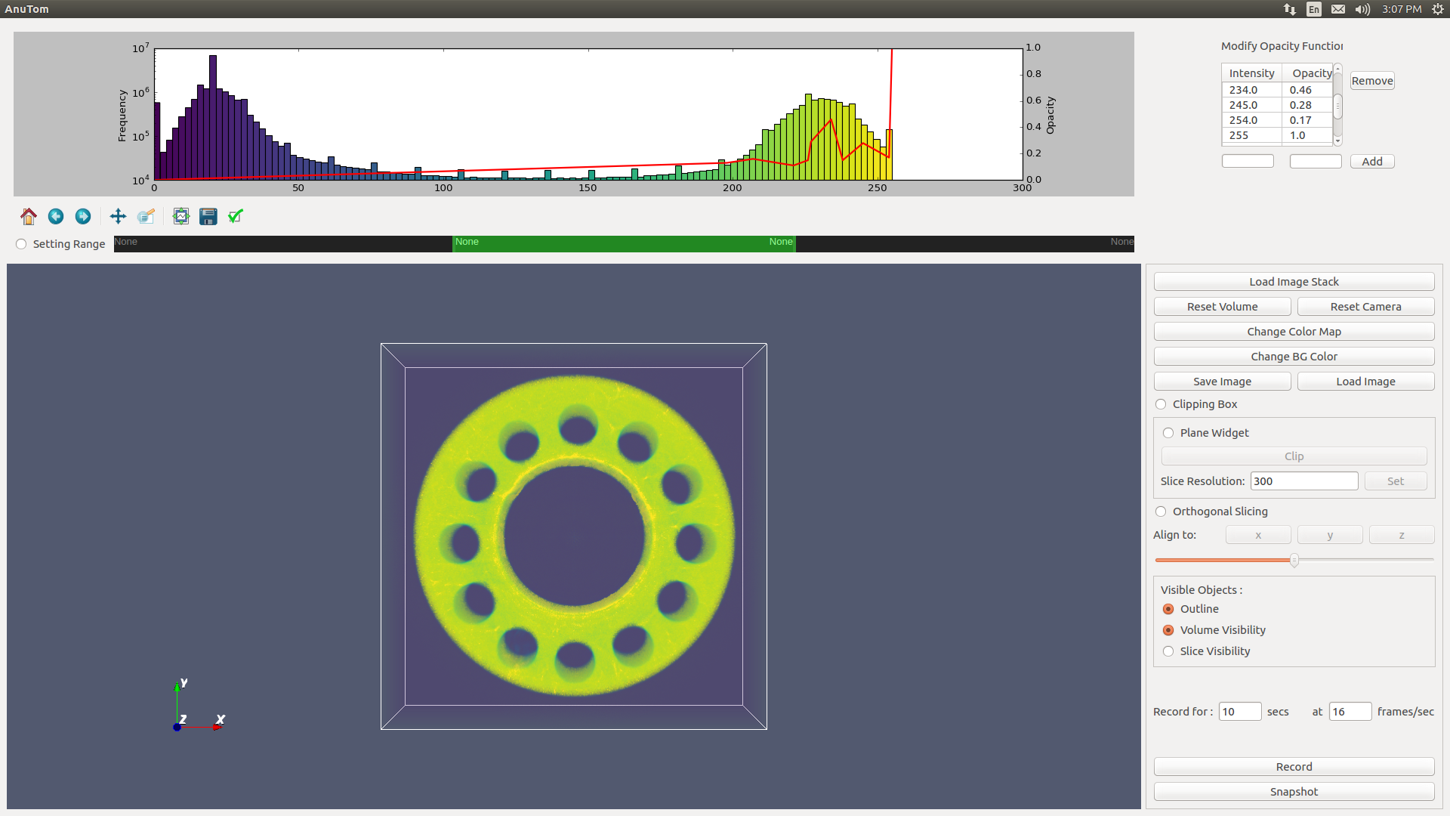

HISTOGRAM WIDGET(ADD POINT)
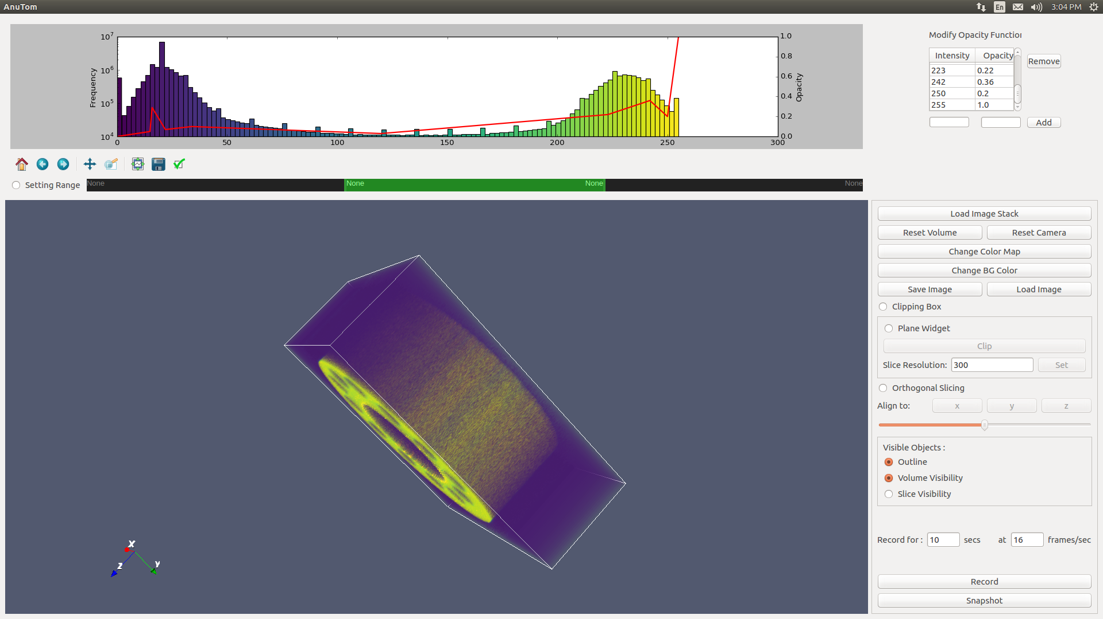
Points are Added just by clicking on the histogram widget

COLOR MAP

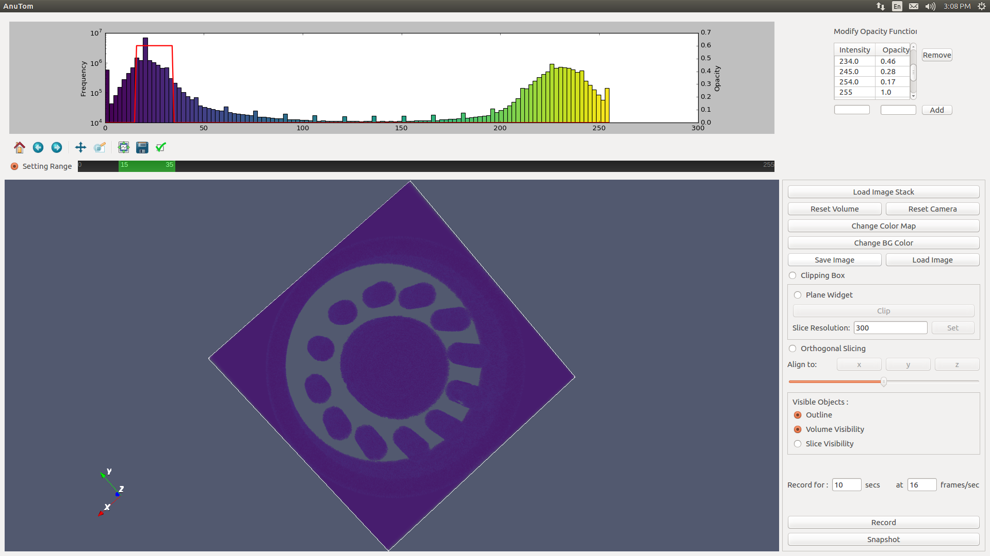
1. Click on the toggle button to enable the rangeslider
2. As we go on moving the slder the graph on histogram will be plotted accordingly
3. Clicking on the renderer window volume with the set properties will be rendered

ValueError: invalid literal for int() with base 10: 'None'

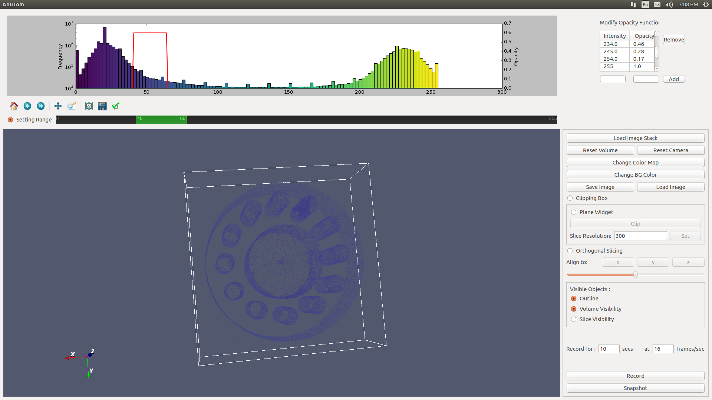

LOG FILE


