Implementation Guide for Social Media Analysis Dashboard

Welcome to the implementation guide for the Social Media Analysis Dashboard! This guide will walk you through the process of extracting data from Adidas's official YouTube channel and Facebook page using 3rd party libraries and Google API, followed by creating a dashboard using the Dash library. Additionally, we'll explore how to perform sentiment analysis using TextBlob and utilize the Facebook Prophet model for future forecasting.

**Prerequisites:**

* **Python:** Ensure you have Python installed on your system.
* **Required Libraries:** Install necessary Python libraries using the following command:

pip install -r requirements.txt

* **Data Extraction:**

Utilize 3rd party libraries and Google API to extract data from Adidas's official YouTube channel and Facebook page. Store the extracted data in CSV or Excel files for further analysis.

**Steps to Implement the Dashboard:**

**Download the Source Code:**

Download the source code files for the dashboard from the repository or provided source.

**Data Extraction:**

Extract engagement metrics data from Adidas's YouTube channel and Facebook page using 3rd party libraries and Google API. Ensure the extracted data is organized and stored properly.

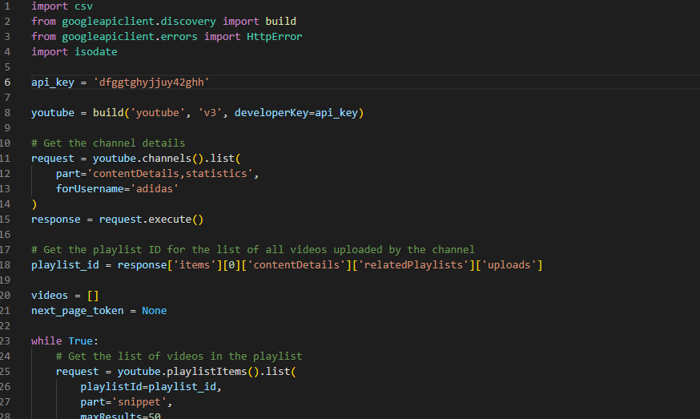

Figure -data extraction from youtube

Figure -data extraction from facebook

**Data Integration with Dashboard:**

Modify the dashboard code to read the extracted data files. Implement functions to load the data into appropriate components of the dashboard, such as YouTube video metrics and Facebook post metrics.

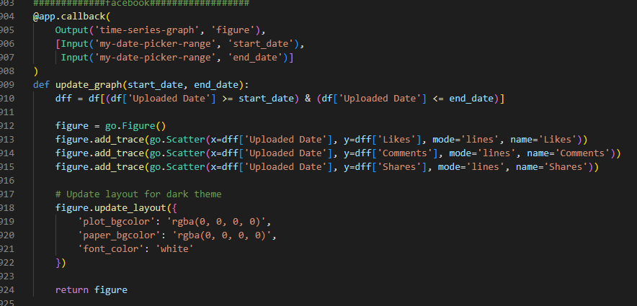

Figure -dashboard layouts

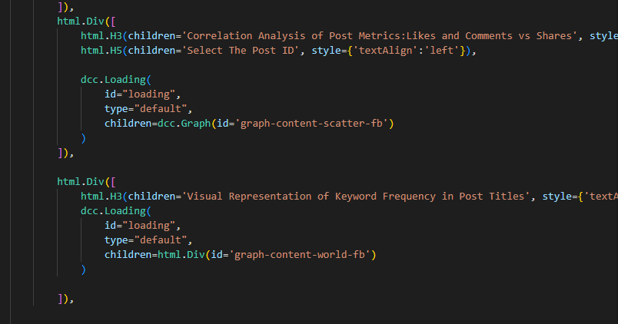

Figure -dashboards callbacks

**Sentiment Analysis Configuration:**

Utilize TextBlob for sentiment analysis. Configure the sentiment analysis code to process comments and other textual data. Ensure that the dashboard can effectively analyze text data and generate sentiment scores.

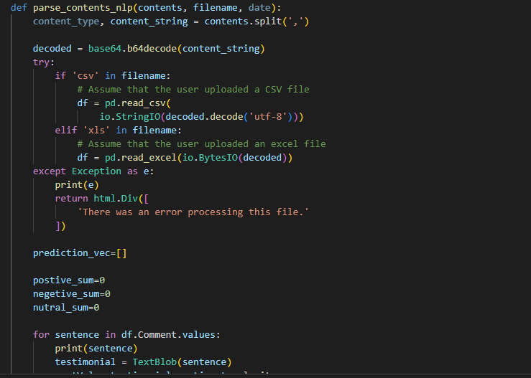

Figure -sentiment analysis using TextBlob

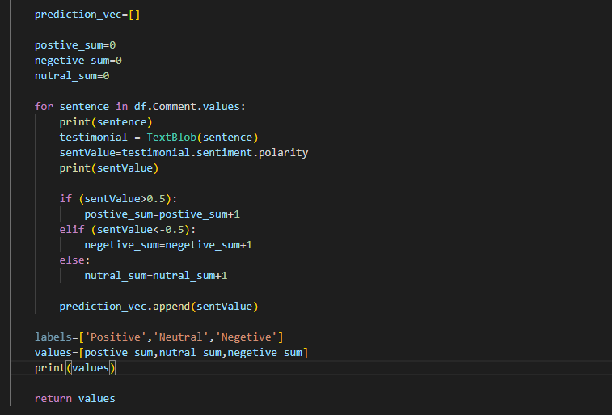

Figure -sentiment analysis using TextBlob code

**Configure Future Prediction Model:**

Utilize the Facebook Prophet model for future forecasting of engagement metrics. Configure the model with historical data from Adidas's social media channels. Customize the model parameters based on your dataset characteristics.

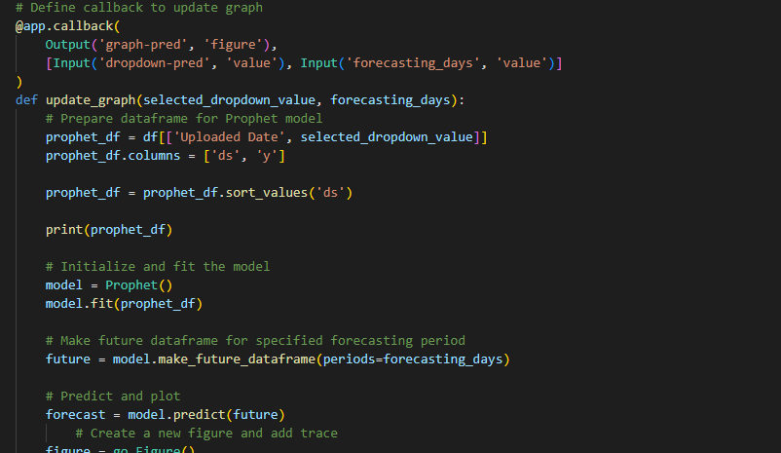

Figure -future forecasting using facebook prophet

**Dashboard Customization:**

Customize the dashboard layout, color schemes, and labels to align with your branding guidelines. Modify the HTML and CSS files to achieve the desired visual presentation.

**Testing and Debugging:**

Thoroughly test the dashboard by running it locally. Check all interactive features, data loading, and analysis functionalities. Debug any issues encountered during testing.