Social Media Analysis Dashboard User Manual

Introduction

Welcome to the Social Media Analysis Dashboard! This interactive dashboard is designed to provide you with insightful visualizations and analytics based on social media data. It utilizes Python and the Dash library to offer a user-friendly experience.

**System Requirements**

* Operating System: Windows, macOS, Linux
* Web Browser: Chrome, Firefox, Safari, Edge
* Python Version: 3.6 or higher
* Required Libraries: Dash, Pandas, Plotly, and any other dependencies specified in the requirements.txt file.

Getting Started

**Installation:**

* Ensure you have Python installed on your system.
* Install required libraries using pip install -r requirements.txt

**Running the Dashboard:**

* Navigate to the project directory in your terminal.
* Run the Python script for the dashboard: python app.py.
* Open your web browser and go to http://localhost:7002 to access the dashboard.

Dashboard Features

**1. YouTube Social Media Content Analysis:**

**Overview:**

Total Engagement Summary: Six cards display the total count of likes, comments, and shares for all videos, along with the average count per video.

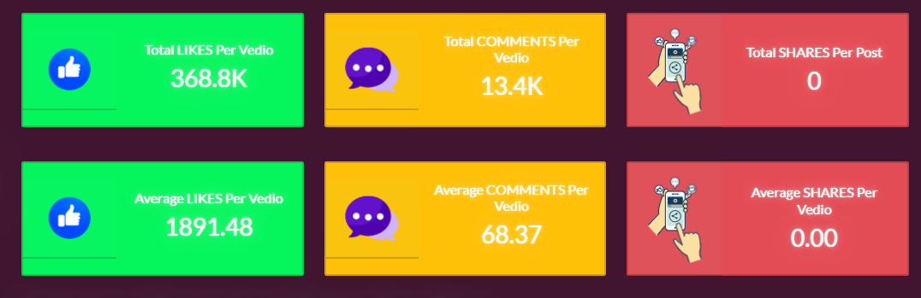

Each visualization plot on the dashboard provides the following options:

* Download: Allows you to download the plot as a PNG image.
* Zoom: Enables you to zoom in and out of specific areas of the plot.
* Pan: Lets you move the plot around.
* Box Select: Allows you to select a specific area of the plot.
* Zoom In: Enables you to zoom into a specific area of the plot.
* Auto Scale: Automatically scales the plot to fit the window.

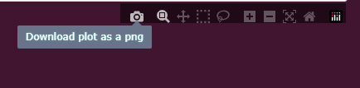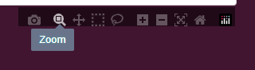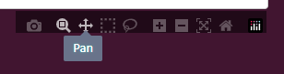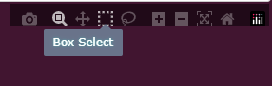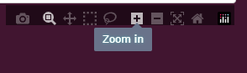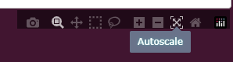

**Evolution of Engagement Metrics:**

This plot shows the trend of likes, views, and shares over time. You can choose a date range to generate a dynamic time plot graph.

**Instructions:**

* Select each option in the legend menu on the graph.
* The plot will only visualize data for the selected column.

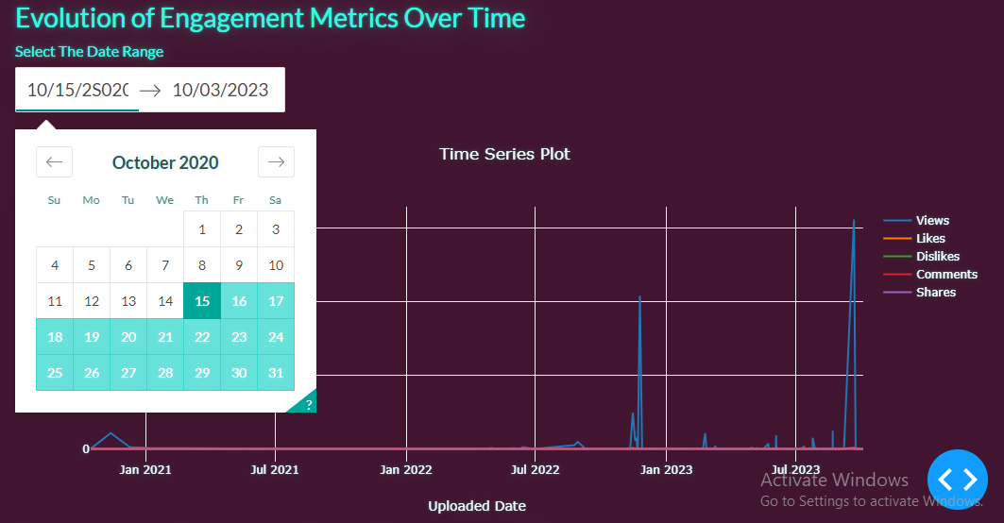

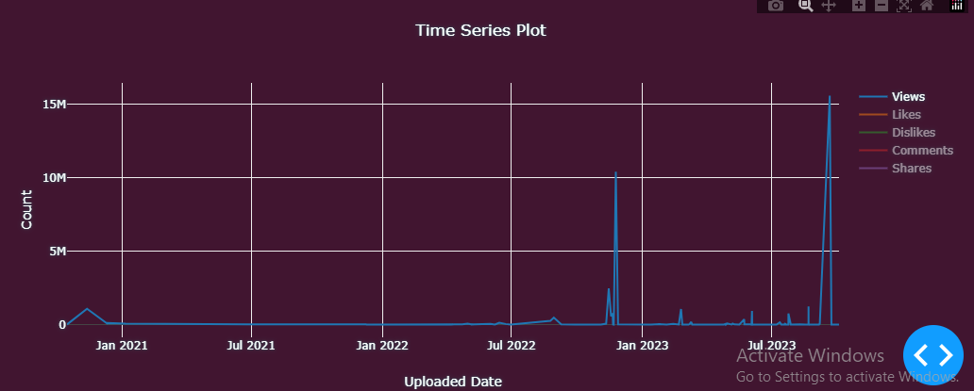

**Comparative Analysis:**

This plot allows you to compare engagement metrics (likes, views, shares, comments) for specific videos using bar graphs.

**Instructions:**

* Select the video title from the dropdown menu.
* The plot will visualize total likes, dislikes, comments, and shares for the selected video.

**Proportional Distribution:**

This pie chart shows the proportional distribution of engagement metrics (likes, views, shares, comments) for a specific video.

**Instructions:**

* Select the video title from the dropdown menu.
* The plot will visualize total likes, dislikes, comments, and shares for the selected video.

**Correlation Analysis:**

This scatter plot allows you to explore correlations between Views vs Likes and Comments vs Shares for a specific video.

**Instructions:**

* Select each option in the legend menu on the graph.
* The plot will only visualize data for the selected column.

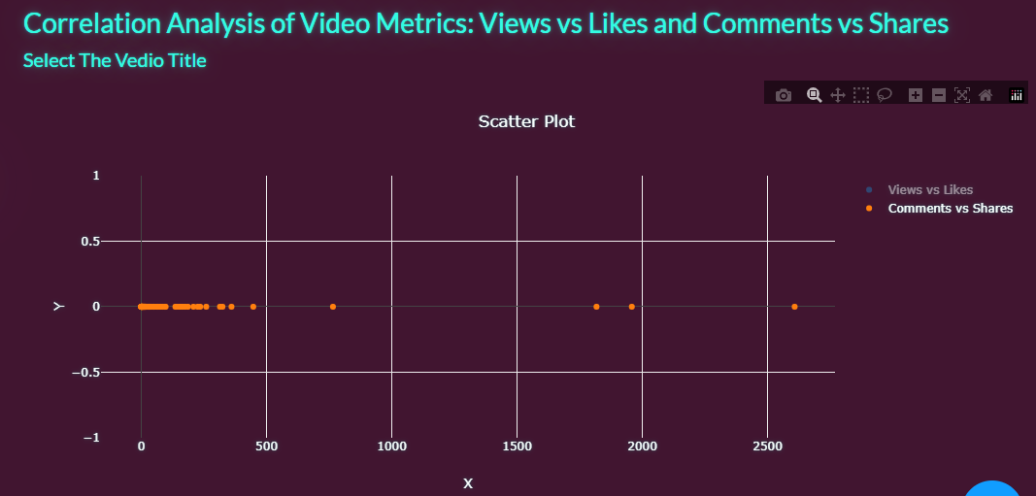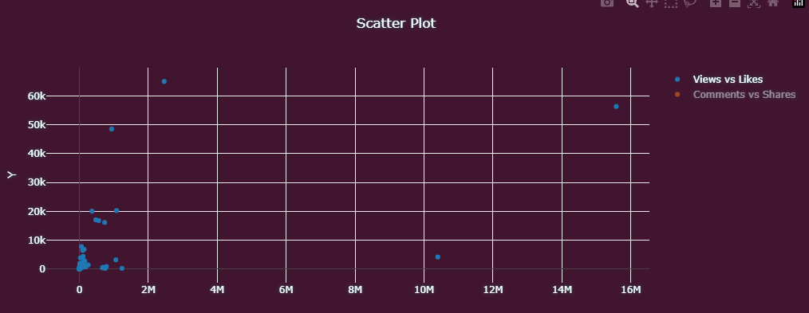

**Video Duration Distribution**:

This histogram helps you understand the distribution of video durations.

**Instructions:**

* Identify which video durations are most common.

**Keyword Frequency Visualization:**

* This word cloud graph visually represents the frequency of keywords in video content across all videos.

**2. Facebook Social Media Content Analysis:**

**Overview:**

Total Engagement Summary: Six cards display the total count of likes, comments, and shares for all posts, along with the average count per post.

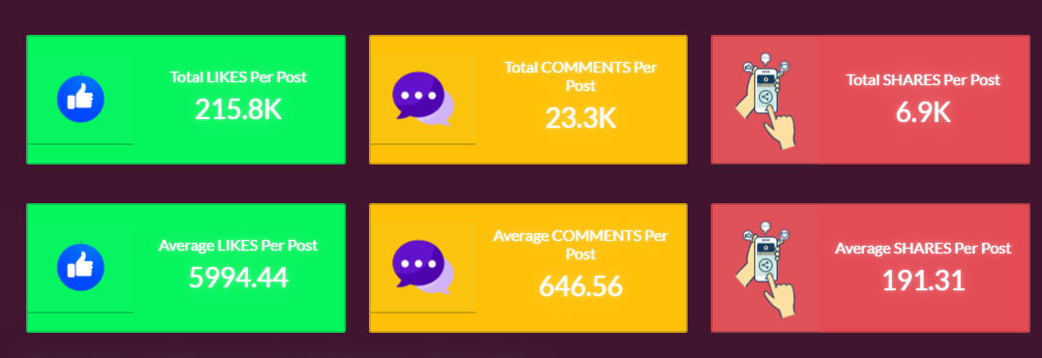

**Evolution of Engagement Metrics:**

This plot shows the trend of likes, comments, and shares over time. You can choose a date range to generate a dynamic time plot graph.

**Instructions:**

* Select each option in the legend menu on the graph.
* The plot will only visualize data for the selected column.

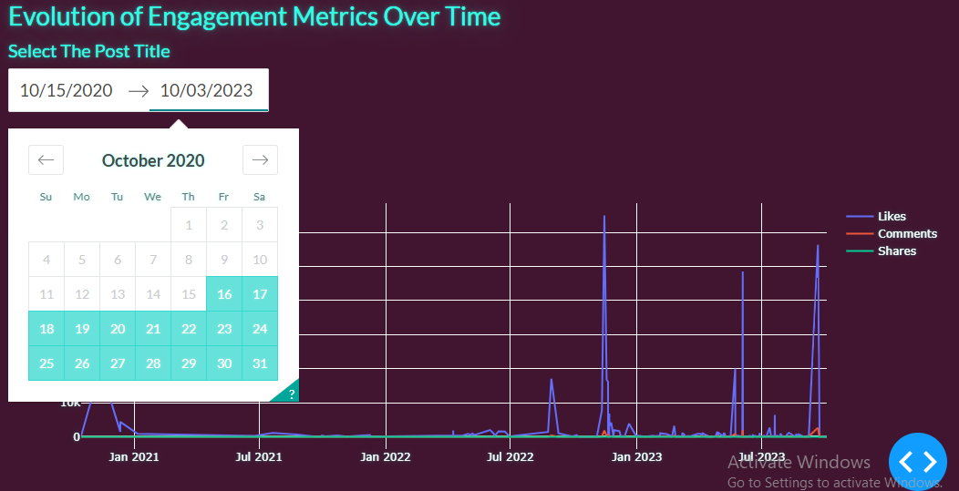

**Comparative Analysis:**

This plot allows you to compare engagement metrics (likes, shares, comments) for specific videos using bar graphs.

**Instructions:**

* Select the post ID from the dropdown menu.
* The plot will visualize total likes, comments, and shares for the selected post.

**Proportional Distribution:**

This pie chart shows the proportional distribution of engagement metrics (likes, ,shares, comments) for a specific post.

**Instructions:**

* Select the Post ID from the dropdown menu.
* The plot will visualize total likes, comments, and shares for the selected Post.

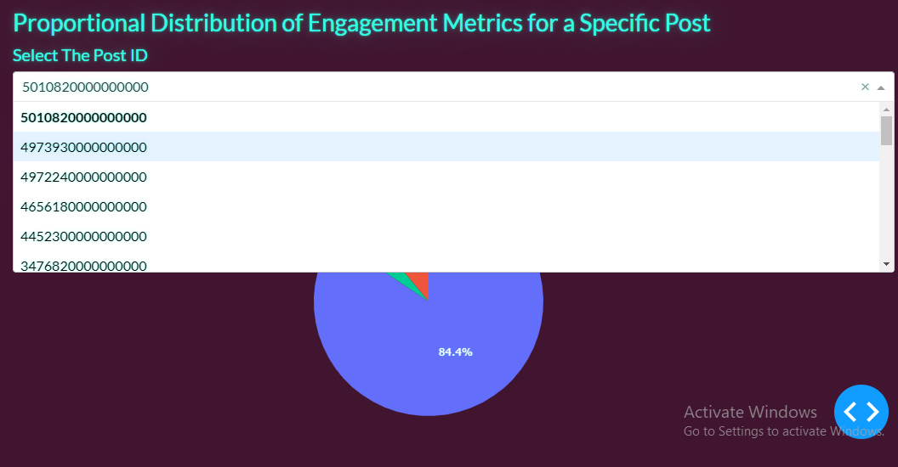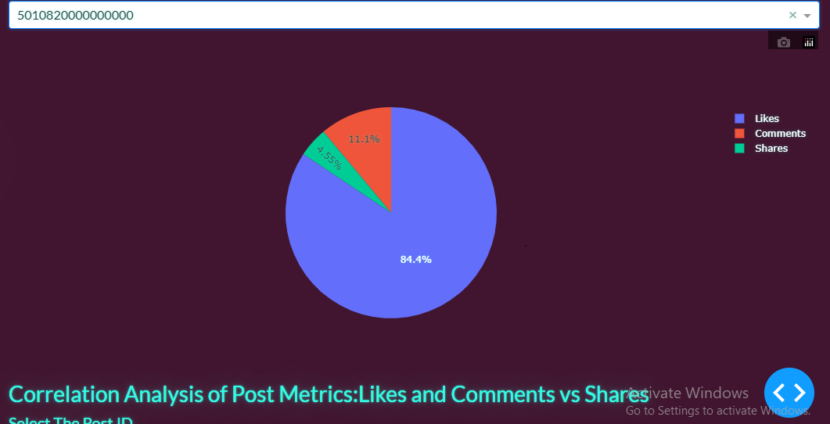

**Correlation Analysis:**

This scatter plot allows you to explore correlations between comment vs Likes and Comments vs Shares for a specific Post.

**Instructions:**

* Select each option in the legend menu on the graph.
* The plot will only visualize data for the selected column.

.

**Keyword Frequency Visualization:**

A word cloud graph visually represents the frequency of keywords in post content.

**3. Sentiment Analysis:**

Upload Comments: Upload a text file containing comments for videos. The dashboard will process the sentiment of the comments and present an overall sentiment score in a user-friendly graph.

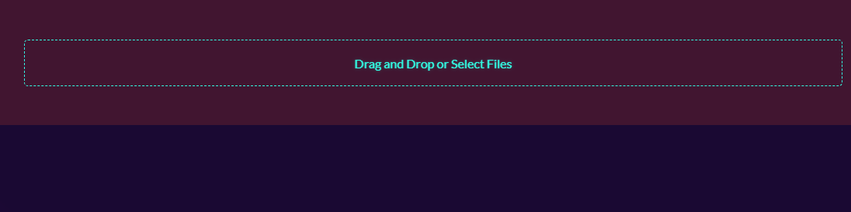

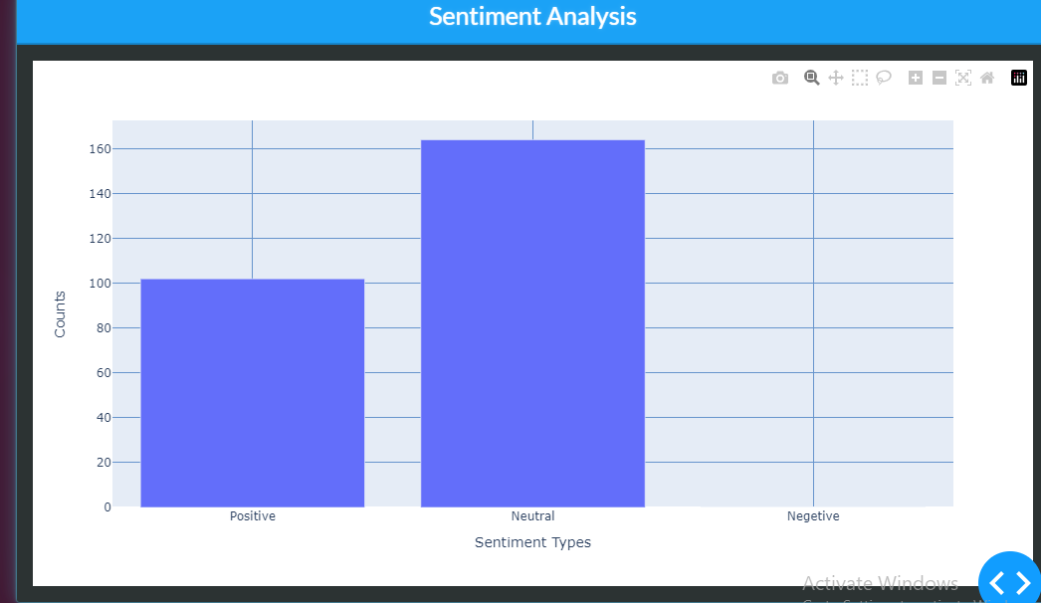

**4. Future Prediction:**

Forecasting Model: Predict the likes and views count of future videos using the dashboard's forecasting model. Provide necessary inputs, and the dashboard will generate predictions based on historical data.

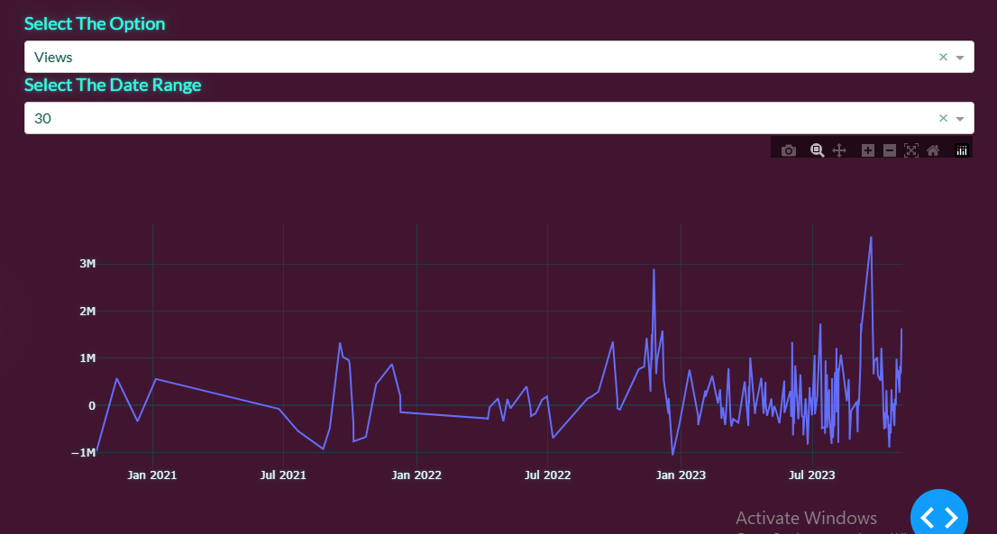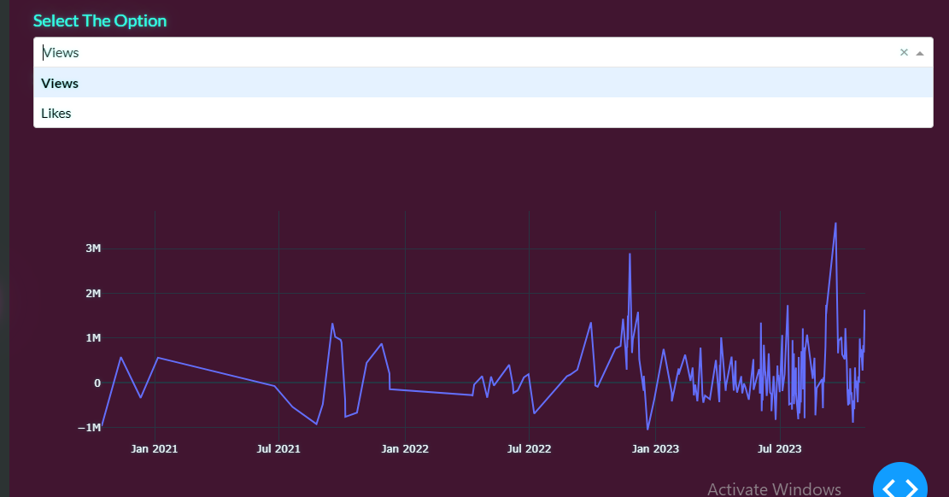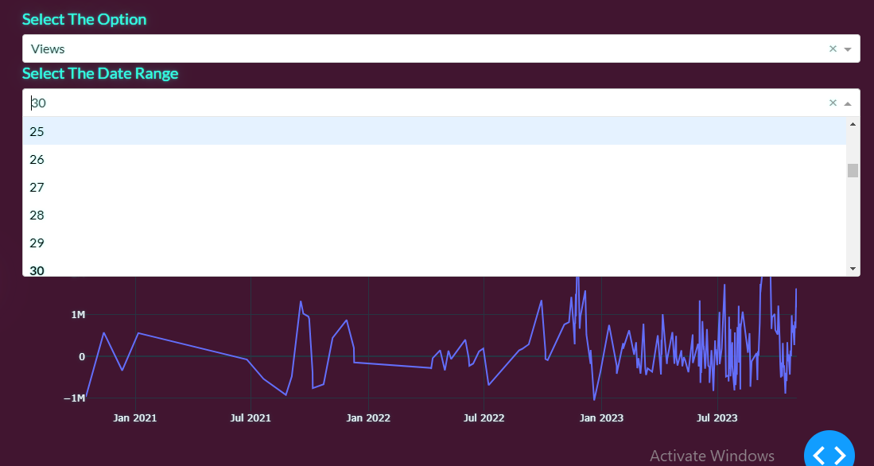

**How to Use the Dashboard:**

**Navigation:**

Use the navigation menu to switch between YouTube Analysis, Facebook Analysis, Sentiment Analysis, and Future Prediction sections.

**Data Selection:**

For YouTube and Facebook analysis, select specific videos or posts to view detailed metrics.

Choose date ranges for analyzing historical data.

**Interact with Visualizations:**

Interact with graphs and charts by hovering over data points to view detailed information.

For sentiment analysis, upload a text file containing comments to generate sentiment scores.

**Future Prediction:**

Provide necessary inputs (such as video content type, category, etc.) to the forecasting model and get predicted likes and views count for future videos.

**Export Data:**

If required, export visualizations and analysis results for your records.