**Second Iteration and Project Work**

Advanced Software Engineering

Team: **Hunter** Team ID: 4

**Introduction**

Our project deals with the cardboard application and majorly focuses on the voice or speech control of the application which allows the user a lot many features in addition to the current cardboard application. This application can be easily installed as the other applications making it more handy for the cardboard users.

**Project Goal and Objectives (revised)**

Our objective is to make the next level of the cardboard application with more sophisticated implementation of the voice control feature. In the regular cardboard application any act needs the use of the touch. So why not go hands free? Using the voice control we can browse through the playing video front and back, play the next video, skip the video, pause the video, increase the volume levels in the video and the list can be extended for a large set of operations. Our future scope will be extending the features of security to this voice like the google services have provided in order to restrict the intersections of the different voices.

**Significance/Uniqueness**

None of the cardboard applications render the feature of speech control in it. So to make man’s life more sophisticated and interesting the combination of the features of the ok google in the cardboard will become a new area of interest. This opens a new style of using the application’s feature like by simply connecting the android device in the cardboard we can start streaming through pages, become hands free and that too within the small pricing range. I think these features make our project to be pushing the edge of this internet revolution.

**System Features:**

The main features include:

* Browsing through the video with the voice over.
* Opening the new video or selecting the next video.
* Skip the video for specific time.
* Moving to the next video.
* Playing the previous video.
* Change in the levels of the volume during the video.

**Second Iteration Report**

The user uses mobile phone and its camera to take pictures. When user wants to do any activity like comparison of image, getting face attributes, the application will pass the data to web API. Then as per retrieved result, there will be application logic which manipulates the response and displays results. For google home authentication, is the user’s validation response is true, then it will allow google home to operate. There is the provision of Face DB which stores all images.

**5. Project Management**  
For iteration 2, We completed the following tasks:

1. Research cardboard and face recognition apis
2. Created the login and the register page.
3. Developed the face recognition application for the login.
4. Working application of the cardboard on an android phone.

The relative application images are presented in the following:

Test results:

Face recognition as the sign in option:

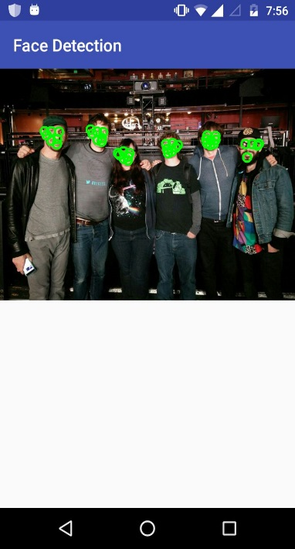

Working cardboard application:

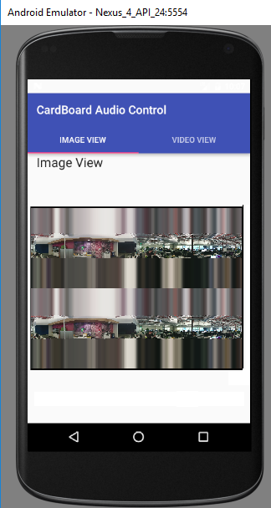

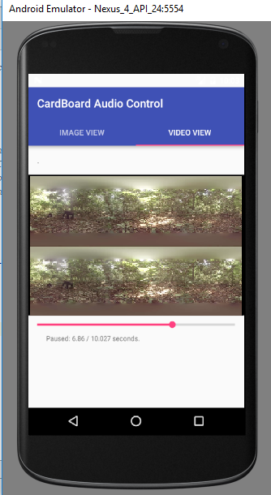

**References:**

1. Innovation spot light <http://ieeexplore-spotlight.ieee.org/article/virtual-presence-avatars-and-vr-applications/>
2. http://through-the-interface.typepad.com/through_the_interface/2014/11/adding-more-speech-recognition-to-our-stereoscopic-google-cardboard-viewer.html
3. http://ieeexplore-spotlight.ieee.org/article/virtual-presence-avatars-and-vr-applications/
4. https://www.wired.com/2015/12/google-cardboard-camera-app/
5. https://uploadvr.com/vr-101-whats-the-difference-between-rift-vive-playstation-vr-cardboard-and-gear-vr/