2.

Go to apex.oracle.com-🡪Click on get started for free([https://apex.oracle.com/en/learn/getting-started/)-->click](https://apex.oracle.com/en/learn/getting-started/)--%3eclick) on Free APEX Workspace(<https://apex.oracle.com/pls/apex/r/apex/quick-sign-up/request-workspace>)

Created the workspace with the name -🡪 SHALINEE_MOTARWAR_MINE

Verify the mail-🡪sign with mail and password is Sanket@14--->Click on SQL Commands

**Video No 3.Prepare the Sample Data**

Go to SQL Commands🡪Click on Utilities-🡪Click on Sample Data🡪Click on Manage Sample Dataset-🡪Install EMP/DEPT table🡪Click on Exit

Click on SQL Commands🡪to run SQL commands

**Video No 4.Dedicated TA support**

**Section 2:Single Table Queries**

SQL language is not case sensitive

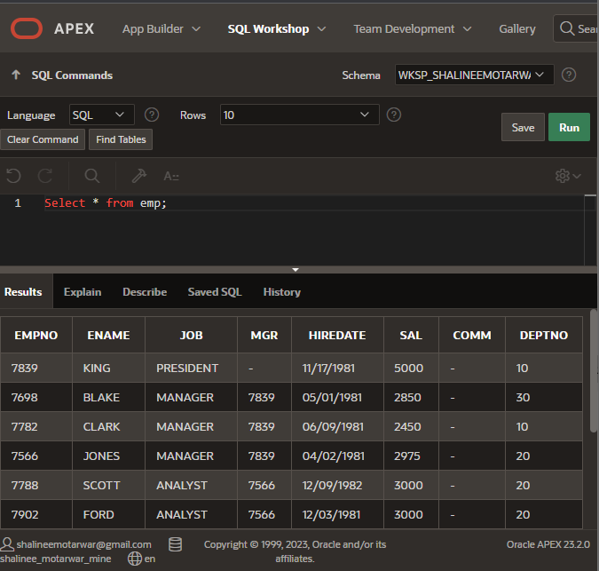

**Syntax of SELECT Query:**

SELECT <column-name> from table-name;

**Example:**

**1.Select * from emp;(for retrieving all columns from the table)**

**2.Select JOB,ENAME from emp;**

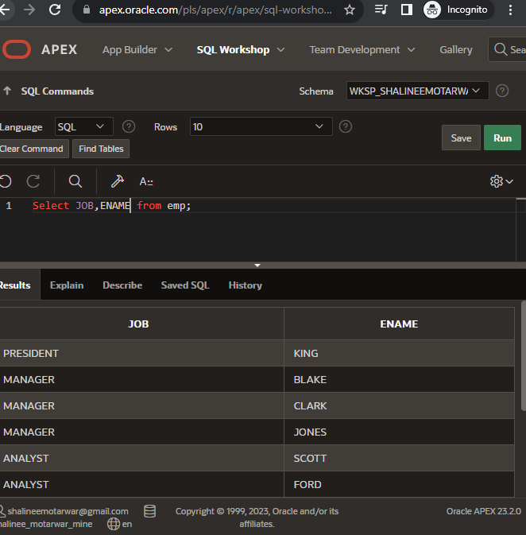



Assignment -🡪

Q1.Select the deptno and department name from department table

* Select DEPTNO,DNAME from dept;

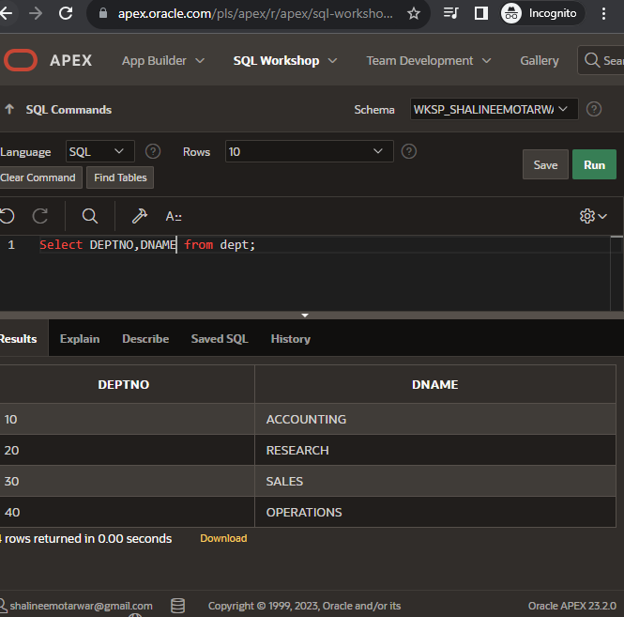

Distinct keyword: To retrieve the unique data from table we need to use the distinct keyword

Example 1: Select distinct job from emp;(it retrives unique jobs from the employee table)

**Section 2.3(Video 10) Using the Where Clause in a query**

1. Select * from emp where job=’MANAGER’

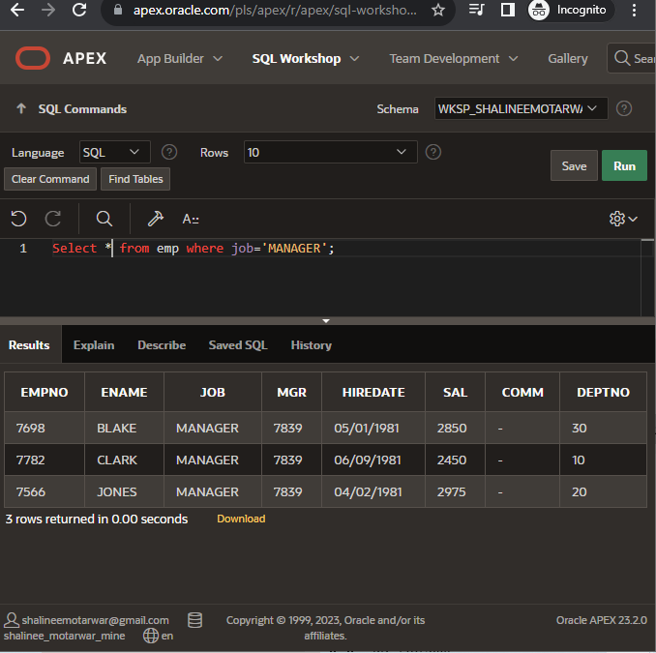

**2.Select * from emp where JOB=’SALESMAN’ AND sal=16000**

**Video 13:Combining WHERE,AND and OR with operators**

Select * from emp where job=’manager’ OR job=’salesman’

Select * from emp where job!=’manager’ OR job=’salesman’

Select * from emp where job=’manager’ and sal>=2000

**Video 14: Query Filtering Continued Between,IN and NULL**

**Video 19. Single Row Functions(SRF) and using the Dual Tables**

**1.Concat()**

Example: select ‘my name is’ || ename from emp; OR select concat(‘my name is’,ename) from emp

Select concat(‘my name is’,ename) as sentence from emp

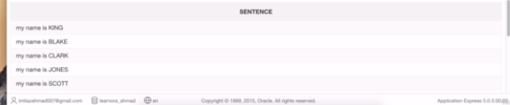

**2.Upper()**

Example: select upper(“hello”) from emp;

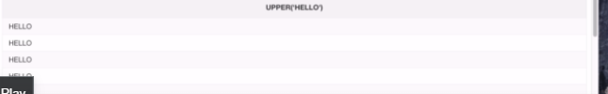

3.select ‘hello’ from emp

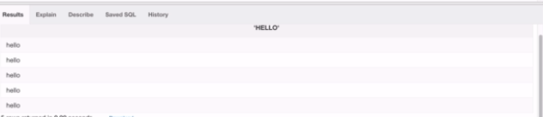

4.select ‘pizza’ as FOOD,’fansta’ as drink from dual

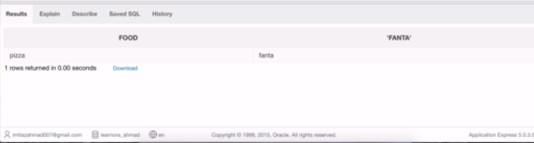

5.Select concat(lower(ename),upper(‘is the name’)) from emp where deptno=20

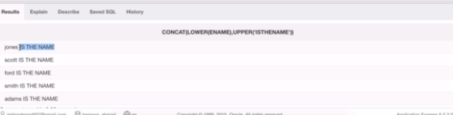

6

**Video 20**.

**1.ROUND(number,number_of_places_round)**

Example:

1.select round(107.088,2) from dual---🡪 107.09

2.Select round(107.088,3) from dual--🡪107.088

3.select round(107.087) from dual-🡪107

**2.trunc(number)**

Example:

1.select round(107.088345,2) from dual---🡪 107.088

2.Select round(107.088,3) from dual--🡪107.088

3.select round(107.087) from dual-🡪107

**DATE & TIME FUNCTIONS**

**1.sysdate-🡪It returns the system’s date**

Example:

1.select sysdate from dual--🡪05/26/2016

**2.systimestamp -🡪It returns the system’s date in more detail**

Example:

1.select systimestamp from dual--🡪05/26/2016……………

**3.ADD_MONTHS(‘7/13/2014’,8)**

Example:

1.Select add_months(‘11/17/2012’,3) from dual-🡪prints the date after next three months

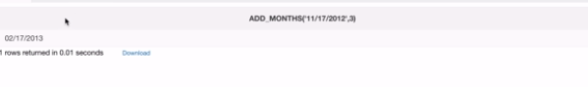2.Select add_months(‘11/17/2012’,-3) from dual-🡪prints the date before three months

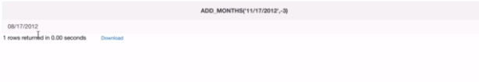

**4.MONTHS_BETWEEN(date1,date2)🡪it returns the numbers of date between two dates**

**Example:**

1.select MONTHS_BETWEEN(‘12/15/2012’,’12/4/2013’) from dual

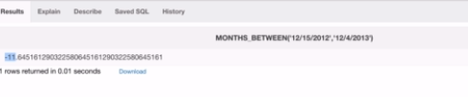

**Video 21. Conversion SRfs & Date Formatting**

**1.to_char()**

**Example:**

1.select to_char(sysdate,’mm-dd-yyyy’) from dual

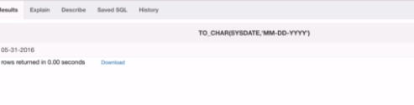

2.select to_char(sysdate,’dd-mm-yyyy’) from dual

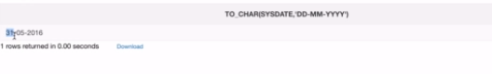

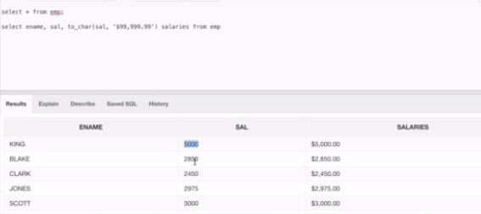

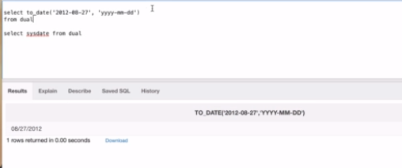

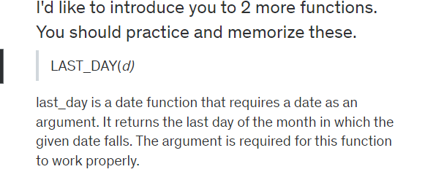**Video 24 :SRF NULL**

**Example: select ename,job,sal,NVL(COMM,0) from emp where empno in (7839,7698,7566,7654)** 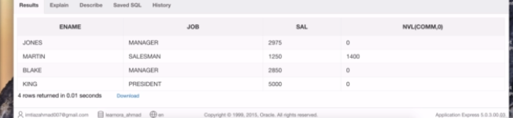

**Select ename,job,sal,NVL(to_char(comm),’No data found’) from emp where empno in (7630,7566,7654)** 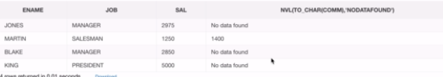

**NULLIF**

**Example: select ename,length(ename),nullif(length(ename),5) from emp**

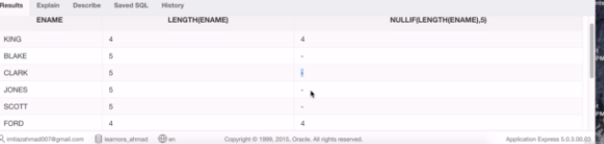

**Select ename,length(ename),nvl(nullif(to_char(length(ename)),to_char(5)),’length is 5’) from emp**

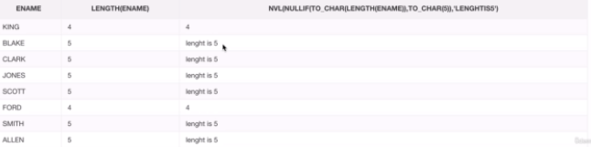

**Section 4**

**Video 26:Grouping functions MIN,MAX,AVG,COUNT**

**Select max(sal) from emp**

**Select min(sal) from emp**

**Select sum(sal) as sum_val from emp**

**Select avg(sal) as avg_sal from emp**

**Select count(ename) as count from emp**

**Select sum(sal)/count(*) as computed_avg from emp**

**Select sum(sal) as sum,avg(sal) as avg from emp**

**Select avg(sal) from emp where job=’MANAGER’**

**Video 27:Group by clause and Having**

**Select avg(sal),job from emp group by job**

**Select count(*),job from emp group by job**

**Select min(sal),job from emp group by job**

**inner join:**

**Selecy ename,mgr,loc from emp join dept using(deptno)**

**Lecture 36 - EQUIJOIN and NON-EQUIJOIN**

**Example:**

**1.Select * from emp,dept where dept.dept_no=emp**

**Lecture 37: Case Statement**

**Example**

1.select job ,email ,(case job when ‘president’ then ‘big shot’

When ‘manager’ then ‘decides the pay’

Else ‘no comment’ end) as “comment “ from pay

2.select ename,sal,case when sal>=1000 then ‘big shot’

When sal<=1000 then ‘small shot’

End from emp;

Orcale Live SQL

**Lecture 38: OVER Clause With Partition BY**

**1.Select b.*,(select count(*) from bricks) total_bricks_in_table from bricks b;**

**2.Select b.*,(select count(*) from bricks where color=b.color ) total_bricks_in_table from bricks b;**

**3.select b.*,count(*) over() total_count)in)table from bricks b;**

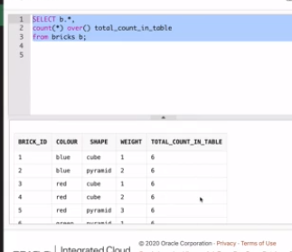

**4. select b.*,count(*) over(partition by color) total_count_in_table from bricks b;**

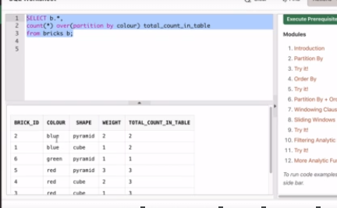

**5**. **select b.*,sum(weight) over(partition by weight) total_count_in_table from bricks b;**

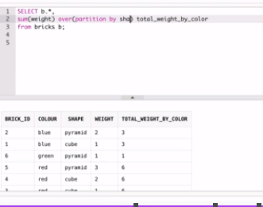

**Lecture 39: Compute Running Totals with ordering and Partitioning**

1. **select b.*,sum(weight) over(order by brick_id) total_count_in_table from bricks b;**

**2**.**select b.*,sum(weight) over(partition by weight order by brick_id ) total_count_in_table from bricks b;**

**Lecture 40:Unbounded Preceding Order In Over Clause**

**Unbounded preceding ranges in the current range and all the previous rows**

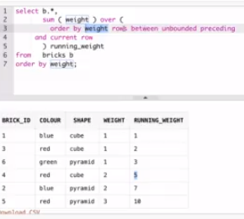

**Lecture 41: Slicing Windows and Filtering with Analytic Functions**

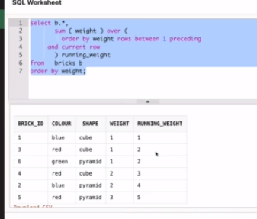

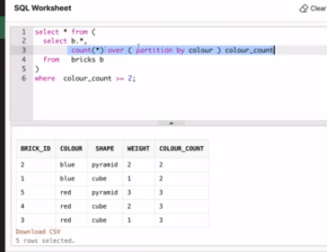

**Lecture 42:Rank,Dense_rank,Lead and Lag functions**

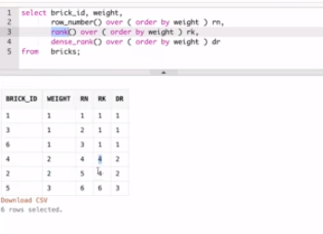

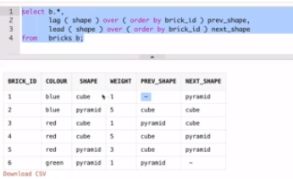

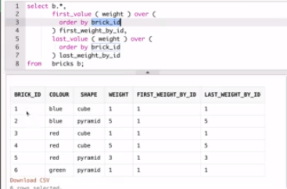

**Lecture 44: Creating Your Own Tables and Design Considerations**

**Syntax: Create table stores(store_id number not null,city varchar(50))**

**Lecture 45:Inserting Data Into Our Table**

**INSERT**

**Example:** Insert into stores(store_id,city) values(1,’San Francisco’)

**INSERT ALL**

**Example:** Insert all into stores(store_id,city) values(4,’philisoph’)

into stores (store_id,city) values (5,’boston’)

into stores (store_id,city) values (6,’boston’)

**Lecture 46:Create Table With A Primary Key Constraint**

**Syntax: Create table products(product_id number not null,name varchar(50),CONSTRAINT product_pk PRIMARY KEY (product_id))**

**Lecture 47: INSERT ALL for Multi-table & Conditional Inserts**

**Syntax:**

**1.Insert all into dest_tb_1 (id,name,date_of)values (EMPNO,ENAME,HIREDATE)**

**into dest_tb_1 (id,name,date_of)values (EMPNO,ENAME,HIREDATE)**

**into dest_tb_1 (id,name,date_of)values (EMPNO,ENAME,HIREDATE)**

**select empno,ename,hiredate from emp;**

**2.Insert all**

**When sal <=1500 then**

**into dest_tb_1 (id,name,date_of)values (EMPNO,ENAME,HIREDATE)**

**when sal between 1500 and 2500 then**

**into dest_tb_1 (id,name,date_of)values (EMPNO,ENAME,HIREDATE)**

**else**

**into dest_tb_1 (id,name,date_of)values (EMPNO,ENAME,HIREDATE)**

**select empno,ename,hiredate from emp;**

**Lecture 48:Using ALTER to modify the table structure**

**Syntax:**

**1.Alter table products modify name varchar(50) not null;**

**2.Alter table products rename name to full_name;**

**3. Alter table products modify (name varchar(50) not null,id varchar(30));**

**Lecture 49 :Create Table with SELECT + UPDATE DATA**

**Syntax:**

1.Create table employee as select empno,ename,job,hiredate,sal,comm from emp;

**Lecture 50:Merge Statement in Oracle**

**Syntax:**

**1.**

**Lecture 52:Sequence Statements in Oracle**

**Syntax:**

Create sequence product_seq MINVALUE 1 MAXVALUE 999999999999 START WITH 1 INCREMENT BY 1 CACHE 20;

**How to use the Sequence**

Select product_seq.NEXTVAL from dual;

Alter sequence product_seq NOCACHE;

**Lecture 53:DELETE,TRUNCATE and DROP Commands**

**Syntax:**

1.delete from dept where deptno=400

**Delete the Constraints of Table:**

Alter table emp drop constraint sys_da

Drop table table_name---🡪It will delete the data as well as a structure of table

Truncate table table_name-🡪It will the delete data from a table

**Lecture 54:Working With Database Indexes**

Syntax: Create [unique] index index_name on table_name(column1,column2) [Compute Statistics]

1.Alter index index_name rebuild compute statistics;

2.drop index index_name;

**Lecture 58:Granting and Revoking Privileges**

**DML-🡪Select,update,delete,insert**

**DDL-🡪Create,drop**

**DCL🡪Data Control Language-🡪grant,revoke,role**

**Grant select on products to U3;--🡪(select is a privilege in a query)**

**Revoke select,update,delete on products from U3;**

**Create role r1;**

**Grant select,update,delete to r1;**

**Alter user U3 default role r1;**

**Show user-----🡪it will show the default user who is updating the table**

**Select sys:context(‘user’,’context schema’) from table_name;**

**Lecture 59:OFFSET and FETCH**

**Oracle database does not have the limit clause.For that purpose FETCH clause will**

**Used.**

**Syntax of FETCH:**

Select product_name,quantity from inventories inner join products using(product_id)

Order by quantity desc **fetch next 5 rows only;**

**OFFSET Clause:**

**The offset clause specifies the number of rows to skip before the row limitating starts.The OFFSET clause is optional.If you skip it,then offset is 0 and row limitating starts with the first row.**

**For skipping the first some rows from the fetch statement we will use offset.The offset must be a number or an expression that evaluates to a number.The offset is subjected to the following rules:**

**1.If the offset is negative,then it is treated as 0.**

**2.If the offset is NULL or greater than the number of rows returned By the query,then no row is returned.**

**3.If the offset includes a fraction,then the fractional portion is truncated**

**Example:**

**1.WITH TIES**

Select product_name,quantity from inventories inner join products using(product_id)

Order by quantity desc FETCH NEXT 10 ROWS WITH TIES;

Even the query resuested 10 rows,because it had the WITH TIES option,the query returned two more additional rows.Notice that these two additional eows have the same valuein the quantity column as the row 10.

**2.Limit by percentage of rows**

Select product_name,quantity from inventories inner join products using(product_id)

Order by quantity desc FETCH 5 PERCENT ROWS WITH ONLY;

**3.OFFSET Example**

Select product_name,quantity from inventories inner join products using(product_id)

Order by quantity desc OFFSET 10 rows FETCH NEXT 10 ROWS WITH TIES;

The above query skips the first 10 products with the highest level of inventory and returns the next 10 ones.

**Lecture 60: ERD Diagrams**

**ERD-🡪Entity Relationship Diagram**

**Lecture 61:Commit,Rollback and Savepoint**

**Commit-🡪 It saves the changes permeantly in a database**

**Rollback-🡪It undoes the changes which are updated in a database**

**Savepoint-🡪It stores the changes of database using savepoint**

**Savepoint my_save_point;**

**Lecture 64:Unused Columns**

**Syntax:Alter table table_name set unused column column_name;**

**If we set the column as a unused then we will lose the data in that column as well as the column also.**

**Lecture 71:Install Oracle SQL developer in Windows**

Go to the chrome and type sql developer and download the windowsx64 +jdk

Username – [shalineemotarwar@gmail.com](mailto:shalineemotarwar@gmail.com)

Password – Sanket@14