**Lecture 3**

**What is PL/SQL?**

* PL/SQL Stands for Procedural Language extension to SQL
* It is platform independence because we can run it on many platforms

**Why PLSQL**

* PL/SQL is not a display language.You cannot create visual things with PL/SQL
* It is developed for business operations or handling some complicated logic with strong logic control statements
* Besides,you can do some after sql statements like logs,controls like constraints,some security things, and reusability with the stored procedures.
* PL/SQL works in database.So It will be much faster than the other languages in its area
* PL/SQL is just created for only data manipulation and there are built in functions which we cannot find in other programming language
* PLSQL is created just for data manipulation

**Lecture 4: PL/SQL Architecture**

* There are two architectures of PL/SQL.one is physical architecture

**Physical Architecture**

* When we run query it steps into three main processes.Parsing,Fetching and Executing.This operation is done by SQL engine.
* When you run your query SQL optimizer optimizes your query.

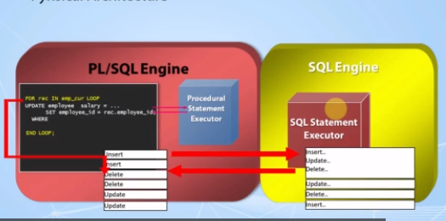

**Logical Architecture**

* **Cooperates with SQL Engine**
  + PL/SQL engine allows us to create, manage and execute SQL and PL/SQL codes and interact with the database
  + If you write an SQL code inside your PL/SQL codes, it will call the SQL engine and have this operation done with SQL engine. Then the result is sent back to the PL/SQL engine. This operation is called as context switches .One engine to another, and the opposite is valid.
* **Enables SubPrograms**
* **Dynamic Queries**
* **Case Insensitivity**
* **Optimizer**
* **Enables Object-Oriented Programming**
* **Web development**

**Lecture 5:What is Pluggable Databases?**

Pluggable database =Multitenant Architecture

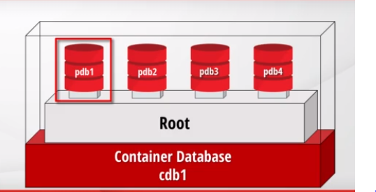

* Container databases does not have it’s objects,tables,etc.CDB store only metadata such as configuration files,etc.
* Pluggable databases have it’s own objects,tables,etc.
* In earlier versions of database,each database should be installed on a separate server.But in companies,there are very small databases used for only some specific jobs.So there is no reason to dedicate another server for such a small database.Besides,each server is a lot of work for the DBAs.To make that easier,oracle updated its architecture now,there are pluggable databases in one container database.

**Lecture 6:The Sample(HR) schema used in this Course**

**What is Schema ?**

* Schemas are the collections of objects for each user in oracle database.

**What is HR Schema?**

* Abbreviation of Human Resources. A Schema that can practice on it.
* A schema can have objects like;
* Tables
* Views
* Triggers
* Constraints

**Lecture 8 : About the Database Installation**

**There are two ways to install database:**

**1.Using virtual box**

**2.using install directly database in a laptop**

**Lecture 9 : The Ways to Get a Database**

We offer 3 options to work with a database

1.Virtual Machine

2.Local Installation

3.Oracle Live SQL

**1.Virtual Machine🡪** To go with this option,we need to install VMware software

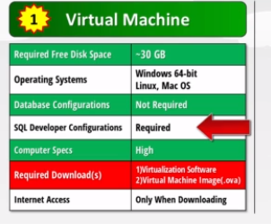

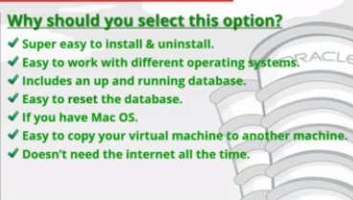

**2.Local Installation**

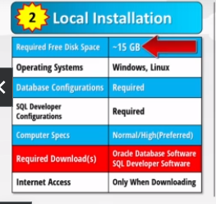

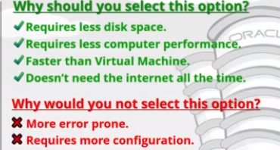

**3.Using Oracle Live SQL**

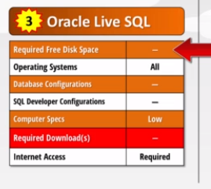

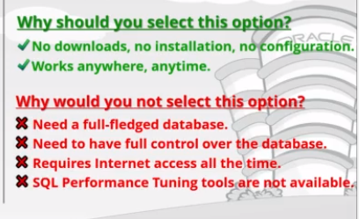

**Lecture 23 : Using Oracle Live SQL**

**Search Oracle LIVE SQL in a browser**

[**https://livesql.oracle.com/apex/f?p=590:1000 (Go**](https://livesql.oracle.com/apex/f?p=590:1000%20(Go) **to this link) and click on start coding button**

**username –** [**shalineemotarwar@gmail.com**](mailto:shalineemotarwar@gmail.com)

**password – Sanket@14**

**Lecture 24 :About Oracle Live SQL Restrictions**

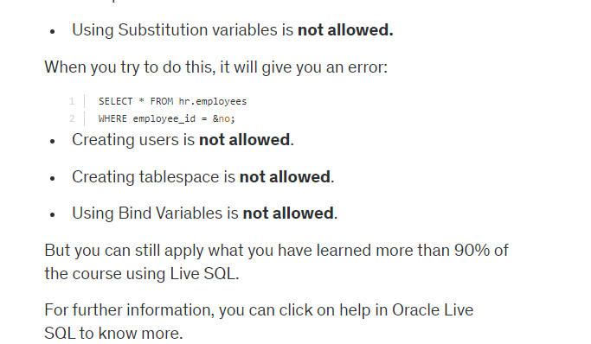

**Lecture 25 :Anonymous Blocks**

1. **Blocks--🡪**

* In PL/SQL programming,you need to write all your code in blocks.
* Blocks are the executable code groups that are inside the “begin end”key words.
* Declare section(optional)
* Begin Section is mandatory
* Exception section is optional
* END;(mandatory)

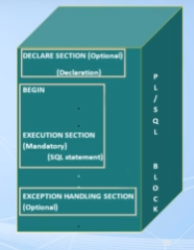

**Create HR schema in SQL developer**

There are 3 types of block

* Anonymous Blocks
* Procedures---🡪it doesn’t return a value
* Functions--🡪it must return a value

**Lecture 26 :PL/SQL Outputs**

1. **Not an output language**
2. **SET SERVEROUTPUT ON**
3. **DBMS_OUTPUT -🡪** It is an oracle’s prebuilt package that can do some output operations

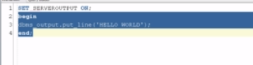

SET Serveroutput on is needed in Oracle SQL developer software

**4.Nested Blocks**

<https://livesql.oracle.com/apex/livesql/s/1e478gzeym455pcj7rbfupg7>

**Lecture 27: What are variables and Why to use them?**

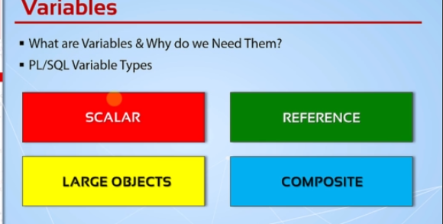

**1.Reference Datatype--🡪This datatypes hold value which point to a storage location**

**2.Large Objects---🡪This are also pointers to other data items that are stored outside of table such as images,files,etc.**

**3.Composite-🡪collections(this datatype can hold more than one value in it).**

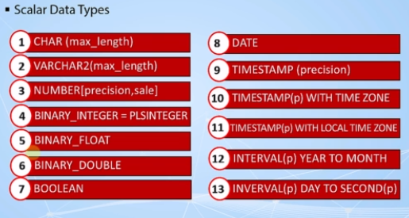

**Lecture 28 : Naming Rules and Naming Conventions**

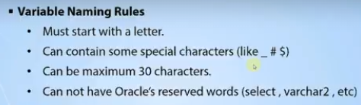

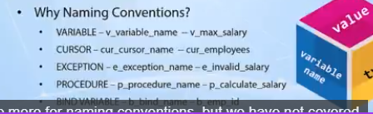

**Lecture 29:Declaring and Initializing & Using Variables Part1**

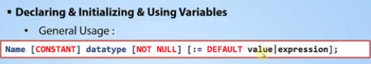

<https://livesql.oracle.com/apex/livesql/s/1e52pzqo7nqemn7o1nq3lkkq>

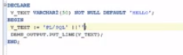

**Lecture 30 : Declaring and Initializing & Using Variables Part2**

Declare

V_number PLS_INTEGER(10,5) NOT NULL :=50.42

BEGIN

DBMS_OUTPUT.put_line(V_number || ‘shalu’);

END;

**Lecture 31 : Declaring and Initializing & Using Variables (Code Samples)**

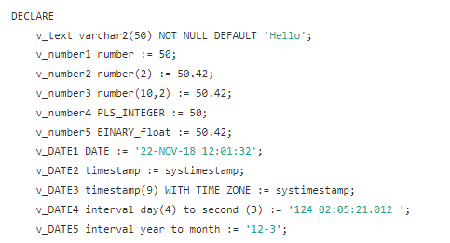

**Lecture 32 : Using % Attribute**

The %TYPE attribute is used to declare variables according to the already declared variable or database column. It is used when you are declaring an individual variable, not a record. The data type and precision of the variable declared using %TYPE attribute is the same as that of the column that is referred from a given table. This is particularly useful when declaring variables that will hold database values. When using the %TYPE keyword, the name of the columns and the table to which the variable will correspond must be known to the user. These are then prefixed with the variable name. If some previously declared variable is referred then prefix that variable name to the %TYPE attribute.

**Syntax:** <var_name> <tab_name>.<column_name>%TYPE;

**Example:**

declare

v_type emp.name%type;

begin

v_type:='shalu';

dbms_output.put_line(v_type) ;

end;

<https://livesql.oracle.com/apex/livesql/s/1iiu4xf1o8ew8qq22vziczi6>

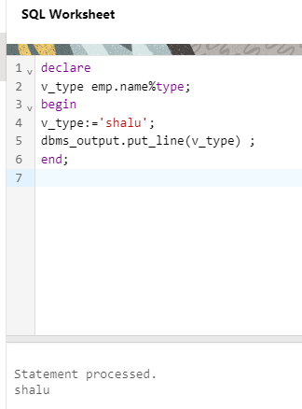

**Lecture 33 : Using %Type Attribute (Code Samples)**

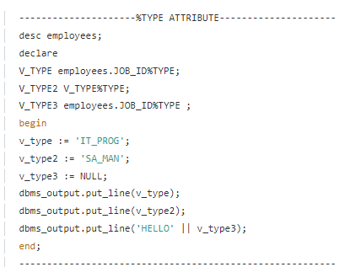

**Lecture 34 :PL/SQL Delimiters and Commenting Your Code**

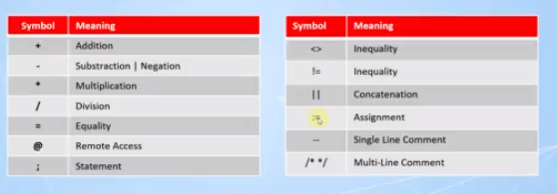

**---(single line comment)**

**/* */ -🡪Multi line comment**

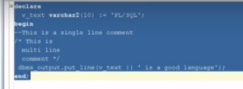

**Lecture 35 :PL/SQL Delimiters and Commenting Your Code(Code Samples)**

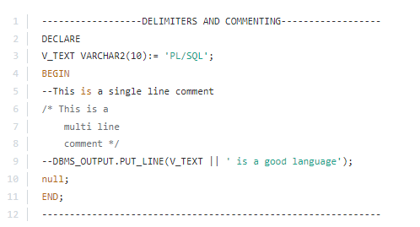

**Lecture 36 :PL/SQL Variable Scope**

1. begin <<outer>>
2. DECLARE
3. --v_outer VARCHAR2(50) := 'Outer Variable!';
4. v_text VARCHAR2(20) := 'Out-text';
5. BEGIN
6. DECLARE
7. v_text VARCHAR2(20) := 'In-text';
8. v_inner VARCHAR2(30) := 'Inner Variable';
9. BEGIN
10. --dbms_output.put_line('inside -> ' || v_outer);
11. --dbms_output.put_line('inside -> ' || v_inner);
12. dbms_output.put_line('inner -> ' || v_text);
13. dbms_output.put_line('outer -> ' || outer.v_text);
14. END;
15. --dbms_output.put_line('inside -> ' || v_inner);
16. --dbms_output.put_line(v_outer);
17. dbms_output.put_line(v_text);
18. END;
19. END outer;

<https://livesql.oracle.com/apex/livesql/s/1izv1v0iomtyb7muw5gsevim>

**Lecture 37 :PL/SQL Variable Scope(Code Samples)**

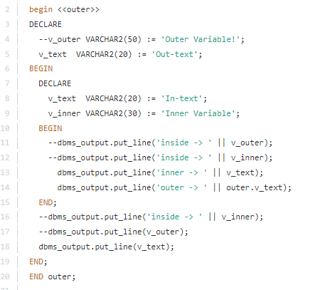

**Lecture 38: Using Bind Variables**

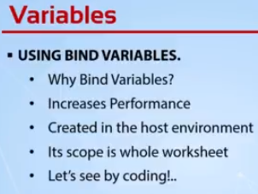

**-🡪We can access bind variables from another block where bind variable is not declared.**

**-🡪We need to call the bind variables explicitly,it’s automatically called during run and it will print the value;**

**-🡪We cannot directly assign the values to a bind variable**

**Syntax for declaration of bind variable:**

Variable var_sql number;////var_sql is the name of bind variable

**Syntax for definition of bind variable:**

var_sql=40;

1. set serveroutput on;
2. set autoprint on;
3. /
4. variable var_text varchar2(30);
5. /
6. variable var_number NUMBER;
7. /
8. variable var_date DATE;
9. /
10. declare
11. v_text varchar2(30);
12. begin
13. :var_text := 'Hello SQL';
14. :var_number := 20;
15. v_text := :var_text;
16. --dbms_output.put_line(v_text);
17. --dbms_output.put_line(:var_text);
18. end;
19. /
20. print var_text;
21. /
22. variable var_sql number;
23. /
24. begin
25. :var_sql := 100;
26. end;
27. /
28. select * from employees where employee_id = :var_sql;
29. /*------------------------BIND VARIABLES--------------------------
30. NOTE: When you run a bind variable creation and SELECT statement
31. together, SQL Developer may return an error but when you execute
32. them separately, there will be no problem.
33. **Lecture 39: Using Bind Variables (Code Samples)**

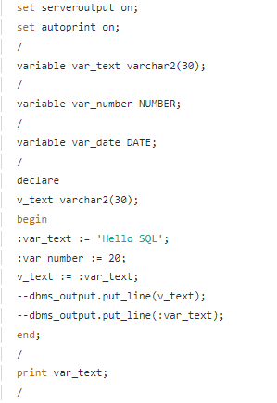

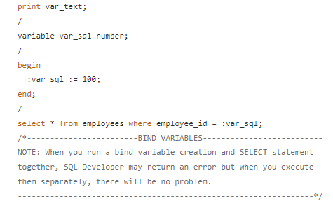

**Lecture 40: What Are Control Structures and If Statements**

**Lecture 41: What Are Control Structures and If Statements ( Code Samples)**

**Lecture 42:Case Expressions**

**Lecture 43:Case Expressions(Code Samples)**

/*************** The Complete PL/SQL Bootcamp ***************

* Author : Oracle Master Training *

* Course : The Complete Oracle PL/SQL Bootcamp *

* Lecture : CASE Expressions *

************************************************************/

/****************** Simple Case Expression ******************/

DECLARE

v_job_code VARCHAR2(10) := 'SA_MAN';

v_salary_increase NUMBER;

BEGIN

v_salary_increase := CASE v_job_code

WHEN 'SA_MAN' THEN 0.2

WHEN 'SA_REP' THEN 0.3

ELSE 0

END;

dbms_output.put_line('Your salary increase is : '|| v_salary_increase);

END;

/************************************************************/

/****************** Searched Case Expression ****************/

DECLARE

v_job_code VARCHAR2(10) := 'IT_PROG';

v_department VARCHAR2(10) := 'IT';

v_salary_increase NUMBER;

BEGIN

v_salary_increase:=CASE

WHEN v_job_code = 'SA_MAN' THEN 0.2

WHEN v_department = 'IT' AND v_job_code = 'IT_PROG' THEN 0.3

ELSE 0

END;

dbms_output.put_line('Your salary increase is : '|| v_salary_increase);

END;

/************************************************************/

/********************* CASE Statements **********************/

DECLARE

v_job_code VARCHAR2(10) := 'IT_PROG';

v_department VARCHAR2(10) := 'IT';

v_salary_increase NUMBER;

BEGIN

CASE

WHEN v_job_code = 'SA_MAN' THEN

v_salary_increase := 0.2;

dbms_output.put_line('The salary increase for a Sales Manager is: '|| v_salary_increase);

WHEN v_department = 'IT' AND v_job_code = 'IT_PROG' THEN

v_salary_increase := 0.2;

dbms_output.put_line('The salary increase for a Sales Manager is: '|| v_salary_increase);

ELSE

v_salary_increase := 0;

dbms_output.put_line('The salary increase for this job code is: '|| v_salary_increase);

END CASE;

END;

/************************************************************/

**Lecture 44: What Are Basic Loops**

**Lecture 45: What Are Basic Loops (Code Samples)**

DECLARE

v_counter NUMBER(2) := 1;

BEGIN

LOOP

dbms_output.put_line('My counter is : '|| v_counter);

v_counter := v_counter + 1;

--IF v_counter = 10 THEN

-- dbms_output.put_line('Now I reached : '|| v_counter);

-- EXIT;

--END IF;

EXIT WHEN v_counter > 10;

END LOOP;

END;

**Lecture 46: While Loops** 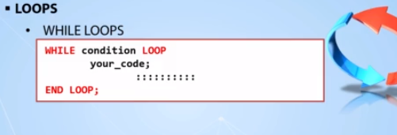

**Lecture 47: While Loops (Code Samples)**

DECLARE

v_counter NUMBER(2) := 1;

BEGIN

WHILE v_counter <= 10 LOOP

dbms_output.put_line('My counter is : '|| v_counter);

v_counter := v_counter + 1;

-- EXIT WHEN v_counter > 3;

END LOOP;

END;

**Lecture 48: For Loops**

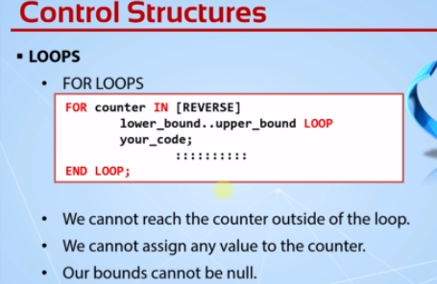

**Lecture 49: For Loops(Code Samples)**

BEGIN

FOR i IN REVERSE 1..3 LOOP

dbms_output.put_line('My counter is : ' || i);

END LOOP;

END;

**Lecture 50: Nested Loops & Loop Labeling**

**Lecture 51: Nested Loops & Loop Labeling(Code Samples)**

DECLARE

v_inner NUMBER := 1;

BEGIN

FOR v_outer IN 1..5 LOOP

dbms_output.put_line('My outer value is : ' || v_outer );

v_inner := 1;

LOOP

v_inner := v_inner+1;

dbms_output.put_line(' My inner value is : ' || v_inner );

EXIT WHEN v_inner * v_outer >= 15;

END LOOP;

END LOOP;

END;

/************************************************************/

/**************** Nested Loops with Labels ******************/

DECLARE

v_inner NUMBER := 1;

BEGIN

<<outer_loop>>

FOR v_outer IN 1..5 LOOP

dbms_output.put_line('My outer value is : ' || v_outer );

v_inner := 1;

<<inner_loop>>

LOOP

v_inner := v_inner+1;

dbms_output.put_line(' My inner value is : ' || v_inner );

EXIT outer_loop WHEN v_inner * v_outer >= 16;

EXIT WHEN v_inner * v_outer >= 15;

END LOOP inner_loop;

END LOOP outer_loop;

END;

/****************/

**Lecture 52: Continue Statement**

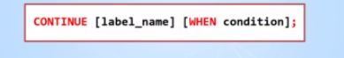

**Lecture 53: Continue Statement(Code Samples)**

DECLARE

v_inner NUMBER := 1;

BEGIN

FOR v_outer IN 1..10 LOOP

dbms_output.put_line('My outer value is : ' || v_outer );

v_inner := 1;

WHILE v_inner * v_outer < 15 LOOP

v_inner := v_inner + 1;

CONTINUE WHEN MOD(v_inner * v_outer,3) = 0;

dbms_output.put_line(' My inner value is : ' || v_inner );

END LOOP;

END LOOP;

END;

**Lecture 54: GOTO Statement**

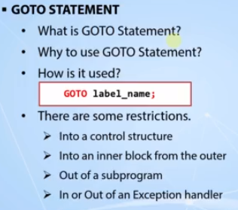

**Lecture 54: GOTO Statement(Code Samples)**

DECLARE

v_searched_number NUMBER := 22;

v_is_prime BOOLEAN := true;

BEGIN

FOR x IN 2..v_searched_number-1 LOOP

IF v_searched_number MOD x = 0 THEN

dbms_output.put_line(v_searched_number|| ' is not a prime number..');

v_is_prime := false;

GOTO end_point;

END IF;

END LOOP;

IF v_is_prime THEN

dbms_output.put_line(v_searched_number|| ' is a prime number..');

END IF;

<<end_point>>

dbms_output.put_line('Check complete..');

END;

/************************************************************/

DECLARE

v_searched_number NUMBER := 32457;

v_is_prime BOOLEAN := TRUE;

x NUMBER := 2;

BEGIN

<<start_point>>

IF v_searched_number MOD x = 0 THEN

dbms_output.put_line(v_searched_number|| ' is not a prime number..');

v_is_prime := FALSE;

GOTO end_point;

END IF;

x := x+1;

IF x = v_searched_number THEN

GOTO prime_point;

END IF;

GOTO start_point;

<<prime_point>>

IF v_is_prime THEN

dbms_output.put_line(v_searched_number || ' is a prime number..');

END IF;

<<end_point>>

dbms_output.put_line('Check complete..');

END;

/************************************************************/

**Lecture 56: Operating with Selected Database data**

Transactions ends with a commit,rollback or a system failure.

**How to use SQL in PL/SQL?**

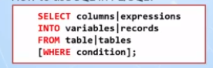

**Lecture 57: Operating with Selected Database data(Code Samples)**

/************************ Example 1 *************************/

DECLARE

v_name VARCHAR2(50);

v_salary employees.salary%type;

BEGIN

SELECT first_name ||' '|| last_name, salary

INTO v_name, v_salary

FROM employees

WHERE employee_id = 130;

dbms_output.put_line('The salary of '|| v_name || ' is : '|| v_salary);

END;

/************************ Example 2 *************************/

DECLARE

v_name VARCHAR2(50);

sysdates employees.hire_date%type;

BEGIN

SELECT first_name ||' '|| last_name, sysdates

INTO v_name, sysdates

FROM employees

WHERE employee_id = 130;

dbms_output.put_line('The salary of '|| v_name || ' is : '|| sysdates);

END;

/************************ Example 3 *************************/

DECLARE

v_name VARCHAR2(50);

v_sysdate employees.hire_date%type;

employee_id employees.employee_id%type := 130;

BEGIN

SELECT first_name ||' '|| last_name, sysdate

INTO v_name, v_sysdate

FROM employees

WHERE employee_id = employee_id;

dbms_output.put_line('The salary of '|| v_name || ' is : '|| v_sysdate );

END;

/************************ Example 4 *************************/

DECLARE

v_name VARCHAR2(50);

v_salary employees.salary%type;

v_employee_id employees.employee_id%type := 130;

BEGIN

SELECT first_name ||' '|| last_name, salary

INTO v_name, v_salary

FROM employees

WHERE employee_id = v_employee_id;

dbms_output.put_line('The salary of '|| v_name || ' is : '|| v_salary );

END;

**Lecture 58: DML Operations in PL/SQL**

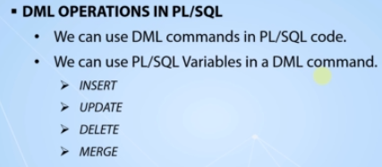

**Lecture 59: DML Operations in PL/SQL(Code Samples)**

**CREATE TABLE employees_copy**

AS SELECT * FROM employees;

DECLARE

v_employee_id PLS_INTEGER := 0;

v_salary_increase NUMBER := 400;

BEGIN

FOR i IN 217..226 LOOP

-- INSERT INTO employees_copy

-- (employee_id, first_name, last_name, email, hire_date, job_id, salary)

-- VALUES

-- (i, 'employee#'||i,'temp_emp','abc@xmail.com',sysdate,'IT_PROG',1000);

-- UPDATE employees_copy

-- SET salary = salary + v_salary_increase

-- WHERE employee_id = i;

DELETE FROM employees_copy

WHERE employee_id = i;

END LOOP;

END;

**Lecture 60: Using Sequences in PL/SQL**

CREATE SEQUENCE employee_id_seq

START WITH 207

INCREMENT BY 1;

/************************ Example 1 *************************/

BEGIN

FOR i IN 1..10 LOOP

INSERT INTO employees_copy

(employee_id,first_name,last_name,email,hire_date,job_id,salary)

VALUES

(employee_id_seq.nextval,'employee#'||employee_id_seq.nextval,'temp_emp','abc@xmail.com',sysdate,'IT_PROG',1000);

END LOOP;

END;

/************************ Example 2 *************************/

DECLARE

v_seq_num NUMBER;

BEGIN

SELECT employee_id_seq.nextval

INTO v_seq_num

FROM dual;

dbms_output.put_line(v_seq_num);

END;

/************************ Example 3 *************************/

DECLARE

v_seq_num NUMBER;

BEGIN

SELECT employee_id_seq.nextval

INTO v_seq_num

FROM employees_copy

WHERE rownum = 1;

dbms_output.put_line(v_seq_num);

END;

/************************ Example 4 *************************/

DECLARE

v_seq_num NUMBER;

BEGIN

v_seq_num := employee_id_seq.nextval;

dbms_output.put_line(v_seq_num);

END;

/************************ Example 5 *************************/

BEGIN

dbms_output.put_line(employee_id_seq.nextval);

END;

/************************ Example 6 *************************/

BEGIN

dbms_output.put_line(employee_id_seq.currval);

END;

**Lecture 62: Extra – Enabling Server Outputs by Default**

**Lecture 63: Simple Data Types vs Composite Data Types**

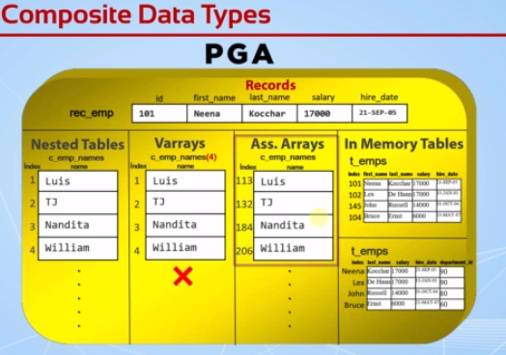

**Nested Tables-🡪**We can add indexes dynamically according to the need.We don’t need to declare it’s size.and the indexes starts from 1.

**Varrays🡪** We can’ add indexes dynamically according to the need.We need to declare it’s size.and the indexes starts from 1

**Ass.Arrays🡪** We can add indexes dynamically according to the need.We don’t need to declare it’s size.and the indexes starts from any number and indexes can be a negative number also.

**Collections-🡪** Nested Tables,Varrays,Ass.Arrays,In Memory Tables

**Lecture 64:PL/SQL Records – Part1**

**We can store a whole row in a record.All the variables stored in a record are related to each other.We can add one record inside a another record.By default all the variables in a record are null.**

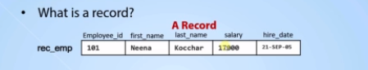

**We get all of the column’s types of a row into one record in one step. Using %rowtype**

**Syntax:**

**Way 1: record_name table_name%rowtype;**

**Example:**

DECLARE

r_emp employees%rowtype;

BEGIN

SELECT * INTO r_emp

FROM employees

WHERE employee_id = '101';

--r_emp.salary := 2000;

dbms_output.put_line(r_emp.first_name || ' ' || r_emp.last_name || ' earns '|| r_emp.salary || ' and hired at : ' || r_emp.hire_date);

end;

**Way 2:**

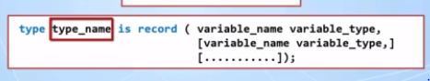

**Example:**

DECLARE

--r_emp employees%rowtype;

type t_emp IS RECORD (first_name VARCHAR2(50), last_name employees.last_name%TYPE, salary employees.salary%TYPE, hire_date DATE);

r_emp t_emp;

BEGIN

SELECT first_name,last_name,salary,hire_date INTO r_emp

FROM employees WHERE employee_id = '101';

dbms_output.put_line(r_emp.first_name || ' ' || r_emp.last_name || ' earns ' || r_emp.salary || ' and hired at : ' || r_emp.hire_date);

END;



Every Record can get only one level.

**Lecture 65:PL/SQL Records – Part2**

DECLARE

TYPE t_edu is RECORD(primary_school VARCHAR2(100),

high_school VARCHAR2(100),

university VARCHAR2(100),

uni_graduate_date DATE

);

TYPE t_emp IS RECORD(first_name VARCHAR2(50),

last_name employees.last_name%type,

salary employees.salary%type NOT NULL DEFAULT 1000,

hire_date DATE,

dept_id employees.department_id%type,

department departments%rowtype,

education t_edu

);

r_emp t_emp;

BEGIN

SELECT first_name, last_name, salary, hire_date, department_id

INTO r_emp.first_name, r_emp.last_name, r_emp.salary, r_emp.hire_date, r_emp.dept_id

FROM employees where employee_id = '146';

SELECT *

INTO r_emp.department

FROM departments

WHERE department_id = r_emp.dept_id;

r_emp.education.high_school := 'Beverly Hills';

r_emp.education.university := 'Oxford';

r_emp.education.uni_graduate_date := '01-JAN-13';

dbms_output.put_line(r_emp.first_name || ' ' ||

r_emp.last_name || ' earns ' ||

r_emp.salary || ' and hired at : ' ||

r_emp.hire_date);

dbms_output.put_line('She graduated from ' ||

r_emp.education.university ||

' at ' ||

r_emp.education.uni_graduate_date);

dbms_output.put_line('Her Department Name is : '|| r_emp.department.department_name);

END;

/************************************************************/