**Deliverable/Expectation:**

**Documentation: A brief write-up about solution explaining assumption, approach, metrics, and other artifacts all are explained below.**

**Documentation about Model:**

* **Model name:**

Object detection using YOLOV5

* **Links to dataset and framework:**

Dataset link:

https://evp-ml-data.s3.us-east-2.amazonaws.com/ml-interview/openimages-personcar/trainval.tar.gz

* **About the model:**

YOLO an acronym for 'You only look once', is an object detection algorithm that divides images into a grid system. Each cell in the grid is responsible for detecting objects within itself. YOLO is one of the most famous object detection algorithms due to its speed and accuracy. **YoloV5** is used to train the model.

* **Primary Analysis:**

Training a model to detect two objects that is car and person in an image.

* **Assumptions:**

The distribution is balanced. If there are very less number of bounding boxes for any class, then it will not produce a very accurate model.

The bounding boxes are drawn with a consistent pattern, i.e., the padding for each box drawn is same when scaled.

* **Inference:**

After training following is the report obtained from evaluation on

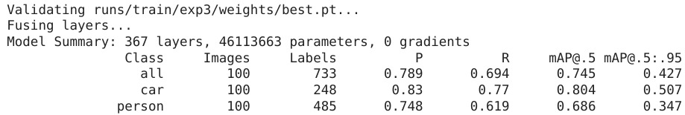

* **False positives:**

1.False positives can definitely be improved with further training.

2.The following image represents the image status is the status obtained on the

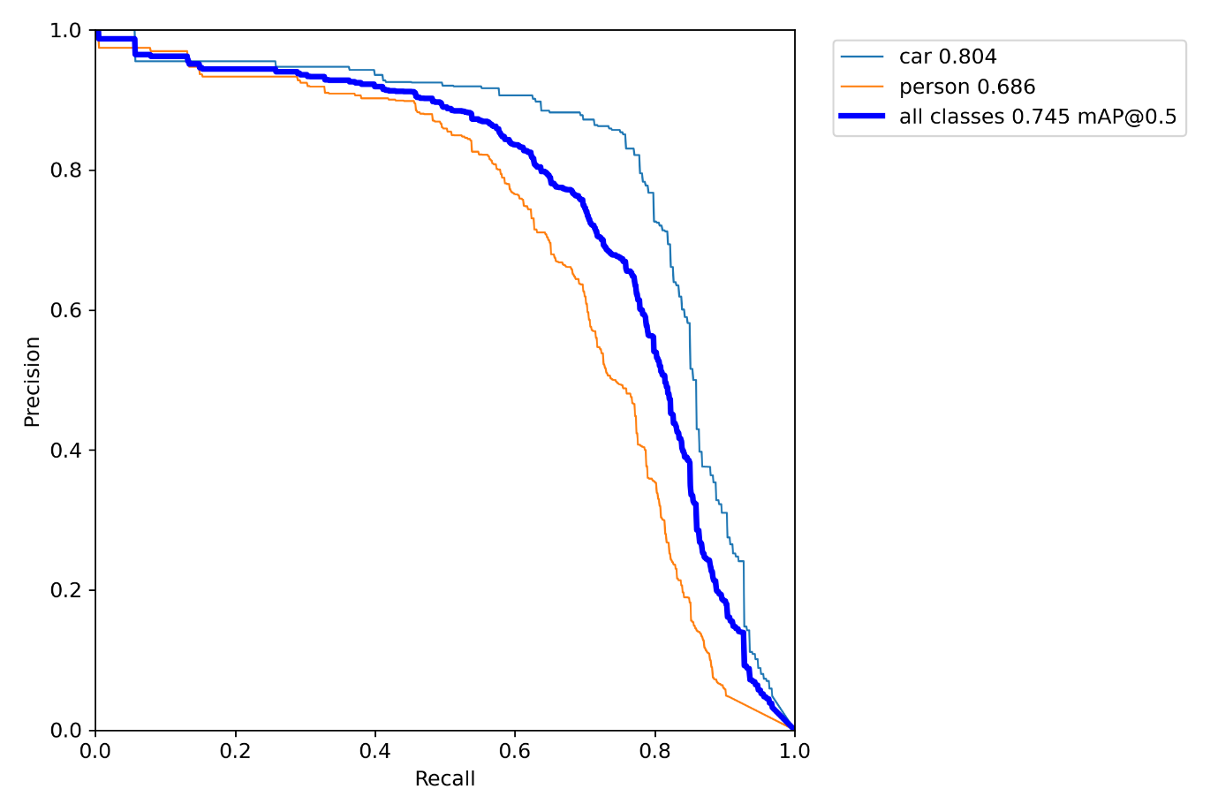

* **Conclusion:**

The IoU threshold was set as 0.5 as the model was trained for a very small amount of time, and mAP of 74.5% was achieved

* **Recommendations:**

To achieve a robust **YOLOv5 model**, it is **recommended** to train with over 1500 images per class, and more than 10,000 instances per class.