**DATA STRUCTURES LAB**

**LAB TASK – 3**

**PROGRAM – 1**

**#include <stdio.h>**

**int main()**

**{**

**int n;**

**printf("enter the size of an array:");**

**scanf("%d",&n);**

**int arr[n];**

**printf("\nenter the elements of the array:\n");**

**for(int i=0;i<n;i++)**

**{**

**scanf("%d",&arr[i]);**

**}**

**int ele;**

**printf("enter ele:");**

**scanf("%d",&ele);**

**int temp=0;**

**for(int i=0;i<n;i++)**

**{**

**if(arr[i]==ele)**

**{**

**printf("successful search: \n%d is present at location %d.",ele,i+1);**

**temp=1;**

**break;**

**}**

**}**

**if(temp!=1)**

**{**

**printf("unsuccessful search: \n%d is not present in the array.",ele);**

**}**

**return 0;**

**}**

**OUTPUT :**

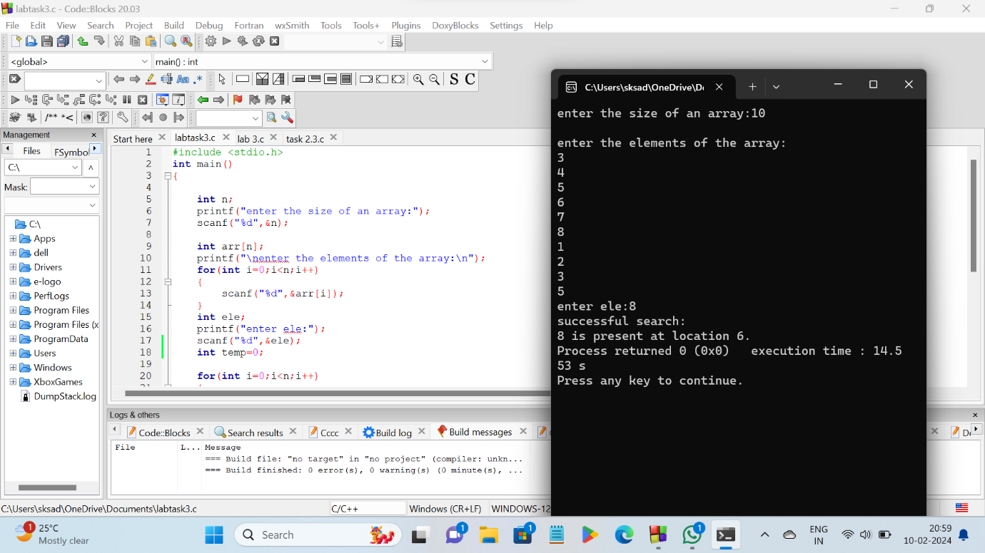

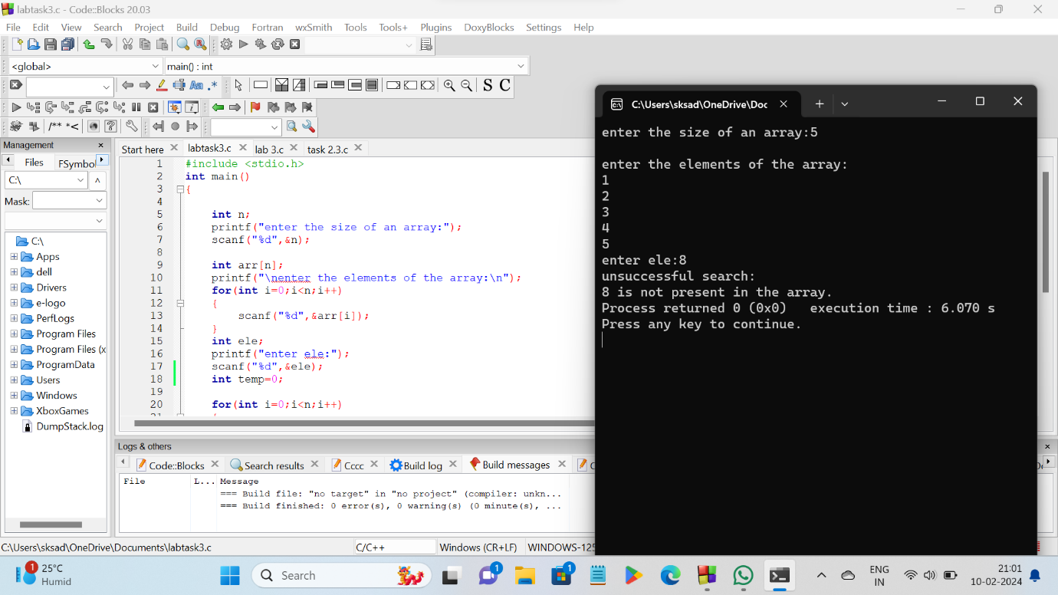

**PROGRAM – 2**

**#include <stdio.h>**

**int main()**

**{**

**int n;**

**printf("enter the size of an array:");**

**scanf("%d",&n);**

**int arr[n];**

**printf("\nenter the elements of the array:\n");**

**for(int i=0;i<n;i++)**

**{**

**scanf("%d",&arr[i]);**

**}**

**int ele;**

**printf("enter key element: ");**

**scanf("%d",&ele);**

**int low,high,mid;**

**low=0;**

**high=n-1;**

**mid=(low+high)/2;**

**while(low<=high)**

**{**

**if(arr[mid]<ele)**

**{**

**low=mid+1;**

**mid=(low+high)/2;**

**}**

**else if(arr[mid]==ele)**

**{**

**printf("key element %d is found at location %d",ele,mid+1);**

**break;**

**}**

**else{**

**high=mid-1;**

**mid=(low+high)/2;**

**}**

**}**

**if(low>high)**

**printf("key element is not found in the array");**

**return 0;**

**}**

**OUTPUT :**

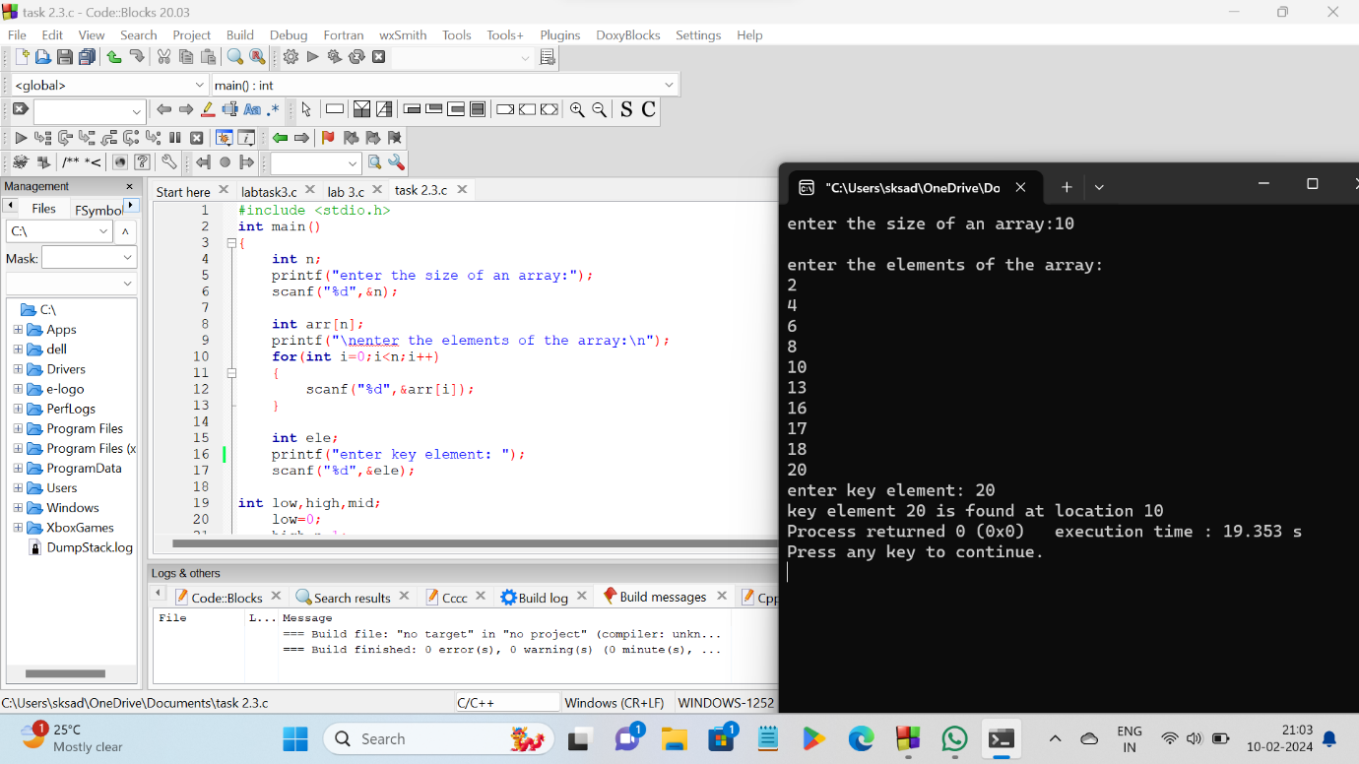

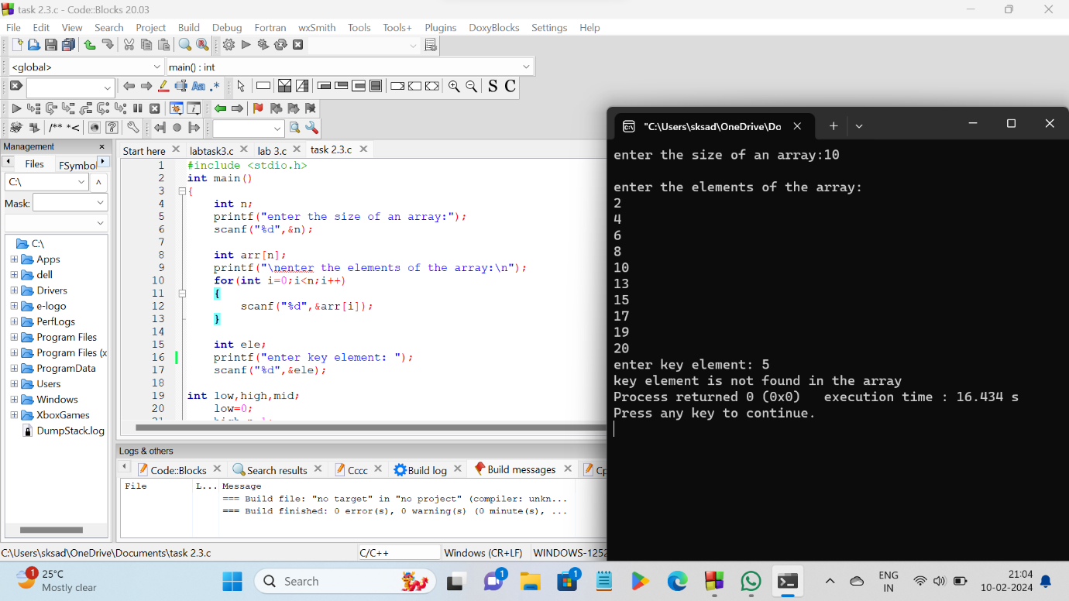

**\*\*\*\*\*THE END\*\*\*\*\***