Industrial Internship Report
Project: Forecasting of Smart City Traffic Patterns
Prepared by: Shalini Kumari
College: IILM University, Greater Noida
Course: B.Tech CSE (Specialization in Data Science)
Semester: Fourth Semester
Internship: upSkill Campus & UniConverge Technologies Pvt. Ltd. (UCT)
Duration: One Month

Executive Summary
This report documents the successful completion of Project 9: Forecasting of Smart City Traffic Patterns. The objective was to analyze historical traffic data, build a machine learning model, evaluate its performance, save the trained model, and develop a simple prediction program. The project demonstrates an end-to-end machine learning workflow using Python.

Table of Contents
1. Preface
2. Introduction
3. About UCT
4. About upSkill Campus
5. Objectives
6. Problem Statement
7. Existing & Proposed Solution
8. Dataset
9. Tools & Technologies
10. Project Workflow
11. Implementation (12 Steps)
12. Performance Test
13. Results
14. Challenges
15. Learnings
16. Future Scope
17. References
18. GitHub Links

Preface
This internship provided practical exposure to solving an industry-oriented machine learning problem. It improved my understanding of data preprocessing, visualization, model training, evaluation, model deployment and technical documentation.

Introduction
Smart city traffic management is an important application of data science. Predicting traffic enables authorities to plan road infrastructure and reduce congestion.

About UniConverge Technologies (UCT)
UCT works in Digital Transformation, IoT, Artificial Intelligence, Cloud Computing and Smart City solutions. The internship project is based on an industry-inspired problem statement.

About upSkill Campus
upSkill Campus provides project-based learning and industrial internships to bridge the gap between academics and industry.

Objectives
• Understand the dataset.
• Preprocess traffic data.
• Train a forecasting model.
• Evaluate model performance.
• Save the trained model.
• Build a prediction system.

Problem Statement
Forecast traffic patterns at different city junctions using historical traffic data to support better traffic management and infrastructure planning.

Existing & Proposed Solution
Existing traffic planning methods rely heavily on manual observation and historical reports. The proposed solution automates traffic forecasting using machine learning with Python, pandas, scikit-learn, matplotlib and seaborn.

Dataset
Training Dataset: train_aWnotuB.csv
Testing Dataset: datasets_8494_11879_test_BdBKKAj.csv
The training data was used to build the model while the test data is reserved for evaluation and future prediction.

Tools & Technologies
Python, VS Code, pandas, NumPy, matplotlib, seaborn, scikit-learn, pickle.

Project Workflow
Load Dataset → Explore Data → Preprocess → Train Model → Heatmap → Prediction → Evaluation → Future Prediction → Visualization → Save Model → User Input → Final Prediction.

Implementation (12 Steps)
Step 1: Load Dataset
Step 2: Explore Dataset
Step 3: Data Preprocessing
Step 4: Train Machine Learning Model
Step 5: Generate Heatmap
Step 6: Prediction
Step 7: Model Evaluation
Step 8: Future Prediction
Step 9: Visualization
Step 10: Save Model (traffic_model.pkl)
Step 11: User Input Program
Step 12: Final Prediction Program
Insert screenshots for important steps in this section.

Performance Test
The trained model was saved successfully and reloaded using traffic_model.pkl. The final program accepted Junction Number and ID as input and generated traffic predictions successfully.

Results
The project successfully demonstrated end-to-end traffic prediction using a trained machine learning model.

Challenges Faced
Handling dataset preprocessing, file paths, saving/loading the model, and debugging Python code during implementation.

My Learnings
Learned Python programming, machine learning workflow, feature preparation, visualization, debugging, project organization, GitHub workflow, and technical report writing.

Future Scope
Use advanced time-series models, integrate live traffic APIs, include weather and holiday information, and deploy the model as a web application.

References
1. UCT Internship Project Statement
2. upSkill Campus
3. Kaggle Dataset
4. Python Documentation
5. scikit-learn Documentation

GitHub Links
Code Repository: https://github.com/shalini05gupta11-cmd/Smart-City-Traffic-Pattern
Project Report:

Screenshots
• Heatmap
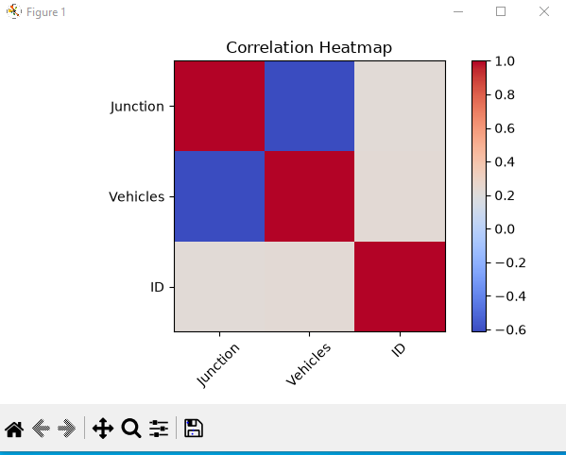
• Visualization
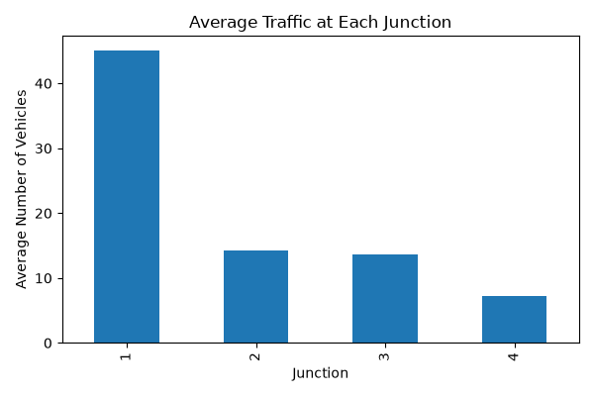
• Model Saved
• Final Prediction Output
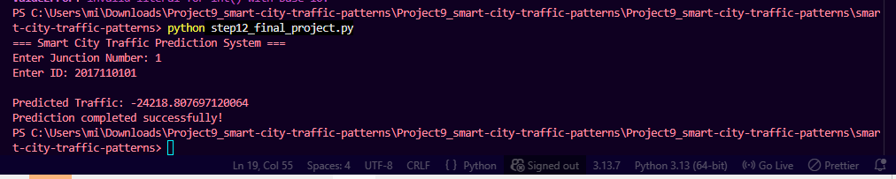
• VS Code Project

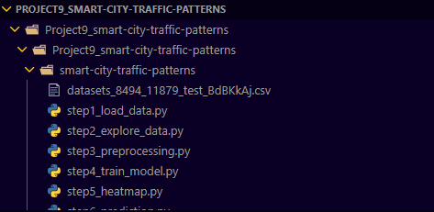
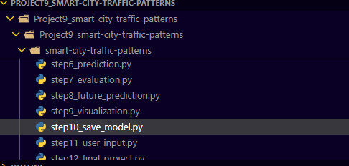
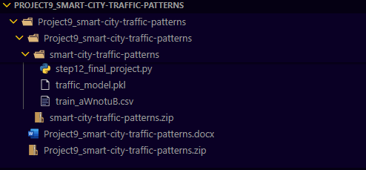
• Terminal Output
