<https://www.mysqltutorial.org/mysql-string-functions/>

# constraint

1. create table supplier(suppid int PRIMARY key AUTO_INCREMENT,

suppname varchar(50) not null,

status int DEFAULT 0,

city varchar(50));

1. alter table supplier modify city varchar(50) not null;
2. INSERT INTO supplier(suppname, city) values('Haldiram','Nagpur');
3. alter table shipment add CONSTRAINT FOREIGN key (itemno) REFERENCES item(itemno);
4. create TABLE shipment (id int PRIMARY KEY,

itemno int,

suppid int,

qty int,

FOREIGN KEY(itemno) REFERENCES item(itemno),

FOREIGN KEY(suppid) REFERENCES supplier(suppid)

);

create table employee(eid int PRIMARY key AUTO_INCREMENT,

ename varchar(50) not null,

phone varchar(20) UNIQUE,

city varchar(50) not null,

country varchar(50) DEFAULT 'India',

email varchar(50) not null UNIQUE);

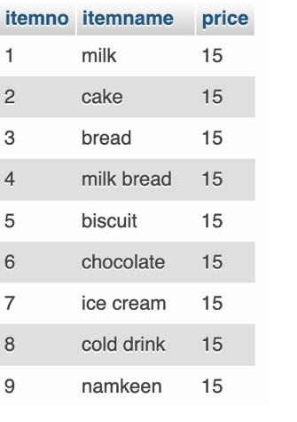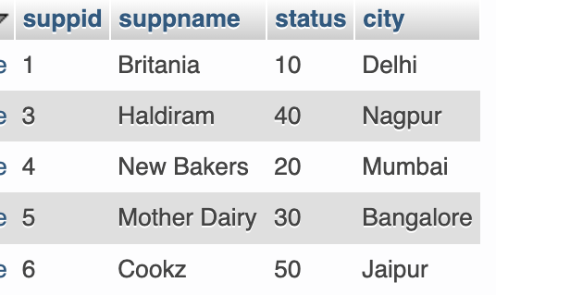

SELECT QUERIES

1. PROJECTION : fetch data for specific columns  
   select ename from employee;
2. after as keyword give the alias name. If alias name is more than 1 word then wrap it within quotes  
   select email as 'Email Id', ename as Name from employee;
3. To get those employees name whose phone is not null  
   select ename, phone from employee WHERE phone is NOT null;
4. To get those employees whose phone is null  
   select ename, phone from employee WHERE phone is null;
5. Get movie title for all the movies directed by director id 1
6. To not get duplicate values for column city  
   SELECT DISTINCT city from supplier
7. Mathematical operations with select  
   SELECT 1+2 as 'Addition of 1 and 2';
8. To get the current date  
   SELECT curdate();
9. To substitute for null value us ifnull  
   select ifnull(phone,'NOT PROVIDED') , ename , email from employee;

HR_DATA provided by GL

1. # put text in query output

select employee_id ,'gets',salary,'/-' from emp_payment;

RELATIONAL OPERATORS

<, >, <=, >=, =, <>

1. Get employee data for salary >= 20000  
   SELECT first_name, email, salary FROM `employees` WHERE salary>=20000;
2. SELECT first_name, email, salary, department_id FROM `employees` WHERE department_id <>50;

LOGICAL OPERATOR

OR AND NOT

1. SELECT first_name, email, salary FROM `employees` WHERE salary>=20000 && salary <= 30000;  
   SELECT first_name, email, salary FROM `employees` WHERE salary>=20000 and salary <= 30000;
2. SELECT first_name, email,job_id, salary FROM `employees` WHERE job_id = 'AD_VP' and salary >20000;

BETWEEN

1. SELECT first_name, email, salary FROM `employees` WHERE salary BETWEEN 20000 and 30000;

IN – condition based on a list

1. SELECT cust_name, city FROM `customer` WHERE city In ('Mumbai','Delhi')
2. List firstname and last name of all the employess whose manager id is 1, 6 and 52

PATTERN MATCHING

1. % matches any substring
2. _ matches any character
3. LIKE
4. Customer info whose name starts with r  
   SELECT * FROM `customer` WHERE cust_name LIKE 'r%';
5. Customer info whose email ends with techgatha.com  
   SELECT email, customer_id FROM `customer` WHERE email LIKE '%techgatha.com';
6. Customer info whose email contains the word test  
   SELECT email, customer_id FROM `customer` WHERE email LIKE '%test%';
7. Escape sequence this is \   
   SELECT customer_id, email FROM `customer` WHERE email LIKE '%\_%'
8. Display all employee details whose job id ends with ‘MGR’

**Regular expressions – pattern matching [ FYI ]**

<https://dev.mysql.com/doc/refman/8.0/en/regexp.html>

1. Character classes
   1. ^ - starts with
   2. $ - ends with
2. Quantifiers ->
   1. ? – 0 or one
   2. *
   3. +
3. Customer info whose gst starts with any alphabet only  
   SELECT email, gst FROM `customer` WHERE gst REGEXP '^[a-zA-Z]'
4. Customer info whose name starts with R or P  
   SELECT cust_name FROM `customer` WHERE cust_name REGEXP '^[RP]'
5. Customer info whose gst starts with digits only  
   SELECT cust_name, gst FROM `customer` WHERE gst REGEXP '^[0-9]'
6. Match the string that has exactly 0 or 1 occurrence of u

SELECT 'color' REGEXP 'colou?r'; -> 1

SELECT 'colour' REGEXP 'colou?r'; -> 1

SELECT 'colouur' REGEXP 'colou?r'; -> 0  
#SELECT 'color' REGEXP 'colou?r';

#SELECT 'colouur' REGEXP 'colou*r';

#SELECT 'color' REGEXP 'colou*r';

#SELECT 'colouur' REGEXP 'colou+r';

SELECT 'color' REGEXP 'colou+r';

ORDER BY CLAUSE

Sorting in asc or desc order

Default is ascending

SELECT cust_name, city FROM `customer` order BY city

For descending order

SELECT cust_name, city FROM `customer` order BY city desc  
  
SELECT city, cust_name FROM `customer` ORDER BY city, cust_name  
  
select city, cust_name from customer order by city;  
  
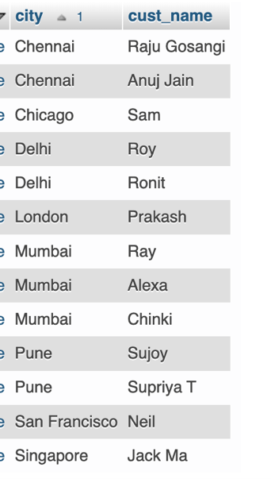 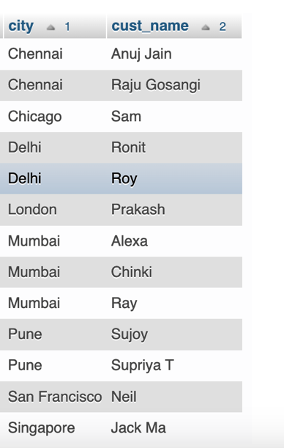

select city, cust_name from customer order by city, cust_name;

STRING FUNCTIONS

<https://dev.mysql.com/doc/refman/8.0/en/string-functions.html>

1. Concat  
   SELECT concat(cust_name,' ',customer_id) as Name from customer;

If gst is null replace with the text 'NO GST'  
SELECT email , concat(cust_name,' ',ifnull(gst,'NO GST')) as Name from customer;  
  
If gst is null replace with the text empty space else the value for gst  
  
SELECT email , concat(cust_name,' ',if(gst is null,'',gst)) as Name from customer;

1. Concat_ws : concatenate with separator  
   SELECT email , concat_ws(',',cust_name, if(gst is null,'NO GST',gst)) as Name from customer;
2. length  
   SELECT cust_name, length(cust_name) as 'NO OF CHARACTERS' FROM customer
3. substring_index(str, delimeter, n)  
   Returns a part of string before the 2nd occurrence of ‘,’  
   SELECT substring_index('shalini,mittal,mumbai,12312323',',',2);
4. replace  
   SELECT replace('shalini mittal,mumbai,12312323','mittal','gupta');
5. how many characters from the right or left  
   SELECT right('shalini mittal',7);  
   SELECT left('shalini mittal',3);
6. trim, ltrim, rtrim  
   SELECT ltrim(' shalini mittal ');
7. repeat  
   SELECT repeat('*',3);
8. substring : index of a string starts from 1  
   SELECT substring('sky is blue', 5);  
   start from index 5 and return 2 character  
   SELECT substring('sky is blue', 5, 2);

AGGREGATE FUNCTIONS

1. count -> returns number of records in a table

select count(*) as count,

sum(price) as sum,

min(price) as min,

max(price) as max,

avg(price) as avg

from item;

GROUP BY clause

Groups a set of rows and give a summary of the same.

It returns 1 row for each group

Used in conjunction with aggregate functions

Returns the number of customers in every city

SELECT count(city), city from customer group by city;

#display the total amount of purchase made by each customer

select customer_id, sum(order_total) from order_table GROUP BY customer_id;

JOINS

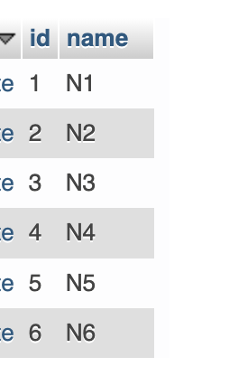  
Join is used to fetch data from more than 1 tables

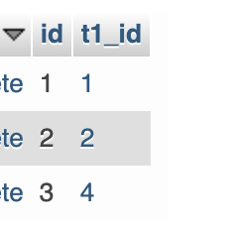

Assume table t1 and t2

1. cartesian product / cartesian join - all possible combination from both the table  
   row1 of t1 * all rows of t2  
   row2 of t1 * all rows of t2
2. inner join / equi join-> common between t1 and t2  
     
   SELECT * FROM t1, t2 where t1.id = t2.t1_id; // cannot use ON with comma separated list of tables  
   SELECT * FROM t1 JOIN t2 where t1.id = t2.t1_id;  
   SELECT * FROM t1 JOIN t2 ON t1.id = t2.t1_id;  
     
   To get specific columns from two tables. Below query gives ambiguous error as id is a common column name in both t1 and t2. Hence need to specify the table from which to pick the data for that column  
   SELECT id, name FROM t2,t1 WHERE t1.id = t2.t1_id;

Below does resolves previous issue as t1_id is only one of the table  
SELECT t1_id, name FROM t2,t1 WHERE t2.t1_id = t1.id;

Alternatively use the table name to specify column of which table for ambigous column names  
SELECT t1.id, name FROM t2,t1 WHERE t2.t1_id = t1.id;

Can also create aliases for table names  
SELECT b.id, name FROM t2 as a,t1 b WHERE a.t1_id = b.id;

1. left join -> t1 join t2  
    all data of t1 and common between t1 and t2  
     
   SELECT a.id as 'T1 ID',name, b.id as 'T2 ID', t1_id as 'FK OF T1'

from

t1 a

LEFT JOIN

t2 b

ON a.id = b.t1_id

1. right join-> t1 join t2  
    all data of t2 and common between t1 and t2  
     
   SELECT a.id as 'T1 ID',name, b.id as 'T2 ID', t1_id as 'FK OF T1'

from

t1 a

RIGHT JOIN

t2 b

ON a.id = b.t1_id

1. full join -> common and uncommon between t1 and t2

SELECT a.id as 'T1 ID',name, b.id as 'T2 ID', t1_id as 'FK OF T1'

from

t1 a

LEFT JOIN

t2 b

ON a.id = b.t1_id

UNION

SELECT a.id as 'T1 ID',name, b.id as 'T2 ID', t1_id as 'FK OF T1'

from

t1 a

RIGHT JOIN

t2 b

ON a.id = b.t1_id

Student and course table

1. Get course name , course fee , email, phone from course and student  
   select course_name, course_fee, email, phone from courses c, student s  
   where c.course_id = s.selected_course

SUBQUERIES

1. Get names of courses for which students have registered

select DISTINCT Course_name from courses t1, student t2

where t1.course_id=t2.selected_course;

OR

get the names of course for which students have registered

SELECT course_name

from courses where course_id IN

(SELECT DISTINCT selected_course from student);

1. get the names of course for which students have not registered

SELECT course_name

from courses where course_id NOT IN

(SELECT DISTINCT selected_course from student); # [1,2,3]

HAVING CLAUSE

Is used to apply conditions along with the group by clause

1. count of students joined from different sources  
   SELECT COUNT(source_of_joining) , source_of_joining

from student

GROUP by source_of_joining

1. count of students joined from different sources where count is <=5  
   SELECT COUNT(source_of_joining) , source_of_joining

from student

GROUP by source_of_joining

HAVING COUNT(source_of_joining) <=5

1. filter by location

SELECT COUNT(source_of_joining) as total , source_of_joining, location

from student

where LOCAtion ='Delhi'

GROUP by source_of_joining

HAVING total <=5