# constraint

1. create table supplier(suppid int PRIMARY key AUTO_INCREMENT,

suppname varchar(50) not null,

status int DEFAULT 0,

city varchar(50));

1. alter table supplier modify city varchar(50) not null;
2. INSERT INTO supplier(suppname, city) values('Haldiram','Nagpur');
3. alter table shipment add CONSTRAINT FOREIGN key (itemno) REFERENCES item(itemno);
4. create TABLE shipment (id int PRIMARY KEY,

itemno int,

suppid int,

qty int,

FOREIGN KEY(itemno) REFERENCES item(itemno),

FOREIGN KEY(suppid) REFERENCES supplier(suppid)

);

create table employee(eid int PRIMARY key AUTO_INCREMENT,

ename varchar(50) not null,

phone varchar(20) UNIQUE,

city varchar(50) not null,

country varchar(50) DEFAULT 'India',

email varchar(50) not null UNIQUE);

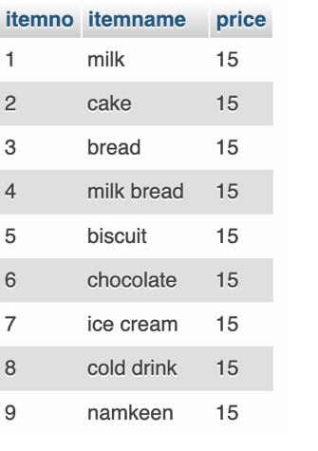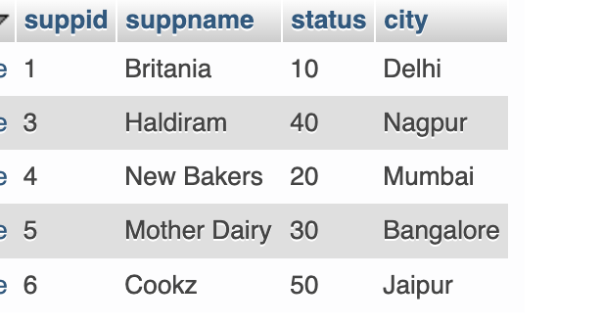

SELECT QUERIES

1. PROJECTION : fetch data for specific columns  
   select ename from employee;
2. after as keyword give the alias name. If alias name is more than 1 word then wrap it within quotes  
   select email as 'Email Id', ename as Name from employee;
3. To get those employees name whose phone is not null  
   select ename, phone from employee WHERE phone is NOT null;
4. To get those employees whose phone is null  
   select ename, phone from employee WHERE phone is null;
5. Get movie title for all the movies directed by director id 1
6. To not get duplicate values for column city  
   SELECT DISTINCT city from supplier
7. Mathematical operations with select  
   SELECT 1+2 as 'Addition of 1 and 2';
8. To get the current date  
   SELECT curdate();
9. To substitute for null value us ifnull  
   select ifnull(phone,'NOT PROVIDED') , ename , email from employee;