Healthy Bites- HTML Live Lab 3

### Use Case:

It’s said, health is the first thing that should be taken care of. Take care of health with proper exercise and diet. Need to create a website that provides with information on health.

The assignments in this lab are divided in 5 sections starting from easy to difficult level taking you through the process of creating a website for online book store.

NOTE:

Can change the color and styles or can choose your own images

### Lab Name: Assignment 1

### Content Mapping: HTML Class Attribute, HTML ID Attribute, HTML - The Head Element, HTML Meta, HTML Semantic Elements, HTML Entities

### Learning Pre-requisites:

- Tags: Anchor, header, div, h1

- HTML Entities, Css Codes

- margin, padding, colors, fonts

### Env Needed:

VSCode, Google Chrome

### Asset Needed: Images

### Difficulty: Easy

### Duration: 10 Minutes

Input:

- Use HTML tags header to create the menu links within. Keep heading on left and call icon on left.

- Place the links below the heading and add some margin between links

- Create index.html, services.html, contact.html and about.html as follows:

Output:

Index.html

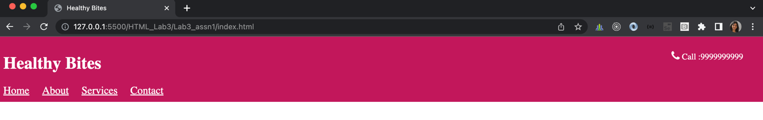

About.html

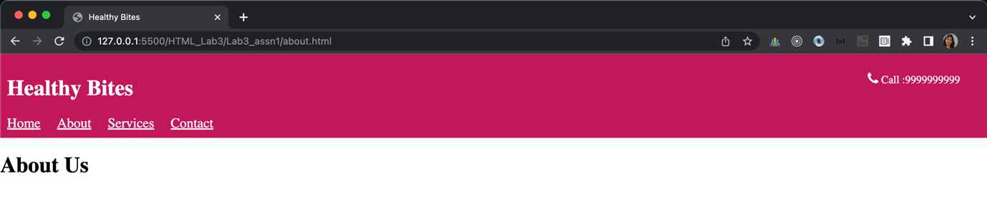

Services.html

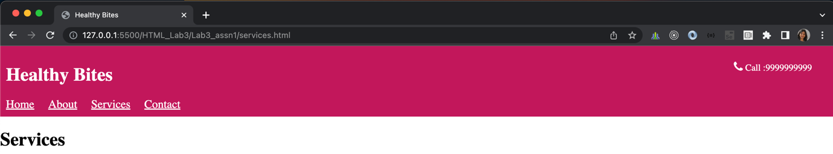

Contact.html

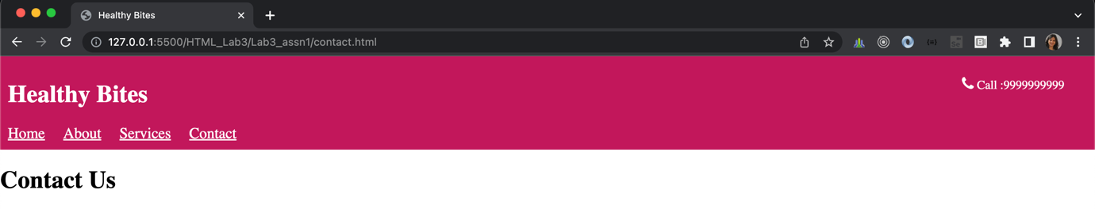

### Lab Name: Assignment 2

### Content Mapping: HTML Class Attribute, HTML ID Attribute, HTML - The Head Element, HTML Meta, HTML Semantic Elements, HTML Entities, HTML iframe

### Learning Pre-requisites:

- Tags: Anchor, header, div, h1, details

- HTML Entities, Css Codes

- margin, padding, colors, fonts

- Iframe

### Env Needed:

VSCode, Google Chrome

### Asset Needed: Images

### Difficulty: Easy

### Duration: 10 Minutes

Input:

- Add an iframe in the home page and display a default wiki page

- Create details tag. When click on details dropdown, it allows to click on links to learn about importance of nutrition

Output –

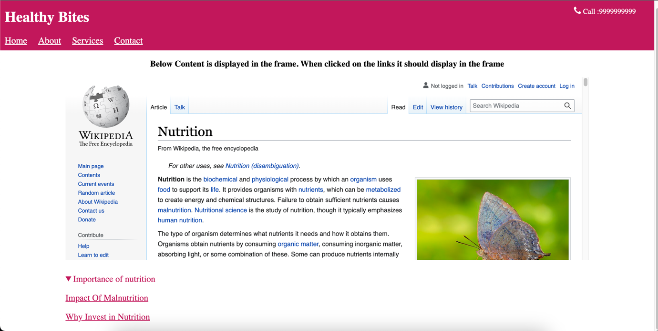

### Lab Name: Assignment 3

### Content Mapping: HTML Class Attribute, HTML ID Attribute, HTML - The Head Element, HTML Meta, HTML Semantic Elements, HTML Entities, HTML iframe, HTML Canvas, SVG, Audio, Video

### Learning Pre-requisites:

- Tags: footer

- margin, padding, colors, fonts

- canvas, svg, audio, video

### Env Needed:

VSCode, Google Chrome

### Asset Needed: Images

### Difficulty: Medium

### Duration: 20 Minutes

Input:

- Update the index.html page to add footer using footer tag. Draw the rectangle using canvas and draw circle using svg.

- Update the services.html for displaying audio and video

Output –

index.html

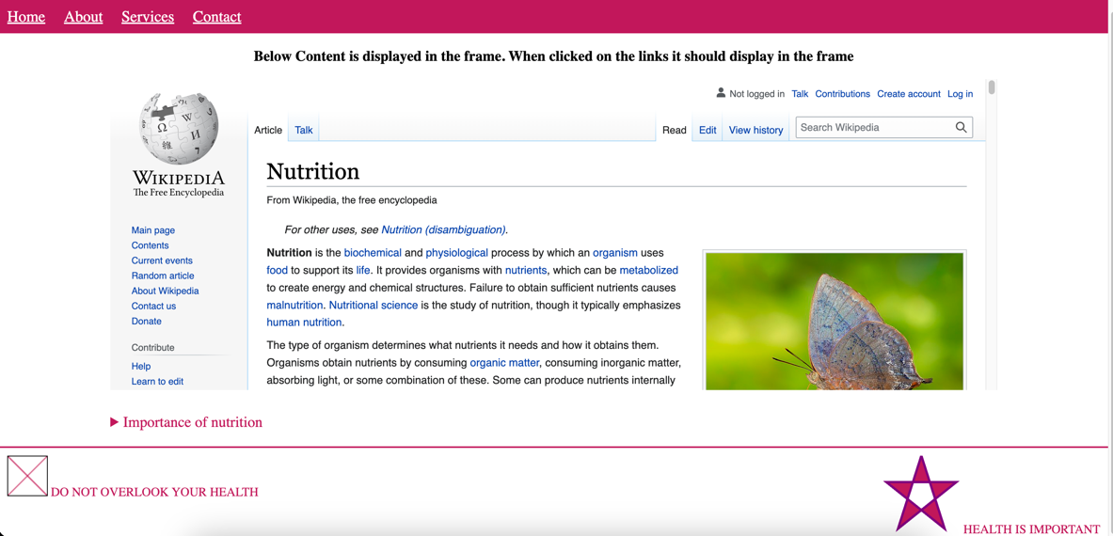

services.html

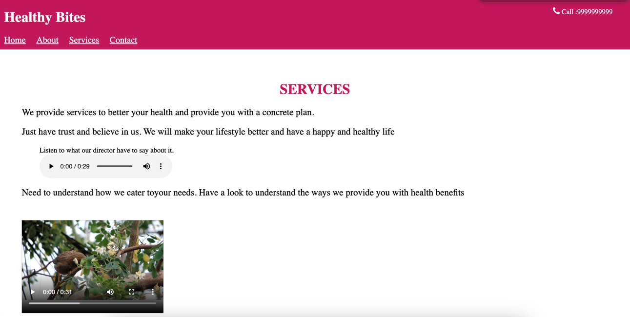

### Lab Name: Assignment 4

### Content Mapping: HTML5 Forms and attributes, HTML Block and Inline Elements, HTML Formatting

HTML Style

### Learning Pre-requisites:

- Tags: form, input, div,p, h1, output

- Form Attributes

### Env Needed:

VSCode, Google Chrome

### Asset Needed: Images

### Difficulty: Medium

### Duration: 20 Minutes

Input:

- Modify index.html to add an input element of type color. Based on the color chosen the background color of the page should change

- Modify index.html page to add contact form and also allow user to calculate their BMI. Output as shown below

Output –

Index.html

Default it shows the below

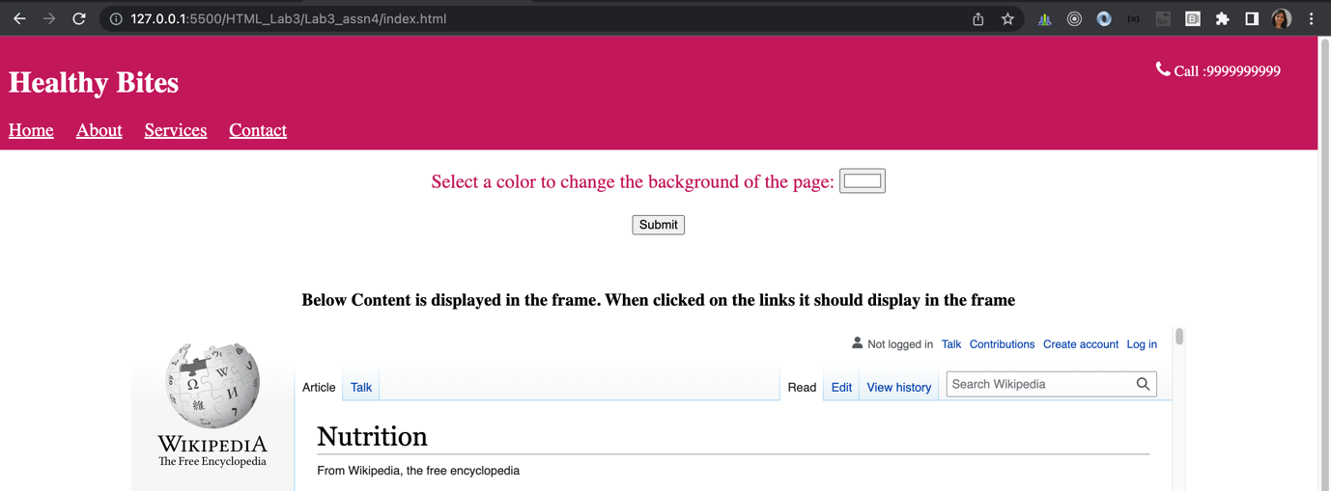

When the color chosen it changes the background color:

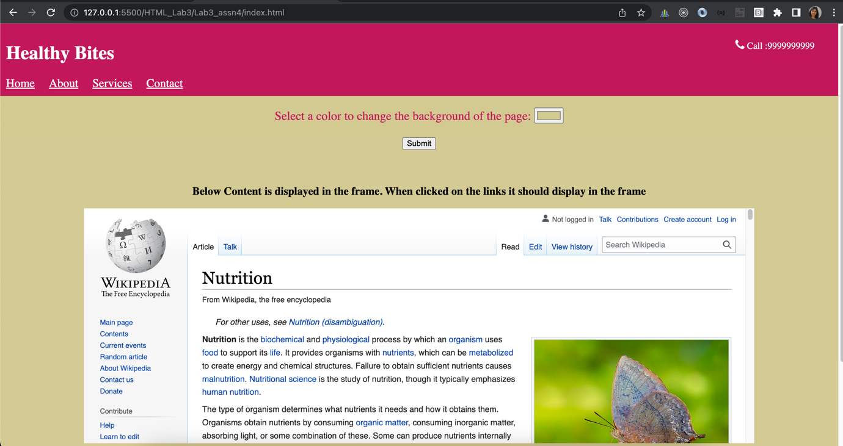

Contact.html

Page looks as below:

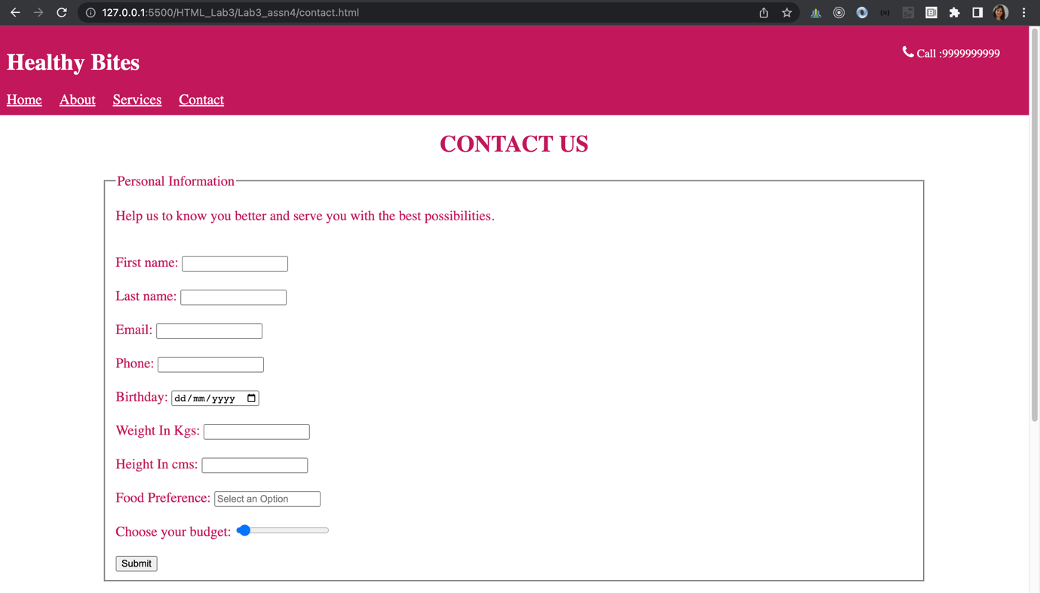

When clicked on food preference it should open a dialog box as below. Use Datalist

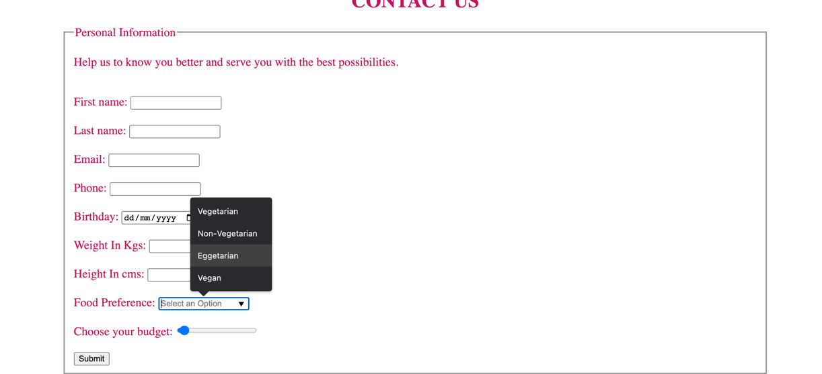

When an option is selected, should modify the UI as below:

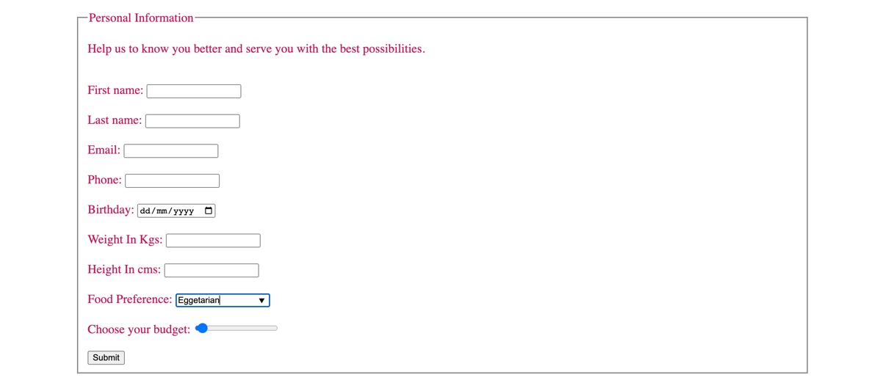

Add one more form in contact.html as shown below. Use output tag to display the calculation

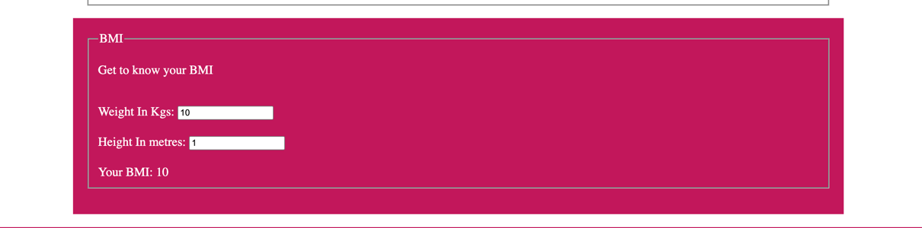

When values are updated it should update the UI

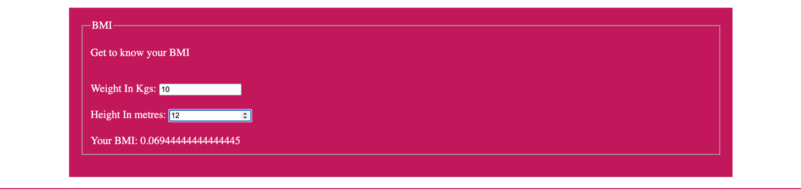

### Lab Name: Assignment 5

### Content Mapping: Responsiveness

HTML Style

### Learning Pre-requisites:

- Tags: div,p, h1, output

- css styles float , width, margin, media queries

### Env Needed:

VSCode , Google Chrome

### Asset Needed: Images

### Difficulty: Difficult

### Duration: 30 Minutes

Input:

- Modify index.html to add the content as shown in the image below. It should have content on left, then in centre and on right. Use float to divide the sections. Place the content appropriately. It should be responsive so that when the width of screen reduces the content should align itself automatically occupying the 100% width.

- Move all the common styles across all the pages in another file styles.css and refer this stylesheet in all the pages.

- Add footer in all the pages that was added in assignment 3 only in index.html page

Output –

index.html

