**Testing a Full Stack Application**

FSD: Lab Guide - Phase 5



This section will guide you to:

* Use practice labs to execute all demos included in this course

This lab has two subsections, namely:

1. Starting practice labs on LMS
2. Using different IDEs and software required for Phase 5

**Step 1:** Starting practice labs on LMS

* Login to Simplilearn LMS
* Navigate to the respective course and click on it

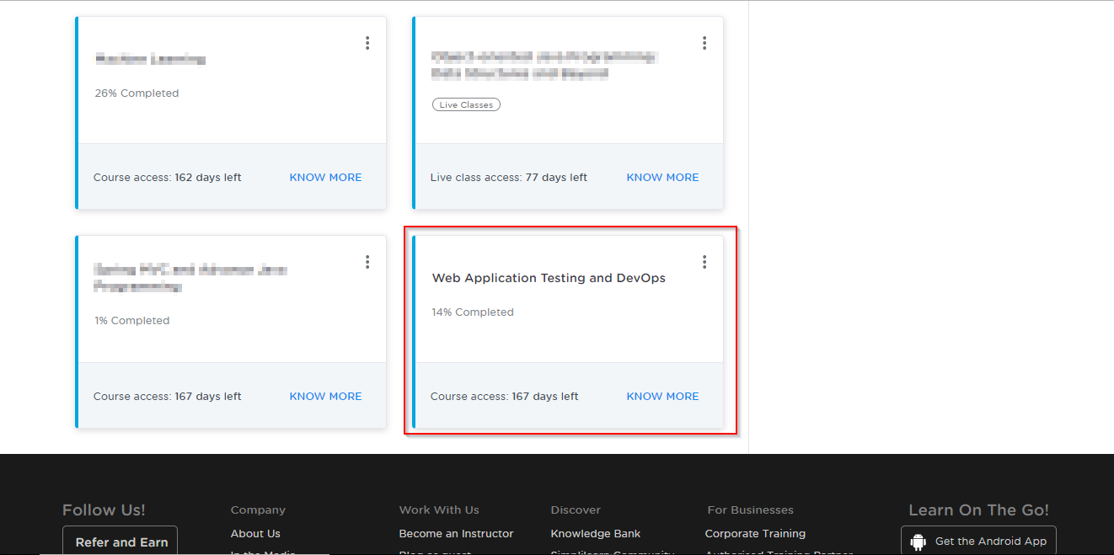

* On the left, you will find the course ToC page
* To its left, you will find the **PRACTICE LABS** tab
* Click on it

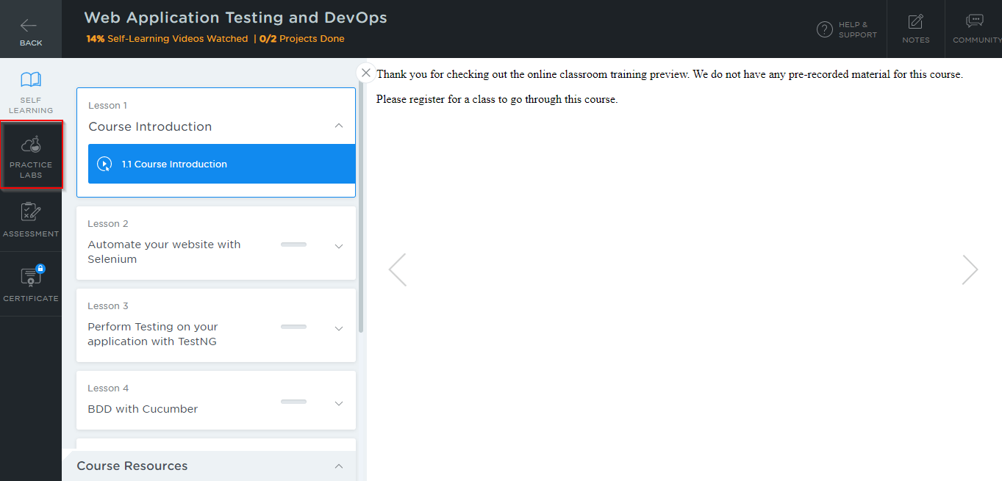

* As a new window opens, read the instructions and click on **LAUNCH LAB**
* This will launch the practice labs for this course

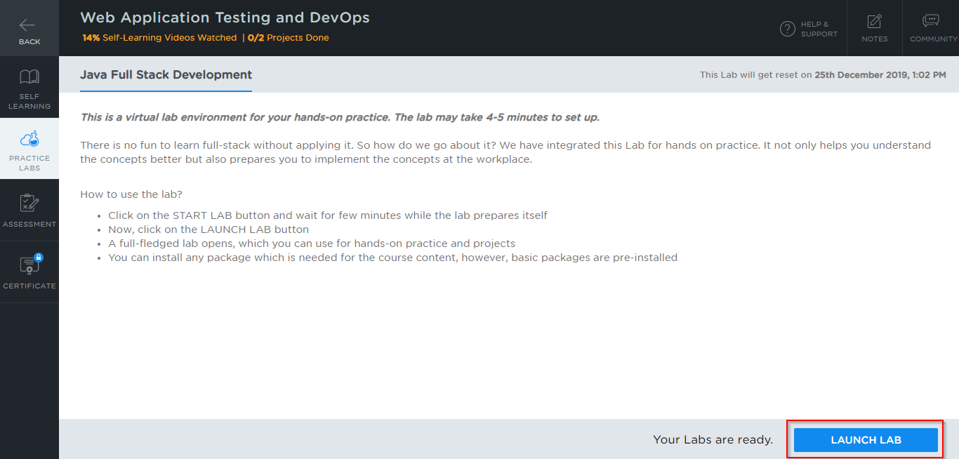

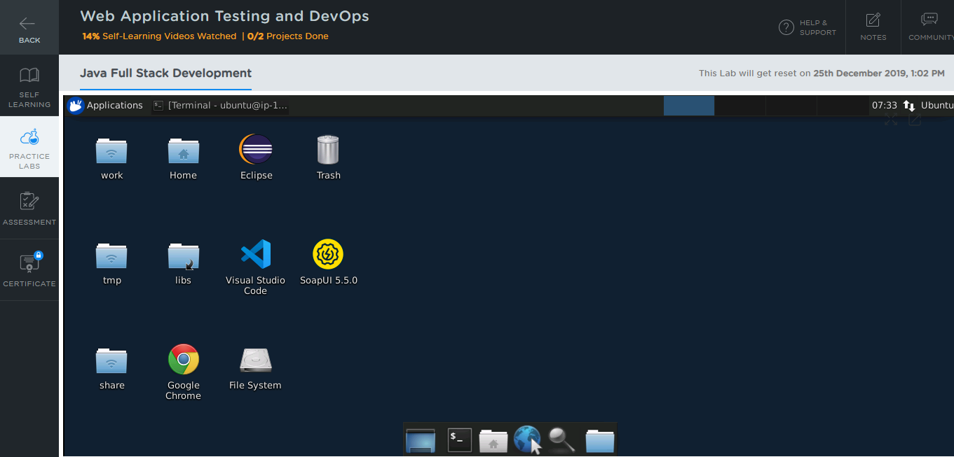

**Step 2:** Using different IDEs and software required for Phase 5

All the required IDEs and software can be accessed from the labs

**Selenium:**

* You will find Selenium in the directory *home/ubuntu/libs* which is shown in the screenshot below:

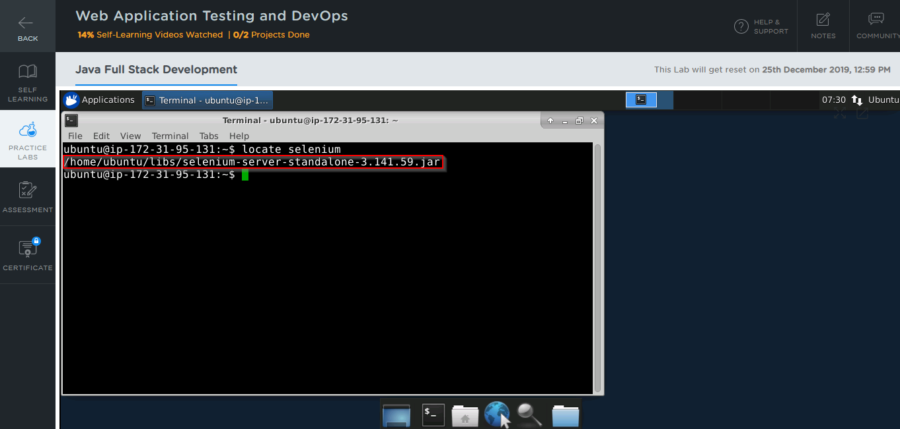

* In case Selenium is not installed in your practice lab, you can install it using the command:

*sudo npm install selenium-standalone@latest -g*

**TestNG:**

* TestNG is installed as an Eclipse plugin in your practice lab
* To verify the installation:

1. Open the Eclipse environment from your desktop
2. Click the **Help** tab and select **Install New Software**

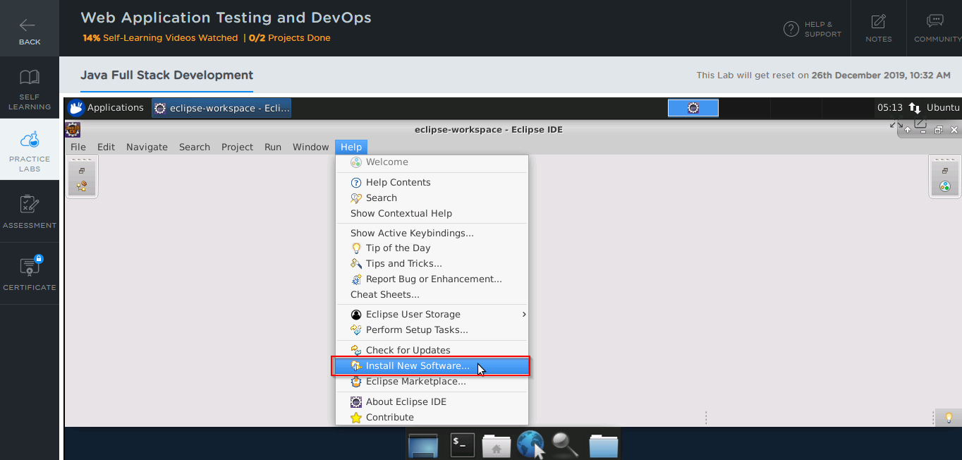

1. In the next window, click on **Already Installed**

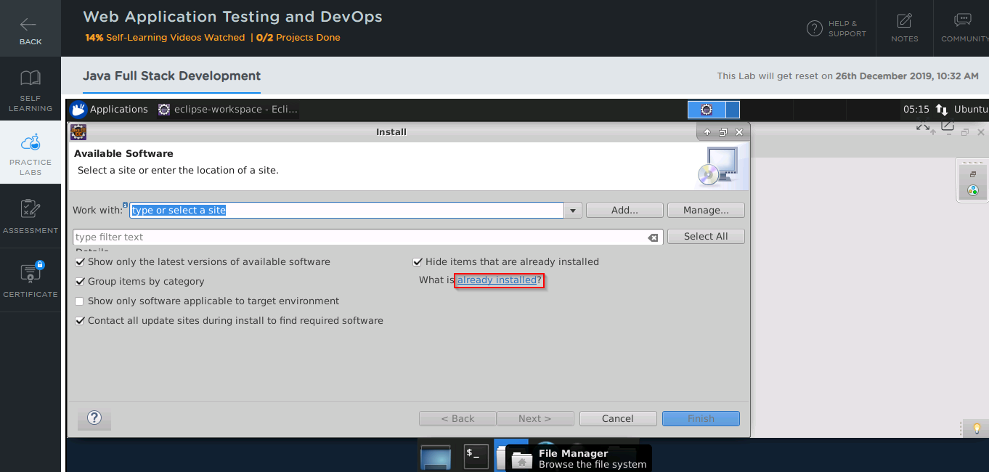

1. In the **filter text** field, type **TestNG**

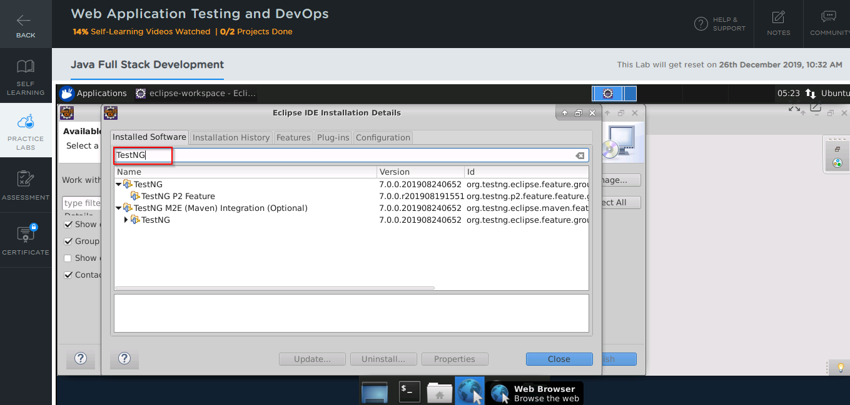

* In case TestNG is not installed in your practice lab, you can install it following these steps:

1. Open the Eclipse environment from your desktop, navigate to the **Help** tab, and click on **Eclipse Marketplace**

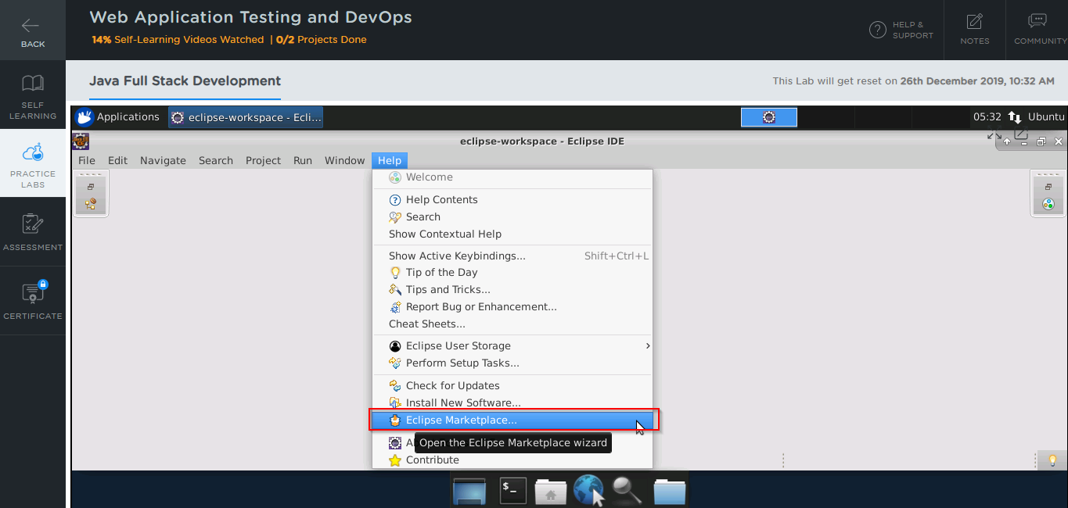

1. Type **TestNG** in the **Find** field and click on **Go**

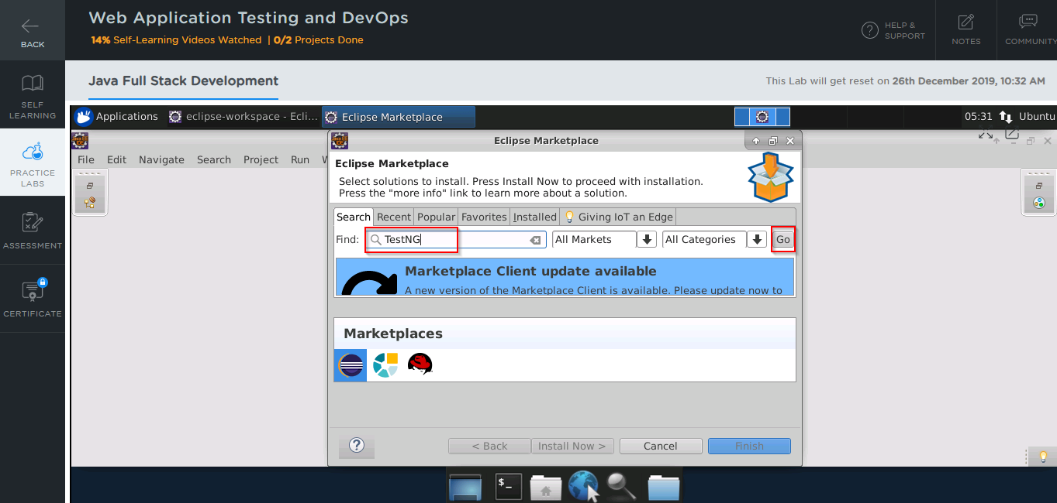

1. In the next window, you will see the TestNG tool
2. Click on the **Install** button to start the installation

**Jenkins:**

* Jenkins is already installed in your practice lab
* You will find it in the directory */usr/share*
* Use the following commands to navigate to the above-mentioned directory

*cd /usr/share/jenkins*

*ls*

1. *Download Jenkins.war or on lms labs open terminal and type   
   cd /usr/share/Jenkins*
2. *Open terminal or cmd to the the folder where you have downloaded war file*
3. *java –jar jenkins.war –httpPort=8081 . Once you execute this command if running for first time there will be password in the console. Please copy that and go to the browser and type localhost:<your port number> or default is 8080*
4. *Once the Jenkins dashboard opens on the browser paste the password you copied. Click continue, then choose install suggested plugins. Some plugins might fail and that is ok. Click continue and you should get a screen to enter your credentials.* ***Enter and remember the username and password***

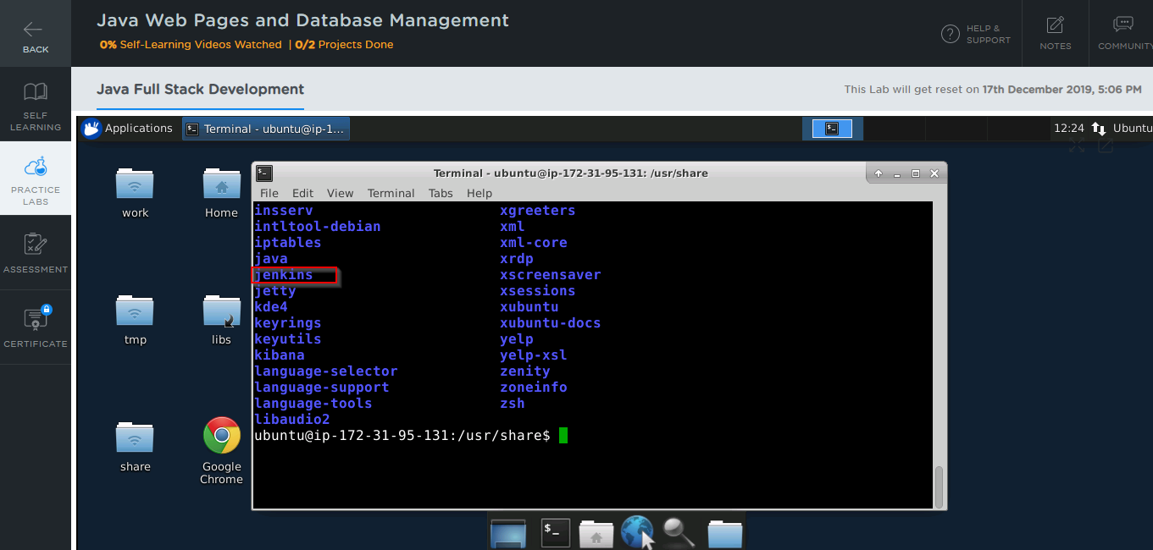

* In case Jenkins is not installed in your practice lab, you can install it using the commands:

*sudo apt update*

*sudo apt install jenkins*

**Cucumber:**

* Cucumber is installed as an Eclipse plugin in your practice lab
* To verify the installation:

1. Open the Eclipse environment from your desktop
2. Click the **Help** tab and select **Install New Software**



1. In the next window, click on **Already Installed**



1. In the **filter text** field, type **Cucumber**

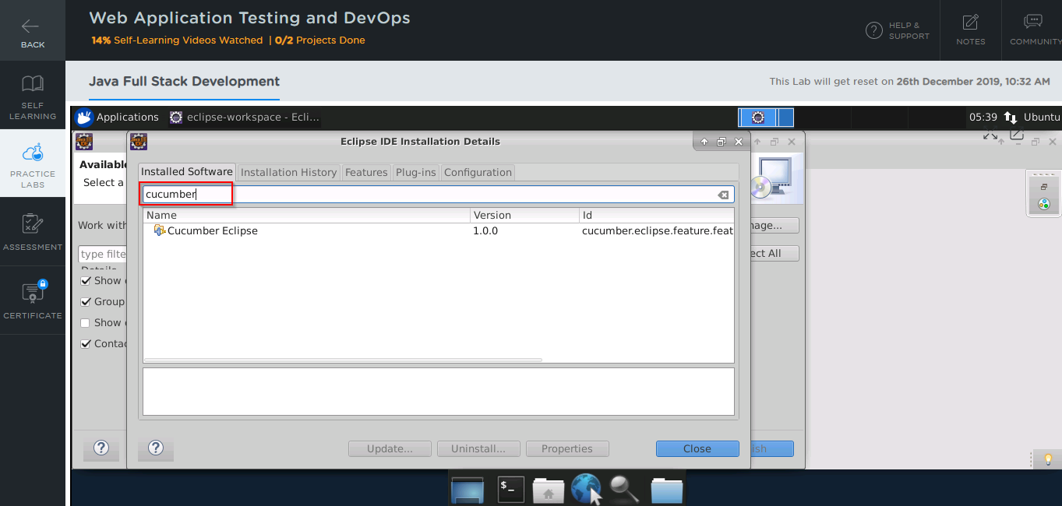

* In case Cucumber is not installed in your practice lab, you can install it following these steps:

1. Open the Eclipse environment from your desktop, navigate to the **Help** tab, and click on **Eclipse Marketplace**



1. Type **Cucumber** in the **Find** field and click on **Go**
2. In the next window, you will see the Cucumber tool
3. Click on the **Install** button it to start the installation

**Docker:**

* Docker version 18.09.7 is already installed in your practice lab
* To verify the installation:

1. Open the command-line interface
2. Type the command:

*docker --version*

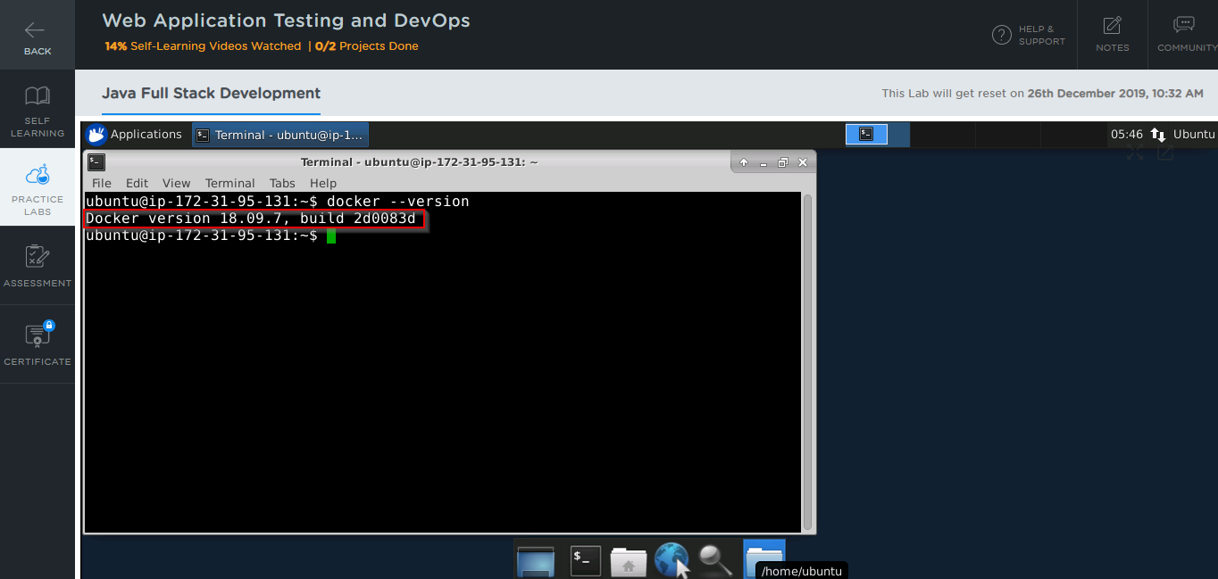

* In case Docker is not installed in your practice lab, you can install it following these steps:

1. Set up the Docker repository using the following commands:

*sudo apt-get update*

*sudo apt-get install apt-transport-https ca-certificates curl software-properties-common*

*curl -fsSL https://download.docker.com/linux/ubuntu/gpg | sudo apt-key add -*

*sudo add-apt-repository "deb [arch=amd64] https://download.docker.com/linux/ubuntu $(lsb_release -cs) stable"*

1. Install Docker using the command:

*sudo apt-get install docker-ce*

**Kubernetes:**

* Kubernetes is already installed in your practice lab
* To verify the installation:

1. Open the command-line interface
2. Type the command:

*Kubeadm version*

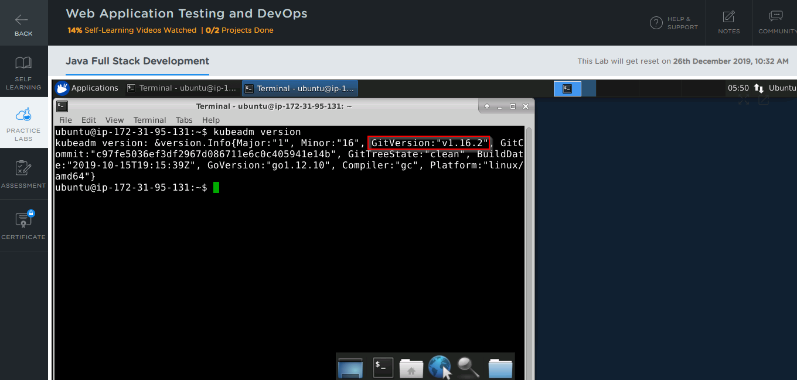

* In case Kubernetes is not installed in your practice lab, you can install it following these steps:

1. Set up the repository using the following commands:

*curl -s https://packages.cloud.google.com/apt/doc/apt-key.gpg | apt-key add -*

*echo 'deb http://apt.kubernetes.io/ kubernetes-xenial main' | sudo tee*

*/etc/apt/sources.list.d/kubernetes.list*

1. Install Kubernetes using the command:

*sudo apt-get install kubelet kubeadm kubectl -y*