Create a visual representation in Figma highlighting the key elements of mobile network

protocol stacks.

Aim: -

Design a visual representation in Figma highlighting the key elements of mobile network

protocol stacks.

Procedure: -

1. open Figma

2. Create a new file

3. Select the Frames

4. Fill in the content that is required for presentation

5. Design Visual Elements

6. Make it Interactive

7. Add Annotations and Explanations

8. Incorporate Multimedia

9. Storyboard Animation

11. Review and edit the Prototype

12. Save and Share

Design: -

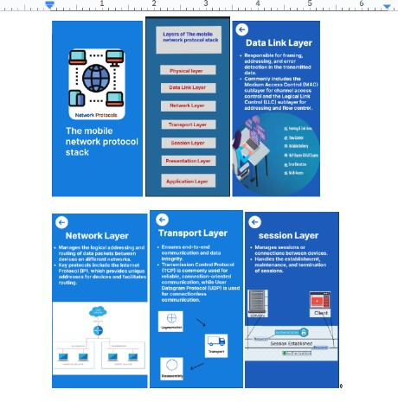

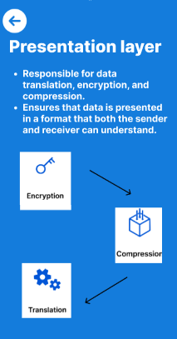

**Prototype: -**

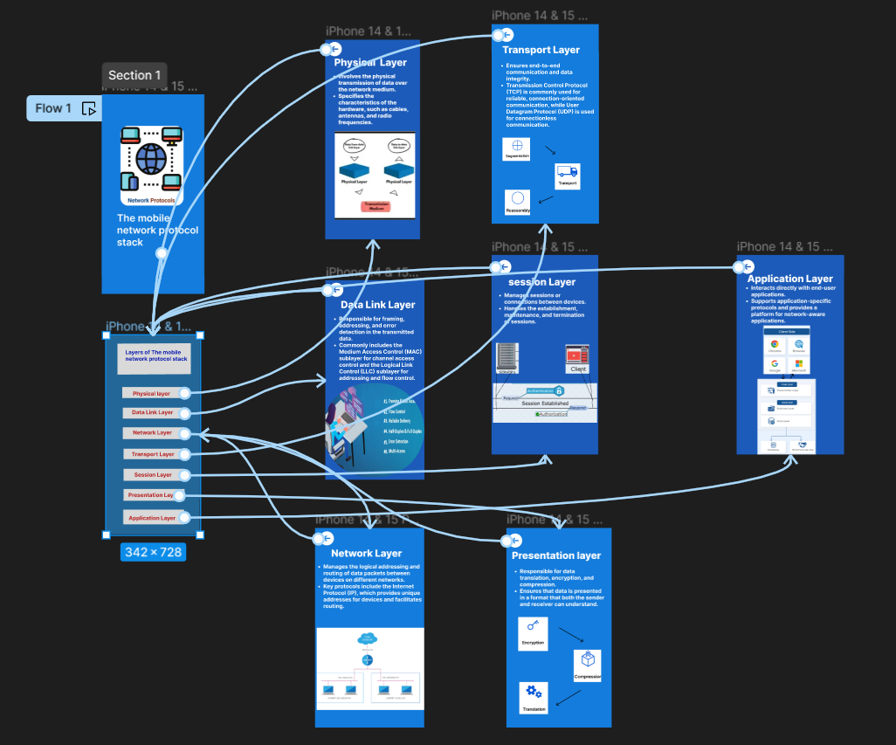

**Result: -**

Hence the visual representation in Figma highlighting the key elements of mobile network protocol stacks is created and executed successfully