**EXPERIMENT-1**

**AIM:**

To computea Pandas program to select distinct department id from employees file.

**PROGRAM:**

import pandas as pd

data = {

'DEPARTMENT_ID': [10, 20, 30, 40, 50, 60, 70, 80, 90, 100, 110, 120, 130, 140, 150, 160, 170, 180, 190, 200, 210, 220, 230, 240, 250, 260, 270],

'DEPARTMENT_NAME': ['Administration', 'Marketing', 'Purchasing', 'Human Resources', 'Shipping', 'IT', 'Public Relations', 'Sales', 'Executive', 'Finance', 'Accounting', 'Treasury', 'Corporate Tax', 'Control And Credit', 'Shareholder Services', 'Benefits', 'Manufacturing', 'Construction', 'Contracting', 'Operations', 'IT Support', 'NOC', 'IT Helpdesk', 'Government Sales', 'Retail Sales', 'Recruiting', 'Payroll'],

'MANAGER_ID': [200, 201, 114, 203, 121, 103, 204, 145, 100, 108, 205, 0, 0, 0, 0, 0, 0, 0, 0, 0, 0, 0, 0, 0, 0, 0, 0],

'LOCATION_ID': [1700, 1800, 1700, 2400, 1500, 1400, 2700, 2500, 1700, 1700, 1700, 1700, 1700, 1700, 1700, 1700, 1700, 1700, 1700, 1700, 1700, 1700, 1700, 1700, 1700, 1700, 1700]

}

df = pd.DataFrame(data)

distinct_department_ids = df['DEPARTMENT_ID'].unique()

print(distinct_department_ids)

**OUTPUT:**

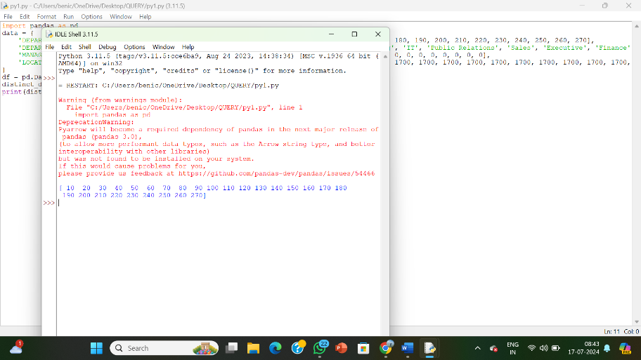

**RESULT:**

The pythonprogram to select distinct department id from employees file.