1: In Delete, Error notice is showing. Please check it

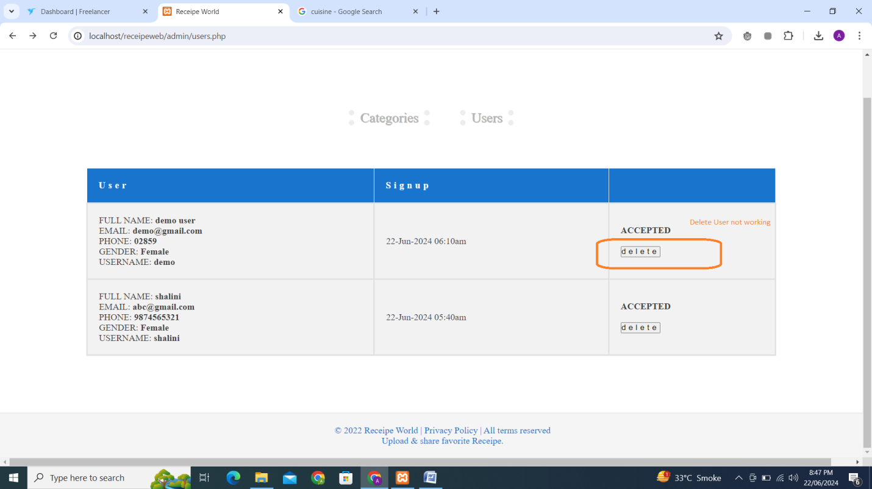

2: Add change password in Forget password at login page. Near button Login, add Forget Password button

3: search should be performed without login. At home page, search results should be shown.

4: User can edit his profile