Smart Traffic Management System
Using Internet of Things

Abstract

Traffic management system is considered as one of the major dimensions of a smart city. With the rapid growth of population and urban mobility in metropolitan cities, traffic congestion is often seen on roads. To tackle various issues for managing traffic on roads and to help authorities in proper planning, a smart traffic management system using the Internet of Things (IoT) is proposed in this paper. A hybrid approach (combination of centralized and decentralized) is used to optimize traffic flow on roads and an algorithm is devised to manage various traffic situations efficiently. For this purpose, the system takes traffic density as input from a) cameras b) and sensors, then manages traffic signals. Another algorithm based on Artificial Intelligence is used to predict the traffic density for future to minimize the traffic congestion. Besides this, RFIDs are also used to prioritize the emergency vehicles such as ambulances and fire brigade vehicles during a traffic jam. In case of fire on the road, Smoke sensors are also part of this system to detect this situation. To demonstrate the effectiveness of the proposed traffic management system, a prototype is developed which not only optimizes the flow of traffic but also connects nearby rescue departments with a centralized server. Moreover, it also extracts useful information presented in graphical formats that may help the authorities in future road planning.

Introduction
A city is a complex system which consists of many interdependent subsystems where traffic system is one of its important subsystems. A study says; it is the cornerstone of the world’s economy. Moreover, it is also declared as one of the major dimensions of the smart city . With the rapid growth of the population of the world, the number of vehicles on roadways is increasing consequently, the rate of traffic jams is also increasing in the same manner . Traffic jams are not just wasting time but in some cases, it is witnessed that criminal activities like mobile snatching at traffic signals also happen in metropolitan cities. On the other hand, it is not only affecting ecosystem badly but the efficiency of industries is also being affected . In order to solve traffic congestion, traffic signal systems are established in urban areas. However, the frequency division of traffic lights is equivalent and persistent for all the roads. Due to the dynamic nature of arrival traffic on all sides of the road, the signals are not equal, resulting in resource waste. As the volume of road infrastructures and automobiles grows, managing a traffic and transport network will be difficult. Generally, each road has a zebra crossing near the road signal, and each signal also has an assigned time to perform its function . This complete process appears in a series. This traditional traffic-handling framework has a flaw in that it cannot detect the occurrence of automobiles across each route, and when a route is vacant, the traffic signal for that route squanders time. This traditional automobile management structure cannot handle traffic and control traffic jams. So, cities want a better alternative for the “Smart Traffic Management System”.
IoT includes linking physical things to the internet to create intelligent networks and mobile communication connectivity with innovative materials such as ITM. Communication among IoT-based automobiles is a new information-exchange paradigm contributing to ITM. IoT is a composition of data collection and analysis of sensor data and computing to effectively manage and support traffic networks . On the other hand, automatic transportation containing a traffic signal utilizes a timer for each phase. The use of electronic sensors is another method of tracking automobiles. Although electronic traffic-control sensors have been used for traffic control, road traffic also happens. An intelligent transport system can resolve traffic congestion and other issues . The primary aim of a smart city is to build a social structure that can accomplish the productive usage of urban services and infrastructure via AI and ML. This also concentrates on controlling the key characteristics, productivity, and enhancing the quality of resources for its community members . Air quality and climate-change issues are essential research areas in smart cities. One research study includes a viewpoint on the opportunities for highlighting urban air-quality management (UAQM) concerns by employing an intelligent urban model in ‘Smart urban computing.’ This research explains the responsibility of Intelligent urban computing in UAQM and offers a collaborative platform for smart urban computing environments for air pollutants processes.
Problem Definition:
Traffic congestion is a major problem in cities around the world. It leads to increased travel times, air pollution, and fuel consumption. Smart traffic management systems (STMSs) use technology to improve traffic flow and reduce congestion.
Traditional traffic management systems are often unable to cope with the increasing volume and complexity of traffic. Smart traffic management systems (STMSs) offer a new approach to traffic management that can help to reduce congestion and improve traffic flow.
- Traffic congestion: STMSs can help to reduce traffic congestion by optimizing traffic signals and coordinating public transportation. This can lead to shorter travel times, reduced fuel consumption, and improved air quality.

- Safety: STMSs can help to improve safety by detecting and responding to accidents more quickly. They can also be used to warn drivers of potential hazards, such as black ice or congestion ahead.
- Efficiency: STMSs can help to improve the efficiency of the transportation system by providing drivers with real-time traffic information. This can help drivers to choose the best route and avoid congestion.

Design Thinking:
Design thinking is a human-centered approach to innovation that can be used to solve a wide range of problems, including traffic problems. Design thinking is a non-linear, iterative process that involves five key stages:
- Empathize: The first step is to understand the needs and pain points of the people who are affected by the problem. This can be done through interviews, surveys, and other forms of user research.

- Define: Once you have a good understanding of the problem, you need to define it clearly. This will help you to identify the root cause of the problem and to develop potential solutions.

- Ideate: The next step is to generate ideas for how to solve the problem. This can be done through brainstorming, sketching, and other creative activities.

- Prototype: Once you have a number of ideas, you need to prototype them. This means creating quick and dirty versions of your ideas so that you can test them with users and get feedback.

Innovation:
Smart traffic management systems (STMSs) are a new and innovative approach to managing traffic.
STMSs have the potential to revolutionize the way we manage traffic. By using technology to improve traffic flow and reduce congestion, STMSs can lead to a number of benefits, including:
  - Reduced travel times: STMSs can help to reduce travel times by optimizing traffic signals and coordinating public transportation. This can save drivers time and money.

  - Improved safety: STMSs can help to improve safety by detecting and responding to accidents more quickly. They can also be used to warn drivers of potential hazards, such as black ice or congestion ahead.

  - Reduced emissions: STMSs can help to reduce emissions by optimizing traffic flow and reducing congestion. This can improve air quality and reduce the impact of climate change.

  - Increased economic productivity: STMSs can help to increase economic productivity by reducing travel times and improving the efficiency of the transportation system.

Problem solving:
STMSs have a number of potential benefits, including:
  - Reduced traffic congestion: STMSs can reduce traffic congestion by optimizing traffic signals and coordinating public transportation. This can lead to shorter travel times, reduced fuel consumption, and improved air quality.

  - Improved safety: STMSs can help to improve safety by detecting and responding to accidents more quickly. They can also be used to warn drivers of potential hazards, such as black ice or congestion ahead.

  - Increased efficiency: STMSs can help to improve the efficiency of the transportation system by providing drivers with real-time traffic information. This can help drivers to choose the best route and avoid congestion.

Literature Review

A smart traffic management system that is partially deployed in Cambridge city where queue detectors are buried in the roads that detect the traffic queue and inform the central control unit which takes decision accordingly. Since the system is centralized that can slow down due to networking issues . The researcher used surveillance cameras to detect traffic and OCR to identify the vehicles through number plate recognition which is a simple detection method but the system will fail in Pakistan as there are different kinds of traffic including cycles, donkey carts which have no number plate .Osman et al. proposed a system in which they have used surveillance cameras to detect traffic density using MATLAB, a traffic controller and a wireless transmitter used to send images to the server after that server calculated traffic density by using those images of every section. This system used fixed (predefined) thresholds that depend on a number of vehicles on road. An algorithm was used to set a time span of red light for a particular lane of the intersection, which is determined by traffic density on road and forwarded to the microcontroller and then server .

SYSTEM IMPLEMENTATION

Steps in the proposed system for controlling traffic light 1:
1. Camera: Continuously record traffic video.
2. Read Image: Read frames of the traffic image.
3. Grayscale Image Conversion: It converts color image to grayscale image. This method is based on different color transforms. According to the R, G, B value in the image, it calculates the value of grayscales and converts the image into a grayscale image.
4. Image Binarization: Grayscale image is converted into black and white image.
5. Traffic Signal Control: Based on vehicle count signal timings are changed and the respective LED glows.

Steps for controlling traffic light 2:
1. Initialize System.
2. Configure ESP 8266 module for multi access point through AT commands.
3. Connect WI-FI module to WI-FI network.
4. Start UDP local port in WI-FI module.
5. Establish UDP connection to Raspberry pi.
6. Wait for data.
7. Change traffic light signal 2 depending upon their received data from raspberry Pi.

Components
Smart traffic management system consists the Following components.

• Radio signal detector
• Radio waves transmitter
• Ultra-sonic sensor/Hall Effect sensor
• Raspberry Pi
• Python programming
• Light Emitting Diode

Radio signal detector

The transmitter was turned on and off to create short or extensive stretches of radio waves, illuminating messages in various codes, similar to that of Morse code. In this manner, the early radio recipients had just a single application or function that was to separate between the nearness or nonappearance of any radio sign. The gadget that played out this specific capacity was known As a locator.
The parts of a radio detector are: -
• Antenna: It helps in catching the radio waves. Commonly, the reception apparatus is basically a long wire. At the point when this wire is vulnerable to radio waves, the waves cause a little substituting current (AC) inside the receiving wire.
•RF enhancer: It is a sense speaker that enhances the exceptionally weak radio recurrence signal from the reception apparatus with the goal that the sign can be prepared by the tuner.
•Tuner: A circuit that can pull back sign of a specific recurrence from a blend of sign of various
frequencies.
• Detector: This part is answerable for isolating the sound data from the transporter wave. For AM (Amplitude balance) flag, this can be satisfied with the assistance of a diode that just amends the rotating current sign.
• Audio speaker: The motivation behind this part is to enhance the powerless sign that originates from the identifier with the aim that it tends to be heard by anybody
Hall Effect Sensor
The Hall Effect is the most common method of measuring magnetic field and the Hall Effect sensors are very popular and have many contemporary applications. For example, they can be found in vehicles as wheel speed sensors as well as crankshaft or camshaft position sensors.The basic Hall Element of the Hall Effect magnetic sensors mostly provides very small voltage of only a few micro volts per Gauss, so therefore, these devices are usually manufactured with built-in high gain amplifiers.

Raspberry PI

The Raspberry Pi is a small sized personal computer (PC) which is structured and fabricated by the Raspberry Pi Foundation (a non-benefit association) which is dedicated to making PCs and programming guidelines as effectively open as conceivable to the intended interest group. Software engineers over the world have taken the modest stage for ventures which are from reproducing setting up modest however amazing home media gadgets.

Advantages

•It is a solitary board PC
•It is very cost effective.
Light-Emitting Diode

A light-producing diode is a semiconductor which has a light source that conveys light when current is permitted to move through it. Electrons in the semiconductor join with the electron gaps, along these lines discharging vitality as photons. LEDs have numerous points of interest over other radiant light sources.
They are:
•Lower vitality utilization
• Longer lifetime
•Improved strength
•Small in size
• Faster rate of exchanging

Contributions Include
- The proposed ATM system utilizes the architecture and smart traffic signal to avoid congestion.
- We introduce a completely deterministic adaptive technique for effective and close traffic monitoring and a congestion-control system at major regional intersections on any sequence of events.
- One critical advantage of the proposed ATM structure is its ability to integrate with any adaptive method without requiring changes to the architectural style.
The complete research article is organized into various sections discusses existing work and covers a comparative analysis. In , materials and methods are covered. simulation experimental results and comparison of the results are covered in section 4. In the last section, five conclusions and future work are discussed.
ITM boosts the ever-increasing vehicle motion and vehicular traffic in highway areas to avoid overcrowding. The generation of vast amounts of information produced by plenty of smart devices linked to the transportation system enables the formation of datasets that utilize deep learning algorithms to analyze data in depth.

Traffic Monitoring Based on Traffic Conditions
The authors of explained an intelligent transmission-control system employing cloud perspective and ML methods. The graphics of its next vehicular intersection are captured and saved in the cloud database. The concentration and vehicle characteristics are identified using the cloud image API. The condition is also returned to the subsequent traffic signal. The prior traffic signal, which is now the current signal, will track the progress of the next traffic signal and then proceed with the activity predicated on the conditions. In order to increase the safety and efficiency of ITM, the authors of demonstrated that these methods can help us to anticipate traffic performance, automated traffic-signal management, driveway identification, and recognition of nearby objects/vehicles. Various researchers are working on intelligent transport systems, but better traffic management is still challenging . The authors of demonstrated that significant traffic surveillance frameworks transform smart urban areas. Many studies have been conducted regarding intelligent traffic-control systems centered on the IoT approach.

IoT Based Real-Time Traffic Management
Research has developed an IoT-based intelligent traffic strategy to supervise significant congestion through centralized and decentralized domain controllers. The information-gathering component utilizes sensing devices, camera systems, and radiofrequency identification. Further, the application layer allows management of the traffic lights and notifications based on on-road vehicle frequency and offers a routine update through a software system. The authors of described an inspection for reducing false projections based on the “Rankine-Hugoniot” circumstance and an origin–destination traffic facility. In order to authenticate the effectiveness of the suggested framework, a model was established. The testing results prove that the suggested method can successfully supervise precision and framework latency traffic congestion.

ML Methods in Real-Time Traffic Management
The authors of presented a dynamic vehicular structure based on the IoT and ML concepts. Key responsibilities were played by the image sensor and two different control system panels. A scene detector mainly captured the specifics from the route with video coverage and transferred that to the following driver circuit. The authors of compared multiple simulation models, a provisional logistic regression method, and a support vector machine method with predicting accidents. The method was evaluated relying on the information achieved from “Shanhai Middle Ring Highway,” China.
The authors of suggested a method for predicting the volume of traffic, particular development stage vehicular region, and lane width. Researchers optimized the traffic-signal turnaround time and independent signalized intersections process time using the values produced by vehicles. The authors of proposed a decentralized reinforcement learning-management system utilizing EA for a vehicular regulation system that efficiently improves the transport system’s efficiency. However, this was not incorporated at a certain period due to computing capacity restrictions. The paper also introduced a novel eco-friendly, flow-approximate solution that offered the traffic signal period for each straight path depending on the vehicular intensity. Then it used ML and the AI method to forecast the time duration in a small timeframe.

Materials and Methods

IoT Architecture
The IoT defines the network of connected “things” that are often equipped with sensors, applications, and other advancements to integrate and transfer information between devices and platforms over the Web. The IoT has two main components. The first is an “object or thing” which users intend to make intelligent through interconnection, and another is the embedded platform that enables this communication. The latter part may seem easy, but consists of a complicated structure composed of various sensors, actuators, methods, and data-access layers. Each interconnection is accountable for creating configurable, intelligent, and successful connections with human beings
Fig shows the three-layered architecture of IoT. This model’s first layer (bottom to top) represents the perception layer, including IoT components, i.e., sensors, GPS., RFID tags, and cameras. The application layer includes various protocols CoAP (Constrained Application Protocol), MQTT (Message Queuing Telemetry Transport), XMPP (Extensible Messaging Presence Protocol), and AMQP (Advanced Message Queuing Protocol), which provides application in the field of Smart City, Smart Grid, Smart Healthcare, and Smart Business. The second layer is the network layer, which mainly represents communication technology and media, i.e., internet type (3G/4G), medium, and communication type. The top layer is the application layer representing the final application or end-user viewing the IoT communication.
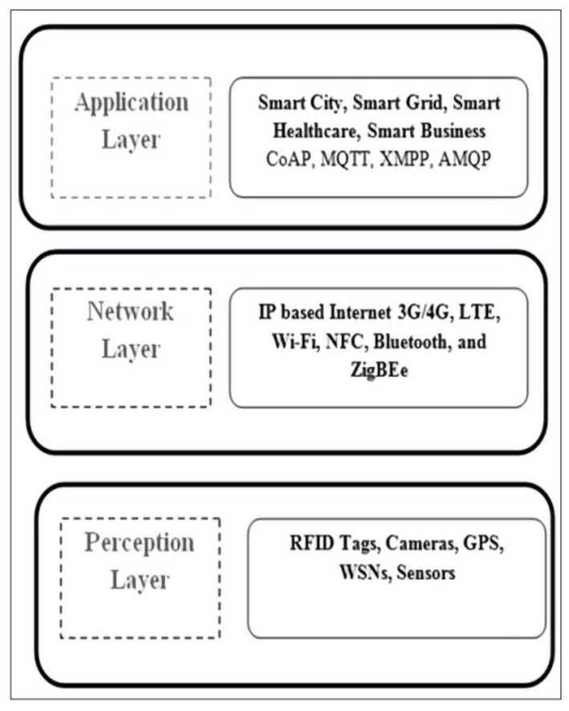

Vehicle Location Tracking
The proposed ATM system helps choose those routes that provide higher precision. The model is validated for its performance with the benchmark’s lower bound precision value. Still, suppose the proposed model generates the desired precision for the lower bound. In that case, this strongly implies there are good effective routes, and all the other lesser communication routes are removed. However, if the lower bound is more than the predicted precision rate, there are not enough routes. The critical paths for effective vehicle localization are further added to the set. Fig displays the functioning model of the proposed vehicle location tracking system module. In the first phase, data are collected using the sensor and camera devices. The capture of data by sensor and camera and the preprocessing of those data are vital components in ITM. The missing value estimation methods are used in the preprocessing data phase . The processing method processes these collected data and later applies the training method to train the dataset. The vehicle’s exact location and traffic details are collected.
Vehicle Location Tracking
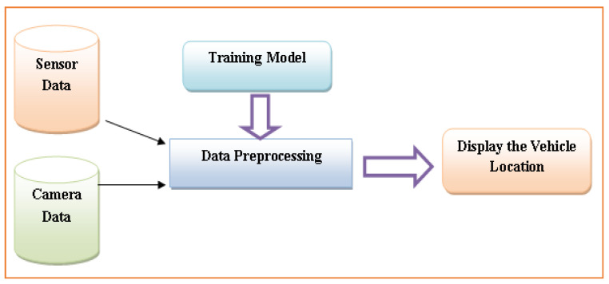

Vehicle Image Processing Module
This model first identifies the motor vehicles via images and electronic sensors integrated into the road surface. A webcam will also be positioned along with the traffic signal and sensors. This will capture patterns of image data. Object detection is the best alternative to regulate the state change of the traffic signal. It can reduce road-traffic congestion and minimize wasted time with a green light over an empty highway. Furthermore, it is more accurate in predicting vehicle presence because it utilizes actual traffic-image data. It analyzes the usefulness and processes much better than all those models that depend on identifying the vehicular surface material . Algorithm 1 represents the working of Image processing in the intelligent transport system.
Algorithm 1: Image processing in the intelligent transport system
Step-1. Image data collection: using a camera and sensor installed over the road.
Step-2 Preprocessing phase: To process the images as follows-
2.1 Images are converted into a standard size (i.e., 450 × 450 pixels)
2.2 Convert all the captured RGB images into grayscale images.
Step-3. Edge detection phase: Canny edge detection method
Step-4. Pixel match technique: The output of step 3 is compared by using pixel to pixel (P.P.M.) matching techniques
Step-5. Timing allocation: It depends on the result of step 4; the percentage of image matching criteria is as follows:
5.1 If the image matched = 40%, then on a green light for 90 s
5.2 If the 40% image matched = 70% then on green light for 60 s
5.3 If the 70% image matched = 90% then on green light for 30 s
5.4 If the 90% image matched = 100% then on Red light for 90 s
5.5 Repeat steps 3–5

In the second scenario, vehicles move backwards and forward over a multilane path .In scenario 3, vehicles move forward and backwards over multiple lanes; this is caused by “Traffic Congestion,” as described in the picture. The traffic congestion is resolved by the proposed intelligent traffic-management system described below.
Vehicle moving on the freeway , connected/linked and automated vehicle, and signals in 3 categories (red, green, and yellow).

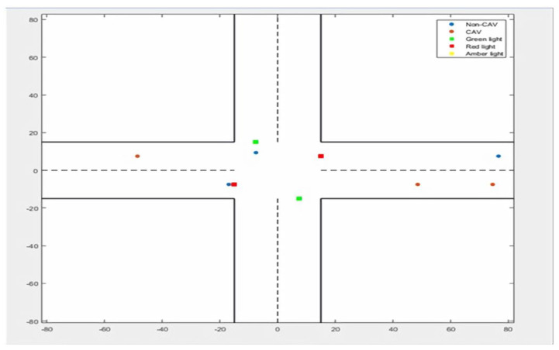

Vehicle moving on forward and backward over multiple lanes (traffic congestion).
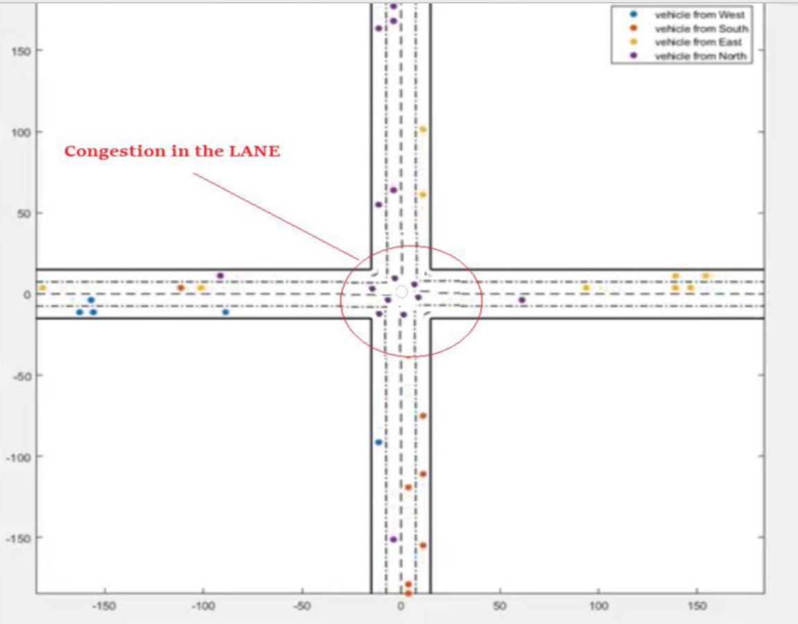

Vehicle movement based on signals received from RSUs.

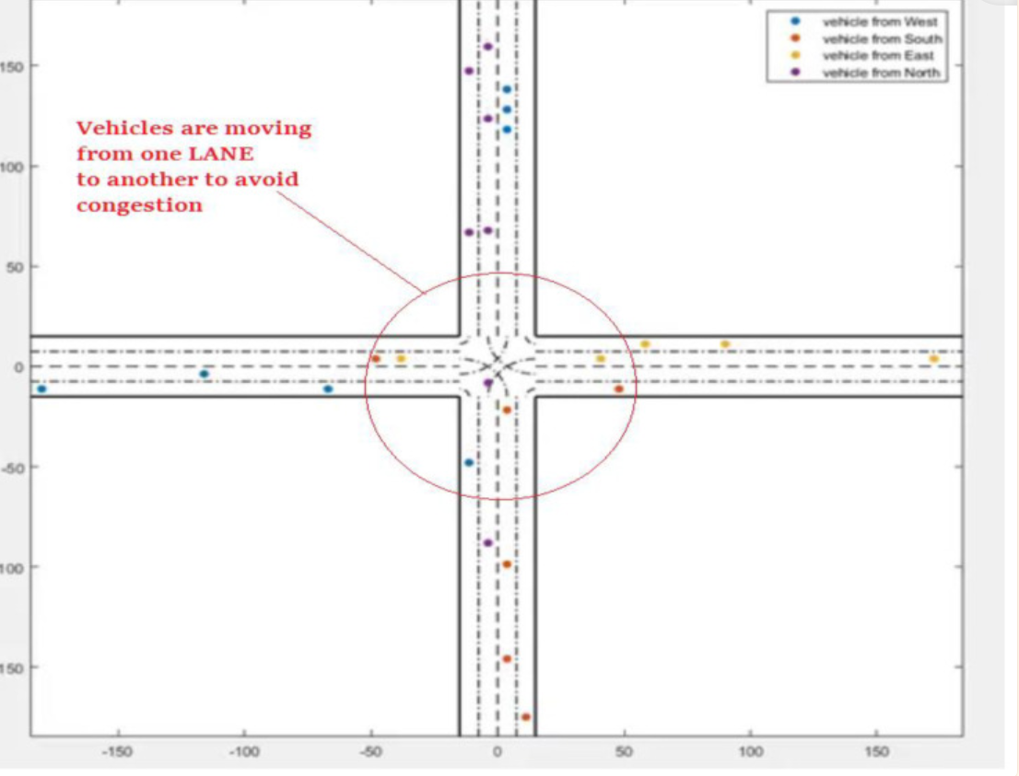

Proposed System

The proposed system, shown in Figure 1, is designed to govern traffic at road networks, sensing through sensors, surveillance cameras, and RFIDs which are embedded on roadsides. The system works in a distributed manner, it processes sensors’ data at the node level and videos’ data at the local server, calculates cumulative density to regulate the traffic according to density. In addition to this, it also tackles emergency vehicles such as ambulance, fire brigade. it also helps the users to know the congestion status at a road through prediction.
The system is divided into three layers.

A) Data Acquisition and Collection layer.
B) Data Processing and Decision-making layer
C) Application and Actuation layer.

A.Data Acquisition and Collection Layer
Several ways of traffic detection have been used by the researchers in the state of the art which consists ultrasonic sensors, RFIDs, surveillance cameras and light beam. All these sources have merits as well as demerits; the suitable sources in the context of the proposed system are surveillance cameras, ultrasonic sensors, RFIDs, smoke sensors and flame sensors .
A surveillance camera is the most widely used source to detect the road traffic in this field due to efficiency and ease of maintenance. Blob detection algorithm is applied to the video stream at the local server due to its performance and capability of noise reduction. After traffic detection, a local server sends the density measured through image processing to the respective microcontroller.
Apart from the cameras, this system is also using ultrasonic sensors to enhance the accuracy. Sensors are integral part used to detect traffic density in many traffic management system applications. It measures distance by sending out a sound wave of a specific frequency and listening for that sound wave to bounce back. This economical sensor measures the distance 2 cm to 400 cm. The system calculates the distance by using the following formula:
Distance = ((a x b) / 2) a= Speed of sound b= time taken .
As shown in Figure , there are three pairs of sensors at a certain distance are embedded on each roadside of an intersection to calculate the traffic density. Each sensor’s reading is 1 or 0 (Either that particular sensor detects the vehicle or not). At the node side, density is calculated by considering the readings of all the sensors embedded at that particular roadside.
𝜮𝒊=𝟏𝟑 (Pi)= Pi + Pi+1 + Pi+2
P is the pair of ultrasonic sensors.

B. Data Processing and Decision-making layer

The system manages the road traffic according to the traffic condition. a) In the first situation, each traffic signal has a preset time that is α seconds, when there is normal traffic on road. Every signal is going for green at their turn for α seconds, and rest of signals at that time remains red until all remaining traffic signal at an intersection complete their turn. Traffic ratio is increasing day by day and our current Fixed-time signal control system is not working well in this situation, there is a dire need to add a density based traffic management module which allocates time dynamically to each lane on the base of the traffic density, in second part of algorithm when the capacity of traffic is increased and flow of traffic is not in routine, the system calculates the level of density according to Table 2. and update the time β of traffic signal on the basis of traffic density. further, undergoes to traffic management algorithm discussed in Figure .

Algorithm:

Part(I) When no emergency vehicle detected

if (Traffic Density == high)
if (Rush Interval==Yes)
Time= ((α ex sinθ) + β) + γ
else
Time = (α ex sinθ) + (cosθ * γ) + β
else
if (Rush Interval==Yes)
Time= (α ex sinθ) + γ
else
Time = α

Part(II)When RFID tags detect emergency vehicle

While(vehicle Exits)
Time !=0

Where α is regular prefixed time given to a specific roadside, θ=90, x=0, β is extra time added in case of traffic congestion and γ is extra time added when there is rush interval near to approach.
Moreover, if the emergency vehicle is detected, the system stops its normal operation and immediately turns the respective signal green and it remains green until that particular vehicle passes to that intersection. In addition to this, if the fire is detected on the road, the microcontroller intimates to the respective local server through which it goes to the centralized server and then this information goes to the respective department through a mobile application. The flow, how the system calculates signal time, is presented in Figure .

C.Application and Actuation layer

In this layer, there are two types of information delivered i) duration of a green signal from node to traffic signal and ii) daily, weekly, monthly and yearly reports to the administration of smart traffic management system through the web application from a centralized server. First of all, the system calculates rush interval by using Regression Tree algorithm on the data saved at the local server and updates this report to the centralized server on the daily basis (after 24 hours). The rush interval is the time span of thirty minutes. This report is then displayed on the web application which is linked to a centralized server which is for the administration of smart traffic management system, that shows daily, weekly, monthly and yearly graphs of rush intervals for roads. This graphical information is fruitful for the future road planning and resource management.
Secondly in the actuation module, whenever the rush interval is identified, the local server intimates.

In this layer, there are two types of information delivered i) duration of a green signal from node to traffic signal and ii) daily, weekly, monthly and yearly reports to the administration of smart traffic management system through the web application from a centralized server. First of all, the system calculates rush interval by using Regression Tree algorithm on the data saved at the local server and updates this report to the centralized server on the daily basis (after 24 hours). The rush interval is the time span of thirty minutes. This report is then displayed on the web application which is linked to a centralized server which is for the administration of smart traffic management system, that shows daily, weekly, monthly and yearly graphs of rush intervals for roads. This graphical information is fruitful for the future road planning and resource management.
Secondly in the actuation module, whenever the rush interval is identified, the local server intimates to the respective microcontroller along with the road id. After receiving the rush interval intimation, the decision-making module updates the duration of the green signal to the respective traffic signal. In this modern era, where time is money and wastage of time are not affordable, there is a need to know the traffic condition on the particular road prior to travel on that road by using mobile application. Moreover, this system is also capable of managing emergency situations like if the smoke and fire are detected on the road. In case of fire on the road, which is detected by flame sensors and extensive smoke through smoke sensors, the system intimates to the nearby relevant department through a mobile application for further actions.
Results and Discussion
A prototype was developed to demonstrate the applicability of our proposed system. Several experiments on real traffic data were carried out to evaluate the efficiency of the proposed algorithm. The traffic density was monitored and calculated by vehicle detection as shown in Figure . As soon as the traffic density crosses the specified threshold on a road, the system stopped the normal operation and kept the green light on till the situation on the road became normal. The real-time data was also being sent to the local and central server as well.

Besides this, a web interface was also developed for the authorities to show them the statistics of traffic on the roads so that they could make real-time and future decisions as discussed in section III. Figure shows the statistical traffic data i.e. number of vehicles passed in a particular time span at a particular road. The bar graph is representing real-time traffic data. Different bar graphs based on historical and real-time data are being drawn in this application which is helpful for traffic department and other related authorities for
i)managing traffic congestions on roads
ii) and future planning.

Conclusion

This research presents an effective solution for rapid growth of traffic flow particularly in big cities which is increasing day by day and traditional systems have some limitations as they fail to manage current traffic effectively. Keeping in view the state of the art approach for traffic management systems, a smart traffic management system is proposed to control road traffic situations more efficiently and effectively. It changes the signal timing intelligently according to traffic density on the particular roadside and regulates traffic flow by communicating with local server more effectively than ever before. The decentralized approach makes it optimized and effective as the system works even if a local server or centralized server has crashed. The centralized server communicates the nearest rescue department in case of an emergency situation which provides timely human safety. Moreover, a user can ask about future traffic level at particular road hence avoiding wastage of time in traffic jams. The system also provides useful information to higher authorities that can be used in road planning which helps in optimal usage of resource.

