**SMART TRAFFIC MANAGEMENT SYSTEM**

**PHASE III**

Introduction

In order to solve traffic congestion, traffic signal systems are established in urban areas. However, the frequency division of traffic lights is equivalent and persistent for all the roads. Due to the dynamic nature of arrival traffic on all sides of the road, the signals are not equal, resulting in resource waste. As the volume of road infrastructures and automobiles grows, managing a traffic and transport network will be difficult. Generally, each road has a zebra crossing near the road signal, and each signal also has an assigned time to perform its function . This complete process appears in a series. This traditional traffic-handling framework has a flaw in that it cannot detect the occurrence of automobiles across each route, and when a route is vacant, the traffic signal for that route squanders time. This traditional automobile management structure cannot handle traffic and control traffic jams. So, cities want a better alternative for the “Smart Traffic Management System”.

IoT includes linking physical things to the internet to create intelligent networks and mobile communication connectivity with innovative materials such as ITM. Communication among IoT-based automobiles is a new information-exchange paradigm contributing to ITM. IoT is a composition of data collection and analysis of sensor data and computing to effectively manage and support traffic networks . On the other hand, automatic transportation containing a traffic signal utilizes a timer for each phase. The use of electronic sensors is another method of tracking automobiles. Although electronic traffic-control sensors have been used for traffic control, road traffic also happens. An intelligent transport system can resolve traffic congestion and other issues . The primary aim of a smart city is to build a social structure that can accomplish the productive usage of urban services and infrastructure via AI and ML. This also concentrates on controlling the key characteristics, productivity, and enhancing the quality of resources for its community members . Air quality and climate-change issues are essential research areas in smart cities. One research study includes a viewpoint on the opportunities for highlighting urban air-quality management (UAQM) concerns by employing an intelligent urban model in ‘Smart urban computing.’ This research explains the responsibility of Intelligent urban computing in UAQM and offers a collaborative platform for smart urban computing environments for air pollutants processes.

Contributions Include

1. The proposed ATM system utilizes the architecture and smart traffic signal to avoid congestion.
2. We introduce a completely deterministic adaptive technique for effective and close traffic monitoring and a congestion-control system at major regional intersections on any sequence of events.
3. One critical advantage of the proposed ATM structure is its ability to integrate with any adaptive method without requiring changes to the architectural style.

The complete research article is organized into various sections discusses existing work and covers a comparative analysis. In , materials and methods are covered. simulation experimental results and comparison of the results are covered in section 4. In the last section, five conclusions and future work are discussed.

ITM boosts the ever-increasing vehicle motion and vehicular traffic in highway areas to avoid overcrowding. The generation of vast amounts of information produced by plenty of smart devices linked to the transportation system enables the formation of datasets that utilize deep learning algorithms to analyze data in depth.

### Traffic Monitoring Based on Traffic Conditions

The authors of explained an intelligent transmission-control system employing cloud perspective and ML methods. The graphics of its next vehicular intersection are captured and saved in the cloud database. The concentration and vehicle characteristics are identified using the cloud image API. The condition is also returned to the subsequent traffic signal. The prior traffic signal, which is now the current signal, will track the progress of the next traffic signal and then proceed with the activity predicated on the conditions. In order to increase the safety and efficiency of ITM, the authors of demonstrated that these methods can help us to anticipate traffic performance, automated traffic-signal management, driveway identification, and recognition of nearby objects/vehicles. Various researchers are working on intelligent transport systems, but better traffic management is still challenging . The authors of demonstrated that significant traffic surveillance frameworks transform smart urban areas. Many studies have been conducted regarding intelligent traffic-control systems centered on the IoT approach.

### IoT Based Real-Time Traffic Management

Research has developed an IoT-based intelligent traffic strategy to supervise significant congestion through centralized and decentralized domain controllers. The information-gathering component utilizes sensing devices, camera systems, and radiofrequency identification. Further, the application layer allows management of the traffic lights and notifications based on on-road vehicle frequency and offers a routine update through a software system. The authors of described an inspection for reducing false projections based on the “Rankine-Hugoniot” circumstance and an origin–destination traffic facility. In order to authenticate the effectiveness of the suggested framework, a model was established. The testing results prove that the suggested method can successfully supervise precision and framework latency traffic congestion.

### ML Methods in Real-Time Traffic Management

The authors of presented a dynamic vehicular structure based on the IoT and ML concepts. Key responsibilities were played by the image sensor and two different control system panels. A scene detector mainly captured the specifics from the route with video coverage and transferred that to the following driver circuit. The authors of compared multiple simulation models, a provisional logistic regression method, and a support vector machine method with predicting accidents. The method was evaluated relying on the information achieved from “Shanhai Middle Ring Highway,” China.

The authors of suggested a method for predicting the volume of traffic, particular development stage vehicular region, and lane width. Researchers optimized the traffic-signal turnaround time and independent signalized intersections process time using the values produced by vehicles. The authors of proposed a decentralized reinforcement learning-management system utilizing EA for a vehicular regulation system that efficiently improves the transport system’s efficiency. However, this was not incorporated at a certain period due to computing capacity restrictions. The paper also introduced a novel eco-friendly, flow-approximate solution that offered the traffic signal period for each straight path depending on the vehicular intensity. Then it used ML and the AI method to forecast the time duration in a small timeframe.

### Materials and Methods

### IoT Architecture

The IoT defines the network of connected “things” that are often equipped with sensors, applications, and other advancements to integrate and transfer information between devices and platforms over the Web. The IoT has two main components. The first is an “object or thing” which users intend to make intelligent through interconnection, and another is the embedded platform that enables this communication. The latter part may seem easy, but consists of a complicated structure composed of various sensors, actuators, methods, and data-access layers. Each interconnection is accountable for creating configurable, intelligent, and successful connections with human beings

Fig  shows the three-layered architecture of IoT. This model’s first layer (bottom to top) represents the perception layer, including IoT components, i.e., sensors, GPS., RFID tags, and cameras. The application layer includes various protocols CoAP (Constrained Application Protocol), MQTT (Message Queuing Telemetry Transport), XMPP (Extensible Messaging Presence Protocol), and AMQP (Advanced Message Queuing Protocol), which provides application in the field of Smart City, Smart Grid, Smart Healthcare, and Smart Business. The second layer is the network layer, which mainly represents communication technology and media, i.e., internet type (3G/4G), medium, and communication type. The top layer is the application layer representing the final application or end-user viewing the IoT communication.

The layered architecture of IOT[An external file that holds a picture, illustration, etc.
Object name is sensors-22-02908-g001.jpg](https://www.ncbi.nlm.nih.gov/core/lw/2.0/html/tileshop_pmc/tileshop_pmc_inline.html?title=Click%20on%20image%20to%20zoom&p=PMC3&id=9024789_sensors-22-02908-g001.jpg)

#### Vehicle Location Tracking

The proposed ATM system helps choose those routes that provide higher precision. The model is validated for its performance with the benchmark’s lower bound precision value. Still, suppose the proposed model generates the desired precision for the lower bound. In that case, this strongly implies there are good effective routes, and all the other lesser communication routes are removed. However, if the lower bound is more than the predicted precision rate, there are not enough routes. The critical paths for effective vehicle localization are further added to the set. Fig displays the functioning model of the proposed vehicle location tracking system module. In the first phase, data are collected using the sensor and camera devices. The capture of data by sensor and camera and the preprocessing of those data are vital components in ITM. The missing value estimation methods are used in the preprocessing data phase . The processing method processes these collected data and later applies the training method to train the dataset. The vehicle’s exact location and traffic details are collected.

Vehicle Location Tracking

[[An external file that holds a picture, illustration, etc.
Object name is sensors-22-02908-g004.jpg](https://www.ncbi.nlm.nih.gov/core/lw/2.0/html/tileshop_pmc/tileshop_pmc_inline.html?title=Click%20on%20image%20to%20zoom&p=PMC3&id=9024789_sensors-22-02908-g004.jpg)](https://www.ncbi.nlm.nih.gov/core/lw/2.0/html/tileshop_pmc/tileshop_pmc_inline.html?title=Click%20on%20image%20to%20zoom&p=PMC3&id=9024789_sensors-22-02908-g004.jpg" \t "tileshopwindow)

#### Vehicle Image Processing Module

This model first identifies the motor vehicles via images and electronic sensors integrated into the road surface. A webcam will also be positioned along with the traffic signal and sensors. This will capture patterns of image data. Object detection is the best alternative to regulate the state change of the traffic signal. It can reduce road-traffic congestion and minimize wasted time with a green light over an empty highway. Furthermore, it is more accurate in predicting vehicle presence because it utilizes actual traffic-image data. It analyzes the usefulness and processes much better than all those models that depend on identifying the vehicular surface material . Algorithm 1 represents the working of Image processing in the intelligent transport system.

|  |
| --- |
| **Algorithm 1:** Image processing in the intelligent transport system |
| Step-1. **Image data collection:** using a camera and sensor installed over the road. |
| Step-2 **Preprocessing phase:** To process the images as follows- |
| 2.1 Images are converted into a standard size (i.e., 450 × 450 pixels) |
| 2.2 Convert all the captured RGB images into grayscale images. |
| Step-3. **Edge detection phase:** Canny edge detection method |
| Step-4. **Pixel match technique:** The output of step 3 is compared by using pixel to pixel (P.P.M.) matching techniques |
| Step-5. **Timing allocation:** It depends on the result of step 4; the percentage of image matching criteria is as follows: |
| 5.1 If the image matched = 40%, then on a green light for 90 s |
| 5.2 If the 40% image matched = 70% then on green light for 60 s |
| 5.3 If the 70% image matched = 90% then on green light for 30 s |
| 5.4 If the 90% image matched = 100% then on Red light for 90 s |
| 5.5 Repeat steps 3–5 |

In the second scenario, vehicles move backwards and forward over a multilane path .In scenario 3, vehicles move forward and backwards over multiple lanes; this is caused by “Traffic Congestion,” as described in the picture. The traffic congestion is resolved by the proposed intelligent traffic-management system described below.

Vehicle moving on the freeway , connected/linked and automated vehicle, and signals in 3 categories (red, green, and yellow).

[[An external file that holds a picture, illustration, etc.
Object name is sensors-22-02908-g009.jpg](https://www.ncbi.nlm.nih.gov/core/lw/2.0/html/tileshop_pmc/tileshop_pmc_inline.html?title=Click%20on%20image%20to%20zoom&p=PMC3&id=9024789_sensors-22-02908-g009.jpg)](https://www.ncbi.nlm.nih.gov/core/lw/2.0/html/tileshop_pmc/tileshop_pmc_inline.html?title=Click%20on%20image%20to%20zoom&p=PMC3&id=9024789_sensors-22-02908-g009.jpg" \t "tileshopwindow)

Vehicle moving on forward and backward over multiple lanes (traffic congestion).

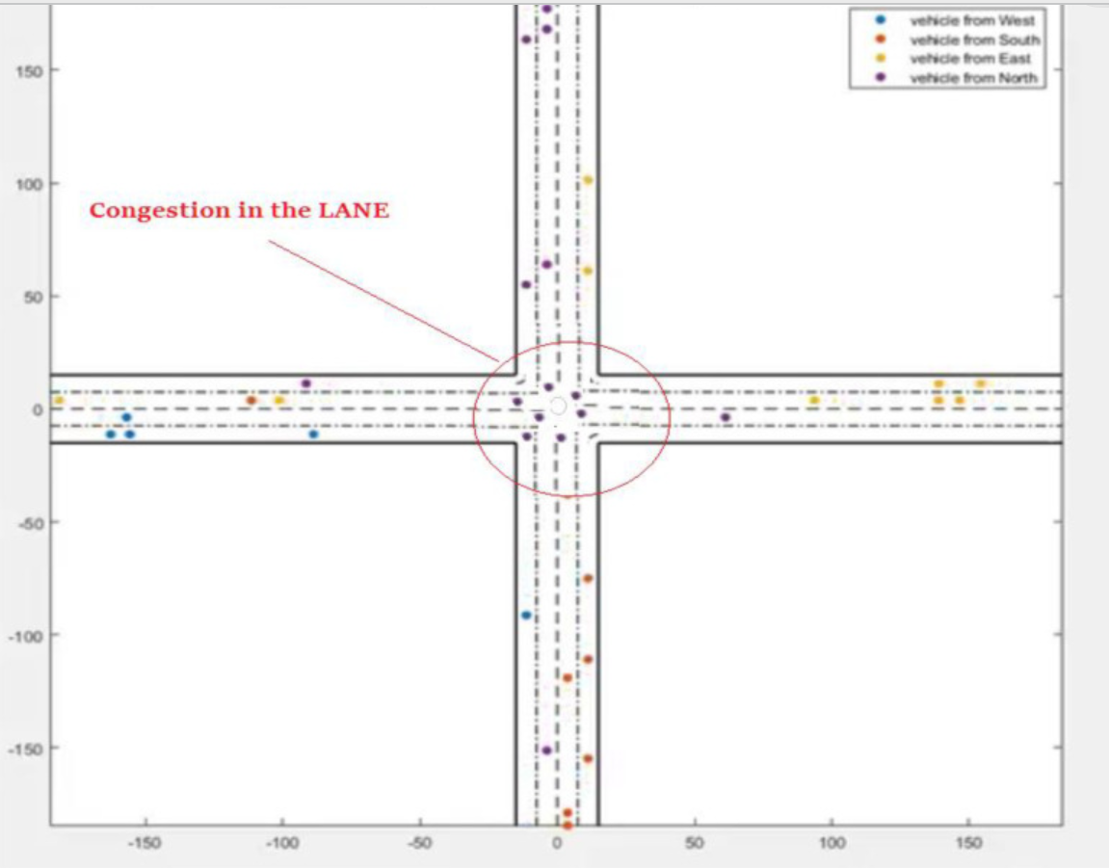

Vehicle movement based on signals received from RSUs.

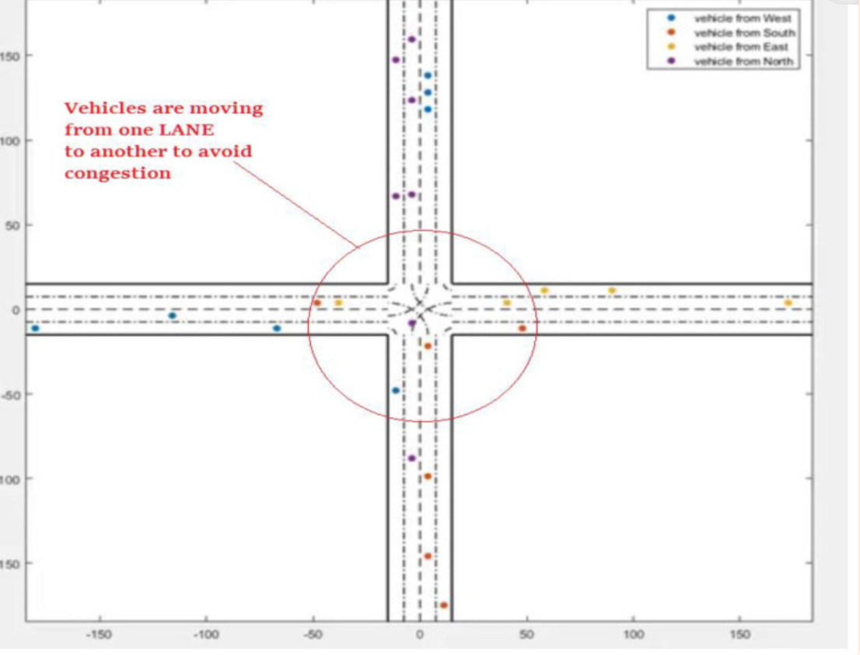

Conclusion

Automatic accident detection has become a popular topic in vehicular traffic-management systems. Surveillance of an accident can help us to avoid possible similar incidents in the future, and it will facilitate security agencies in reopening the road segment to a number of vehicles. We successfully demonstrated that vehicular activity could be evaluated, utilizing vehicular locations and average speeds. Additionally, abnormal events on the highway can be considered a future challenge for drivers who have already been nearest to the accident region. It was found that the proposed ATM system had a superior performance to the existing conventional systems.

Future work will integrate energy-efficient systems and security into the proposed ATM system. The proposed system will be implemented in a real-time environment in the place of the simulator with real-time traffic flow.