Iot gateway to monitor a temparature variation in surrounding

Block Daigram
Asure IOT
Raspberry pi(publishes the current temperatute on to the Mqtt
broker)
Flogo program(which subscribes to the Mqtt broker to get the temperature value)
Frontman app

Sends the data to clould
Creates a form and upload it onto the front man app

(3)

(1) (2)

(4)

(1) Raspberry Pi:
Rapberry Pi is a single board computer(ie the complete computer is built in single PCB board).
- Raspberry has a DHT11 a sensor(temparature humidity sensor) connected to it,where the sensor calculate the temparature and humidty arround it.
- The temperature value is a pulse always either 0 or 1,hence we need to convert them it to the degree celsius.
- To convert the pulse values we use a go lang program deployed inside Raspberry pi.
- The converted value of temparature is now to be sent to Asure IOT as well as the Front man application(isteer app).
- Hence we use a flogo Web UI,which is resposible to push the data on to Asure and Front man.
- But before that we need to send the temperature to Web UI hence we need to Publish that value on to MQTT broker.
- Why MQTT?
MQTT broker is a channel the follows Publisher Subscriber architecture where publisher is a responsible of posting data on to the channel and subcriber is responsible for consume the message posted.
PubSub architecture is nothing but a broker hepls in publishing the concerned message to the channel called “Topic”, where the messages are published and subscribed.
Here the Raspberry Pi is a broker which exposes the message on to the channel topic named as “topic”.Our flogo application is a subscriber which consumes the messages.

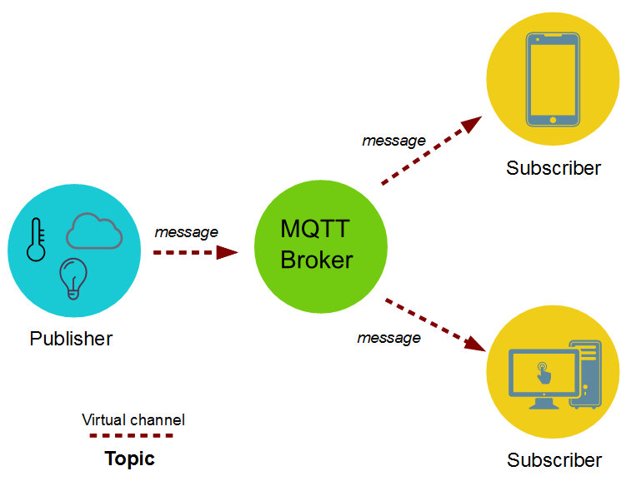
How to install and use MQTT inside Raspberry pi?
Step 1: Before installing the MQTT it is recommended to update and upgrade our raspberry pi by type the below command on ur command line after connecting to Rsapberry pi using “ssh” command.
sudo apt-get updat
sudo apt-get upgrade

Step 2: Now install MQTT as well as Clients.
sudo apt-get install mosquitto -y
sudo apt-get install mosquitto-clients -y

Step 3: now we need to configure the mosquitto broker inside file “/etc/mosquitto/mosquitto.conf”

sudo nano /etc/mosquitto/mosquitto.conf

Step 4: now u will see “include_dir /etc/mosquitto/conf.d” line inside the file delete that line. and add the below configaration at the bottom.
allow_anonymous false
password_file /etc/mosquitto/pwfile
listener 1883
The above command line says that MQTT should listen to the port 1883 and the subscrbers need to provide the username and password credentials to subscribe a topic.

Step 5: now we need to configure the username and password for the broker and reboot the raspberry pi hence we have just configured the credentials.
sudo mosquitto_passwd -c /etc/mosquitto/pwfile username
sudo reboot

Step 6: now to publish and subscribe you need to open two terminals of rapberry pi one to publish and one to subscribe.
Subscribe: mosquitto_sub -d -u username -P password -t test
publish: mosquitto_pub -d -u username -P password -t test -m "Hello, World!"
now the complete set up of MQTT is ready.

(2)Flogo Web UI:
Flogo is a ultra-light ,go based open source ecosystem for building event driven apps.
What are event driven application?
Event driven app comprises of two things triggers and actions, Triggers are responsible for starting an event or triggers an event. An action, a common interface, exposes key capabilities such as application integration, stream processing, etc.
We are using Flogo Web UI for Zero code developers. Flows Web UI is available via Docker Hub or Flogo.io. The Docker image contains the Flows Web UI along with all required components to begin developing, testing and building deployable artifacts right from your web browser.
Using this Web UI we have created two Micro-service application, One to start the Application and register the device on two the Azure Iot Hub. Another to recieve the incoming data from the MQTT publisher that is published from the Raspberrypi.

What are Micro-servivces?
Micro-services is an architectural style that structures an application as a collection of services that are:
- Highly maintainable and testable
- Loosely coupled
- Independently deployable
Azure IOT Hub:
IoT Hub is a managed service, hosted in the cloud, that acts as a central message hub for bi-directional communication between your IoT application and the devices it manages. You can use Azure IoT Hub to build IoT solutions with reliable and secure communications between millions of IoT devices and a cloud-hosted solution backend. You can connect virtually any device to IoT Hub.oT Hub supports communications both from the device to the cloud and from the cloud to the device. IoT Hub supports multiple messaging patterns such as device-to-cloud telemetry, file upload from devices, and request-reply methods to control your devices from the cloud. IoT Hub monitoring helps you maintain the health of your solution by tracking events such as device creation, device failures, and device connections.
IoT Hub's capabilities help you build scalable, full-featured IoT solutions such as managing industrial equipment used in manufacturing, tracking valuable assets in healthcare, and monitoring office building usage.

1) The 1st Micro-service is responsible to register the device on to the Azure Iot Hub on startup of the device.
To create a micro service go through the link below:
https://tibcosoftware.github.io/flogo

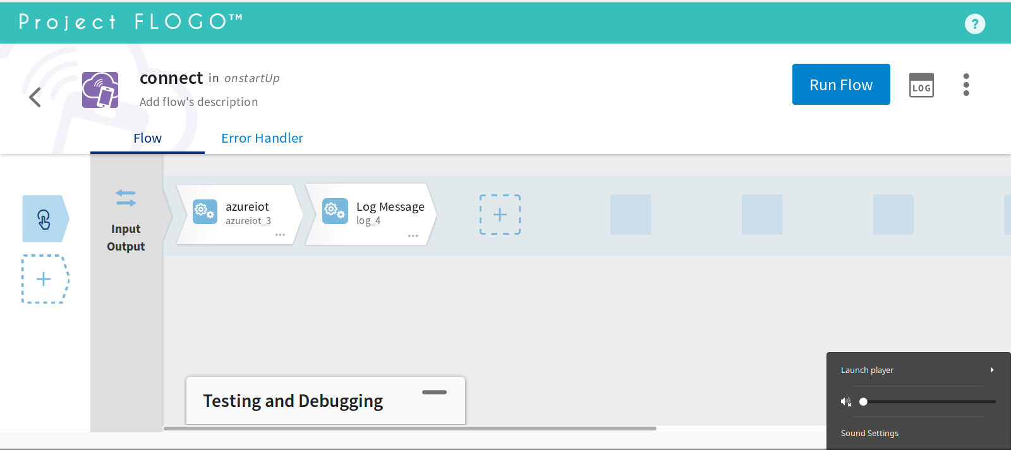
Figure 1
The image 1 represents the flow that registers the device on to the Azure IOT Hub,All the flows must contain a trigger(trigger is nothing but which starts up an activity). Here the trigger is a simple “Timer”(This trigger provides your flogo application the ability to schedule a flow via scheduling service) as shown in figure 2.

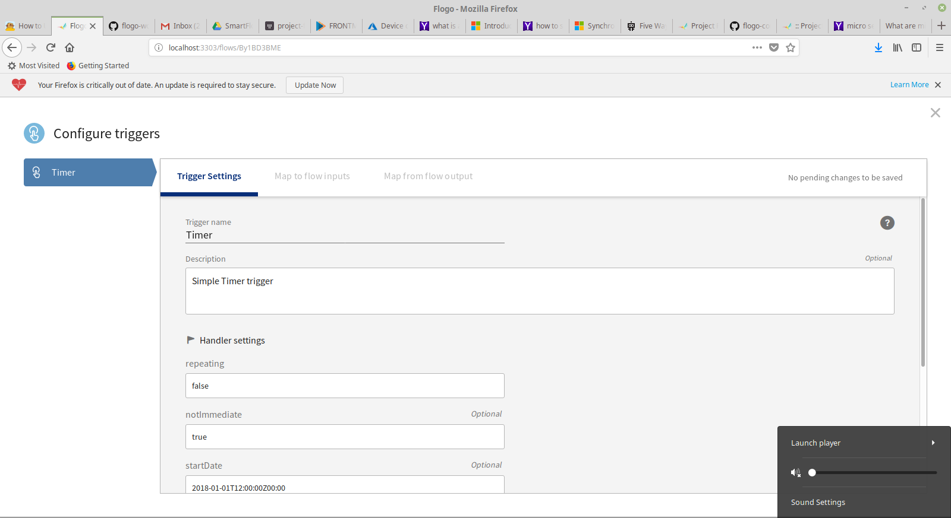
Figure 2
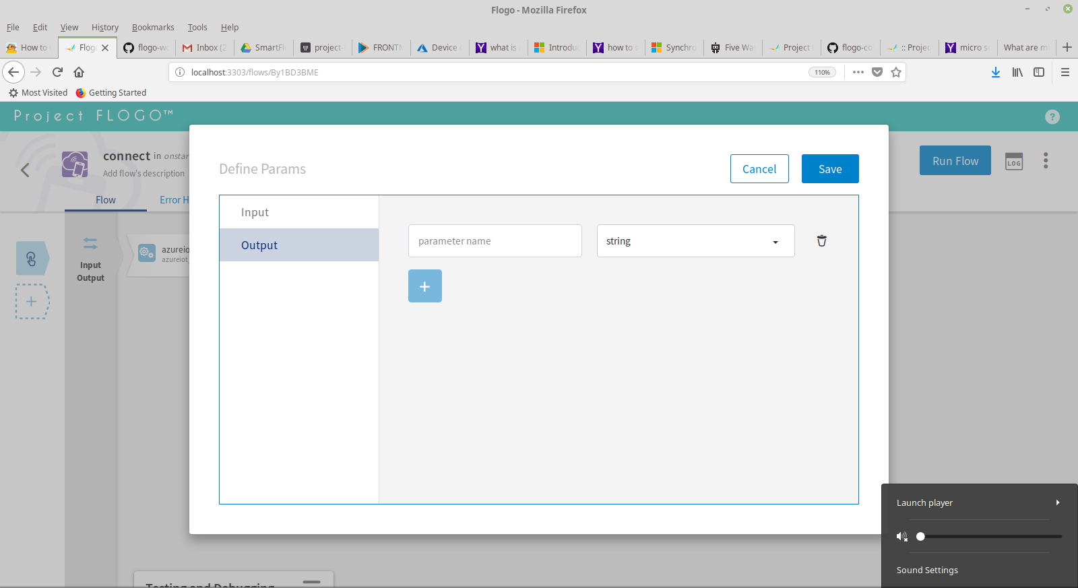
Input and Output of the flow are empty.

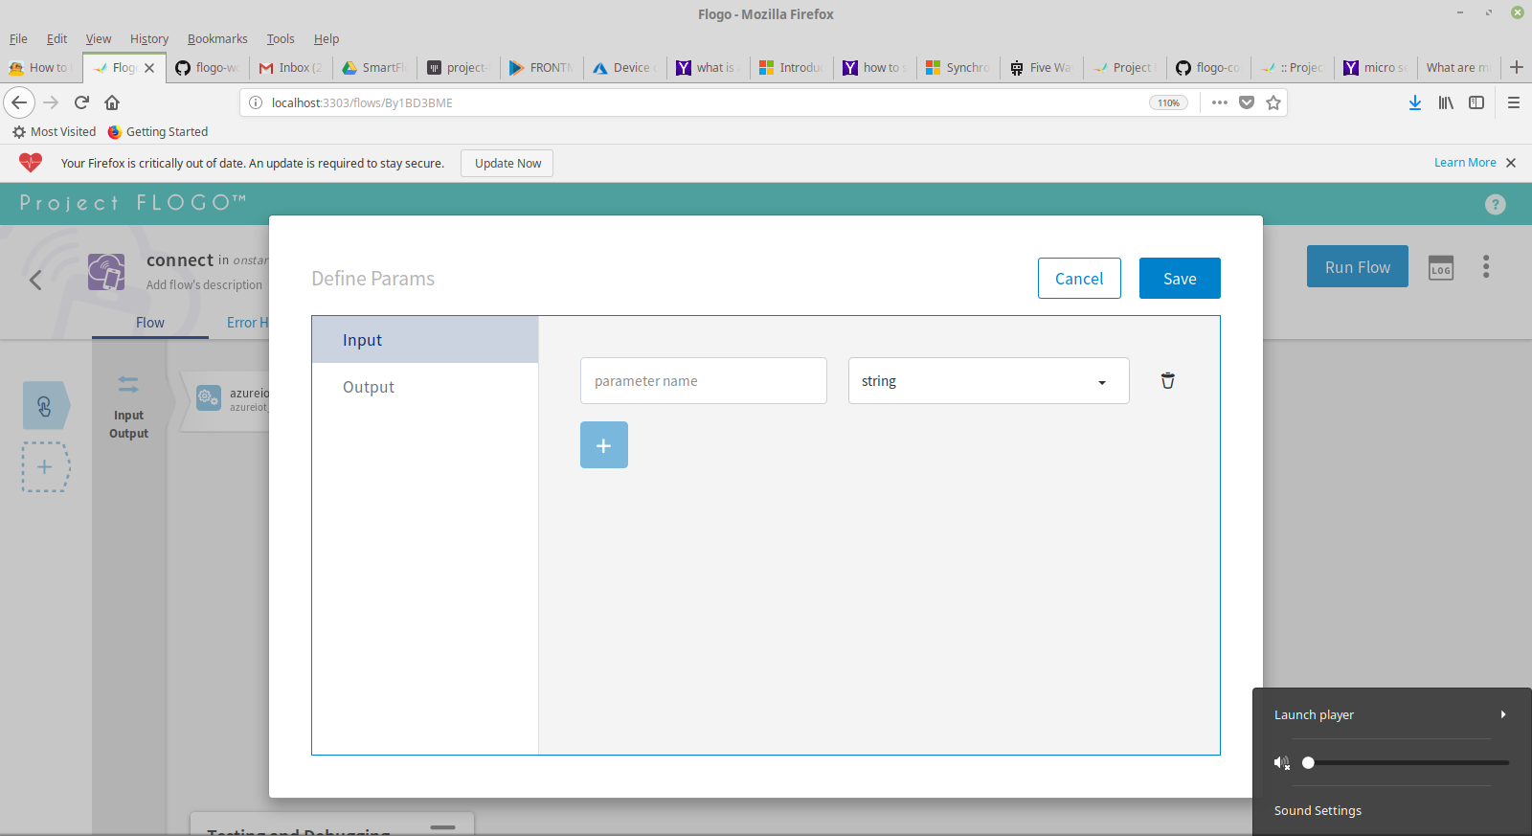

Figure 3
The Activity is responsible for a perticular action performing after a trigger, Here we are making use of “azureiot” to register the device on to the Azure IOT Hub.
- Device Id: is the name of the device that you need to be creating on the Hub
- Type of Operation: the type of operation you need to perform with device wheater to create or delete the device from the Hub
- Connection string: the string value that is responsible for connecting to the IOT Hub
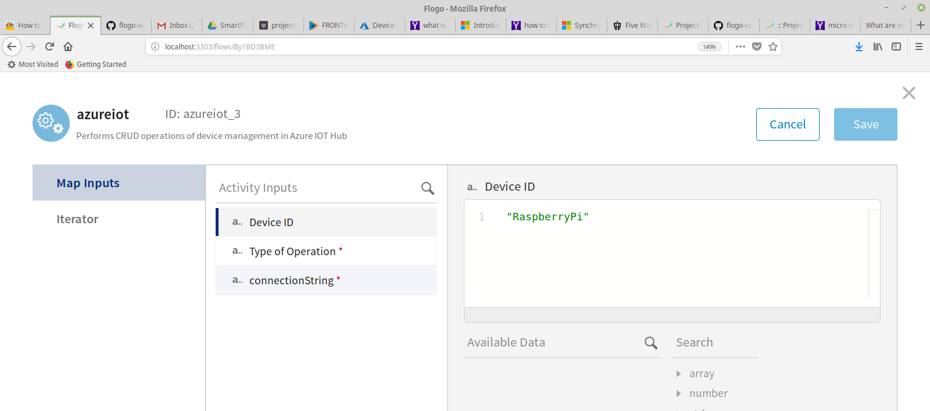

Figure 4
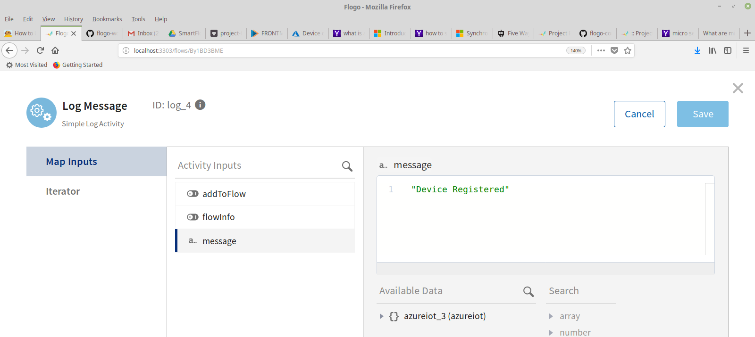
A simple Log to display or keep track of execution of the flow.
Figure 5

2] The Secound Activity:
The secound activity is responsible for subscribing the MQTT message from the Mosquitto publisher published by the RaspberryPi and submit a form to the Front-Man application and send a message to Azure Iot Hub.
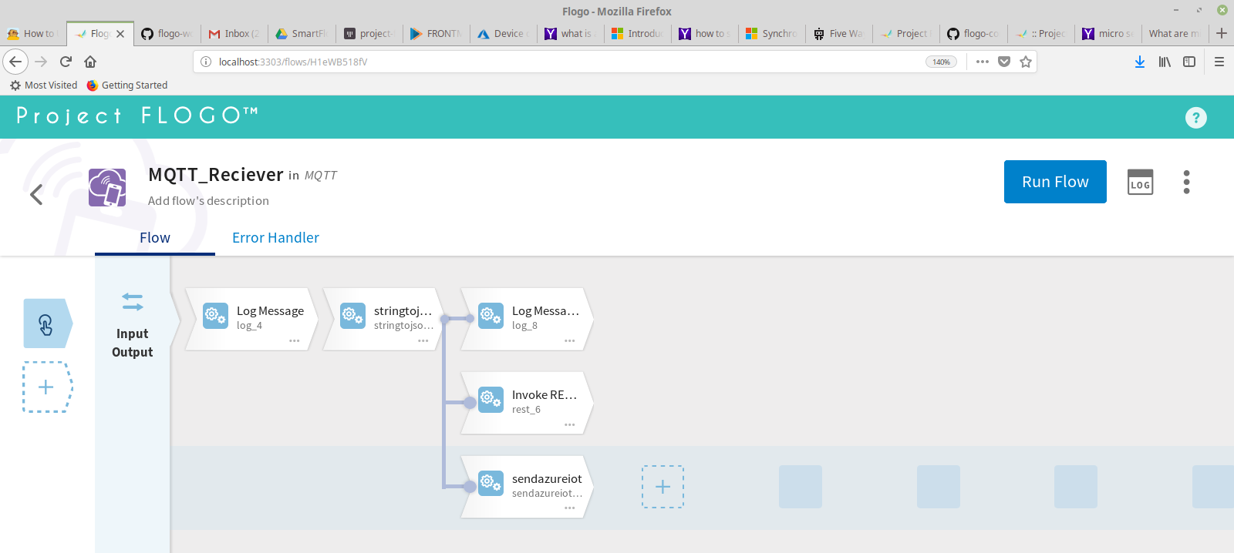
Figure 6
The Trigger used here is a recieve MQTT , That subscribes the published message on to a perticular topic.
- Broker: The IP adress of the subscriber and the port in the format “ipadress:port” in our case it is “192.168.1.92:1883”(ip adress of RaspberryPi)
- ID : is always the id of the subscribe ie “flogo”
- User : is the user name registered in the publisher
- Password : The password registered in the publisher

Note: “the username and password should match with the publisher user name and password hence for Autentication”.

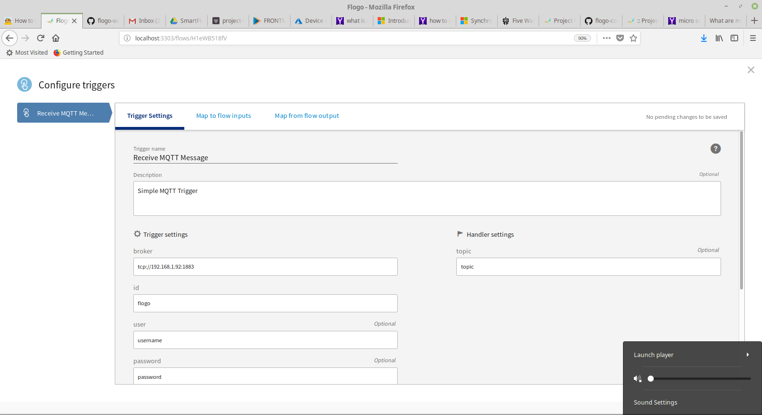
Figure 7
There are three main activities inside this flow:
- stringtoJson
- InvokeRestApi
- SendAsureIot
StringToJson:
The string to Json activity is responsible for breaking the incoming string message into a json object. The incoming string contains temperature as well as humidity value, hence to get those values induvidually we use a custom created activity called “stringtojson”.

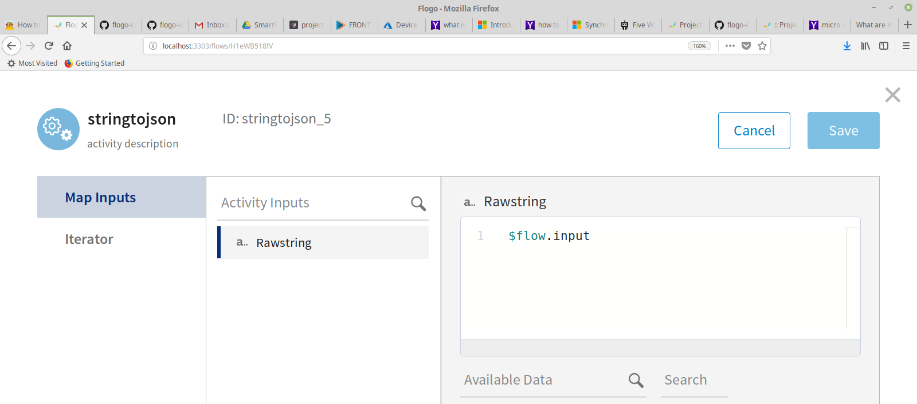
Figure 8

InvokeRestService:
This activity is to create a form and send data to the front-man application.
- Content : The Json file of creating a Form containing Temperature, Humidity and voltage values
- Header : This field contains the header that helps you to connect to the destination page
- Method : The action that needs to be performed on the destination page is to be specified(Post,Get,put,patch,delete)
- uri : The uri of the destination page

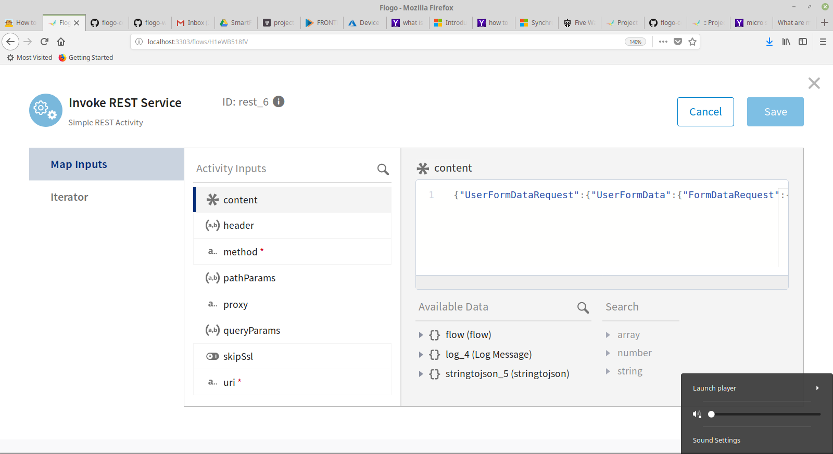
Figure 9
SendAzureIOT:
This activity helps us to send data to the AzureIotHub from our Flogo Web UI to the registered device.
- Action : The action that needs to be done with the device
- Device Id : The device id registered in the Hub
- Connection string : The connection string available in the Hub to get connected so that the activites are performed
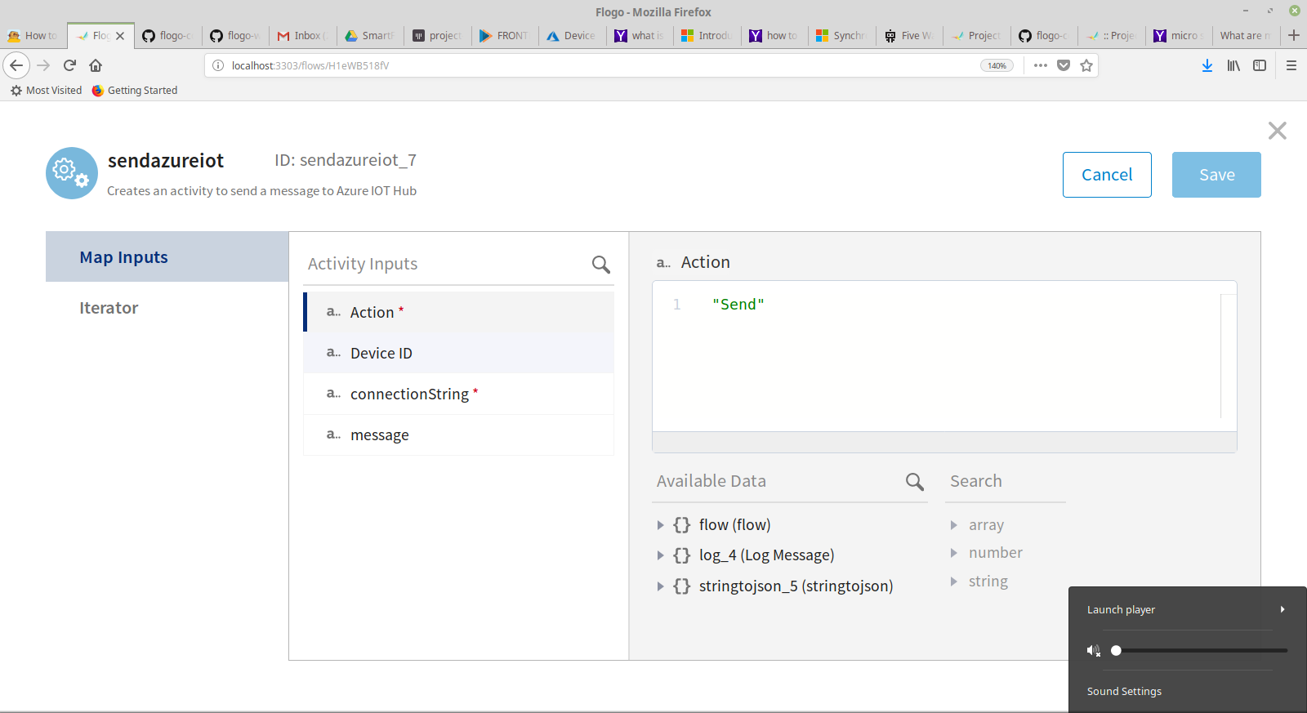
- message : The message that needs to be sent to the IOT Hub

Figure 10

