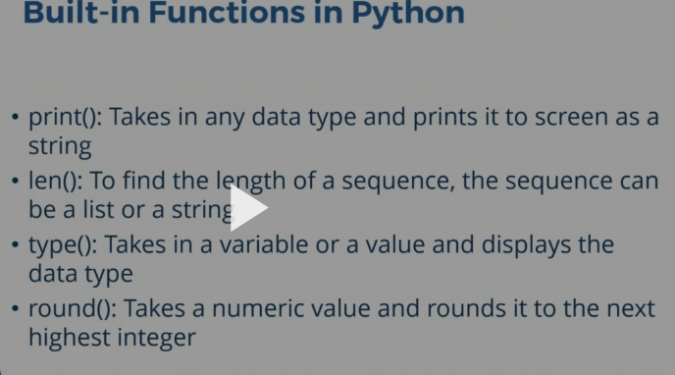

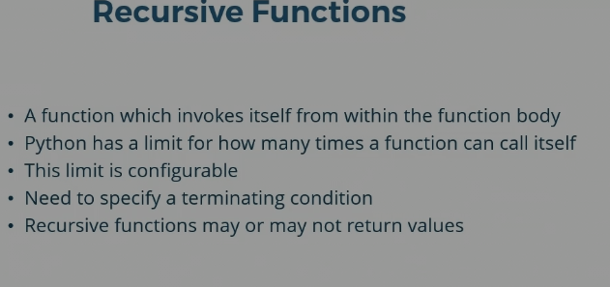
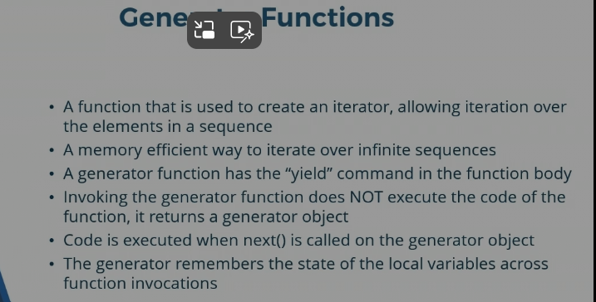
Infinite sequences cannot fit in a list because it won’t fit in Python memory. Therefore Generators are used for generating infinite lists.
It returns a generator object.

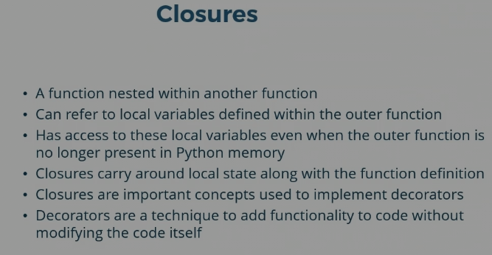

List.extends – for adding more than one value
List3 = list1 + list2
List.index(“6”)
List.remove()
List1 += list2
List.reverse()
List.pop()
List.count(el) – counts the number of times an element el occurs in a list.(case sensitive count)
List.clear – removes all elements from a list.
COPYING
Shallow copy
List1 = list2
List2 = copy.copy(list1)
Max(list)
Min(list)
Sum(list)
Len(list)

SORTING
List.sort() – sorts list in place, default order is ascending.
List_sorted = sorted(list1) – leaves original list unchanged.

List *= 2 – adds same elements again to the list.
List * = 2.0 - invalid
All(list) – returns true only if all the elements of a list are true(non-zero)
All([]) – TRUE
Any(list) – true if any one value is true
List[6:-1] = “value1”,”value2”
Replaces values at 6th and -1 index to value1 and value2
Set.discard(el) – doesn nothing if el not present in set.
Set.remove(el) – throws error

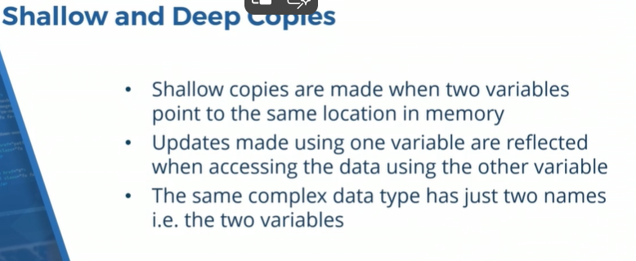

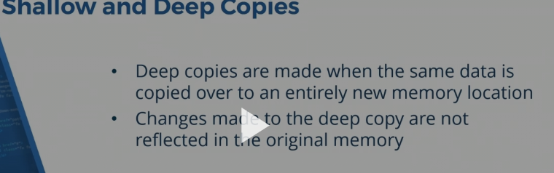

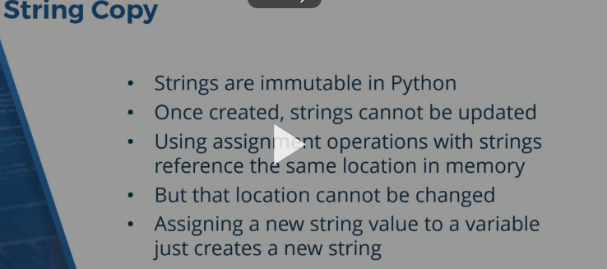

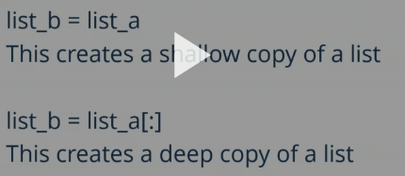
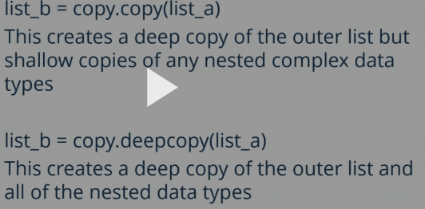
TUPLE COPY
T1 = t2
Shallow copy
For mutable nested objects inside tuple, shallow copy
Copy.copy() – shallow copy of tuple and nested lists
Copy.deepcopy() – deepcopy of nested mutable datatypes.

DICT COPY

Dict1

Copy.copy – deep copy of dict

Dict having an inner dict.
Copy.copy creates deep copy of outer dict but shallow copy of any nested complex data type.
Copy.deepcopy – creates deepcopy of nested complex data type also.

