Read the PDF and extract the last sentence of the paragraph from the PDF

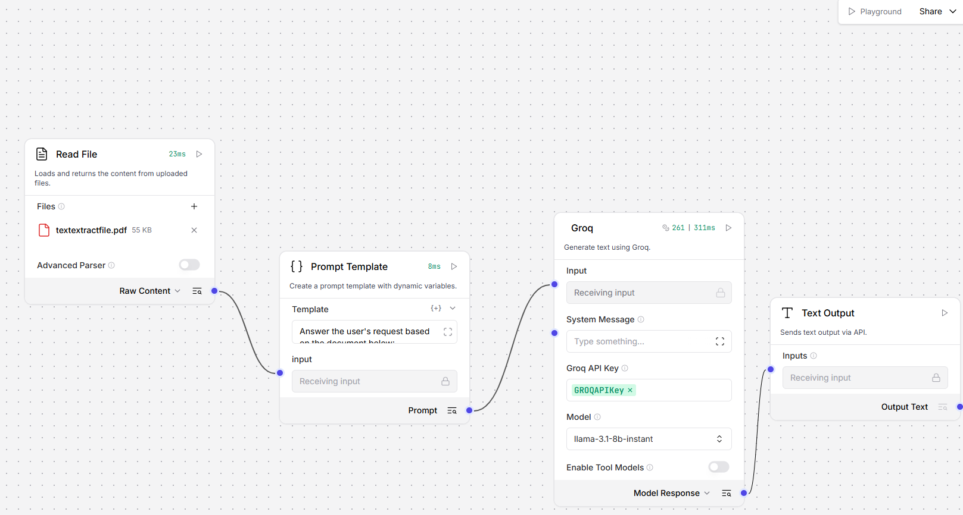

Raw Data when Read File is run:

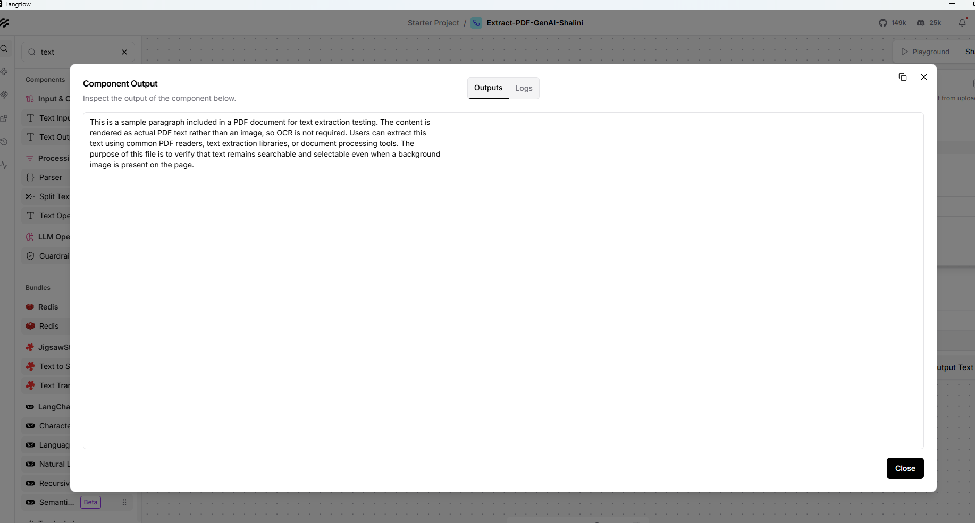

Prompt Template to extract the Last Sentence
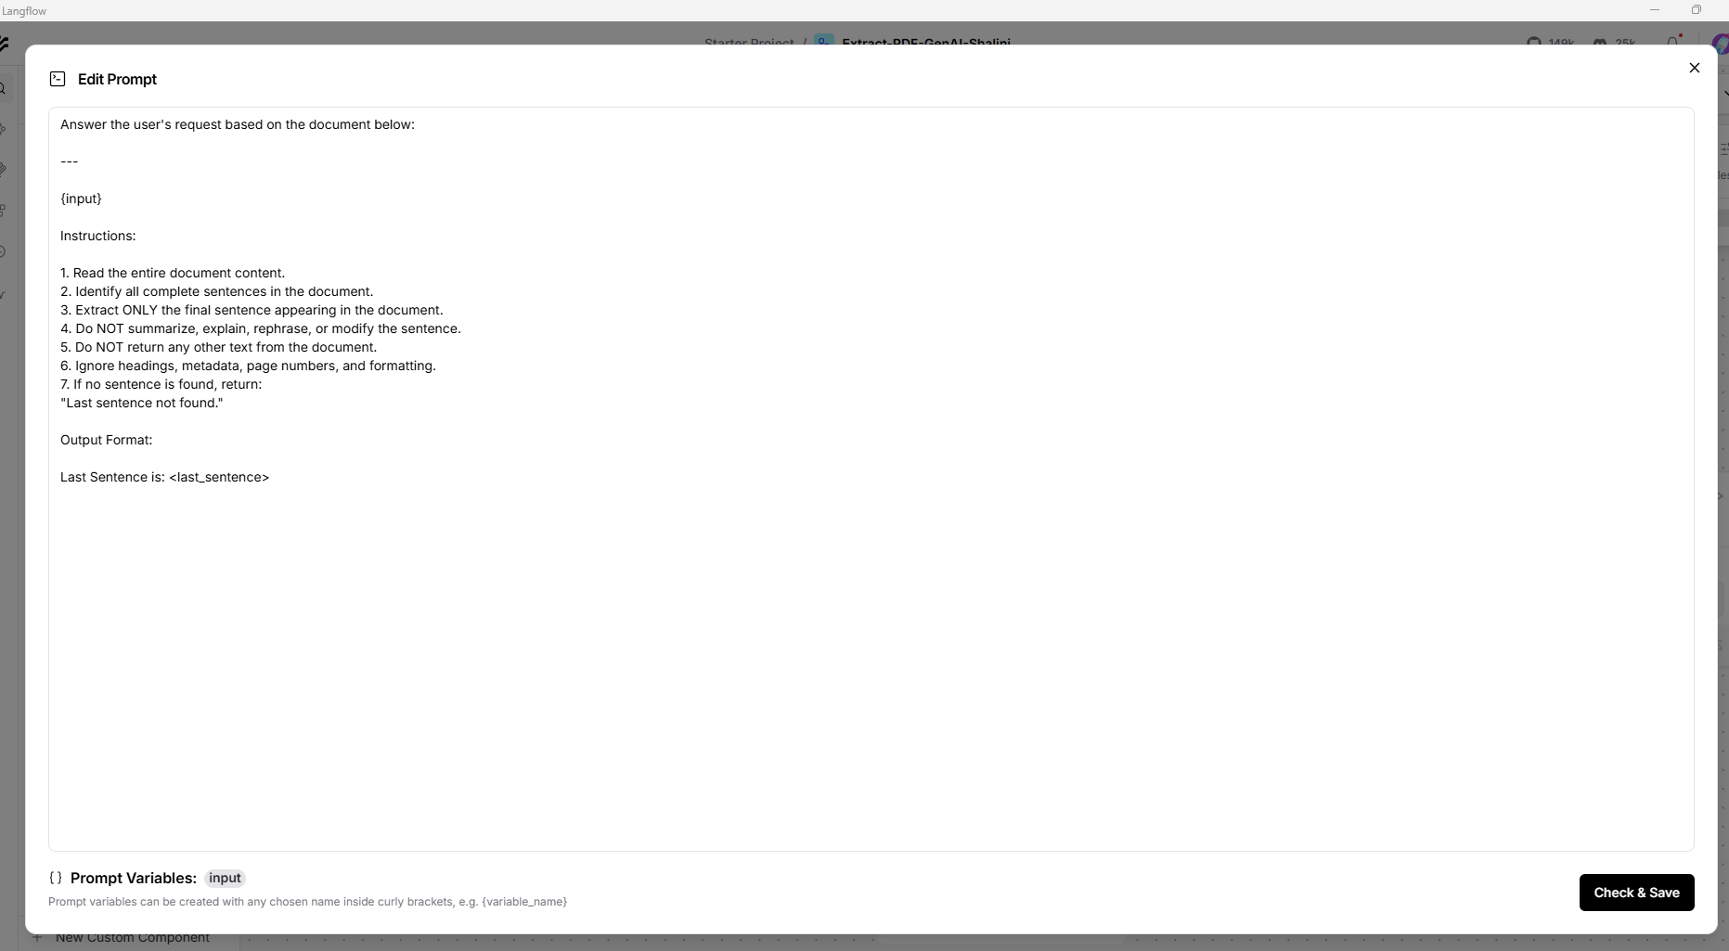

Output:

