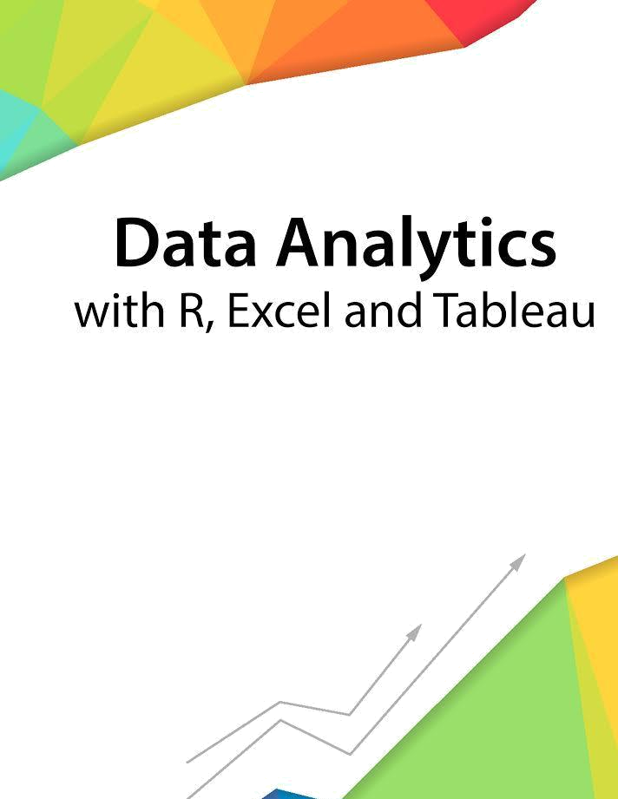

Session 7 – Basic Statistics

Assignment - 3



Contents

Introduction 2

Objective 2

Prerequisites 2

Associated Data Files 2

Problem Statement 2

Expected Output 2

Copyrights© 2017, AcadGild. All Rights Reserved | 1

Introduction

This assignment will help you to understand the key concepts learnt in this session.

Objective

This assignment will test your skills on basic statistics.

Prerequisites

Not Applicable

Associated Data Files

Not Applicable

Problem Statement

- Create a box and whisker plot by class using mtcars dataset.
X=mtcars[,c(1,3,4,5,6,7)]
Y=as.factor(mtcars[,10])
Featureplot(x=x,y=y,plot=”box”)

Expected Output

Not Applicable

Copyrights© 2017, AcadGild. All Rights Reserved | 2

