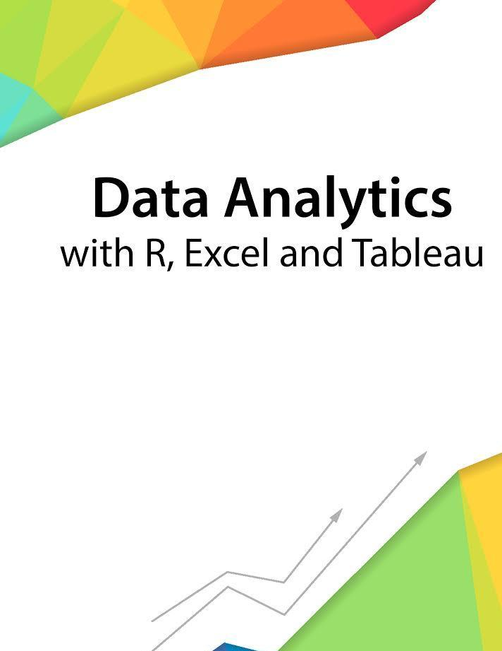

Session 12 – Non- Linear Models

Assignment - 2



Contents

Introduction 2
Objective 2
Prerequisites 2
Associated Data Files 2
Problem Statement 2
Expected Output 2

Copyrights© 2017, AcadGild. All Rights Reserved | 1

Introduction

This assignment will help you to understand the key concepts learnt in this session.

Objective

This assignment will test your skills on the Basics of Regression Analysis and Modeling using Non-linear Models.

Prerequisites

Not Applicable

Associated Data Files

Not Applicable

Problem Statement

1. Use the given link Data Set. Answer the below questions:

- What are the assumptions of ANOVA, test it out?
- Homogenity of variance
- Variable should have normal distribution

Plot(fit,1)
Library(car)
LevenTest(fit)

To test normal distribution
Plot(fit,2)
We cannot apply ANOVA test since both our assumptions are violated

- Why ANOVA test? Is there any other way to answer the above question?
Since we cannot apply multiple t-test at one go therefore we apply ANOVA test to test our hypothesis

Expected Output

Not Applicable

Copyrights© 2017, AcadGild. All Rights Reserved | 2

