s

Session 8 – Exploratory
Data Analytics

Assignment - 2

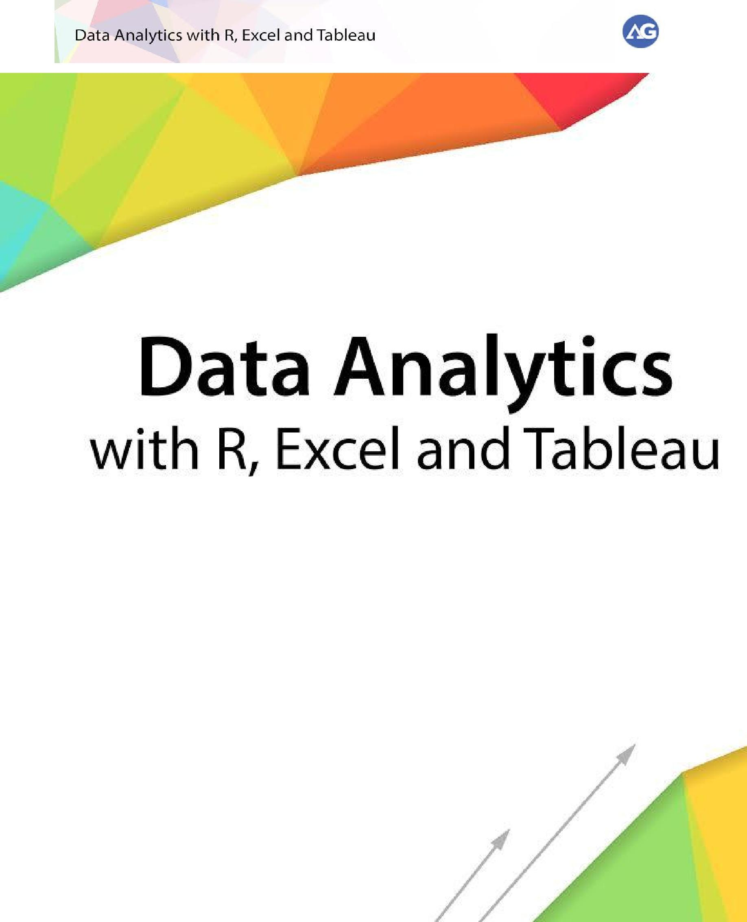


Contents

Introduction 3
Objective 3
Prerequisites 3
Associated Data Files 3
Problem Statement 3
Expected Output 3

Copyrights© 2017, AcadGild. All Rights Reserved | 2

Introduction

This assignment will help you to understand the key concepts learnt in this session.

Objective

This assignment will test your skills on Variables and Distributions in R.

Prerequisites

Not Applicable

Associated Data Files

Not Applicable

Problem Statement

library(RcmdrPlugin.IPSUR)

data(RcmdrTestDrive)

Perform the below operations:

- Compute the measures of central tendency for salary and reduction which variable has highest center?
median(reduction)

- Which measure of center is more appropriate for before and after?
hist(before)
hist(after)
Histogram plot will tell us the skewness
Expected Output
Not Applicable

Copyrights© 2017, AcadGild. All Rights Reserved | 3

