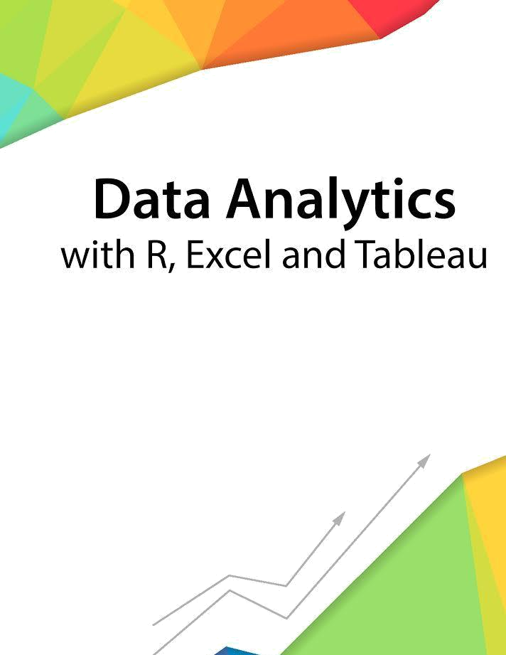

Session 6 – Visualization
and Plotting

Assignment - 2


Contents

Introduction 2

Objective 2

Prerequisites 2

Associated Data Files 2

Problem Statement 2

Expected Output 2

Copyrights© 2017, AcadGild. All Rights Reserved | 1

Introduction

This assignment will help you to understand the key concepts learnt in this session.

Objective

This assignment will test your skills on Visualization and Plotting operations in R.

Prerequisites

Not Applicable

Associated Data Files

Not Applicable

Problem Statement

- Import the Titanic Dataset from the link Titanic Data Set. Perform the following:

a. Is there any difference in fares by different class of tickets? Note - Show a boxplot displaying the distribution of fares by class
data1<- data.table(Titanic)
ggplot(data1, aes(x = factor(pClass), y =fare))+geom_boxplot(color=”red”,
fill=”green”)
labs(x=’Passenger Class’,y=”Fare”,title=”Fare VS Pclass”)
b. Is there any association with Passenger class and gender? Note – Show a stacked bar chart
ggplot( ggplot(data,aes(x=factor(pclass),fill=factor(sex)))+geom_bar(position=”dodge”)
library(dplyr)
library(tidyr)
data2<- data%>% group_by(pclass,sex)%>%tally()%>%mutate(percentage= n/sum(n)*100)
ggplot(data2,aes(sex,percentage,fill=factor(pclass)))+geom_bar(stat=’identity’,position=’dodge’)
Expected Output

Not Applicable

Copyrights© 2017, AcadGild. All Rights Reserved | 2

