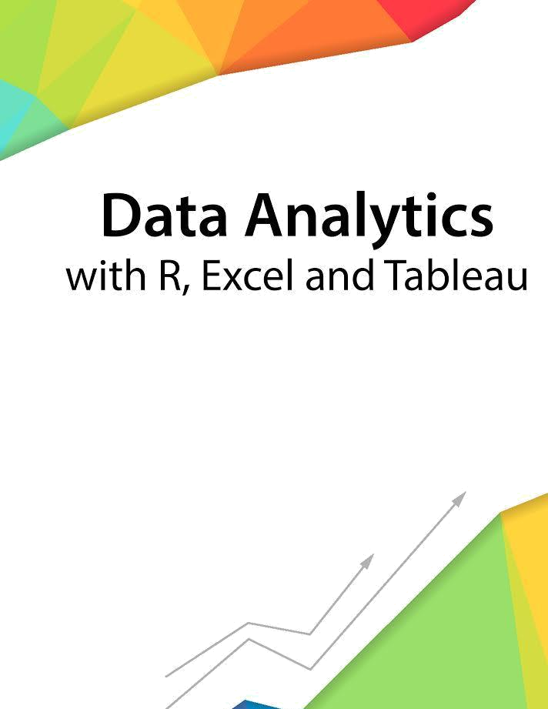

Session 6 – Visualization
and Plotting

Assignment - 1


Contents

Introduction 2

Objective 2

Prerequisites 2

Associated Data Files 2

Problem Statement 2

Expected Output 2

Copyrights© 2017, AcadGild. All Rights Reserved | 1

Introduction

This assignment will help you to understand the key concepts learnt in this session.

Objective

This assignment will test your skills on Visualization and Plotting operations in R.

Prerequisites

Not Applicable

Associated Data Files

Not Applicable

Problem Statement

- Import the Titanic Dataset from the link Titanic Data Set. Perform the following:
Data<-read.csv(“Titanic.csv”,na.strings=c(“”,” “ ”)
sapply(data$name,function(x)strsplit(as.character(x)split’[,.]’)[[1]][1])

  - Preprocess the passenger names to come up with a list of titles that represent families and represent using appropriate visualization graph.
library(ggplot2)
data$famsize<- data$sibsp+data$parch+1
data$family<- paste(data$Surname,data$famsize,sep=’_‘)
ggplot(data,aes(x=famsize,fill=factor(survived)))+geom_bar(stat=’count’,position=’dodge’)+scale_x_continuous(breaks=c(1:30))+labs(x=’Family Size’)+geom_text(stat=’count’,aes(label=..count..),size=4)

  - Represent the proportion of people survived from the family size using a graph.
library(ggplot2)
ggplot(data,aes(x=famsize,fill=factor(survived)))+geom_bar(stat=
count’,position=’dodge’)+scale_x_continous(breaks=c(1:30))+labs(x=’Family Size’)+ geom_text(stat=’count’,aes(label=..count..),size=4)
  - Impute the missing values in Age variable using Mice Library, create two different graphs showing Age distribution before and after imputation.
sum(is.na(data$age))
set.seed(129)
library(mice)
library(randomForest)
mice_mod<mice(data[,!names(data)%in%c(‘name’,’ticket’,’cabin’,’family’,’Surname’,’survived’)],method=’rf’)
mice_output<- complete(mice_mod)
par(mfrow=c(1,2))
hist(data$age,freq=F,main=’Age: Original Data’,col=’green’,ylim=c(0,0.04))
hist(mice_output$age,freq=F,main=’Age: MICE Output’,col=’red’, ylim=c(0,0.04))

Expected Output

Not Applicable

Copyrights© 2017, AcadGild. All Rights Reserved | 2

