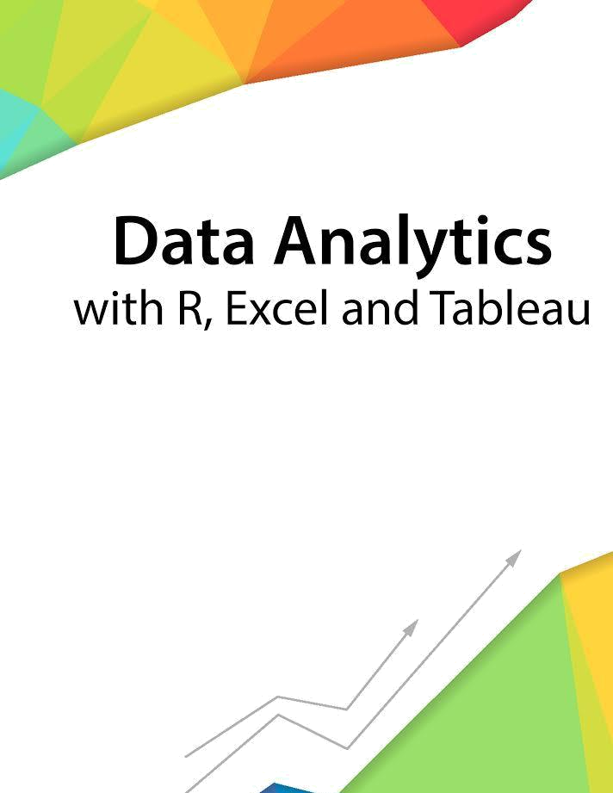

Session 2 – Introduction

Assignment - 1



Contents

Introduction 2

Objective 2

Prerequisites 2

Associated Data Files 2

Problem Statement 2

Expected Output 3

Copyrights© 2017, AcadGild. All Rights Reserved | 1

Introduction

This assignment will help you to understand the key concepts learnt in this session.

Objective

This assignment will test your skills on the basics of functions in R.

Prerequisites

Not Applicable

Associated Data Files

Not Applicable

Problem Statement

- What are the different methods to call a function in R?
There are two methods to call a function :- position based and name based

- The lazy evaluation of a function means, the argument is evaluated only if it is evaluated only if it is used inside the body of the function. Say True or False. TRUE

- State True or False:

- Insights driven from descriptive analytics is not meaningful. FALSE

- The number of values in each Elements of a list, should be equal. FALSE

- The datasets are not stored in memory of the computer using R. FALSE

- Data frames and matrices are two dimensional however the array is multidimensional. TRUE

Copyrights© 2017, AcadGild. All Rights Reserved | 2

Expected Output

Not Applicable

Copyrights© 2017, AcadGild. All Rights Reserved | 3

