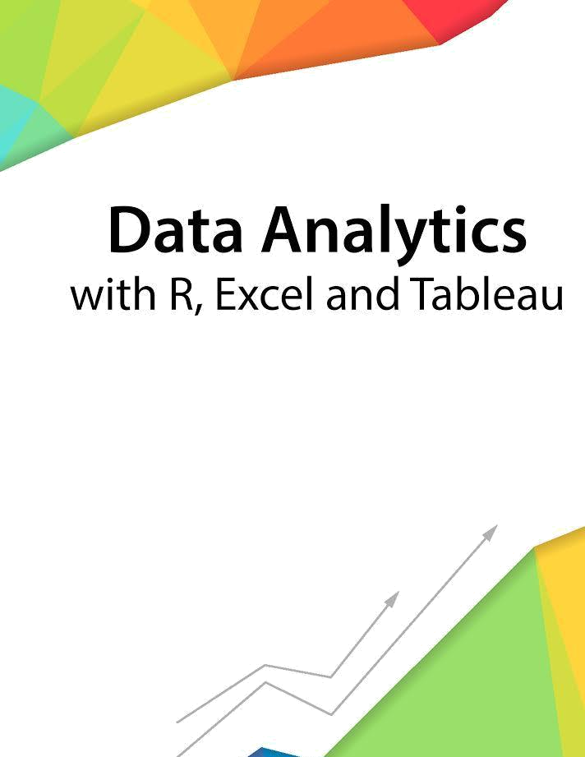

Session 1 - Introduction

Assignment - 1



––

Contents

1. Introduction 2

2. Objective 2

3. Prerequisites 2

4. Associated Data Files 2

5. Problem Statement 2

6. Expected Output 2

Copyrights© 2017, AcadGild. All Rights Reserved | 1

Introduction

This assignment will help you to understand the key concepts learnt in this session.

Objective

This assignment will test your skills on the basics of Data Analytics

Prerequisites

Not Applicable

Associated Data Files

Not Applicable

Problem Statement

1. Say True or False for the below statements:

- Prescriptive Analytics used to predict the future outcomes? TRUE

- Base R packages installed automatically? TRUE

Βase packages are built-in functions, so they are installed already in R

2. What is Recycling of elements in a vector?

When applying an operation to two vectors that requires them to be the same length, R automatically recycles, or repeats, the shorter one, until it is long enough to match the longer one

3. Give an example of recycling of elements.
a<- c(1,2,3,4),
rep(a,5)
Here rep of a will generate the vector elements 5 times in the specified order.
c(1,2,3) + c(2,3,4) . The result will be 3,5,7. So recycling will automatically does the operation element wise based on the indexing.

- Expected Output

Not Applicable

Copyrights© 2017, AcadGild. All Rights Reserved | 2

