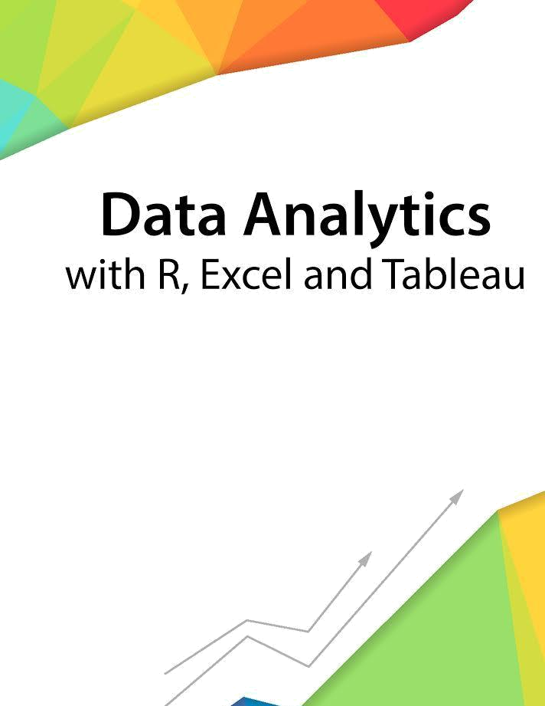

Session 3 – Introduction to working with R

Assignment - 2


Contents

Introduction 2

Objective 2

Prerequisites 2

Associated Data Files 2

Problem Statement 2

Expected Output 2

Copyrights© 2017, AcadGild. All Rights Reserved | 1

Introduction

This assignment will help you to understand the key concepts learnt in this session.

Objective

This assignment will test your skills on Operations on Data Structures in R.

Prerequisites

Not Applicable

Associated Data Files

Not Applicable

Problem Statement

- Define matrix mymat by replicating the sequence 1:5 for 4 times and transforming into a matrix, sum over rows and columns.
mymat<- matrix(rep(seq(5),4), ncol=5)
apply(mymat,1,sum)
apply(mymat,2,sum)

Expected Output

Not Applicable

Copyrights© 2017, AcadGild. All Rights Reserved | 2

