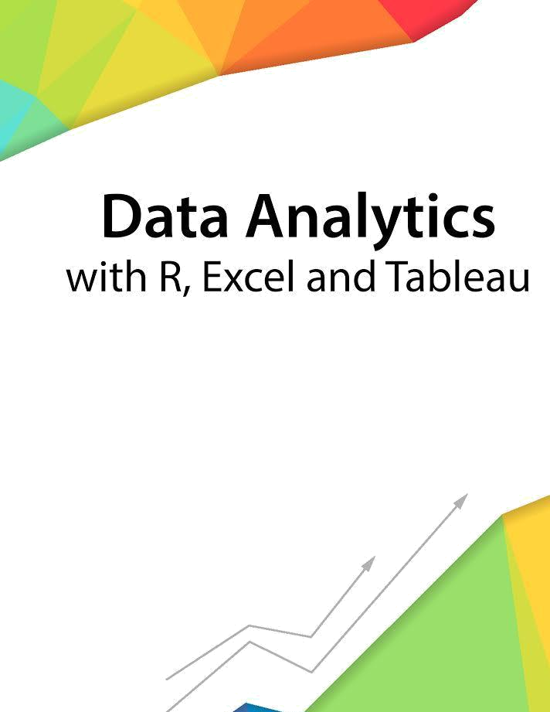

Session 3 – Introduction to working with R

Assignment - 1


Contents

Introduction 2

Objective 2

Prerequisites 2

Associated Data Files 2

Problem Statement 2

Expected Output 2

Copyrights© 2017, AcadGild. All Rights Reserved | 1

Introduction

This assignment will help you to understand the key concepts learnt in this session.

Objective

This assignment will test your skills on the basics of R.

Prerequisites

Not Applicable

Associated Data Files

Not Applicable

Problem Statement

- How to Import SAS XPORT files into R with the foreign package?
library(foreign)
x<- read.xport("C:/carsdata/cars2.xpt")

- How to Import SAS Files into R with the Haven package?
library(haven)
x<- read_sas("record2014_dataset.sas7bdat")

- How to read Weka Attribute-Relation File Format (ARFF) files in R?
library (RWeka)
Testresults<- read.arff(“C:/records_12/test.arff”)

- How to read a heavy csv/tsv file using readr package?
library(readr)
output<- read_csv(file, col_names = TRUE)
output<- read_tsv(file, col_names = TRUE)

Expected Output

Not Applicable

Copyrights© 2017, AcadGild. All Rights Reserved | 2

