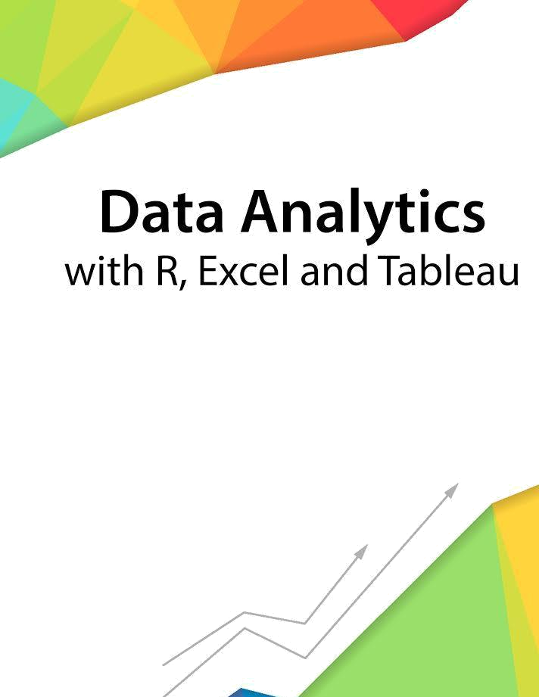

Session 11 – Linear Models

Assignment - 1



Contents

Introduction 2

Objective 2

Prerequisites 2

Associated Data Files 2

Problem Statement 2

Expected Output 2

Copyrights© 2017, AcadGild. All Rights Reserved | 1

Introduction

This assignment will help you to understand the key concepts learnt in this session.

Objective

This assignment will test your skills on the Basics of Regression Analysis and Modeling.

Prerequisites

Not Applicable

Associated Data Files

Not Applicable

Problem Statement

- Use the given link and locate the bank marketing dataset. Data Set Link Perform the below operations:

a. Create a visual for representing missing values in the dataset.
Dataset<- read.csv(file.choose(),sep=”;”)
View(Dataset)
sum(is.na(Dataset))
library(Amelia)
missmap(Dataset)
b. Show a distribution of clients based on a Job.
Distribution<-ggplot(Dataset,aes(“Clients”,y=”job”))+geom_bar(width=1.5)
Pie_dist<- Distribution+coord_polar(“Job”,start=0)
Pie_dist

- Check whether is there any relation between Job and Marital Status?
Chisquare.test(Dataset$Job, Dataset$ Marital Status)

- Check whether is there any association between Job and Education?
- Chisquare.test(Dataset$Job, Dataset$ Education)

- Expected Output

Not Applicable

Copyrights© 2017, AcadGild. All Rights Reserved | 2

