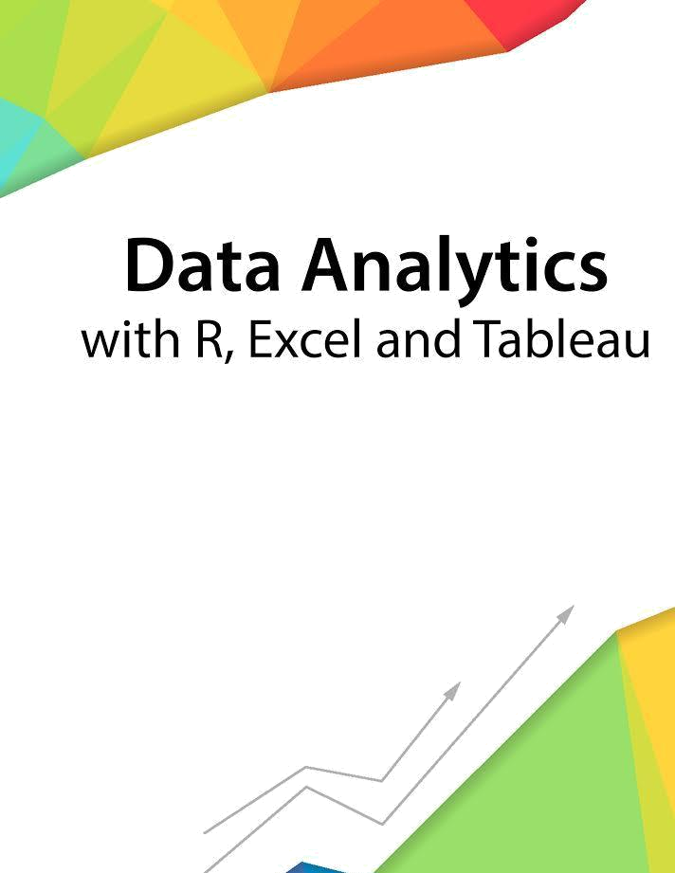

Session 7 – Basic Statistics

Assignment - 1



Contents

Introduction 2

Objective 2

Prerequisites 2

Associated Data Files 2

Problem Statement 2

Expected Output 2

Copyrights© 2017, AcadGild. All Rights Reserved | 1

Introduction

This assignment will help you to understand the key concepts learnt in this session.

Objective

This assignment will test your skills on basic statistics.

Prerequisites

Not Applicable

Associated Data Files

Not Applicable

Problem Statement

- Histogram for all variables in a dataset mtcars. Write a program to create histograms for all columns.
library(reshape2)
library(ggplot2)
ggplot(data = melt(mtcars), mapping = aes(x = value))+geom_histogram(bins = 10) + facet_wrap(~variable, scales = 'free_x')

- Check the probability distribution of all variables in mtcars
Data(mtcars)
Par(‘mar’)
Par(mar=c(1,1,1,1))
par=(mfrow=c(3,4))
for(I in 1:ncol(mtcars)){
hist(Mtcars[,i],main=names)[i])

- Write a program to create boxplot for all variables.
mtcars %>% select(gear,mpg,disp:qsec) %>% gather(measure,value,-gear) %>%ggplot(aes(x=factor(gear),y=value))+geom_boxplot(~measure,scales=”free_y”)

Expected Output

Not Applicable

Copyrights© 2017, AcadGild. All Rights Reserved | 2

