Develop an AI-Powered System Utility (e.g., Intelligent Mail Manager or AI Bot for CLI Commands)
Aim:
To develop an AI-powered system utility using Python that acts as a simple Command Line Interface (CLI) Bot for executing common system commands based on user input.
Objectives
After completing this experiment, students will be able to:
- Understand the concept of AI-powered system utilities.
- Learn how AI assists in command interpretation.
- Develop a simple AI bot for CLI commands using Python.
- Automate common system tasks.
- Execute Linux system commands through natural language-like input.
Theory
AI-Powered System Utility
An AI-powered system utility is a software application that uses Artificial Intelligence techniques to automate system administration tasks or assist users in interacting with the operating system.
Examples include:
- Intelligent Mail Manager
- AI Chatbot
- Command Line Assistant
- Smart File Manager
- Voice-based System Assistant
AI Bot for CLI Commands
A CLI (Command Line Interface) Bot accepts user requests, analyzes the input, and executes the appropriate system command.
The bot uses simple AI logic such as:
- Keyword matching
- Rule-based decision making
- Command mapping
For example:

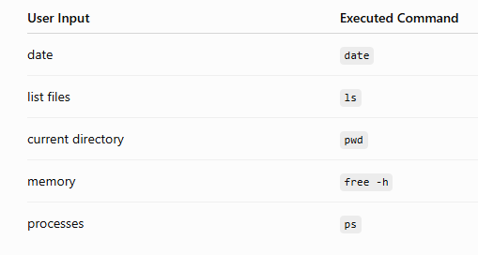
Algorithm
- Start.
- Accept user input.
- Convert the input to lowercase.
- Compare the input with predefined keywords.
- Execute the corresponding system command.
- Display the output.
- Repeat until the user enters exit.
- Stop.
Program
import os
print("===== AI CLI Bot =====")
print("Type 'exit' to quit.\n")
while True:
command = input("You: ").lower()
if command == "date":
os.system("date")
elif command == "list files":
os.system("ls")
elif command == "current directory":
os.system("pwd")
elif command == "memory":
os.system("free -h")
elif command == "processes":
os.system("ps")
elif command == "help":
print("Available Commands:")
print("date")
print("list files")
print("current directory")
print("memory")
print("processes")
print("exit")
elif command == "exit":
print("AI Bot Closed.")
break
else:
print("Sorry! Command not recognized.")
Sample Input
date
list files
current directory
memory
exit
Sample Output
===== AI CLI Bot =====
Type 'exit' to quit.

You: date
Tue Apr 16 11:20:45 IST 2024

You: list files
main.py
data.txt

You: current directory
/home/student

You: memory
total used free
...

You: exit
AI Bot Closed.
Explanation
- The program uses the os module to execute Linux system commands.
- The user enters commands in simple text form.
- The input is converted to lowercase for easy comparison.
- The program uses if-elif statements as a simple AI decision-making mechanism.
- Based on the recognized keyword, the corresponding Linux command is executed using os.system().
- The bot continues accepting commands until the user types exit.
Input
- Simple user commands such as:
  - date
  - list files
  - current directory
  - memory
  - processes
  - help
  - exit
Output
You: current directory
/home/student

You: processes
PID TTY TIME CMD

You: exit
AI Bot Closed.
Applications
- Intelligent Command-Line Assistants
- System Administration
- AI-Based Automation
- Technical Support Tools
- Smart Operating System Utilities
- Server Monitoring
- Virtual Assistants
Advantages
- Automates frequently used system commands.
- Easy to use and extend.
- Reduces manual typing of commands.
- Demonstrates AI-based command interpretation.
- Improves user productivity.
Disadvantages
- Supports only predefined commands.
- Cannot understand complex natural language.
- Requires modification to add new features.
- Limited compared to advanced AI assistants.
Result

