**class 8 : Bash Script Tasks**

**conditions/ifelse statements:**

**If then statement:**

**If this happens=do this otherwise=do this**

**Example1:**

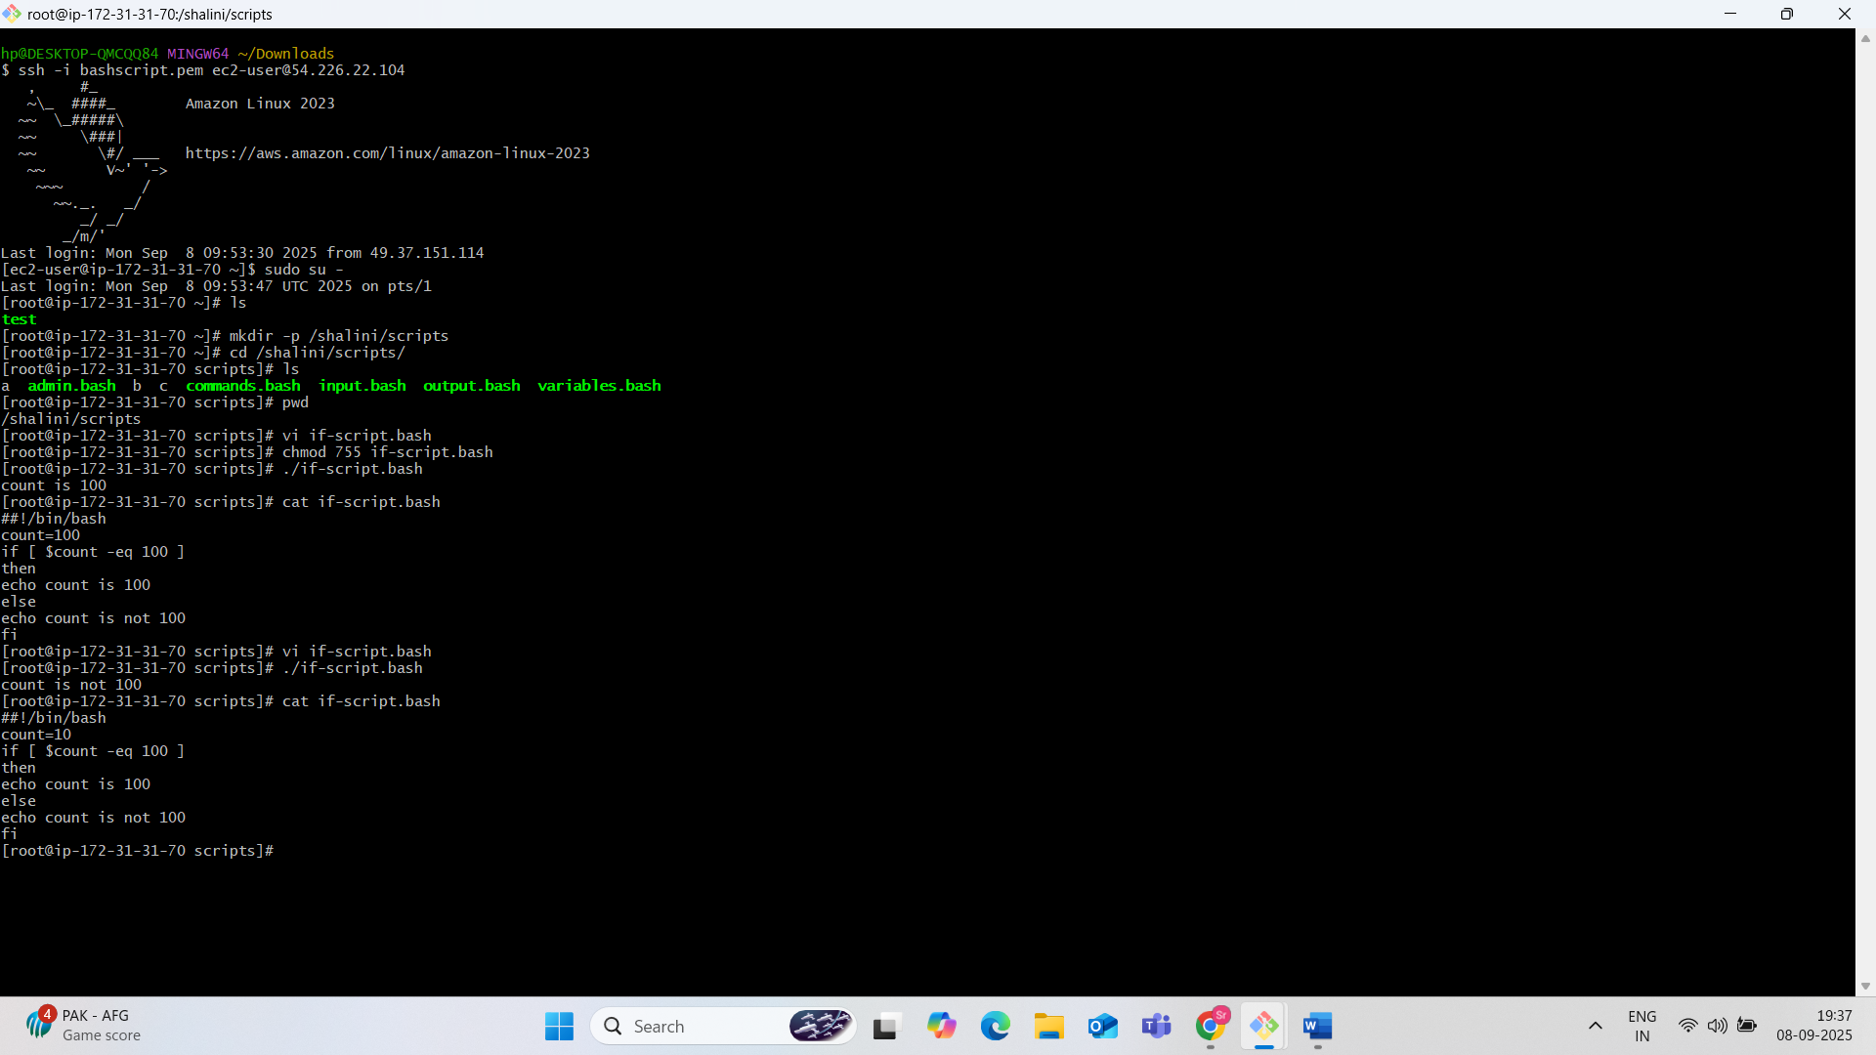

**Example 2:**

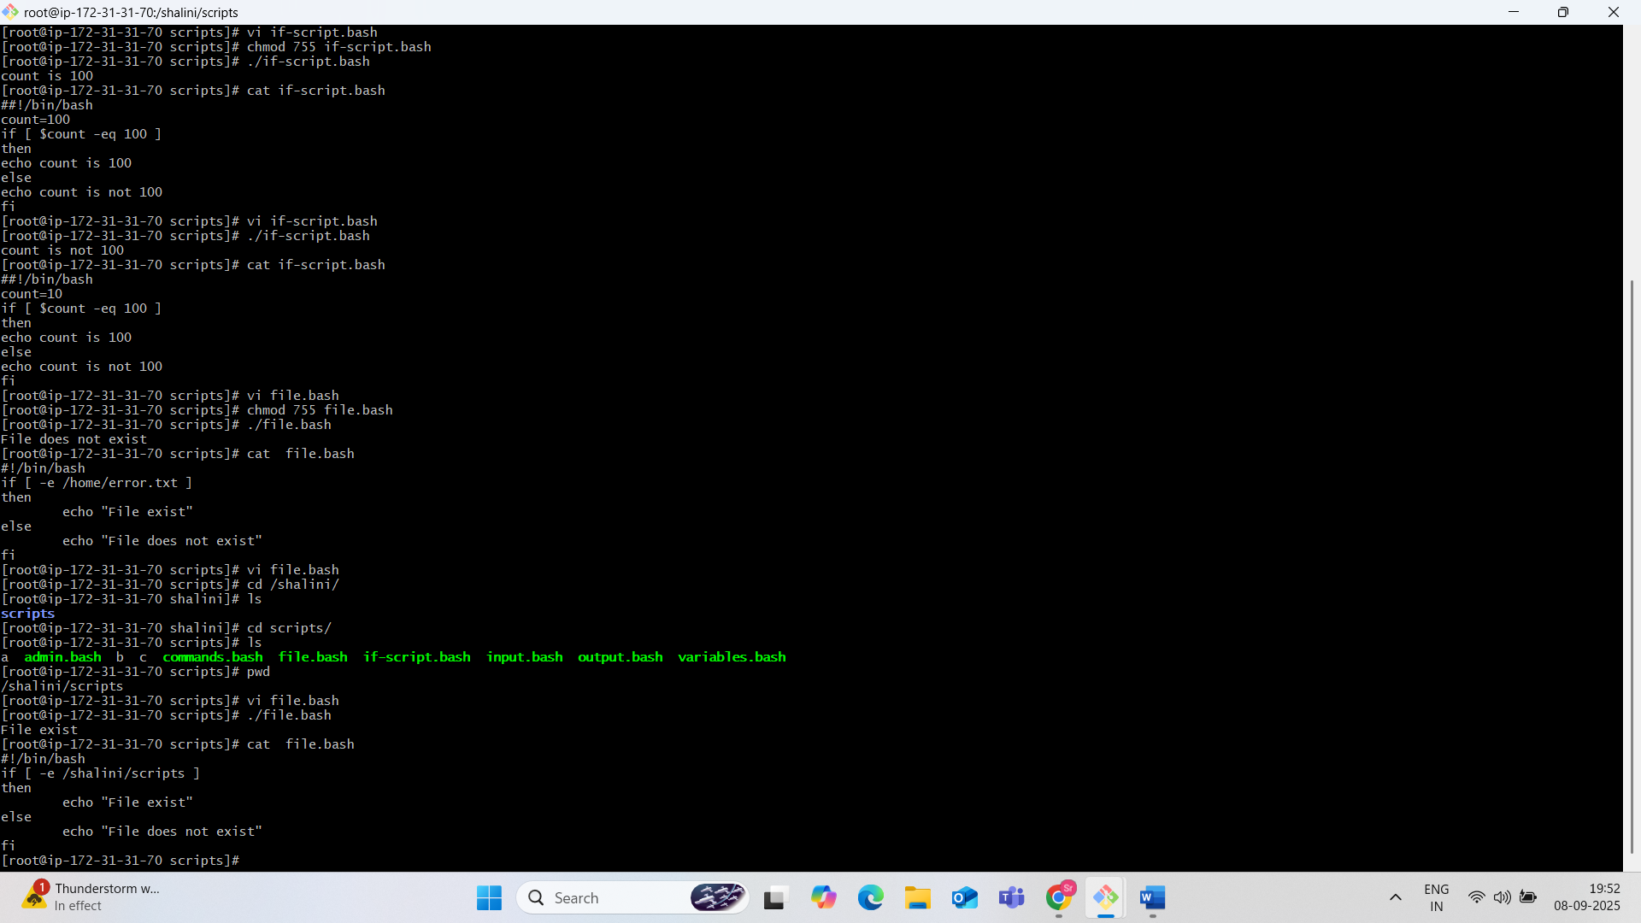

**Case statement scripts:**

**This will be used when we have multiple options to script**

**Case:**

**If option a is selected=do this**

**If option b is selected=do this**

**Example:**

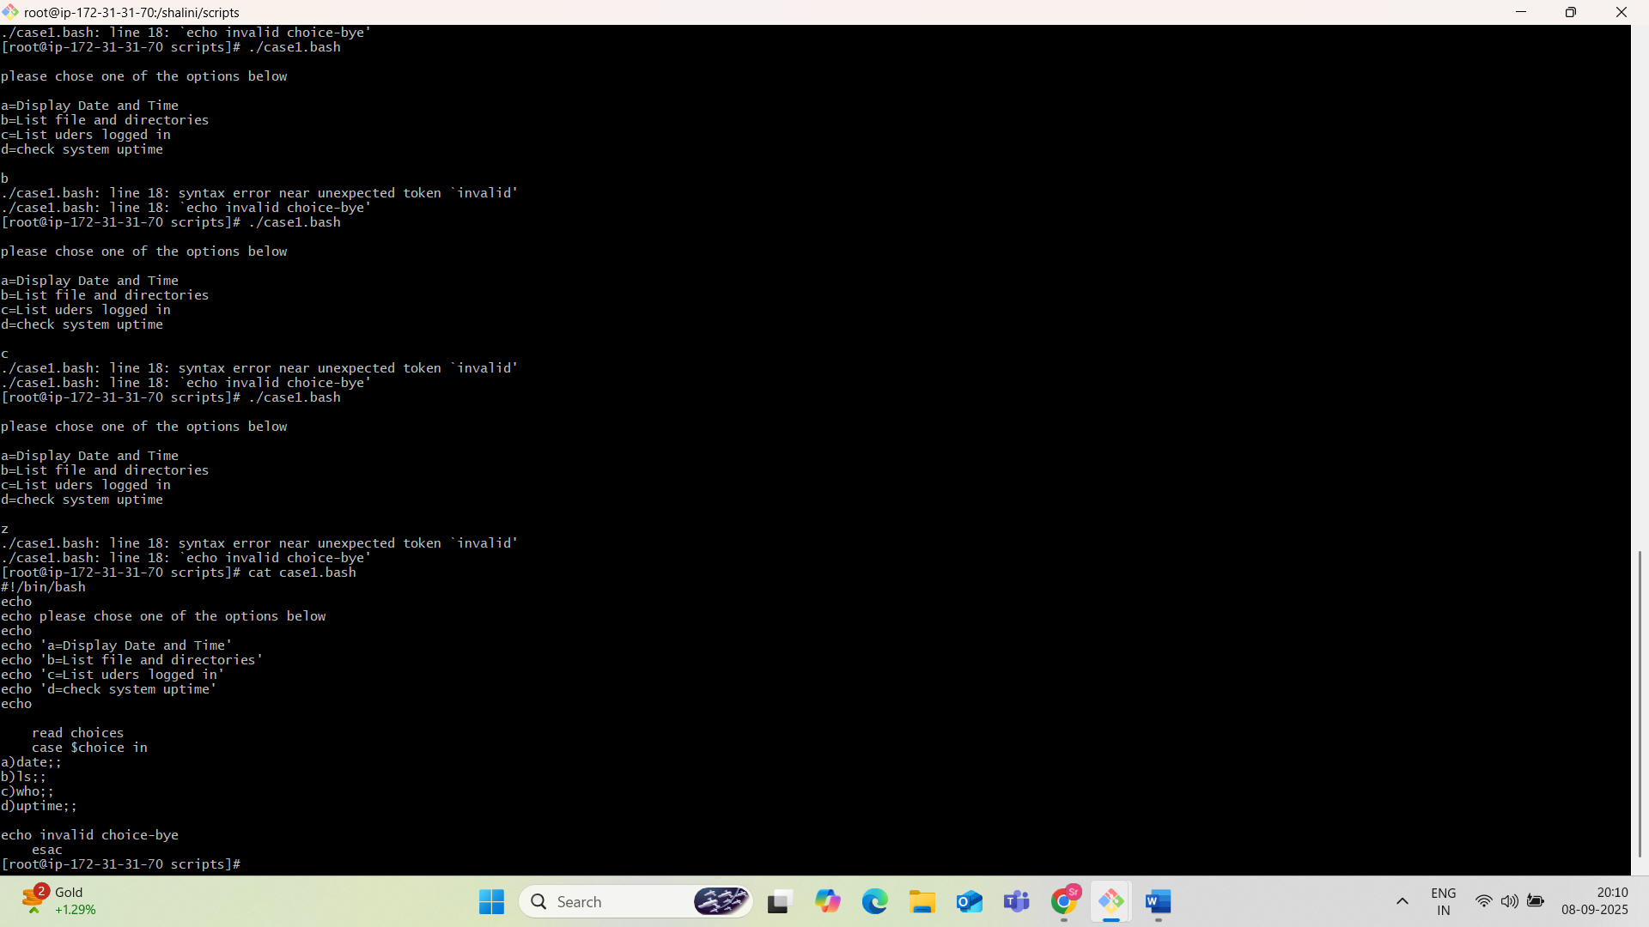

**For Loop Scripts:**

**case:variable=10 then script run for 10 times(or)**

**Variable=green,blue,red(then run the script 3 times for each color)**

**Example1:**

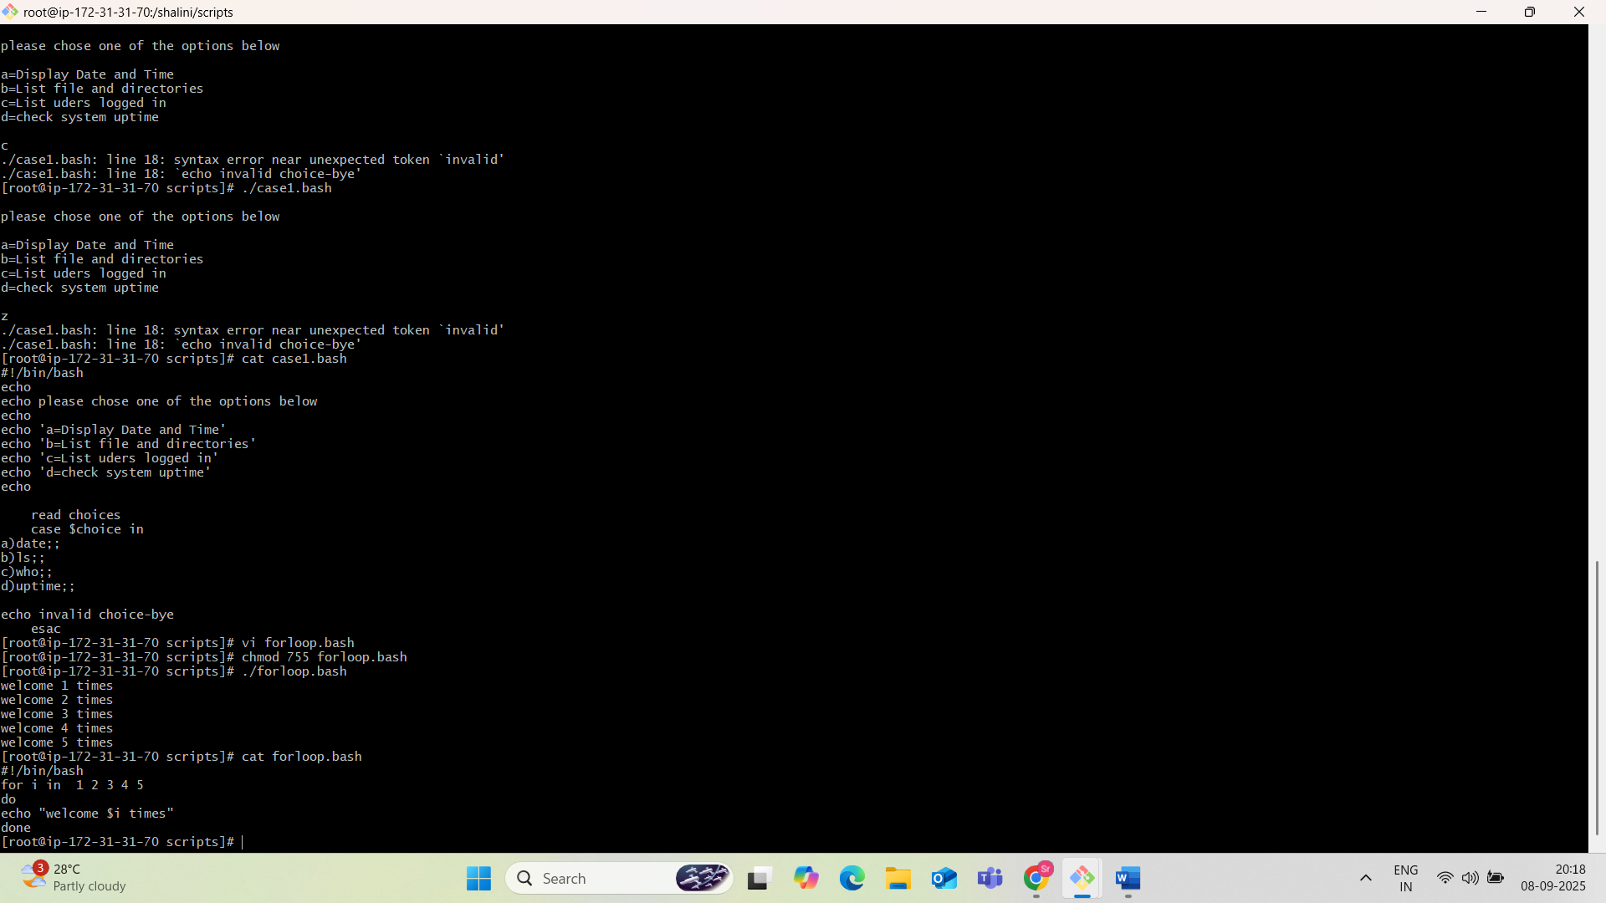

**Example2:**

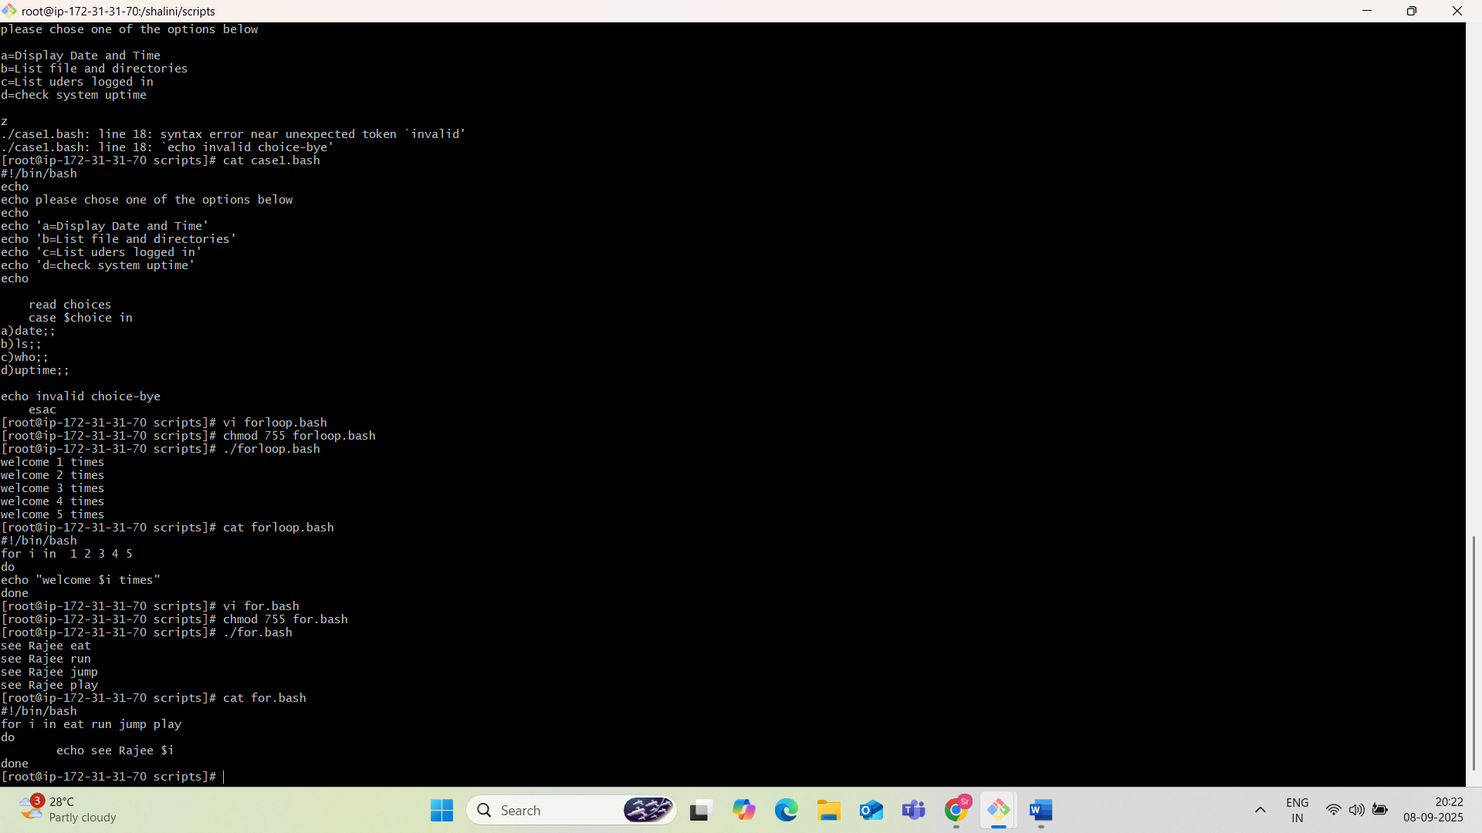

**Do-While scripts:**

**Case:Run a script until 2pm**

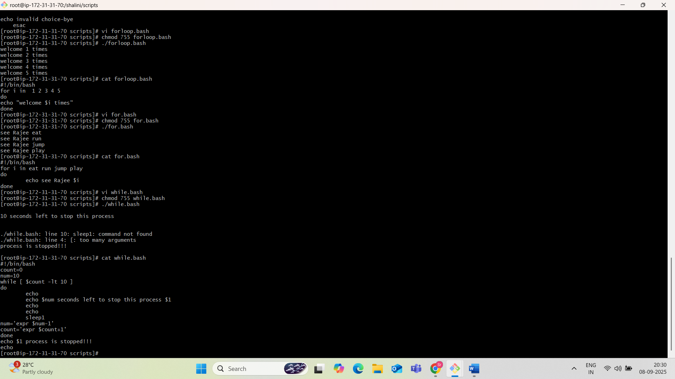

**Exit status ($?):**

**Example1:**

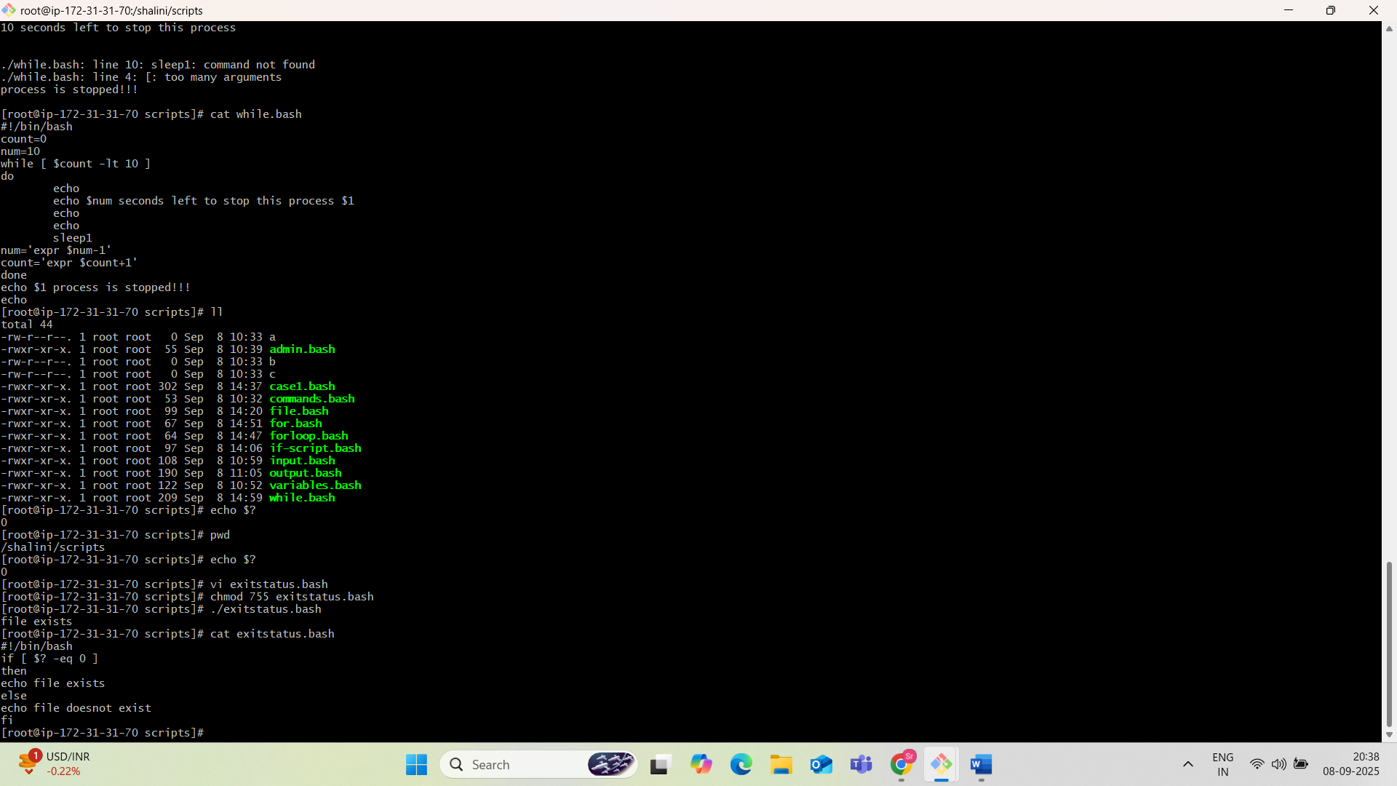

**Edit example1 and add “pwd” in line2.**

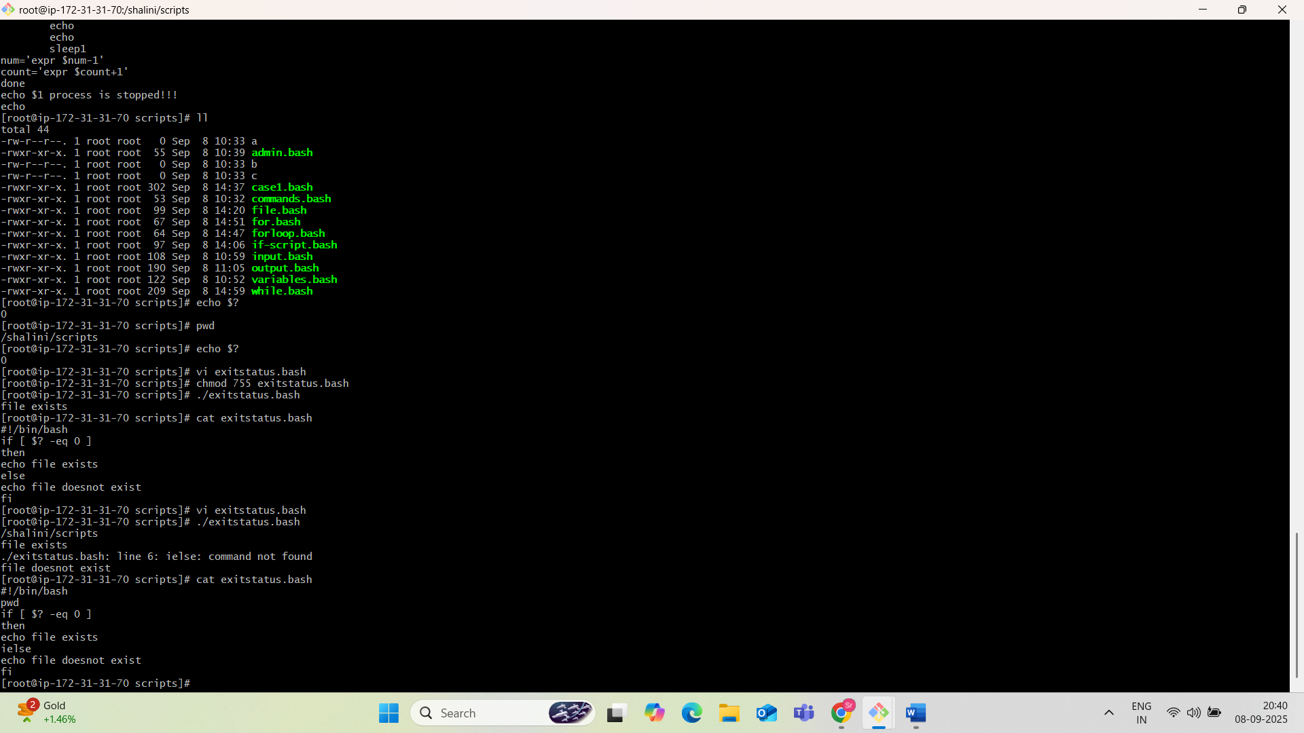

**Example2: Return un-successfull Exitstatus.**

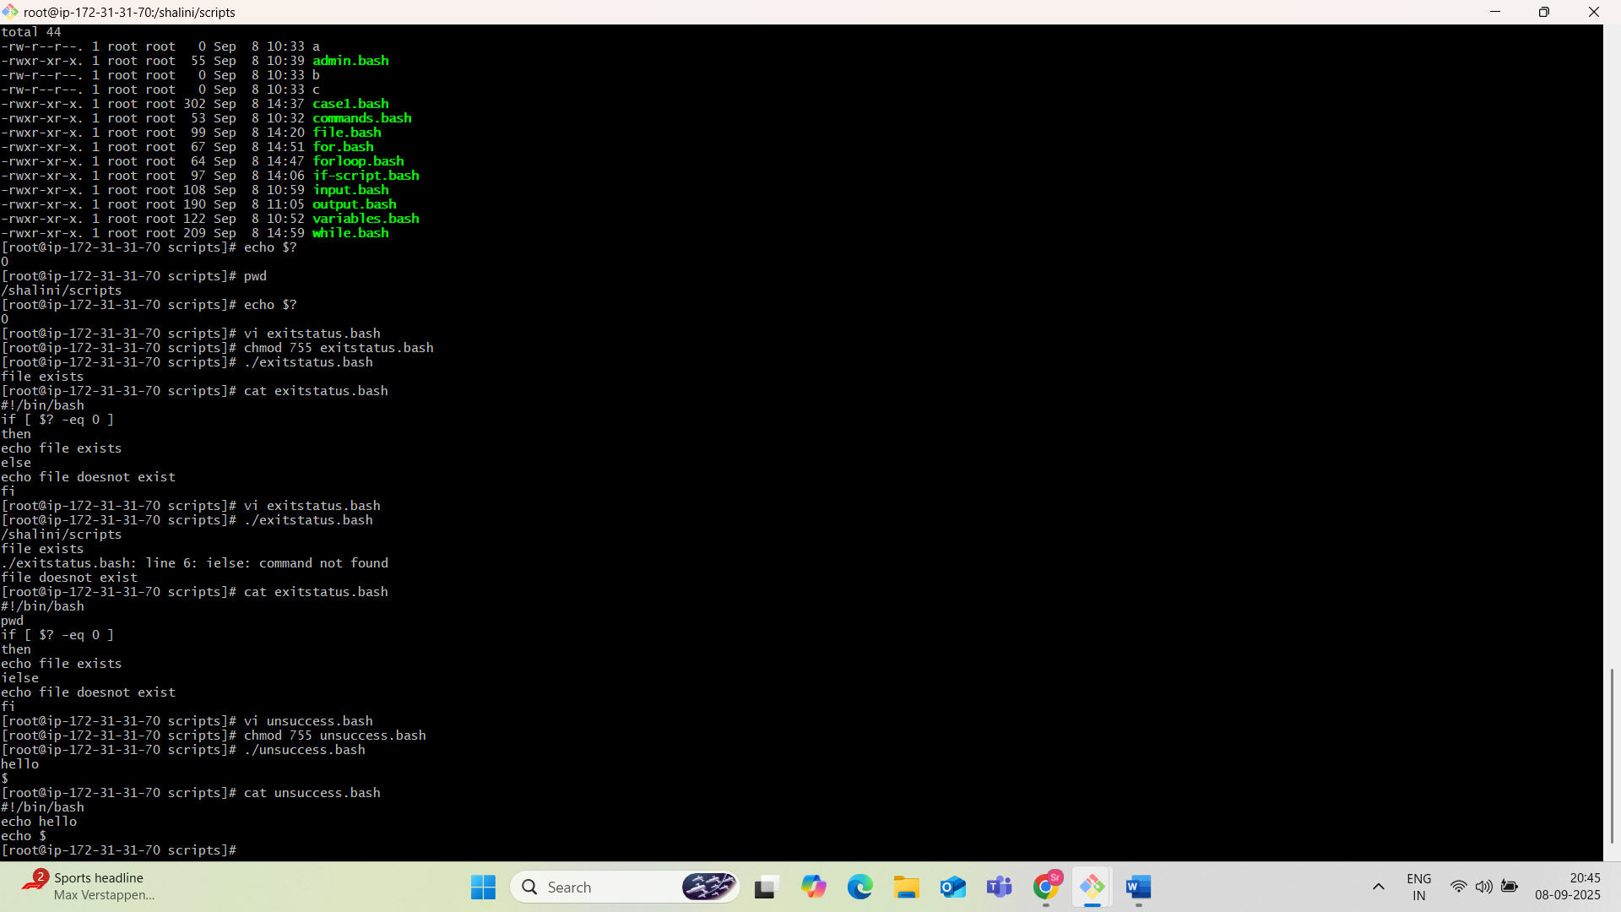

**Example3: Return exit status if file exit**

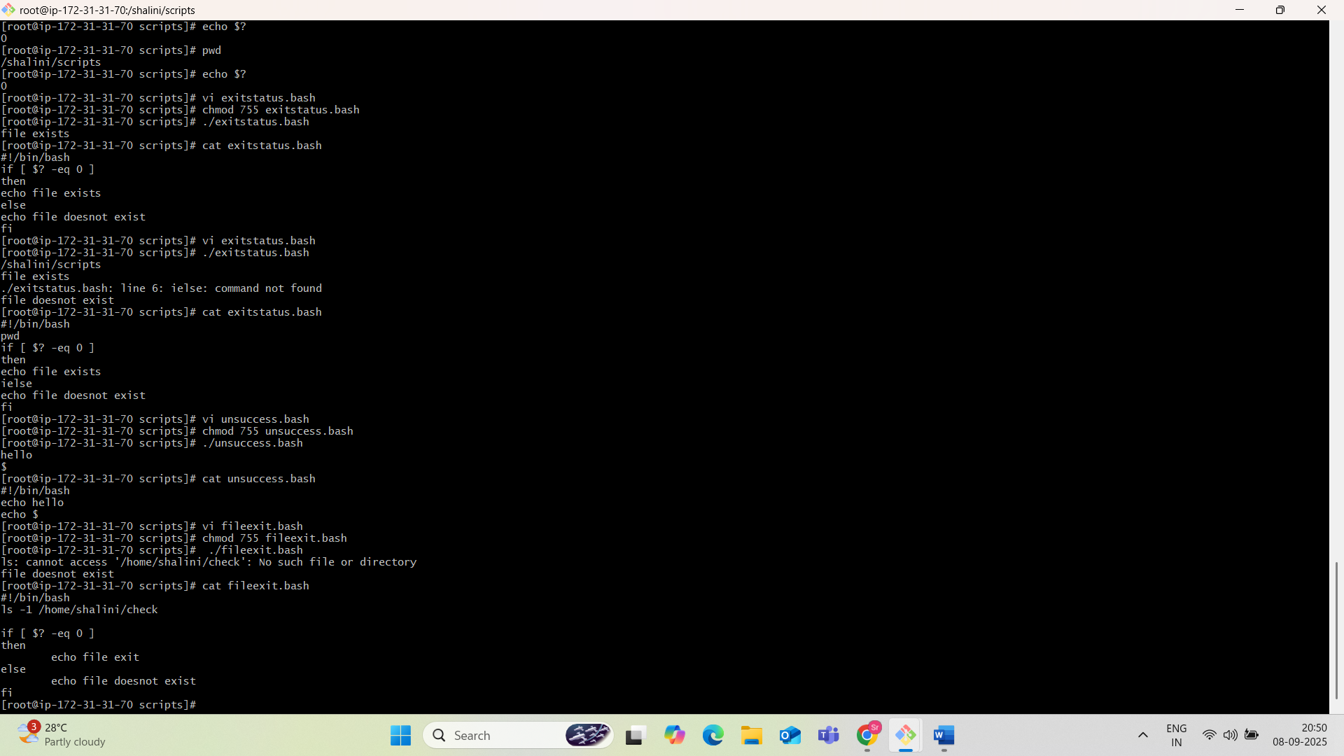

**CRONJOBS:**

