**class 7 : Bash Script Tasks**

Bash-Scripting assignment-01

.Write a scipt?

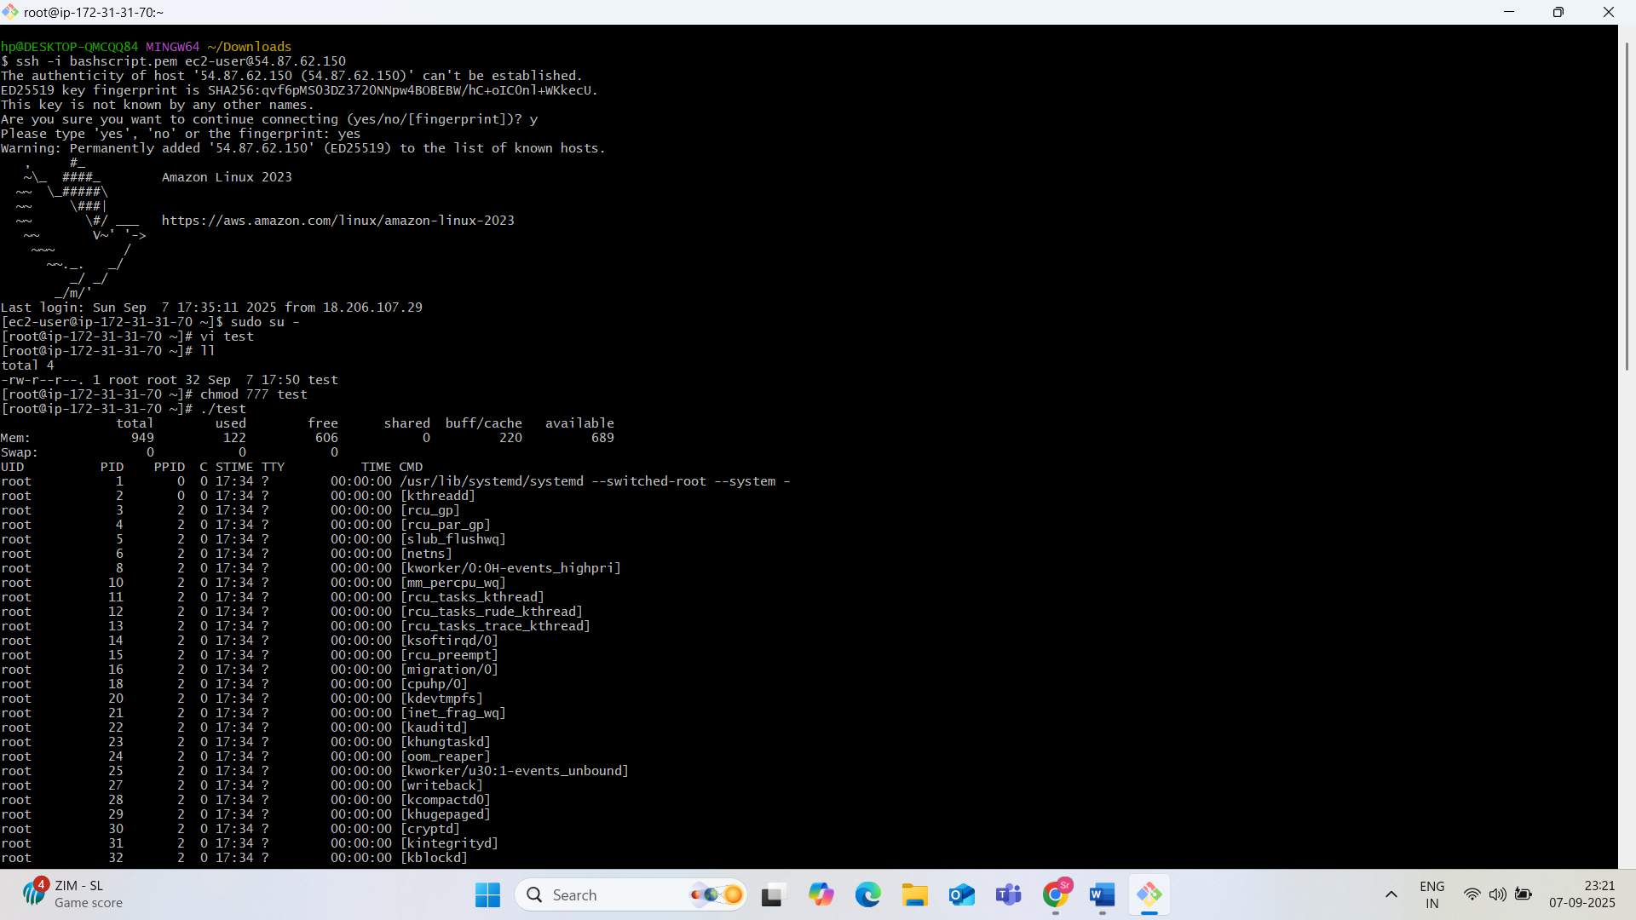

Find your shell:

===============

echo $0 --> WHich shell you are using

cat /etc/shells --> Available shell

cat /etc/passwd --> To know which shell user is assigned with.

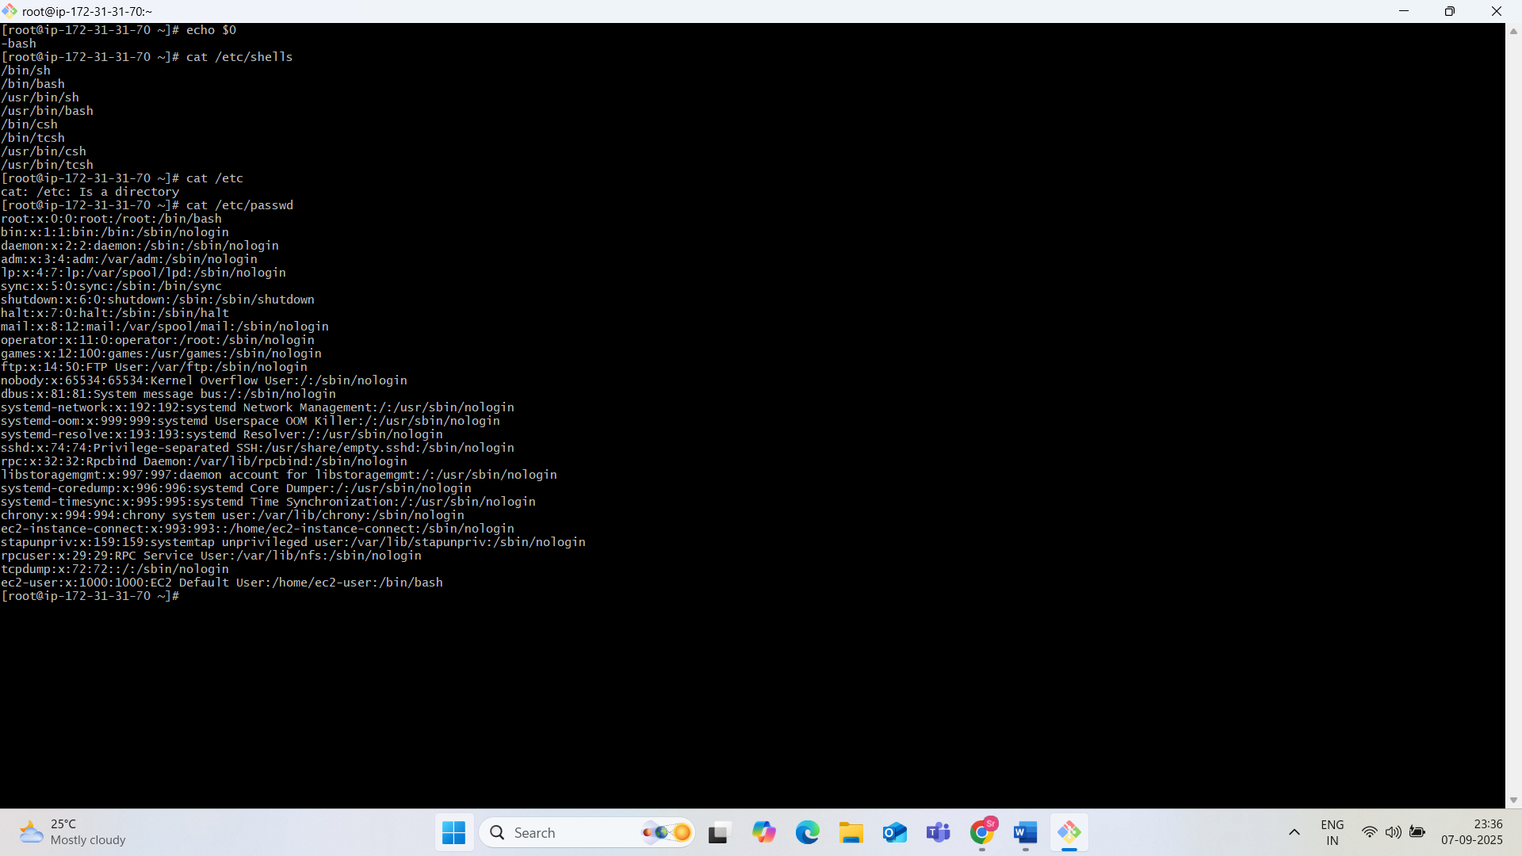

Basic shell scripts:

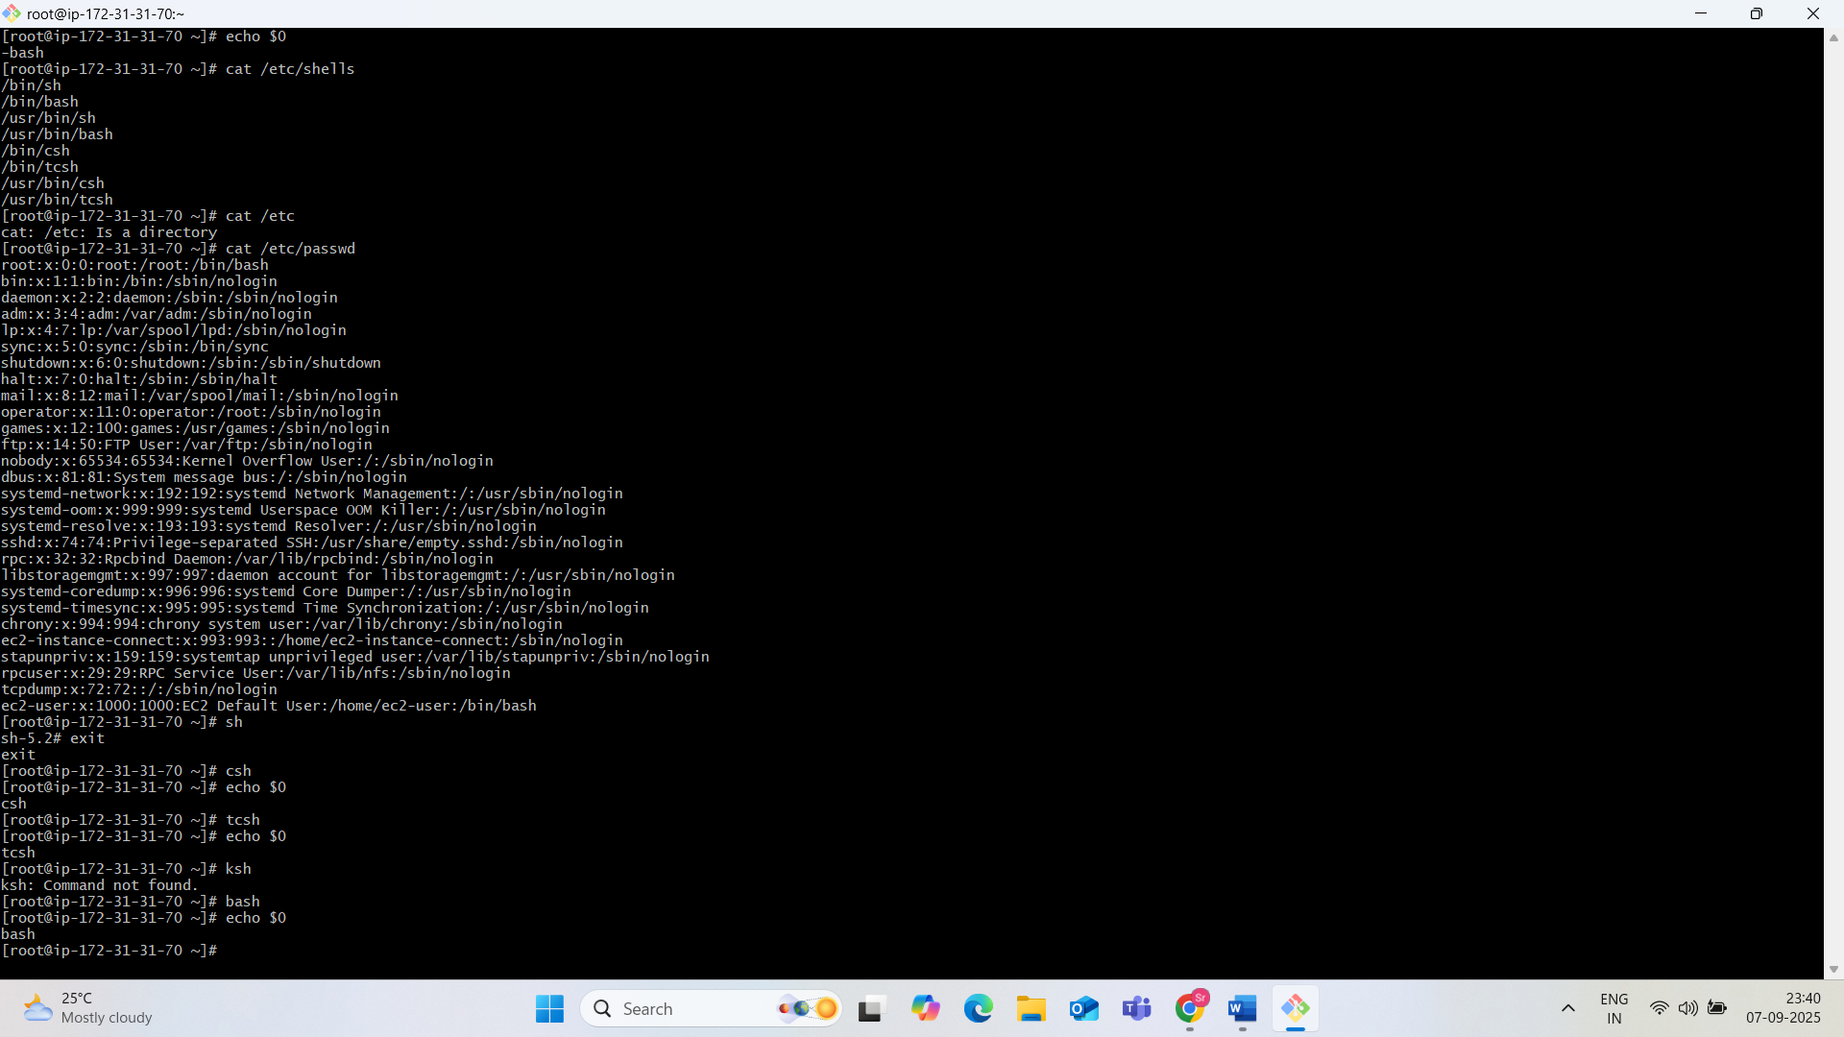

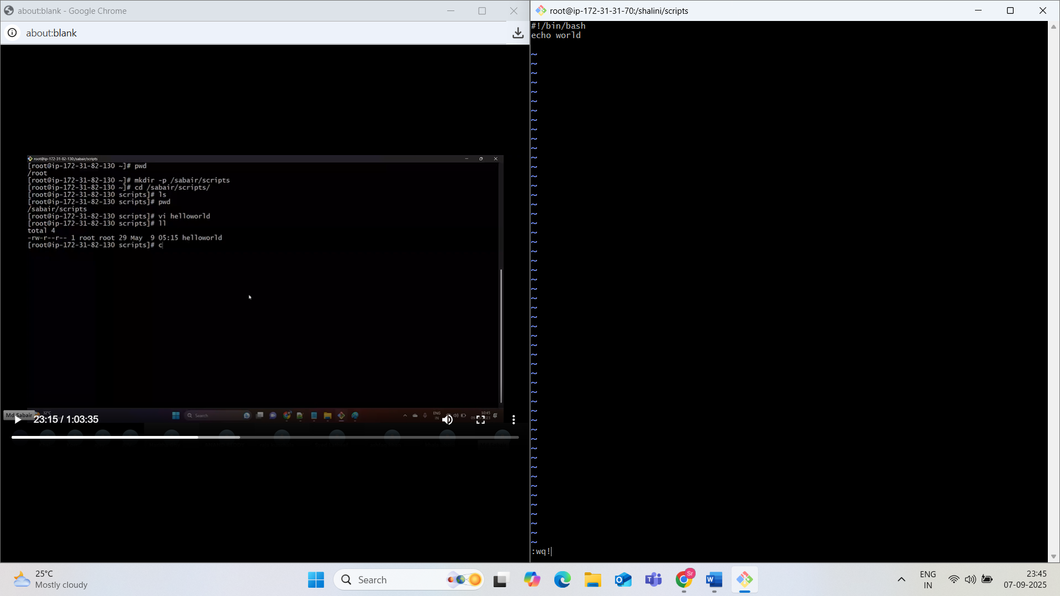

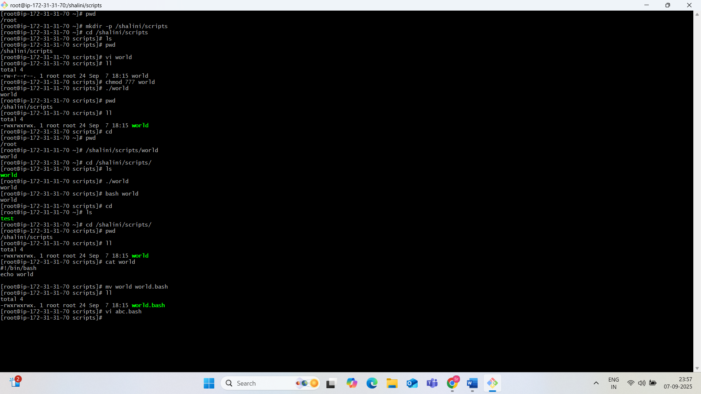



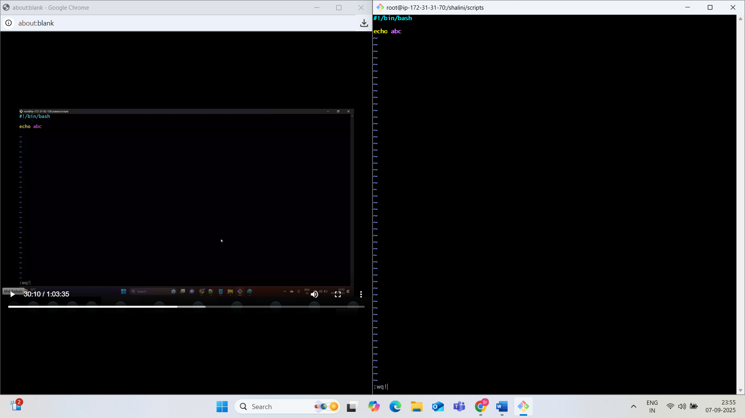

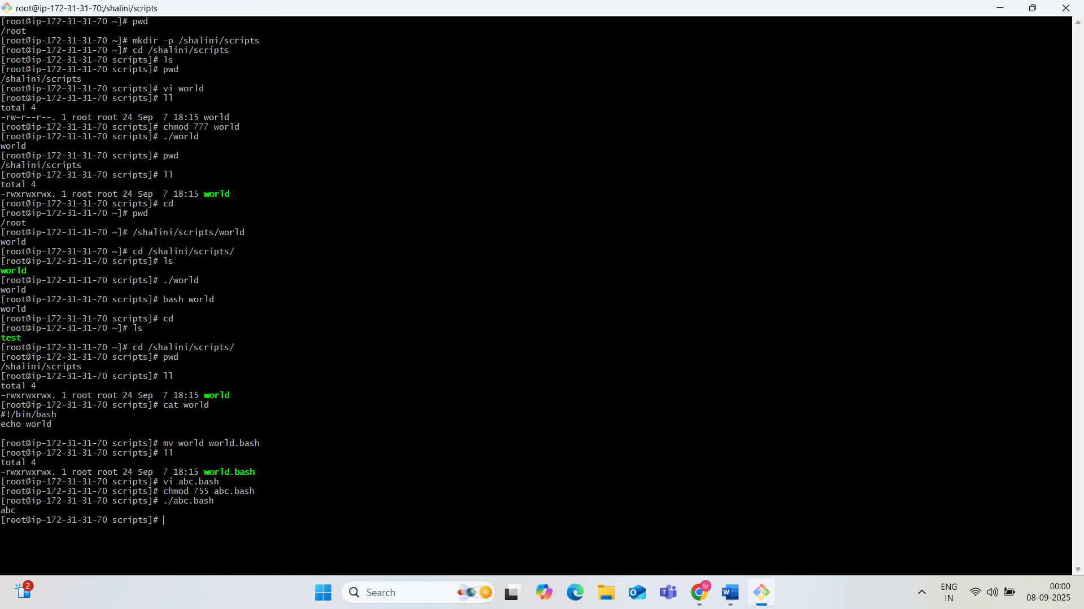

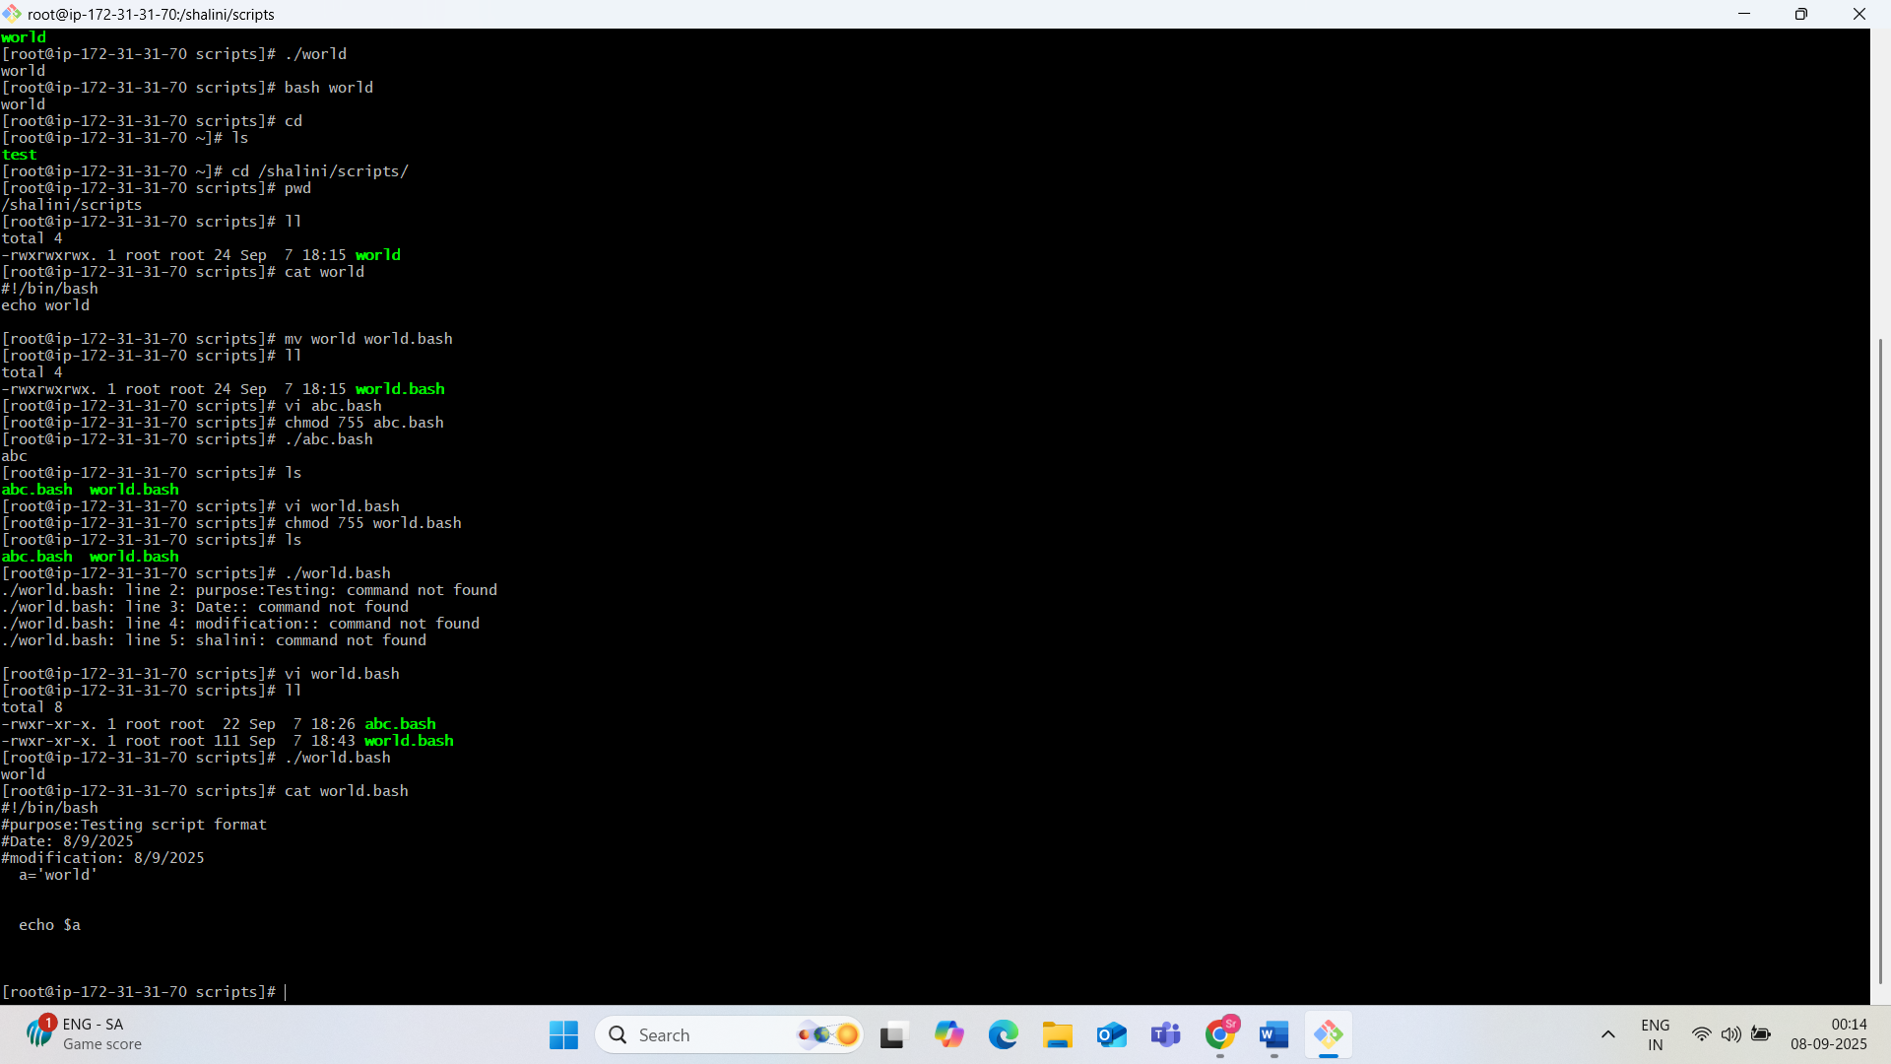

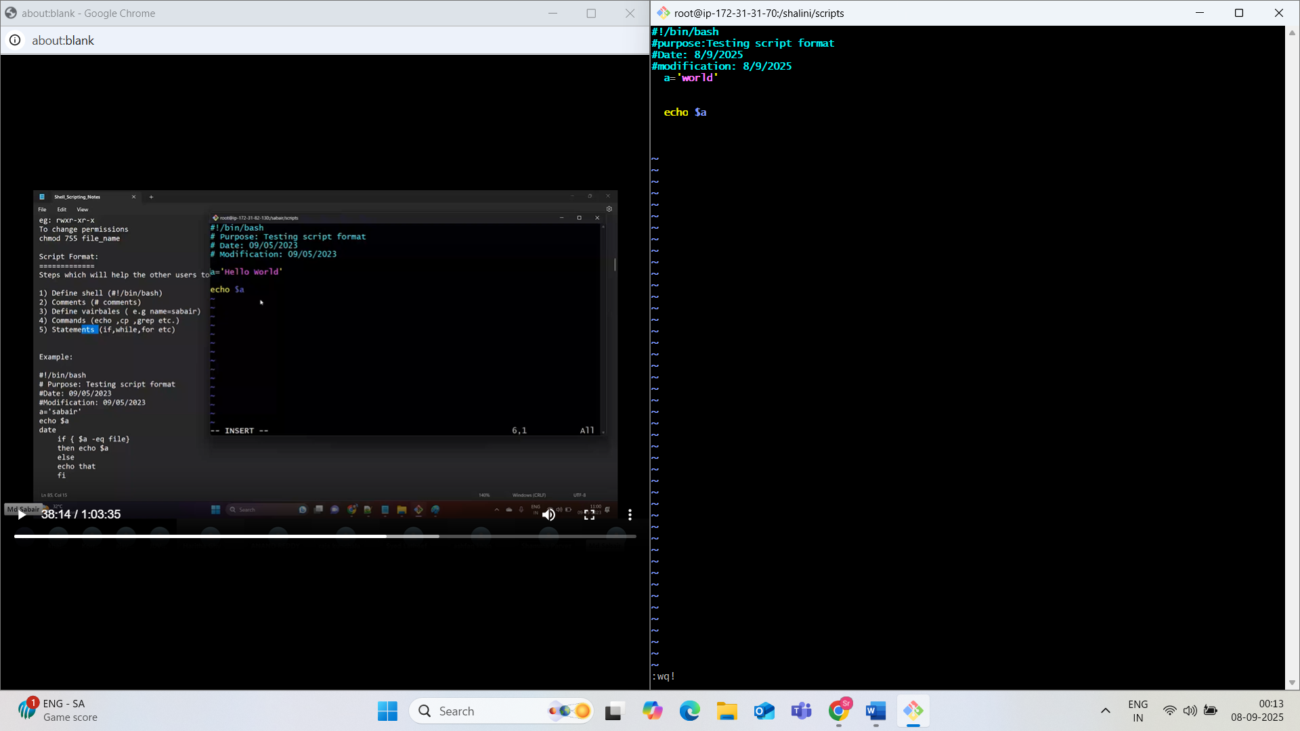



Now changing the variable value.

Am replacing a=WORLD with a=DEVOPS

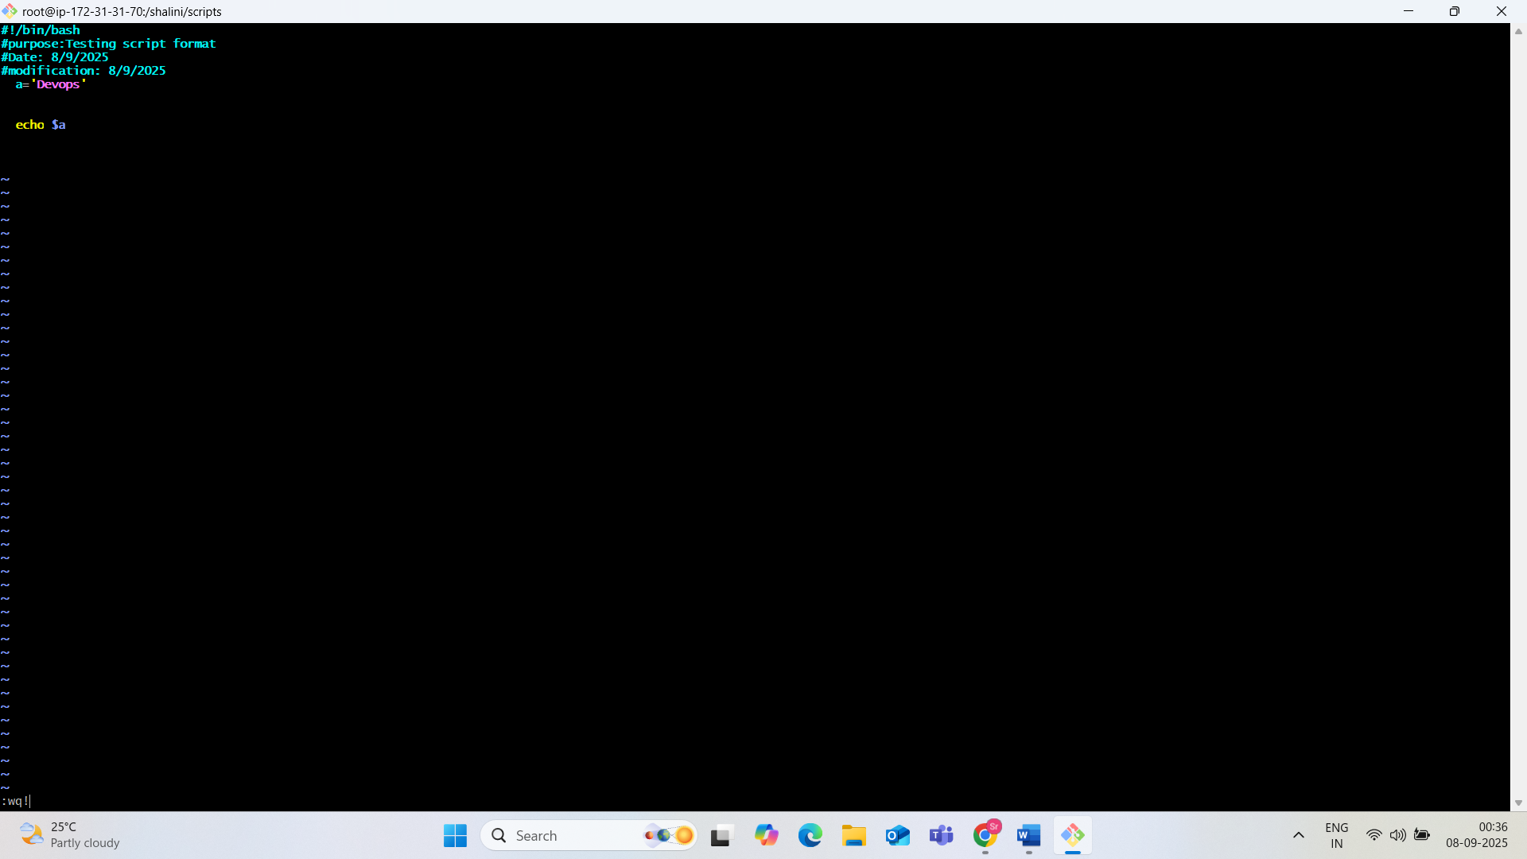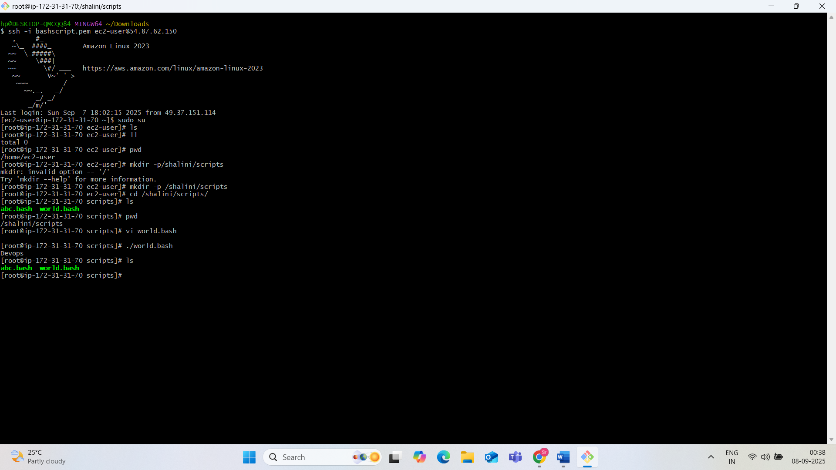

Creat a basic script with output: hello world

#!/bin/bash

# Purpose: script for hello world

#Modification: 08/09/2025

owner= shalini

echo “hello world”

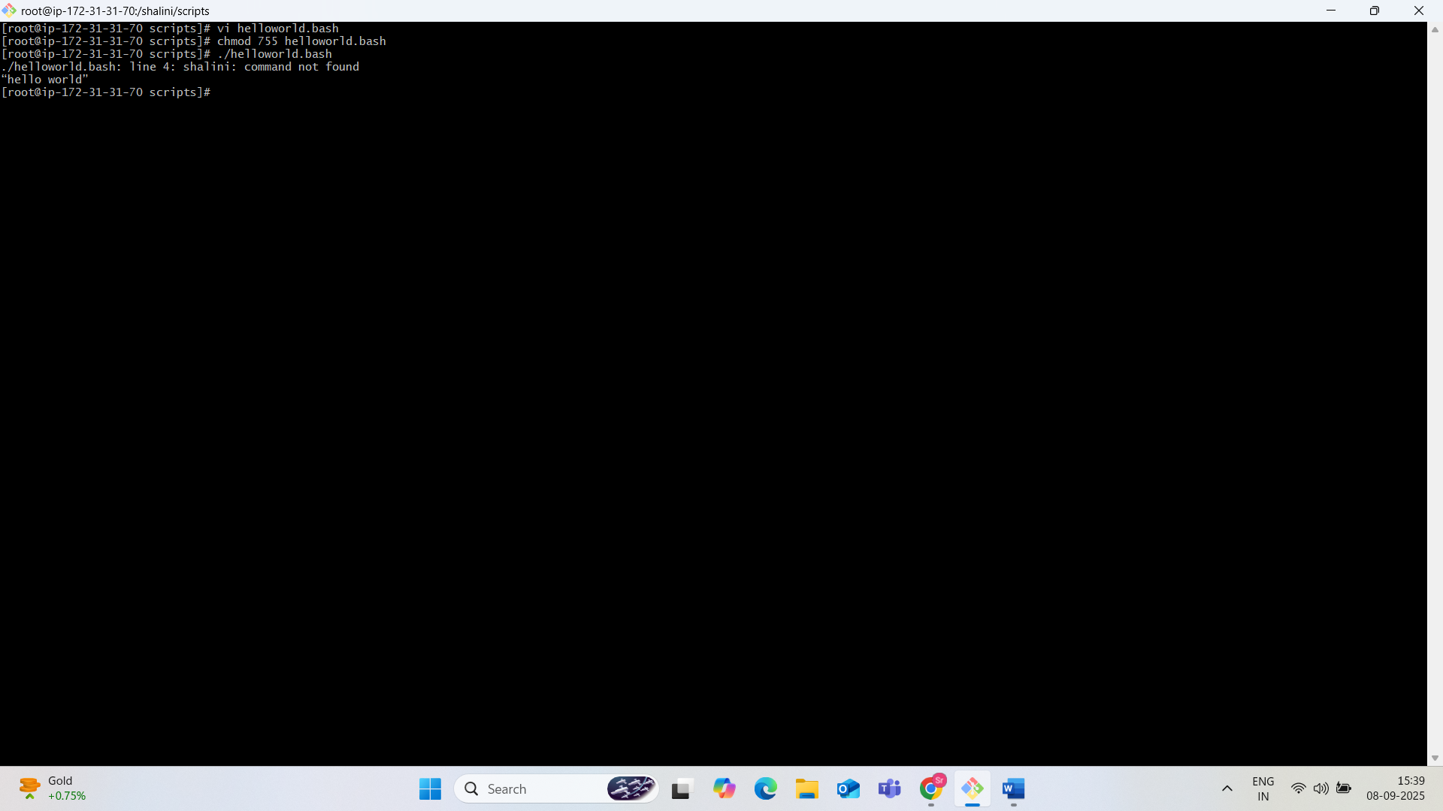

Basic second shell scripts:

#!bin/bash

Pwd

Ls

Whoami

Cal

Touch a b c

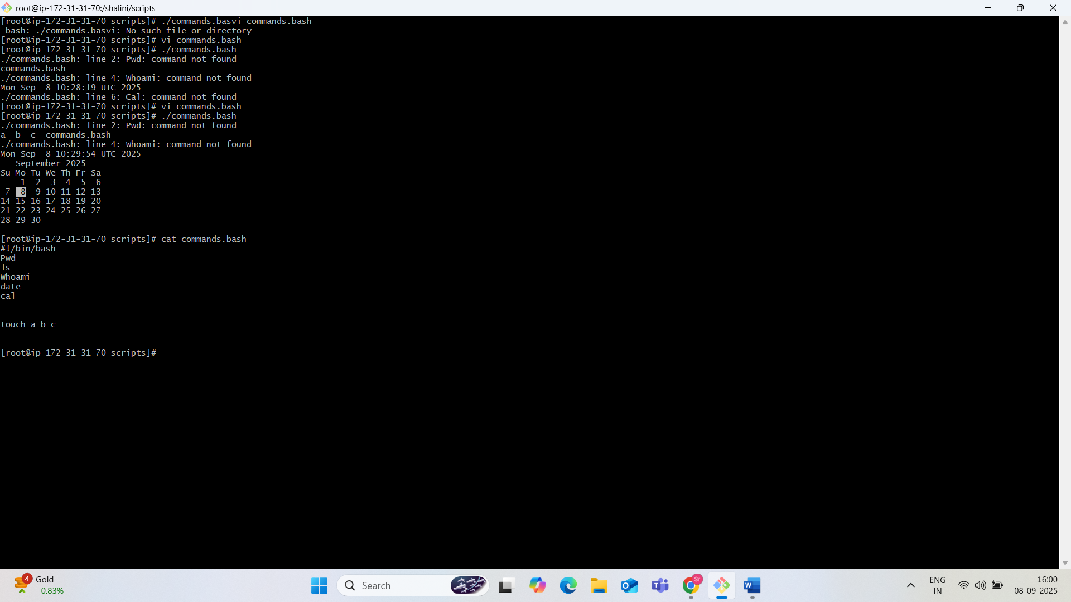

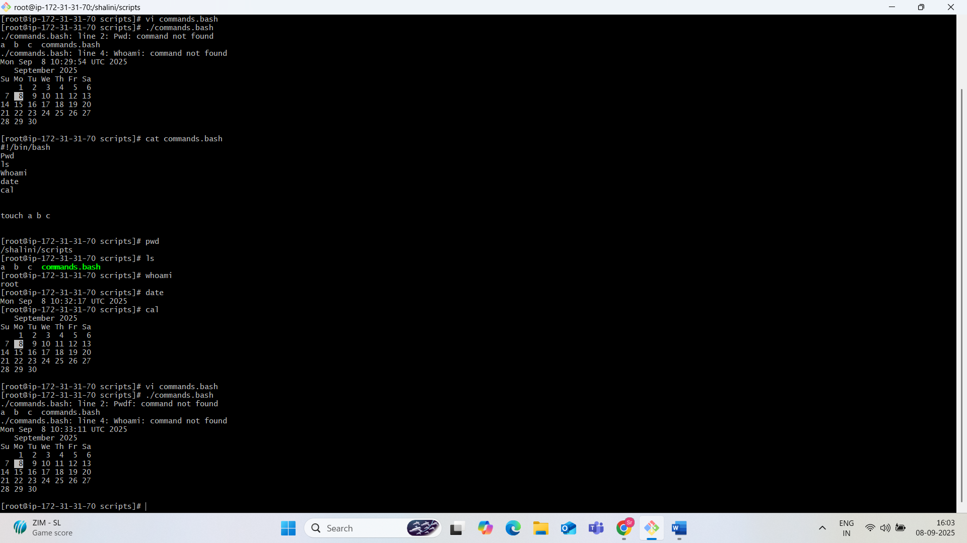

Basic Admin Tasks:

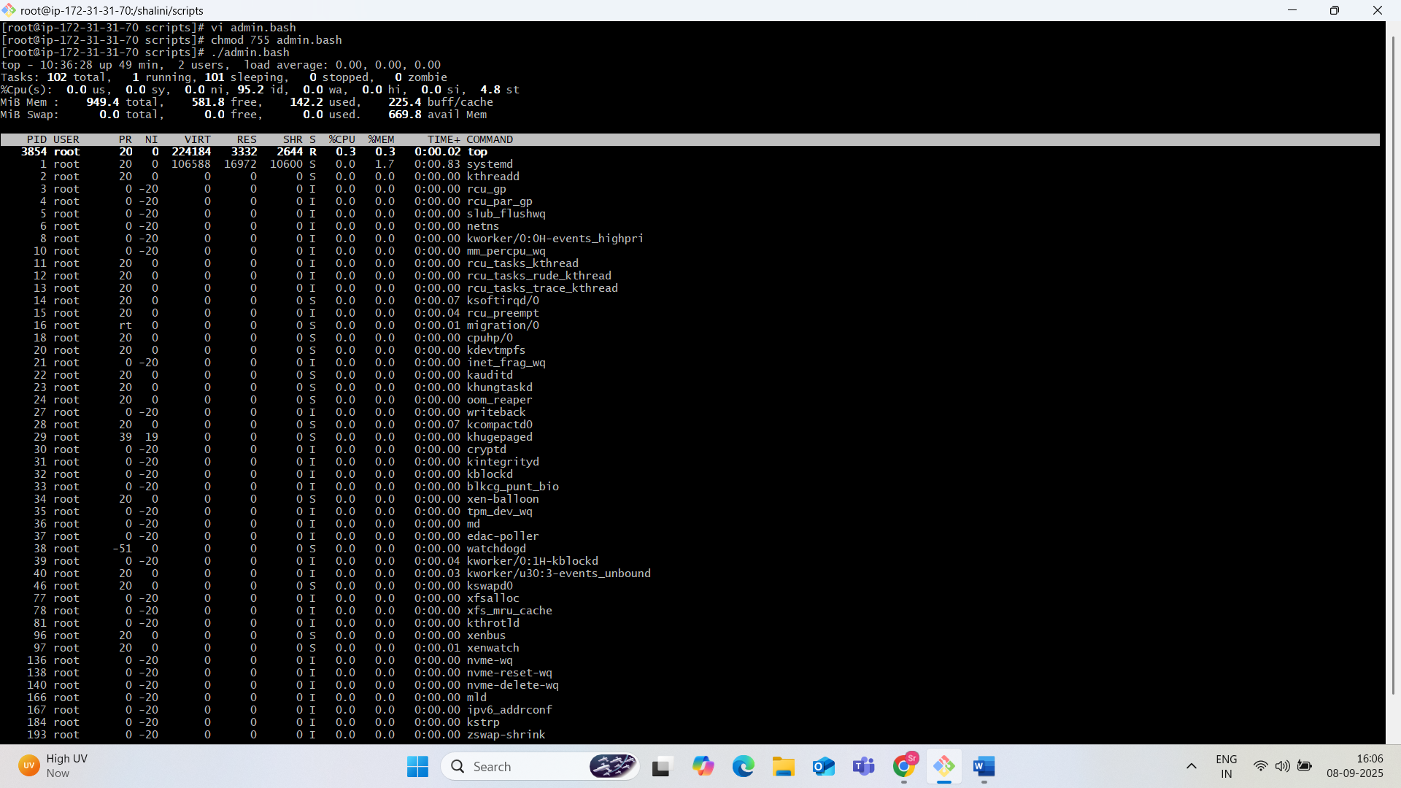

Use top|head -10 to admin.bash

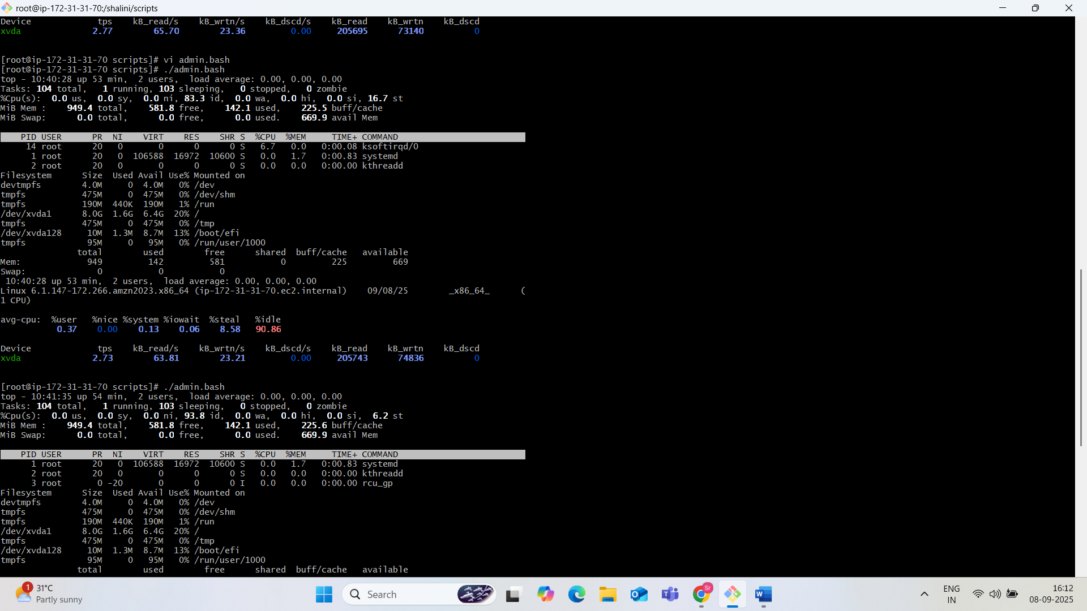

Defining variables:

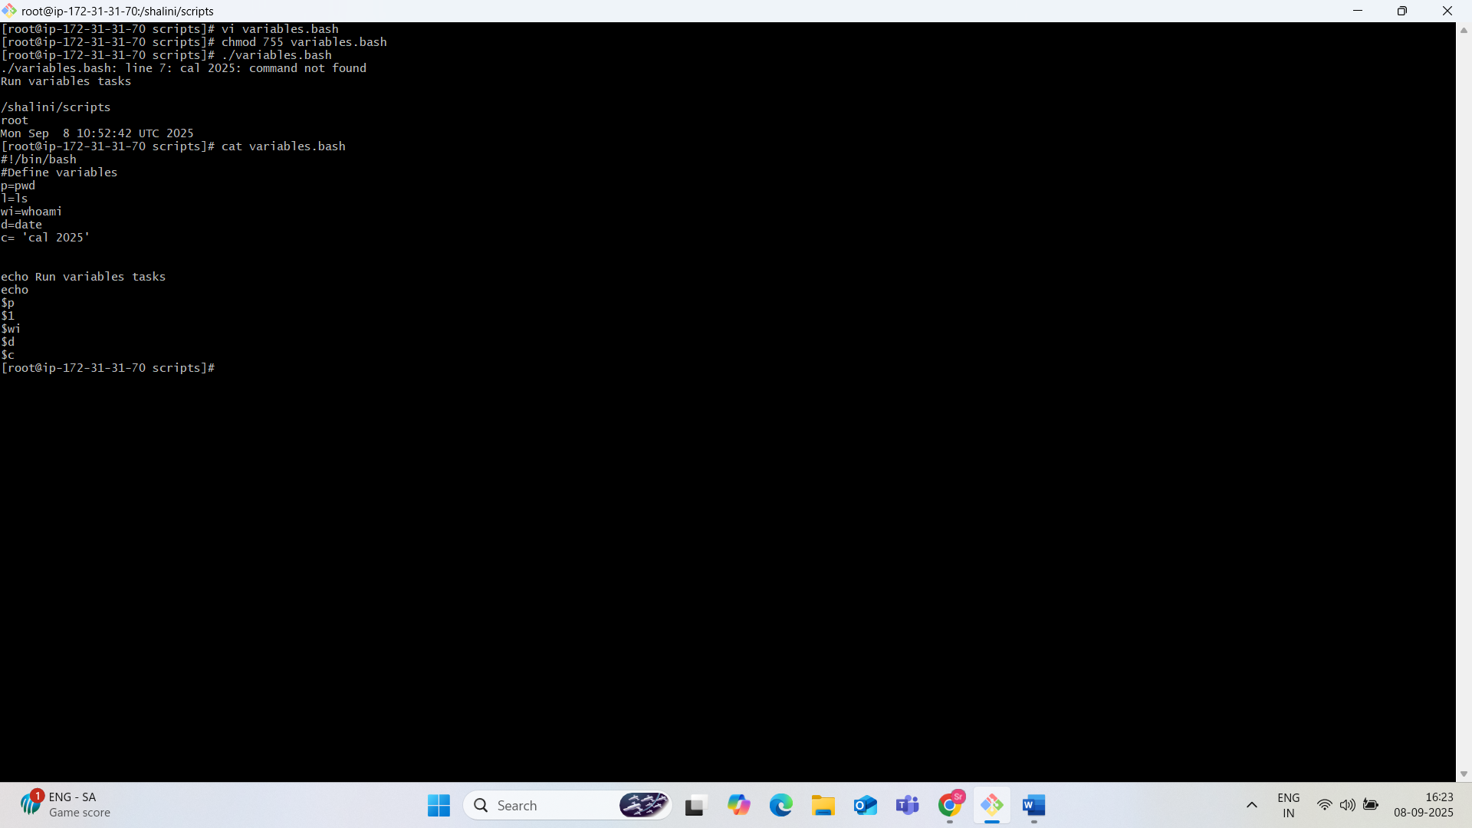

Input and Output :

