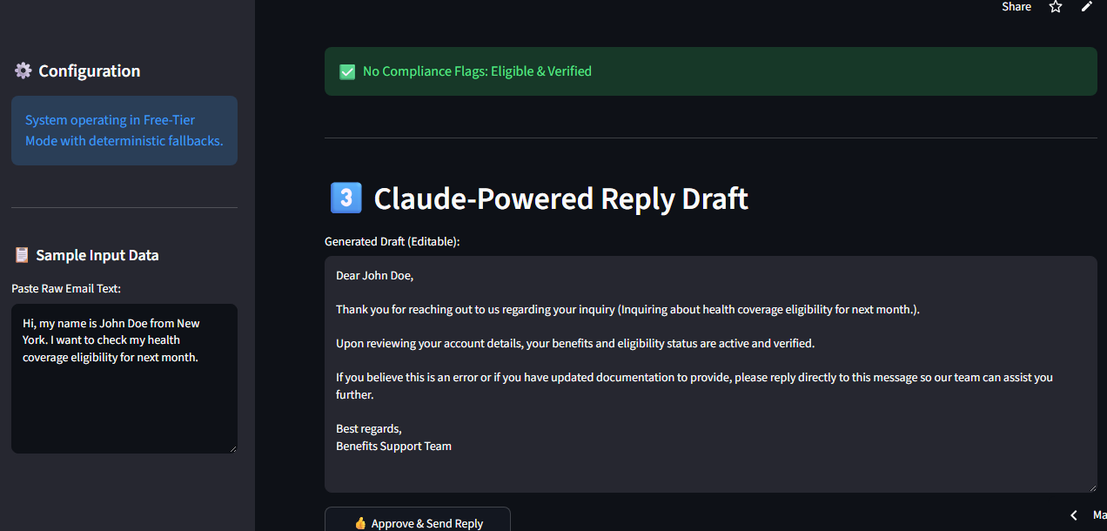
Before:-
import sys
import os
sys.path.append(os.path.abspath(os.path.dirname(__file__)))
import streamlit as st
import pandas as pd
import json
from drafting import call_claude_draft
from rules_engine import check_member

st.set_page_config(
page_title="AI Email & Benefits Query Assistant",
page_icon="✉️",
layout="wide"
)

st.title("✉️ AI-Powered Email & Benefits Assistant")
st.caption("Phase 8 - Capstone MVP (Day 57 — Single-Screen Review UI)")
st.divider()

with st.sidebar:
st.header("⚙️ Configuration")
st.info("System operating in Free-Tier Mode with deterministic fallbacks.")
st.markdown("---")
st.markdown("### 📋 Sample Input Data")
sample_email = st.text_area(
"Paste Raw Email Text:",
height=200,
value="Hi, my name is John Doe from New York. I want to check my health coverage eligibility for next month."
)

st.subheader("🚀 Run Analysis")
analyze_clicked = st.button("🚀 Analyze Email", type="primary", use_container_width=True)

if analyze_clicked:
extracted_fields = {
"member_name": "John Doe",
"location": "New York",
"dates": ["2026-08-01"],
"raw_intent_summary": "Inquiring about health coverage eligibility for next month."
}
st.session_state["extracted_fields"] = extracted_fields
result = check_member(extracted_fields)
flags = result["flags"]
matched_record = result["matched_record"]
st.session_state["flags"] = flags
st.session_state["matched_record"] = matched_record
draft = call_claude_draft(extracted_fields, flags, matched_record)
st.session_state["draft"] = draft

st.divider()

st.header("1️⃣ Extracted Information & Matched Record")
if "extracted_fields" in st.session_state:
col_a, col_b = st.columns(2)
with col_a:
st.markdown("**Extracted Fields**")
st.json(st.session_state["extracted_fields"])
with col_b:
st.markdown("**Matched Member Record**")
matched_record = st.session_state.get("matched_record")
if matched_record:
st.json(matched_record)
else:
st.warning("No matching member record found.")
else:
st.caption("Click **Analyze Email** above to see extracted fields here.")

st.divider()

st.header("2️⃣ Compliance & Rule Flags")
if "flags" in st.session_state:
flags = st.session_state.get("flags", [])
if not flags:
st.success("✅ No Compliance Flags: Eligible & Verified")
else:
for flag in flags:
if flag in ("Member Not Found", "Member Name Missing"):
st.error(f"🚫 {flag}")
elif flag in ("Outside Eligibility Window", "Plan Inactive", "Marked Not Eligible"):
st.error(f"⛔ {flag}")
else:
st.warning(f"⚠️ {flag}")
else:
st.caption("Flags will appear here after you run the analysis.")

st.divider()

st.header("3️⃣ Claude-Powered Reply Draft")
if "draft" in st.session_state:
edited_draft = st.text_area(
"Generated Draft (Editable):",
value=st.session_state["draft"],
height=300,
key="draft_editor"
)
approve_col, _ = st.columns([1, 3])
with approve_col:
if st.button("👍 Approve & Send Reply", use_container_width=True):
st.success("Reply approved and queued for sending!")
else:
st.caption("The reply draft will appear here after you run the analysis.")

st.divider()
st.markdown(
"""
<div style='text-align: center; color: gray; padding: 10px;'>
Built with Claude as part of the AB Talks 60-Day Claude AI Challenge.
</div>
""",
unsafe_allow_html=True
)After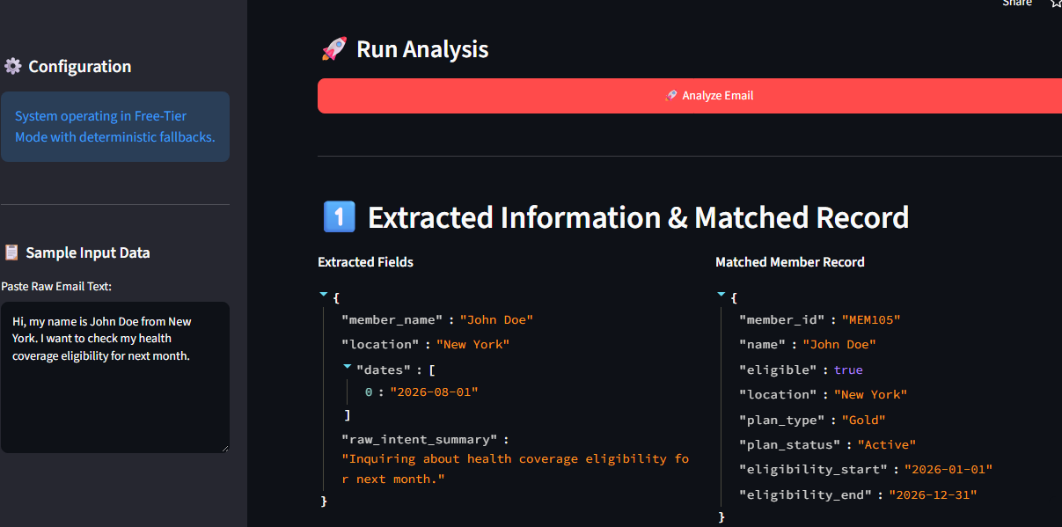

After:-
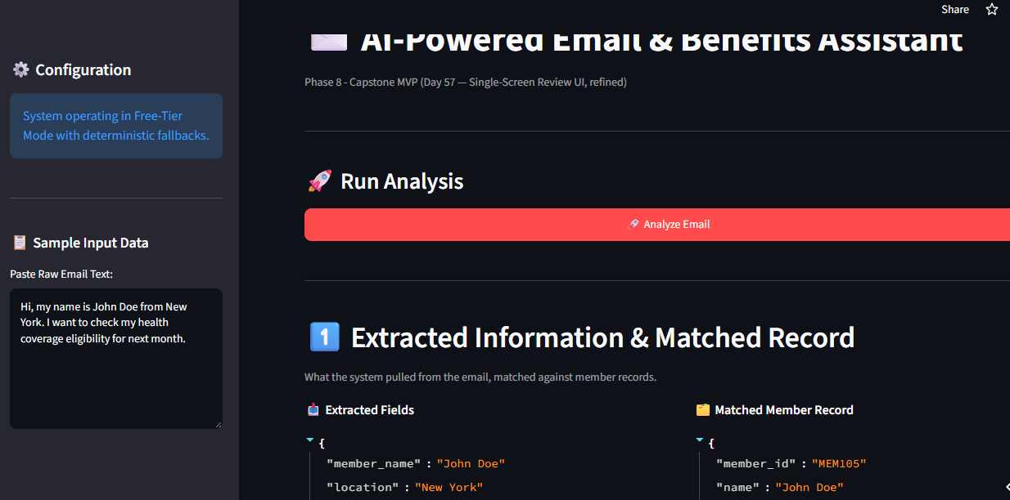

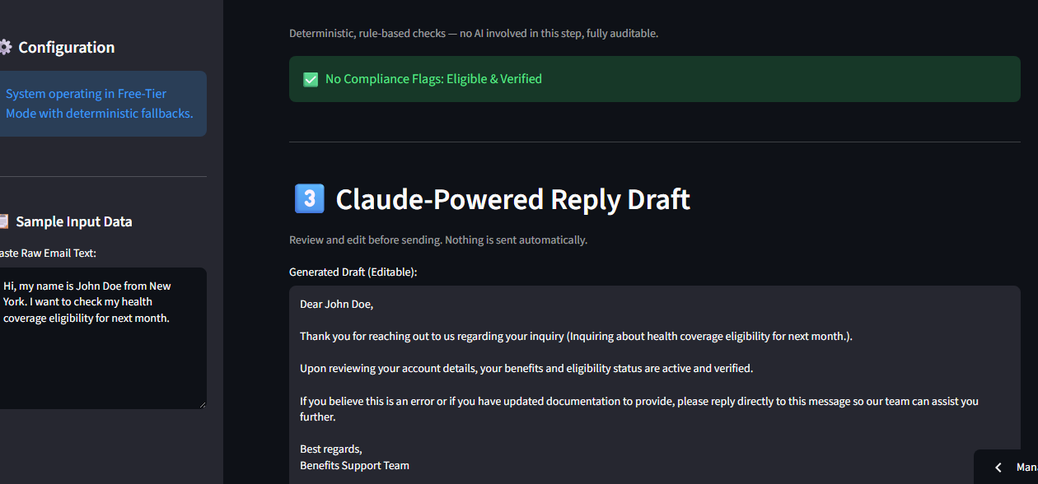

import sys
import os
sys.path.append(os.path.abspath(os.path.dirname(__file__)))
import streamlit as st
import time
from drafting import call_claude_draft
from rules_engine import check_member

st.set_page_config(
page_title="AI Email & Benefits Query Assistant",
page_icon="✉️",
layout="wide"
)

st.title("✉️ AI-Powered Email & Benefits Assistant")
st.caption("Phase 8 - Capstone MVP (Day 57 — Single-Screen Review UI, refined)")
st.divider()

with st.sidebar:
st.header("⚙️ Configuration")
st.info("System operating in Free-Tier Mode with deterministic fallbacks.")
st.markdown("---")
st.markdown("### 📋 Sample Input Data")
sample_email = st.text_area(
"Paste Raw Email Text:",
height=200,
value="Hi, my name is John Doe from New York. I want to check my health coverage eligibility for next month."
)

st.subheader("🚀 Run Analysis")
analyze_clicked = st.button("🚀 Analyze Email", type="primary", use_container_width=True)

if analyze_clicked:
with st.spinner("Analyzing email, matching member record, and drafting reply..."):
extracted_fields = {
"member_name": "John Doe",
"location": "New York",
"dates": ["2026-08-01"],
"raw_intent_summary": "Inquiring about health coverage eligibility for next month."
}
st.session_state["extracted_fields"] = extracted_fields
result = check_member(extracted_fields)
flags = result["flags"]
matched_record = result["matched_record"]
st.session_state["flags"] = flags
st.session_state["matched_record"] = matched_record
draft = call_claude_draft(extracted_fields, flags, matched_record)
st.session_state["draft"] = draft
st.session_state["reply_approved"] = False
# Small delay so the spinner is visibly meaningful even on fast mock calls
time.sleep(0.4)
st.toast("Analysis complete ✅", icon="✅")

st.divider()

# ---------- SECTION 1: Extracted Info ----------
st.header("1️⃣ Extracted Information & Matched Record")
st.caption("What the system pulled from the email, matched against member records.")

if "extracted_fields" in st.session_state:
col_a, col_b = st.columns(2, gap="large")
with col_a:
st.markdown("**📥 Extracted Fields**")
st.json(st.session_state["extracted_fields"])
with col_b:
st.markdown("**🗂️ Matched Member Record**")
matched_record = st.session_state.get("matched_record")
if matched_record:
st.json(matched_record)
else:
st.warning("⚠️ No matching member record found for this email.")
else:
st.info("👉 Click **Analyze Email** above to see extracted fields and the matched member record here.")

st.divider()

# ---------- SECTION 2: Flags ----------
st.header("2️⃣ Compliance & Rule Flags")
st.caption("Deterministic, rule-based checks — no AI involved in this step, fully auditable.")

FLAG_STYLES = {
"Member Not Found": ("🚫", "error"),
"Member Name Missing": ("🚫", "error"),
"Outside Eligibility Window": ("⛔", "error"),
"Plan Inactive": ("⛔", "error"),
"Marked Not Eligible": ("⛔", "error"),
"Plan Pending": ("⏳", "warning"),
"Location Mismatch": ("⚠️", "warning"),
"Date Could Not Be Parsed": ("⚠️", "warning"),
}

if "flags" in st.session_state:
flags = st.session_state.get("flags", [])
if not flags:
st.success("✅ No Compliance Flags: Eligible & Verified")
else:
flag_cols = st.columns(2, gap="medium")
for i, flag in enumerate(flags):
icon, severity = FLAG_STYLES.get(flag, ("⚠️", "warning"))
target_col = flag_cols[i % 2]
with target_col:
if severity == "error":
st.error(f"{icon} **{flag}**")
else:
st.warning(f"{icon} **{flag}**")
else:
st.info("Flags will appear here — organized by severity — after you run the analysis.")

st.divider()

# ---------- SECTION 3: Draft ----------
st.header("3️⃣ Claude-Powered Reply Draft")
st.caption("Review and edit before sending. Nothing is sent automatically.")

if "draft" in st.session_state:
edited_draft = st.text_area(
"Generated Draft (Editable):",
value=st.session_state["draft"],
height=300,
key="draft_editor"
)

approve_col, status_col = st.columns([1, 3])
with approve_col:
approved = st.session_state.get("reply_approved", False)
if not approved:
if st.button("👍 Approve & Send Reply", use_container_width=True, type="primary"):
st.session_state["reply_approved"] = True
st.rerun()
else:
st.button("✅ Reply Sent", use_container_width=True, disabled=True)

with status_col:
if st.session_state.get("reply_approved", False):
st.success("Reply approved and queued for sending!")
else:
st.info("The reply draft will appear here — editable before you approve it — after you run the analysis.")

st.divider()
st.markdown(
"""
<div style='text-align: center; color: gray; padding: 10px; font-size: 0.85em;'>
Built with Claude as part of the AB Talks 60-Day Claude AI Challenge.
</div>
""",
unsafe_allow_html=True
)

