#Day58#
#App is working#
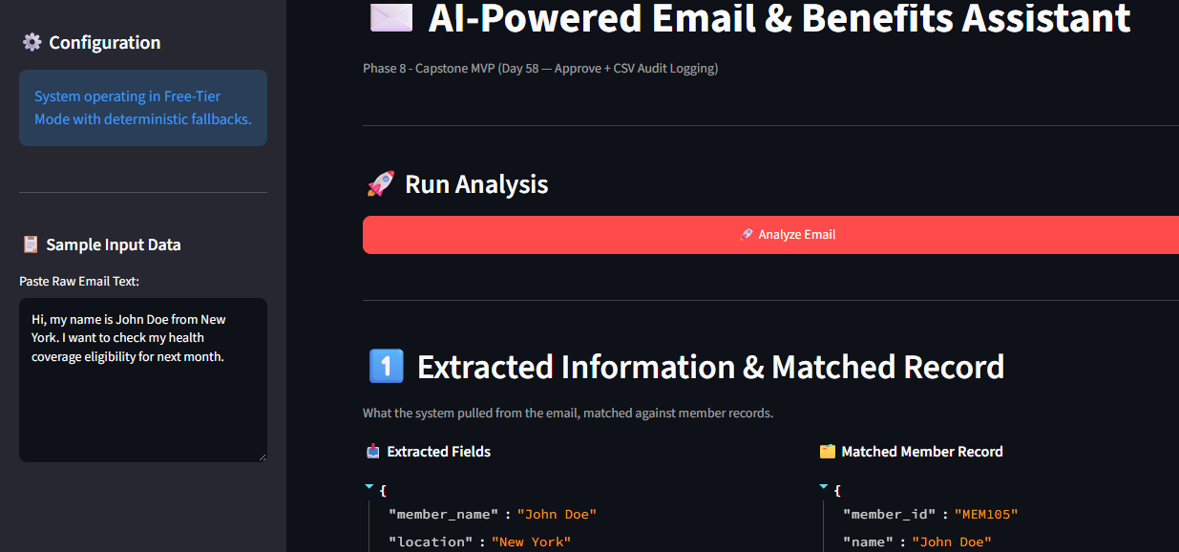

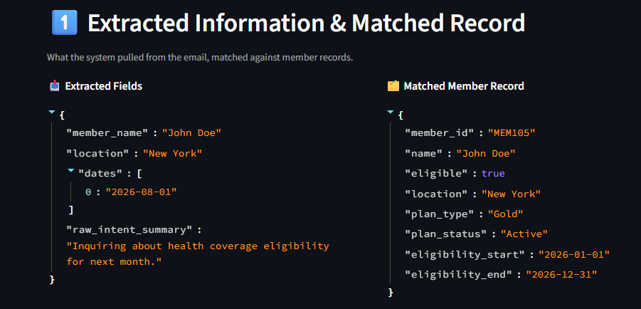

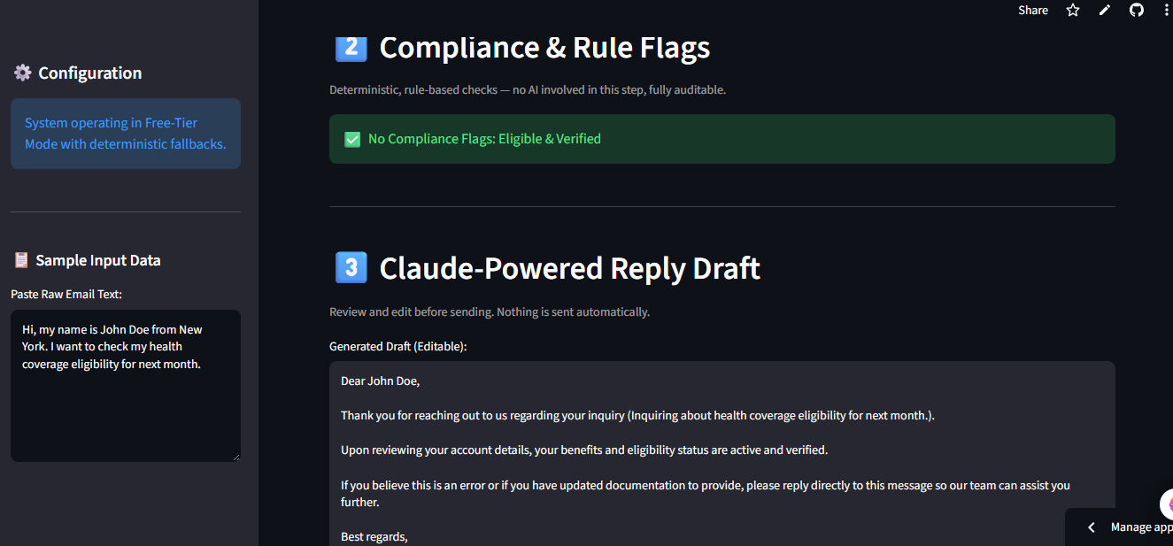

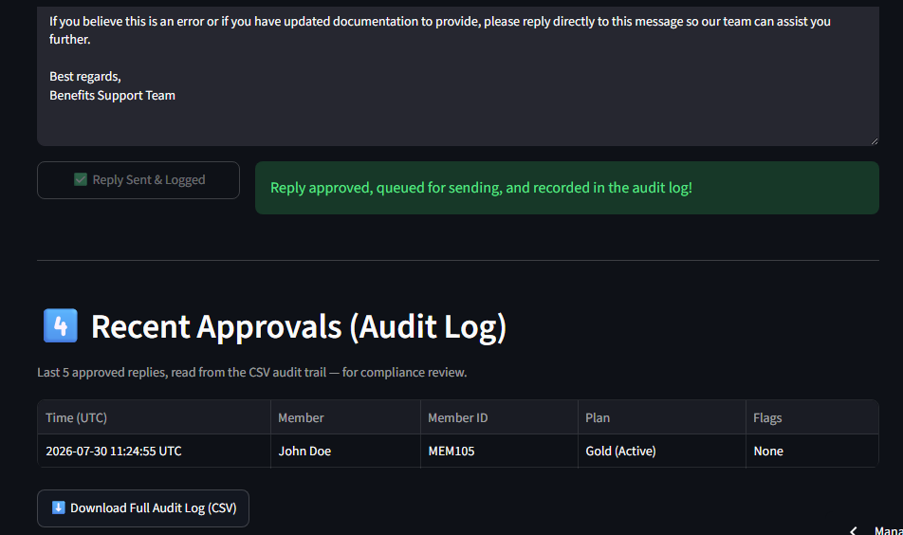
member_name | member_id | email_location | matched_location | plan_type | plan_status | flags | final_draft
John Doe | MEM105 | New York | New York | Gold | Active | None | Dear John Doe, Thank you for reaching out to us regarding your inquiry (Inquiring about health coverage eligibility for next month.). Upon reviewing your account details, your benefits and eligibility status are active and verified. If you believe this is an error or if you have updated documentation to provide, please reply directly to this message so our team can assist you further. Best regards, Benefits Support Team

App is working properly
