**InnovateX 2025**

**OUTPUT:**

**SYSTEM VIEW:**

STEP1: Innovatex HOME PAGE

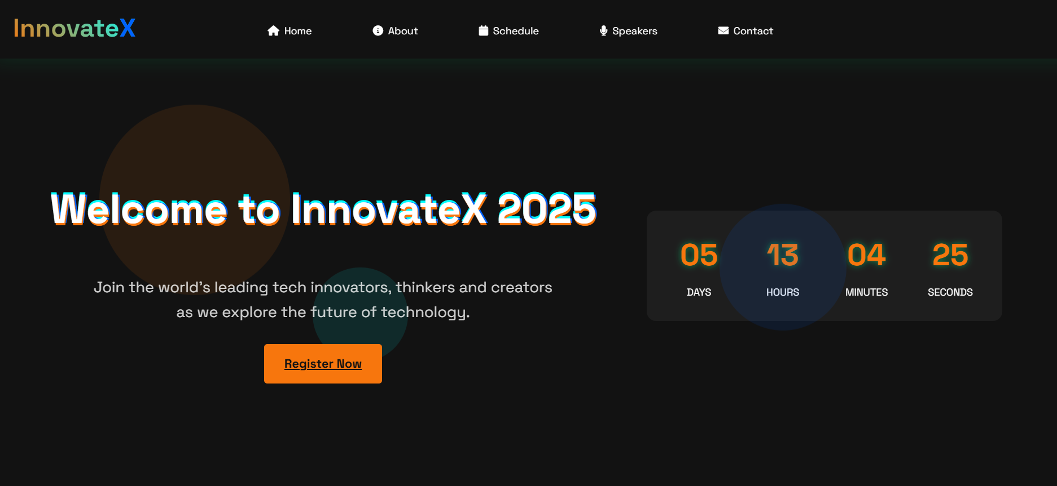

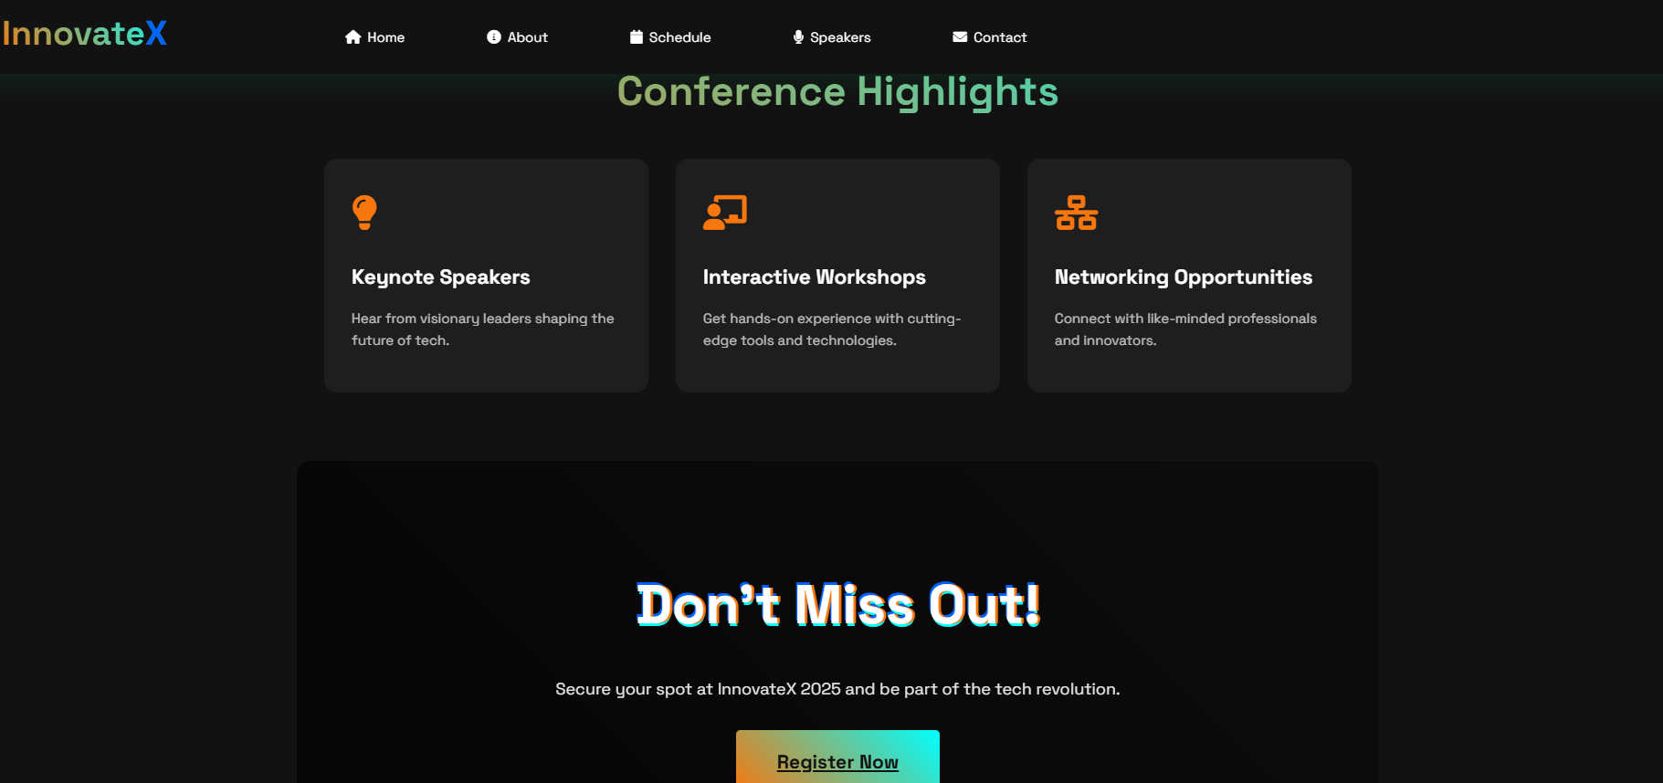

* I have set the countdown button for March 1(Live countdown).

STEP 2: ABOUT PAGE:

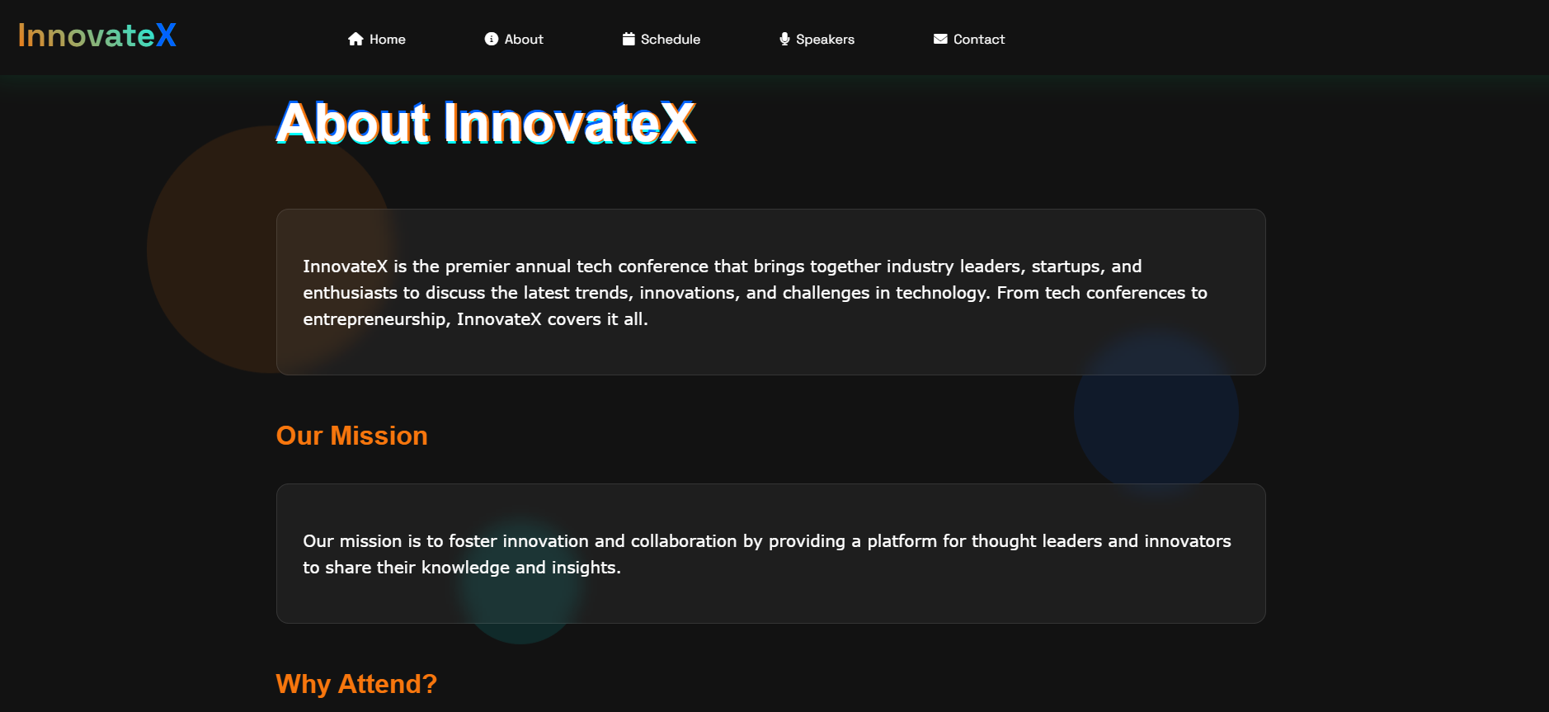

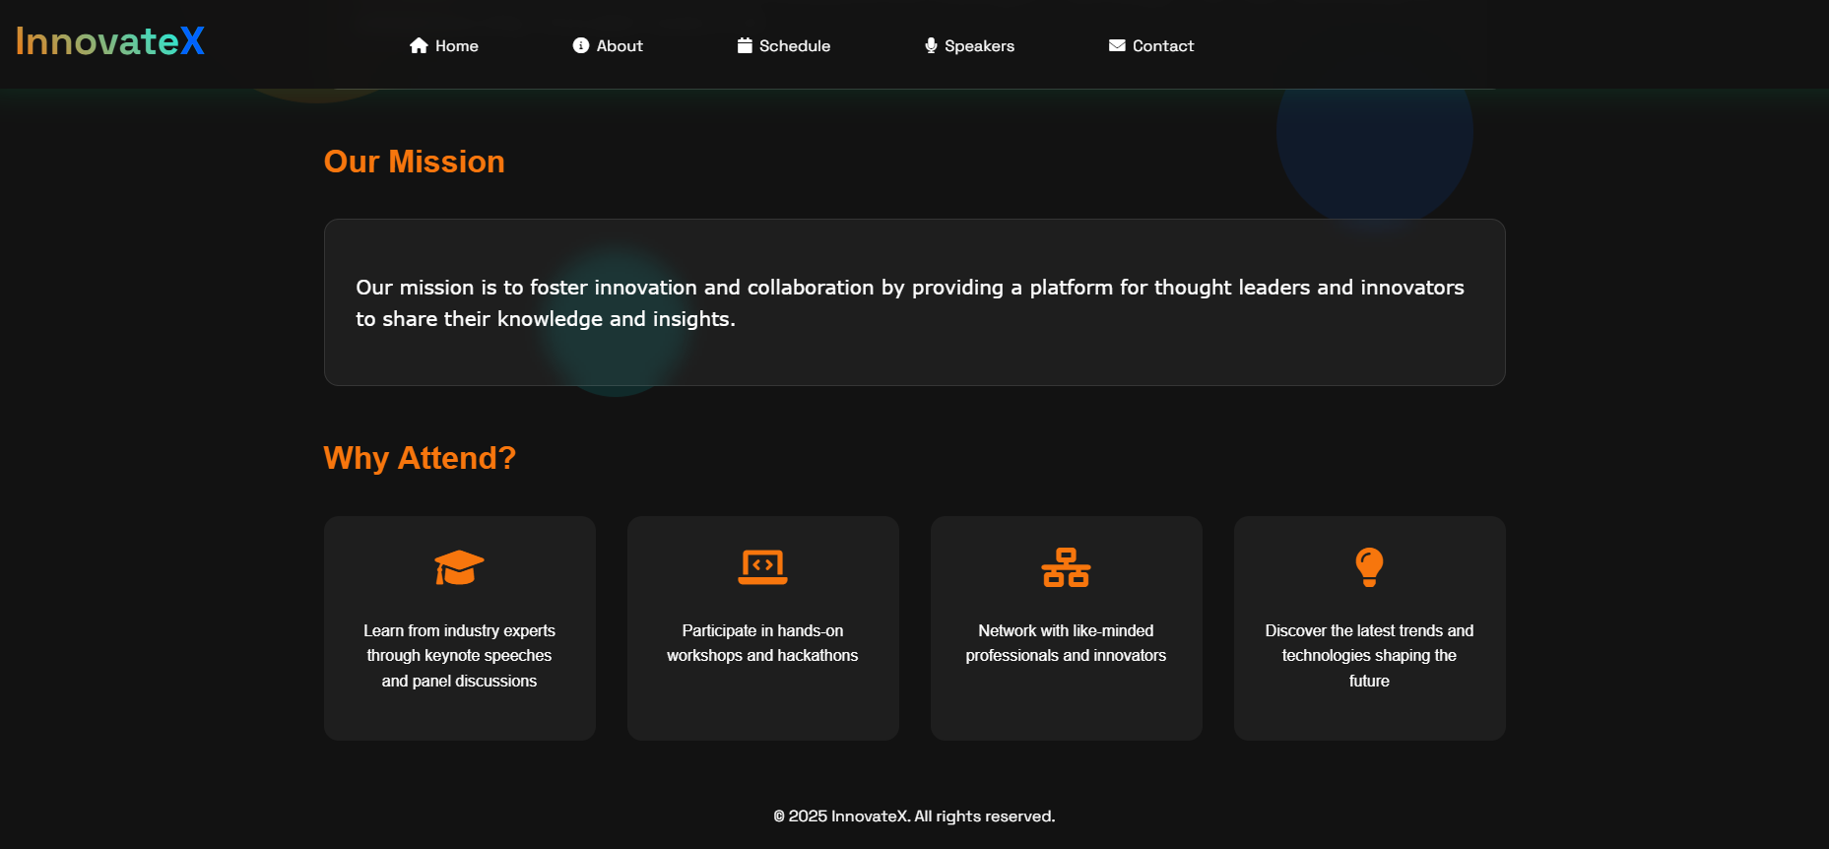

* **Designed an Engaging Layout** – Created a visually appealing and structured "About" page with clear sections, ensuring readability and ease of navigation.

STEP 3: SCHEDULE PAGE

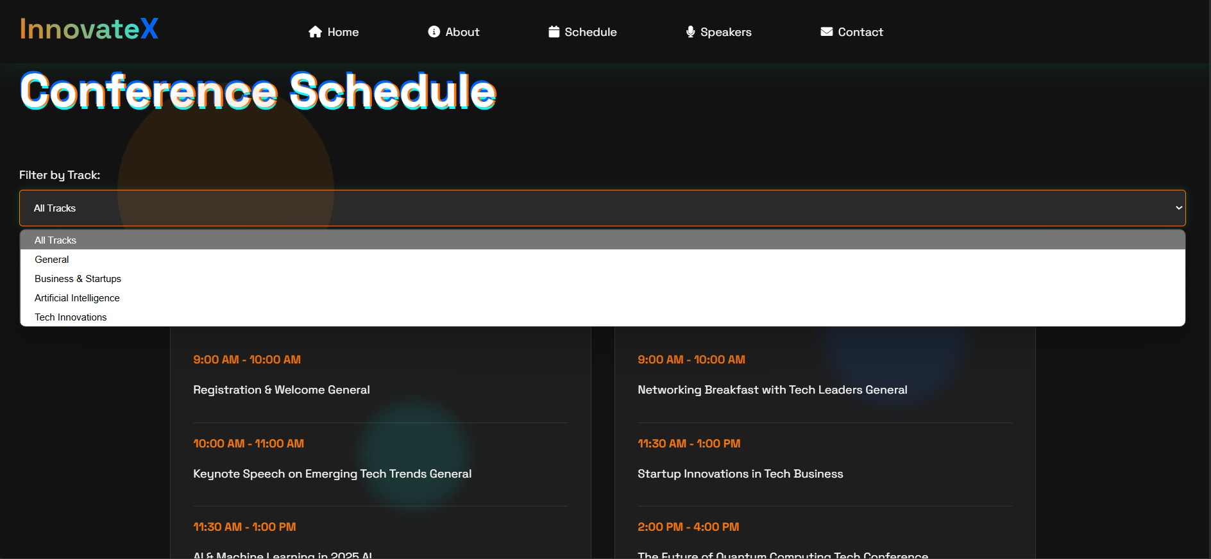

* Selecting the "General" option:

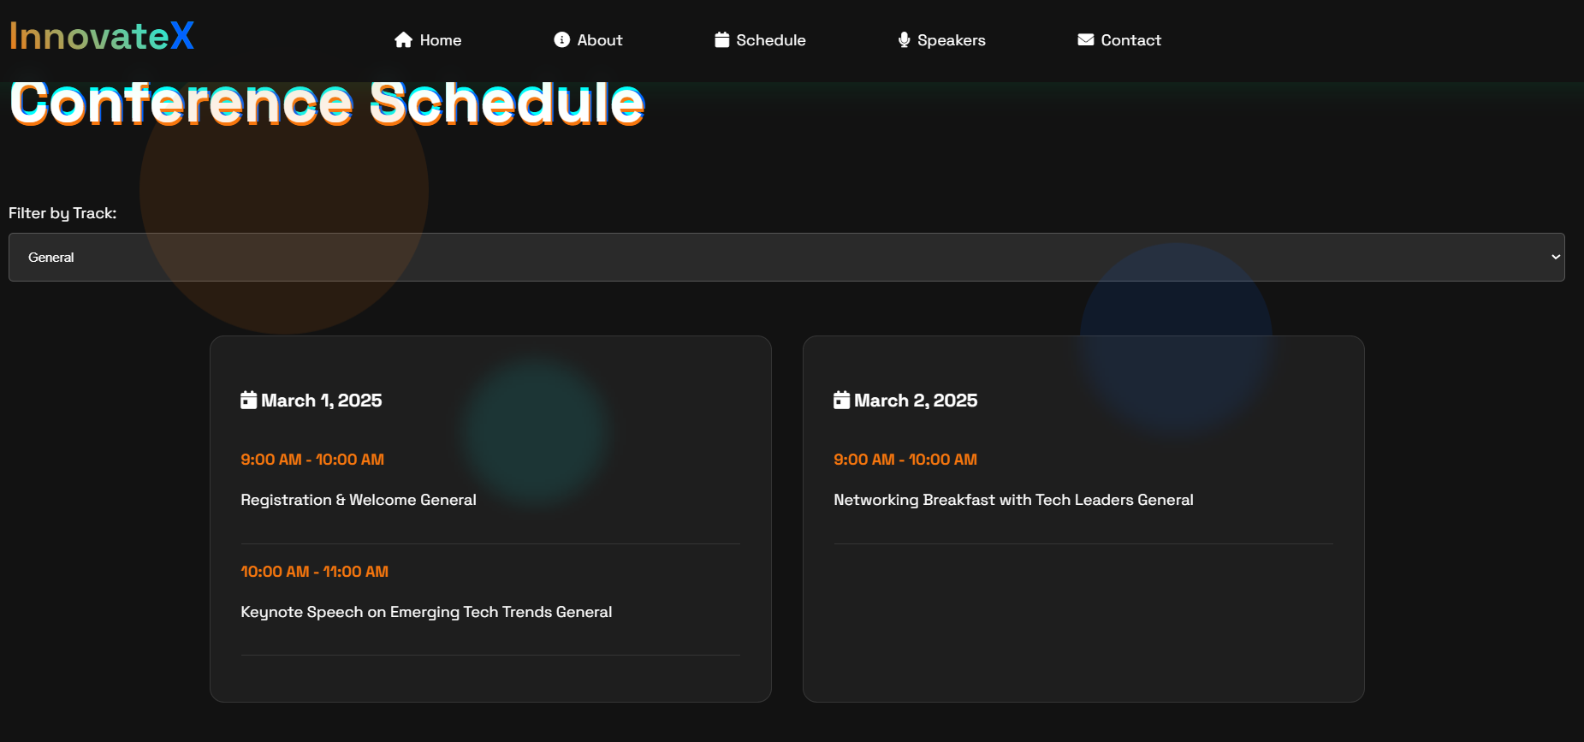

* Selecting the “Business & Startups” option:

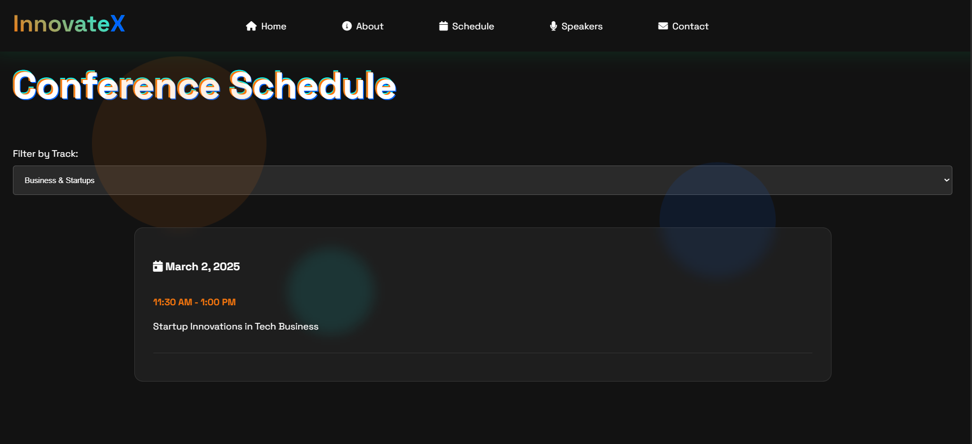

* Selecting the “Artificial Intelligence” option:

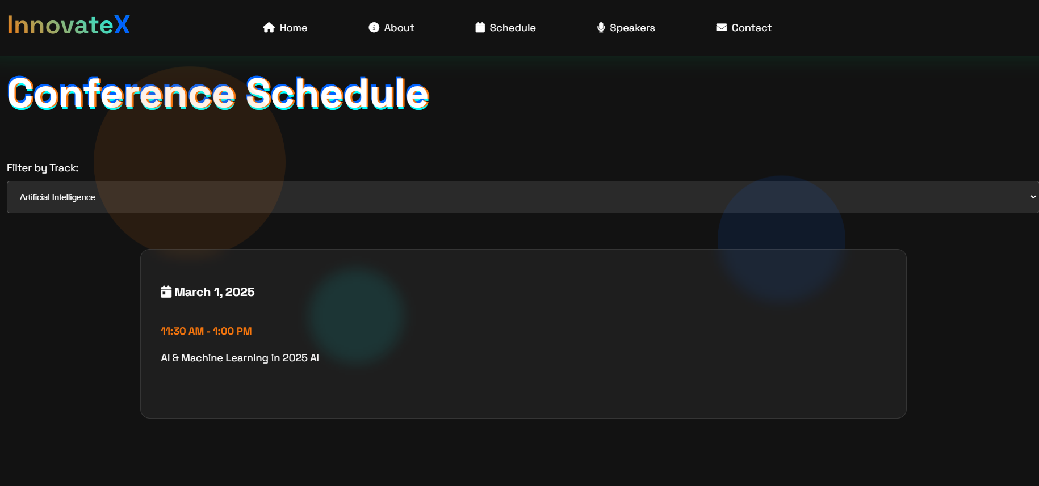

* Selecting an “Tech Innovations” Option:

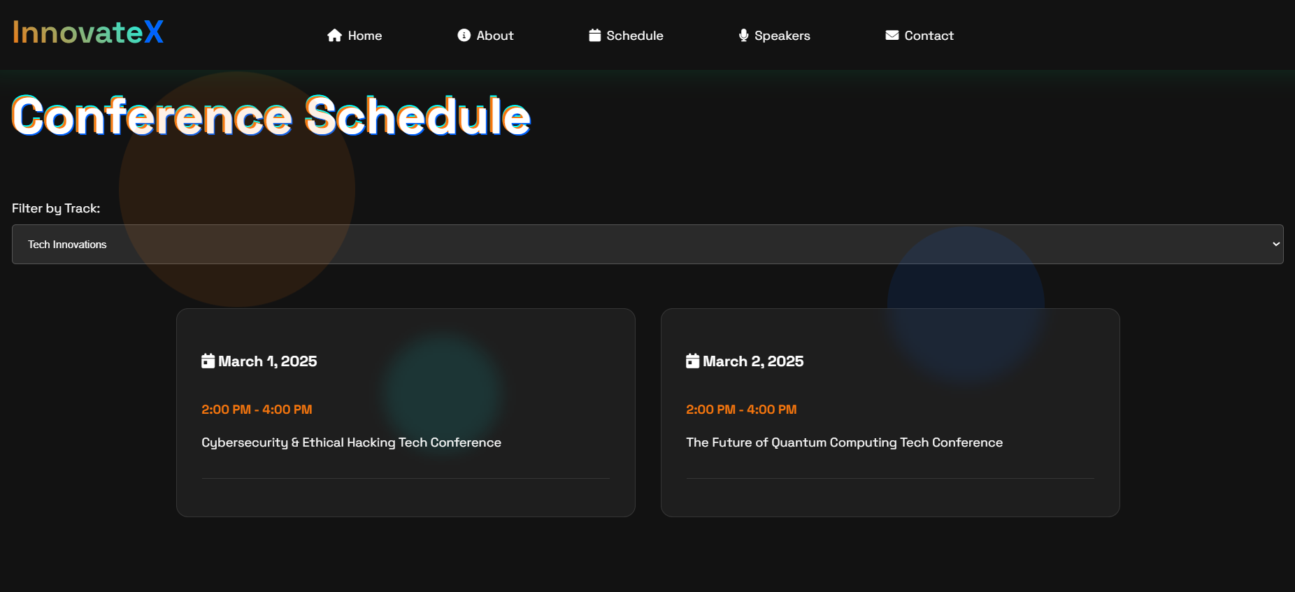

* Added a "Filter by Track" feature to the Schedule page for easier session navigation.

STEP 4: SPEAKERS PAGE:

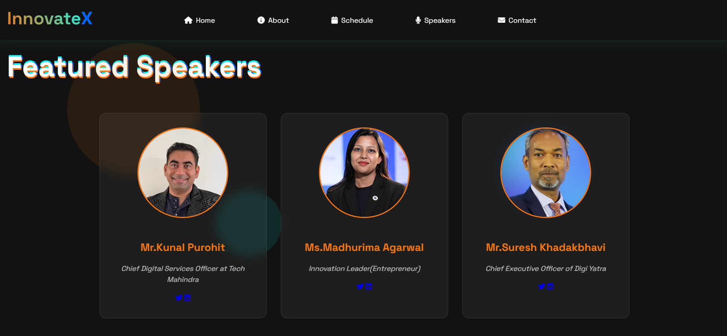

* Created an engaging speaker grid to display top industry experts with their photos, names, and brief details.

STEP 5: CONTACT PAGE

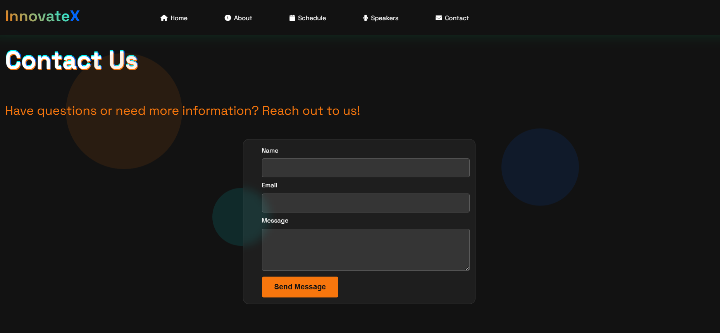

STEP 6: REGISTRATION

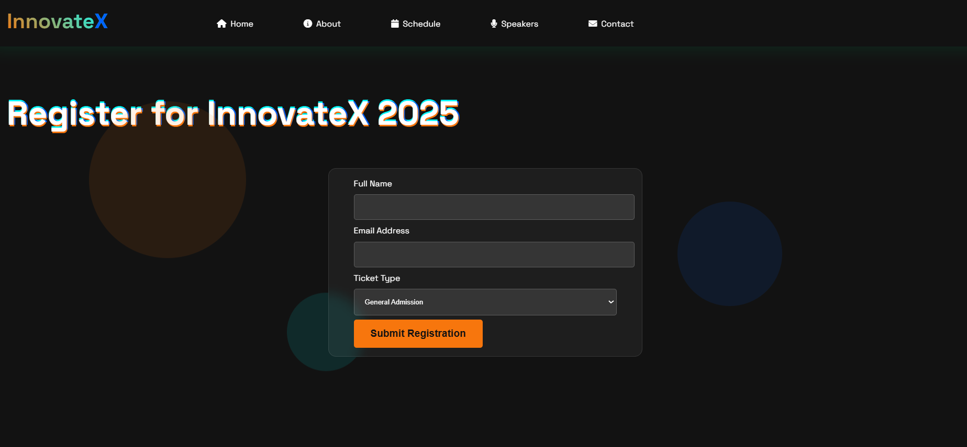

* Validation on Name:

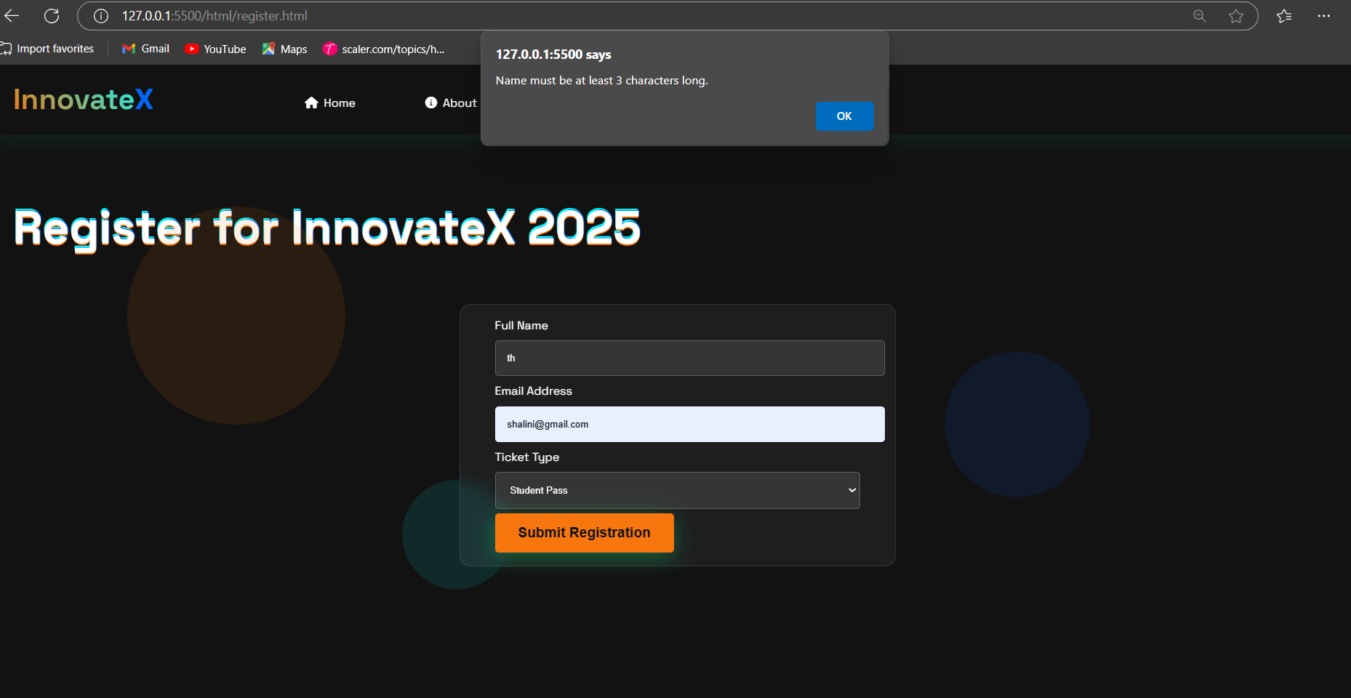

* Validation on email

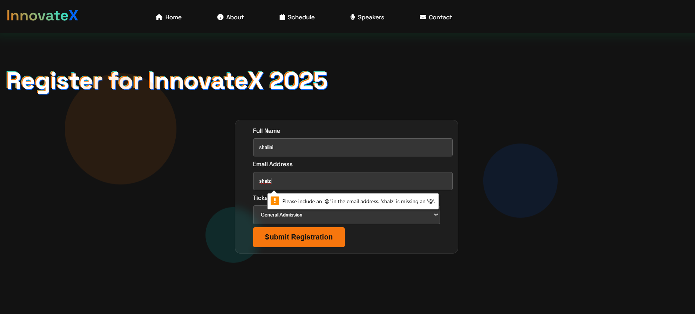

* Successful Registration:

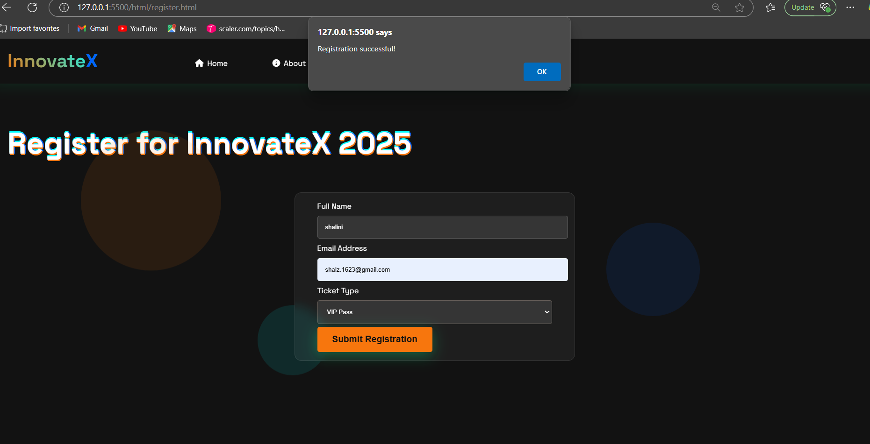

The registration process for the Innovatex conference has been successfully completed.

**MOBILE VIEW:**

* The website is designed to be fully responsive, ensuring a seamless viewing experience on both mobile devices and desktop systems. This is achieved using media queries that adapt the layout and elements based on screen size.
* Home Screen :

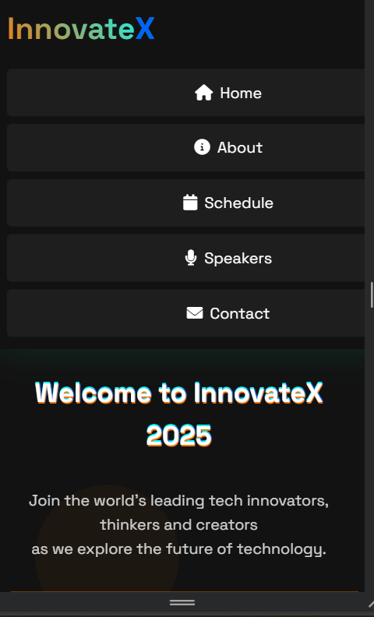

* About Page:

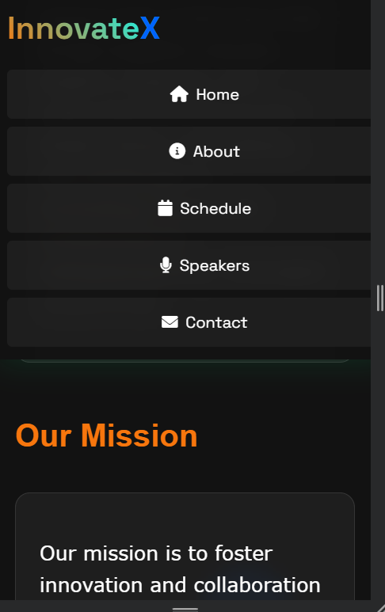

* Schedule Page:

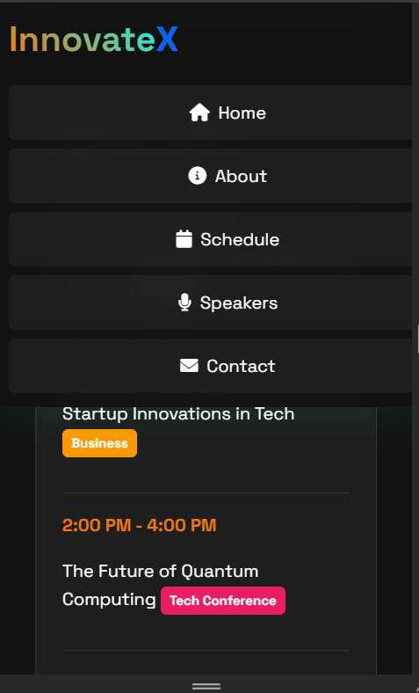

* Speakers Page:

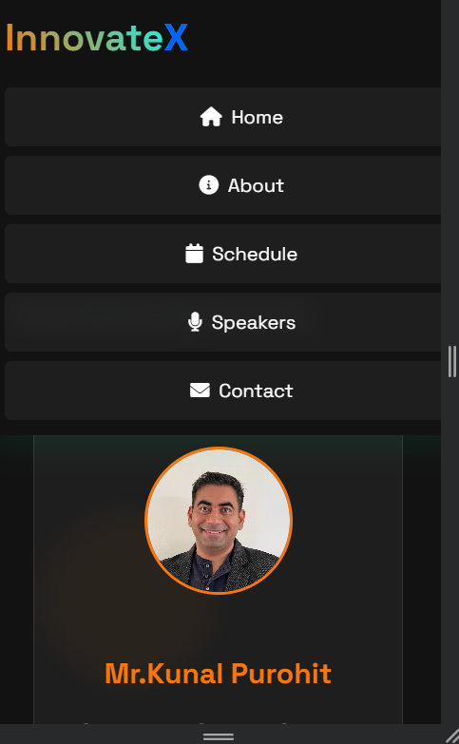

* Contacts Page:

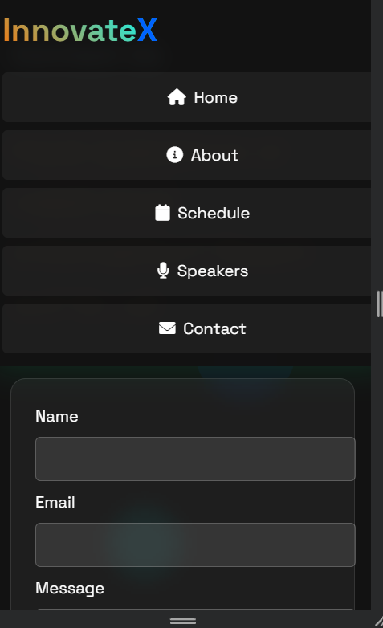

I used media queries to adjust the layout, but it didn’t fit perfectly. However, using Bootstrap or a similar framework ensures a more seamless and responsive design for mobile views.