PRECISION ONCOLOGY ANALYSIS
Detailed Analysis Report — Precision Oncology Cohort
Clinical, molecular and AI-prediction insights from 82 patients (generated with Claude)

Executive summary
Table 1. Cohort at a glance.
Metric | Value | Metric | Value
Patients | 82 | Living / active | 54
Deceased | 16 | High-risk (rule or AI) | 58
Stage IV (of staged) | 63% | Immunotherapy-treated | 31
Actionable biomarker carriers | 20 | MSI-high | 7

Headline findings
- Stage and treatment profile. 63% of staged patients are stage IV; 90% received chemotherapy and 38% immunotherapy.
- Imaging response. 25 of 50 patients with a readable response achieved CR/PR (50%); 33 show progression in at least one report.
- Molecular data is the main opportunity. 20 patients carry a biomarker with a known targeted or immunotherapy association; only 13 have gene-level sequencing on file.
- AI risk stratification is feasible but exploratory. Cross-validated C-index is 0.74 for survival and 0.59 for progression (n=78, 16 deaths): usable for triage and hypothesis generation, not yet for individual forecasts.
- Responder score needs validation. On 22 immunotherapy-treated patients the blended score's leave-one-out AUC was 0.35; a larger treated cohort is required before it informs decisions.
Data note. Figures in this report come from the sample dataset supplied in the same format as the original. Re-run make_reports.py on the real workbook to regenerate every chart, table and sentence.

1. Cohort and data readiness
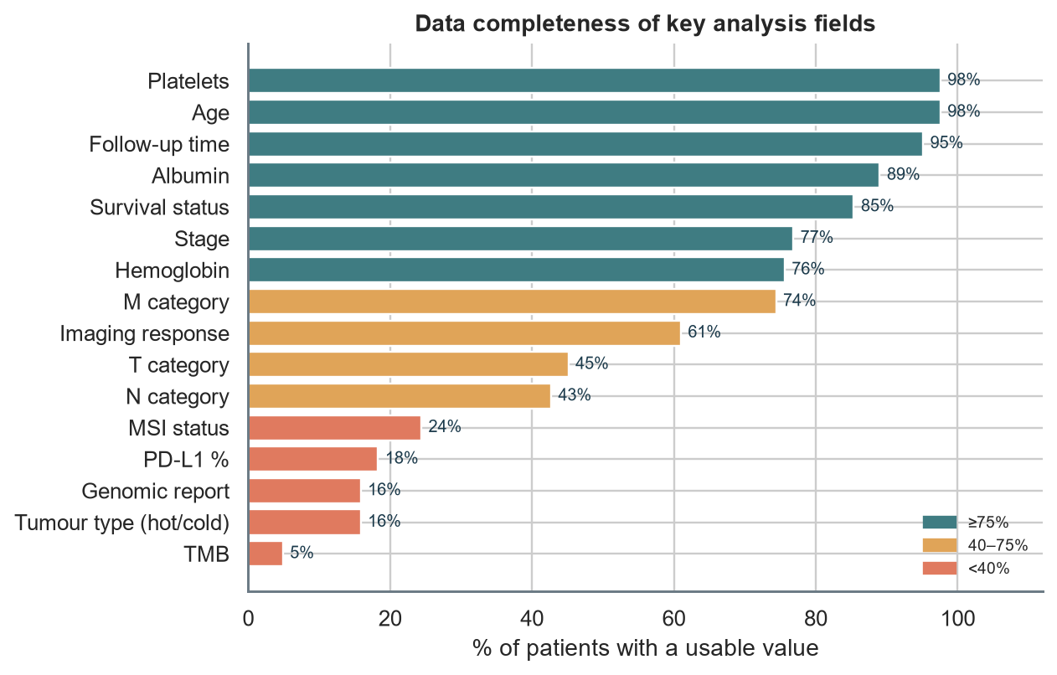
Figure 1. Completeness of analysis-ready fields.
How to read it: Teal bars are well populated, amber are partial, red are sparse. Sparse fields limit what the AI layer can learn.
What the pipeline fixed automatically:
- Patient names removed and scrubbed from free text; 5 notes contained a name that was masked.
- Duplicate patient IDs collapsed to the most complete record.
- Lab values with mixed units (e.g. cells/µL, lakh/cmm, ×10³) standardised; implausible values set to missing.
- Dates in Excel-serial, dd/mm/yyyy and written-month formats parsed; dates after the record's entry time discarded.

2. Clinical landscape
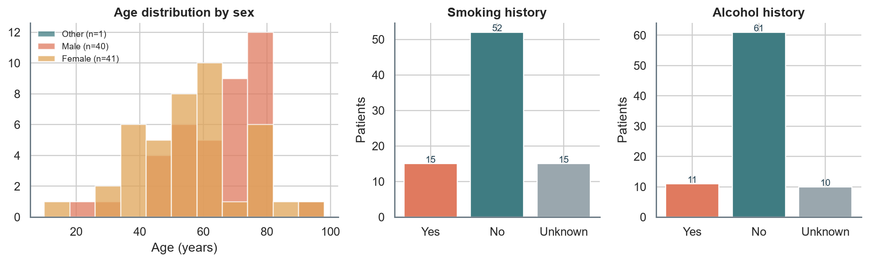
Figure 2. Demographics and lifestyle history.
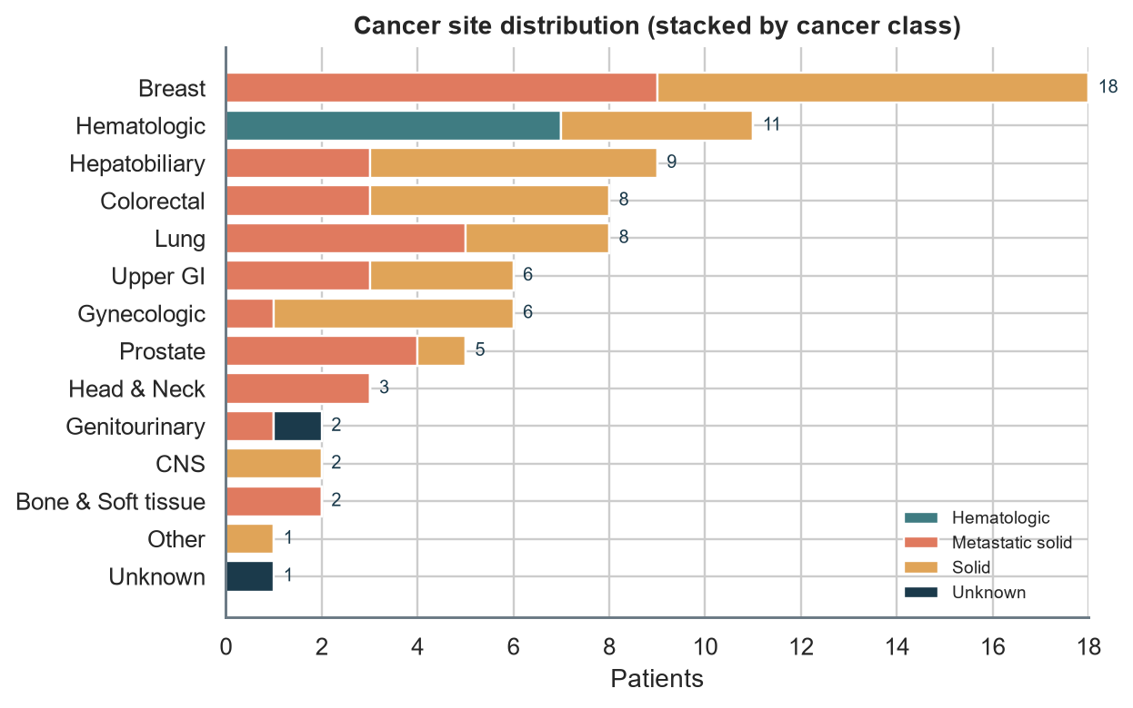
Figure 3. Site and class distribution.
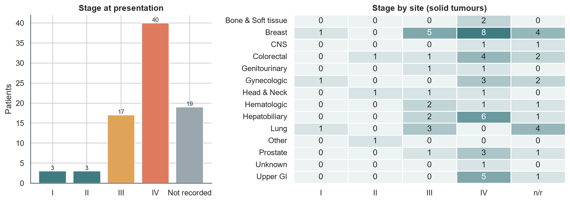
Figure 4. Stage distribution and stage-by-site heat map.
Insight: The three most common site groups are Breast (18), Hematologic (11), Hepatobiliary (9). Stage is not recorded for 23% of patients, so every stage-stratified result below describes only the staged subset.

3. Treatment and response
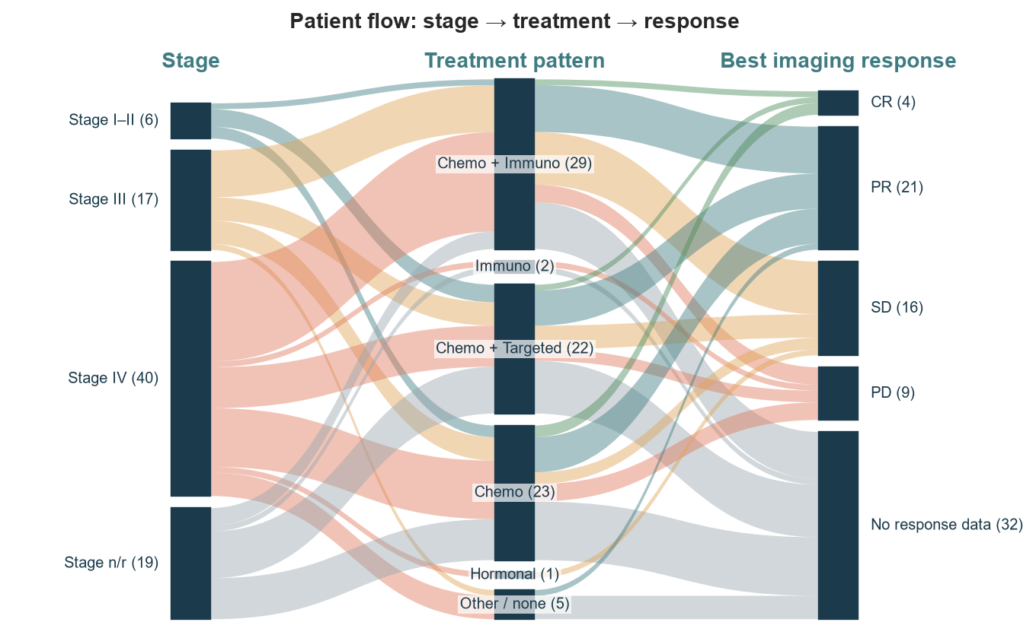
Figure 5. Flow of patients from stage group to treatment pattern to best imaging response.
How to read it: Ribbon width is the number of patients. Follow a ribbon from left to right to see how a stage group was treated and how it responded.
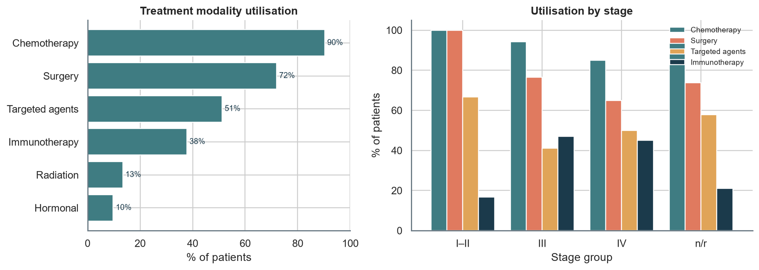
Figure 6. Modality utilisation overall and by stage.
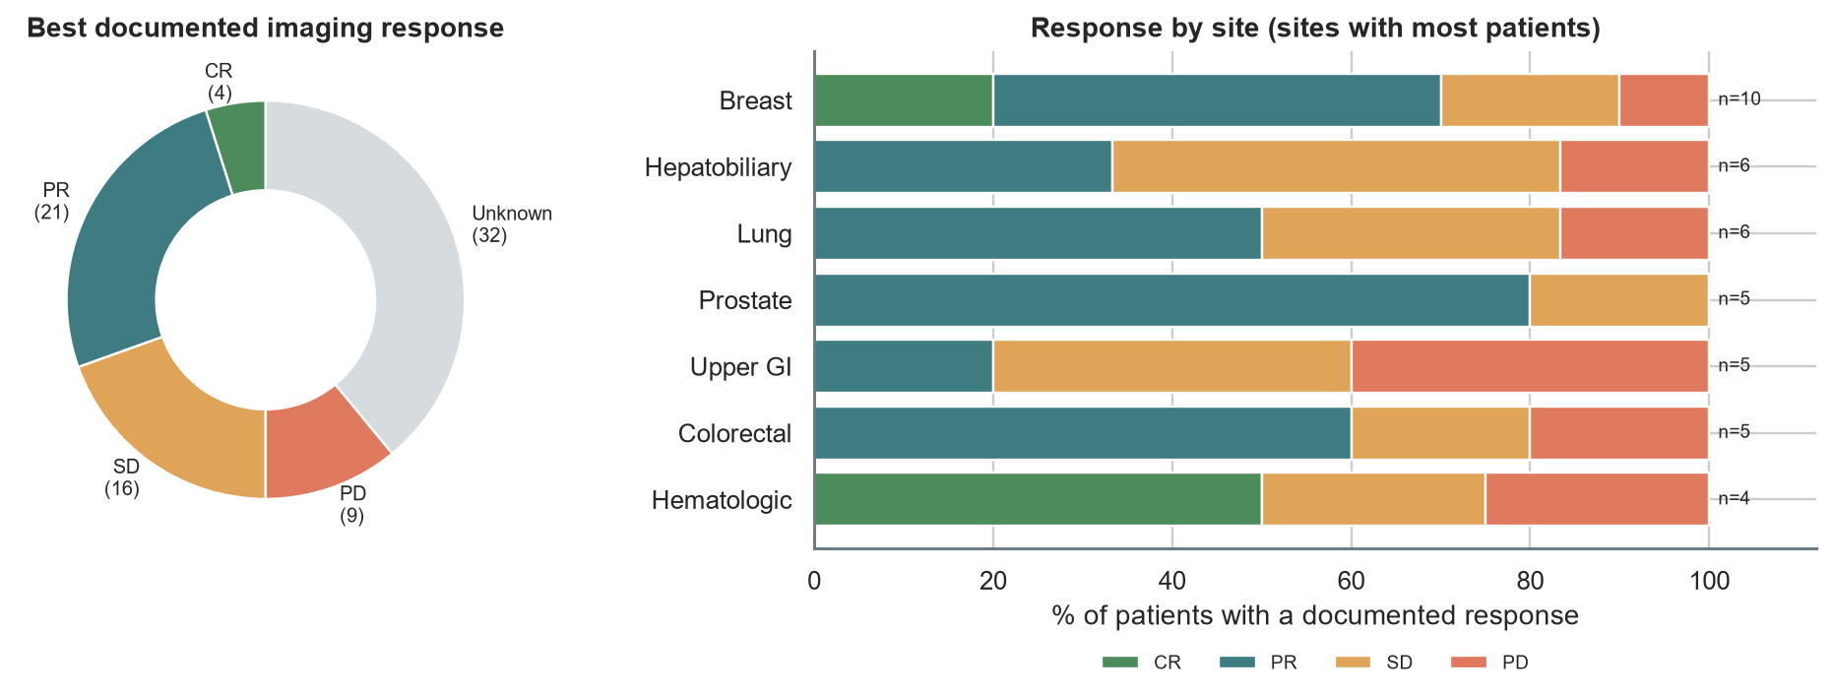
Figure 7. Imaging response overall and by site.
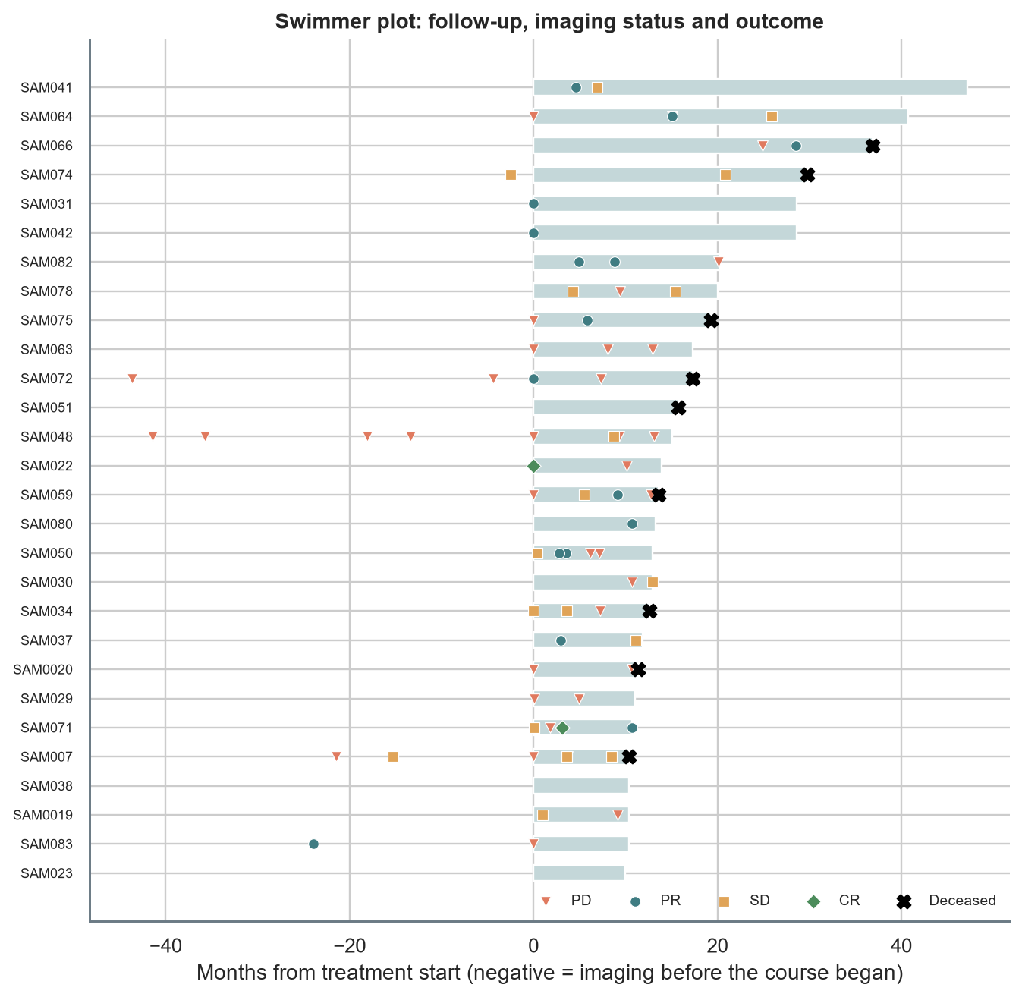
Figure 8. Swimmer plot of the longest-followed patients with dated imaging outcomes.
How to read it: Each bar is one patient's follow-up. Markers show imaging status at each dated report; a black cross marks death.
Table 2. Most frequent treatment combinations.
Treatment combination | Patients | Share
Chemotherapy + Surgery | 32 | 39%
Chemotherapy + Immunotherapy + Surgery | 8 | 10%
Chemotherapy + Immunotherapy | 8 | 10%
Chemotherapy | 8 | 10%
Chemotherapy + Radiation + Surgery | 5 | 6%
Chemotherapy + Hormonal Therapy + Surgery | 3 | 4%
Surgery | 3 | 4%
Chemotherapy + Hormonal Therapy + Radiation + Surgery | 3 | 4%

4. Molecular landscape
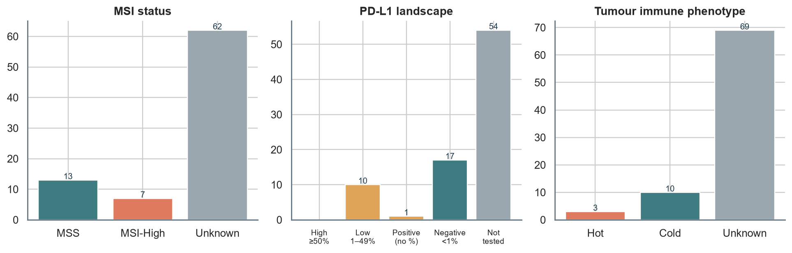
Figure 9. MSI, PD-L1 and tumour immune phenotype.
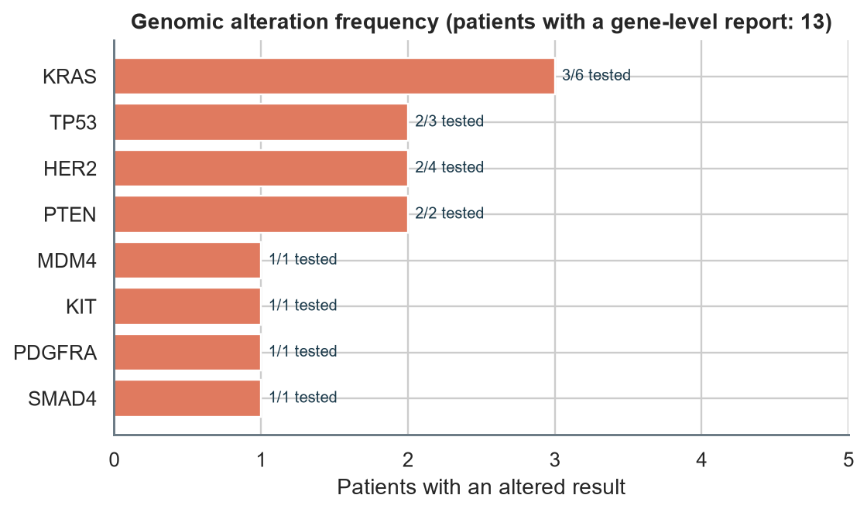
Figure 10. Gene-level alterations.
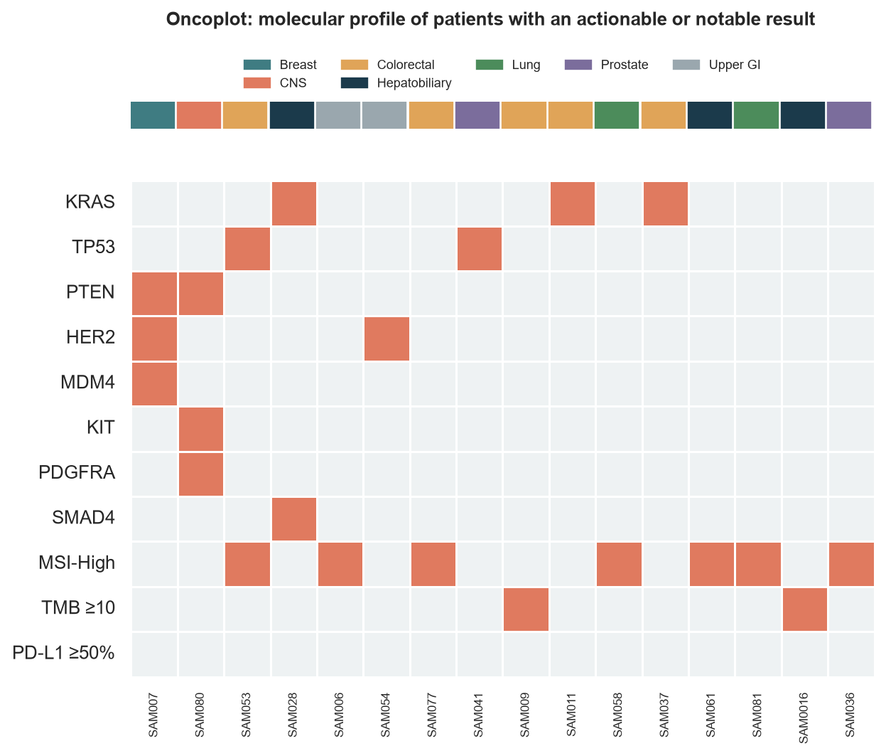
Figure 11. Oncoplot of patients with a notable molecular result.
How to read it: Each column is a patient (coloured strip = tumour site); each orange cell is a detected alteration or biomarker.
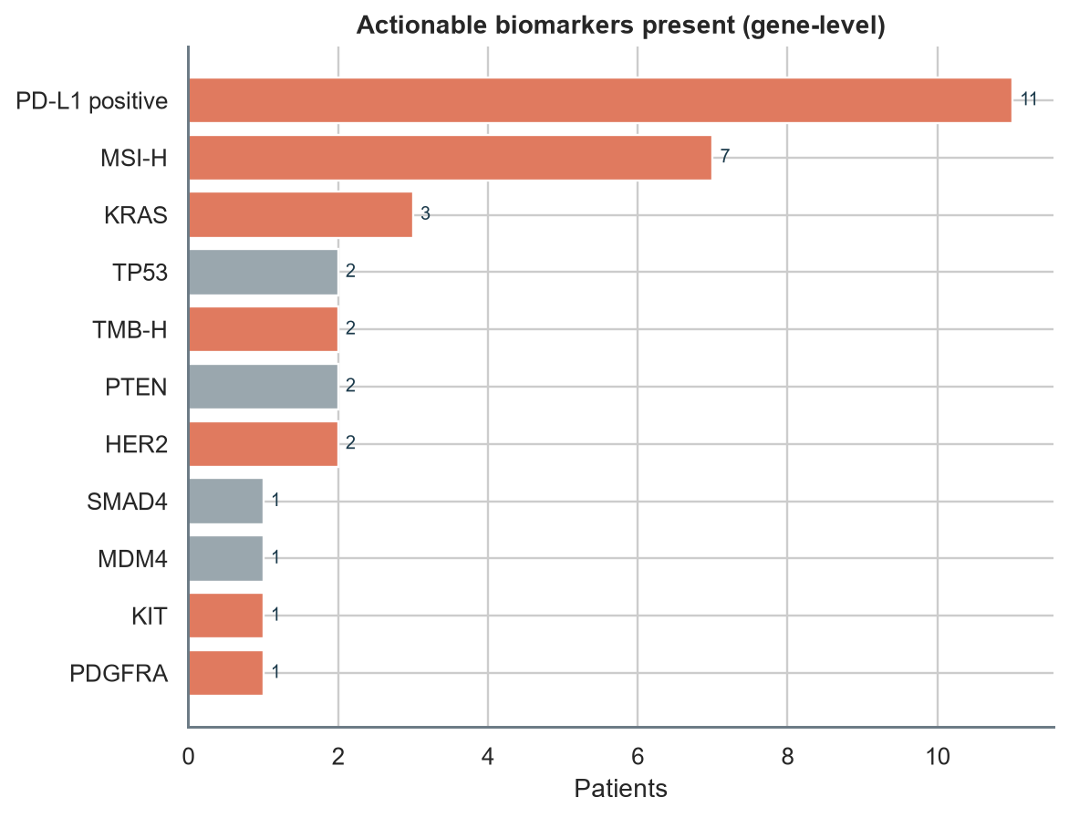
Figure 12. Actionable biomarkers present at gene level.
Insight: 20 patients carry at least one biomarker with a published targeted or immunotherapy association. Matching is at gene level only; the exact variant must be confirmed in the sequencing report before any therapy discussion.

5. Outcomes and prognostic factors
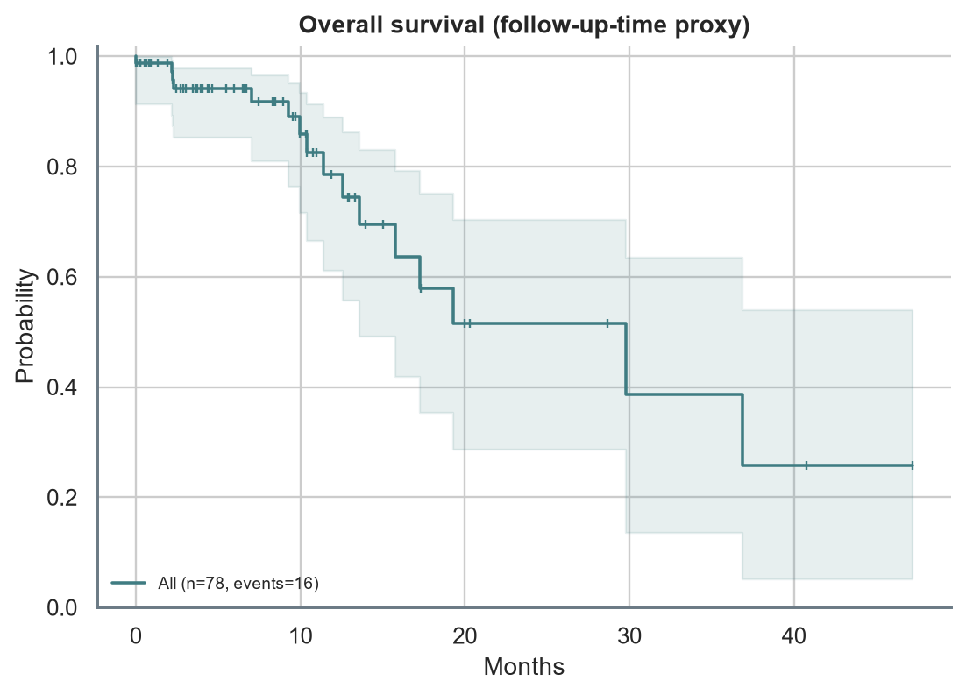
Figure 13. Kaplan–Meier overall survival with 95% confidence band.
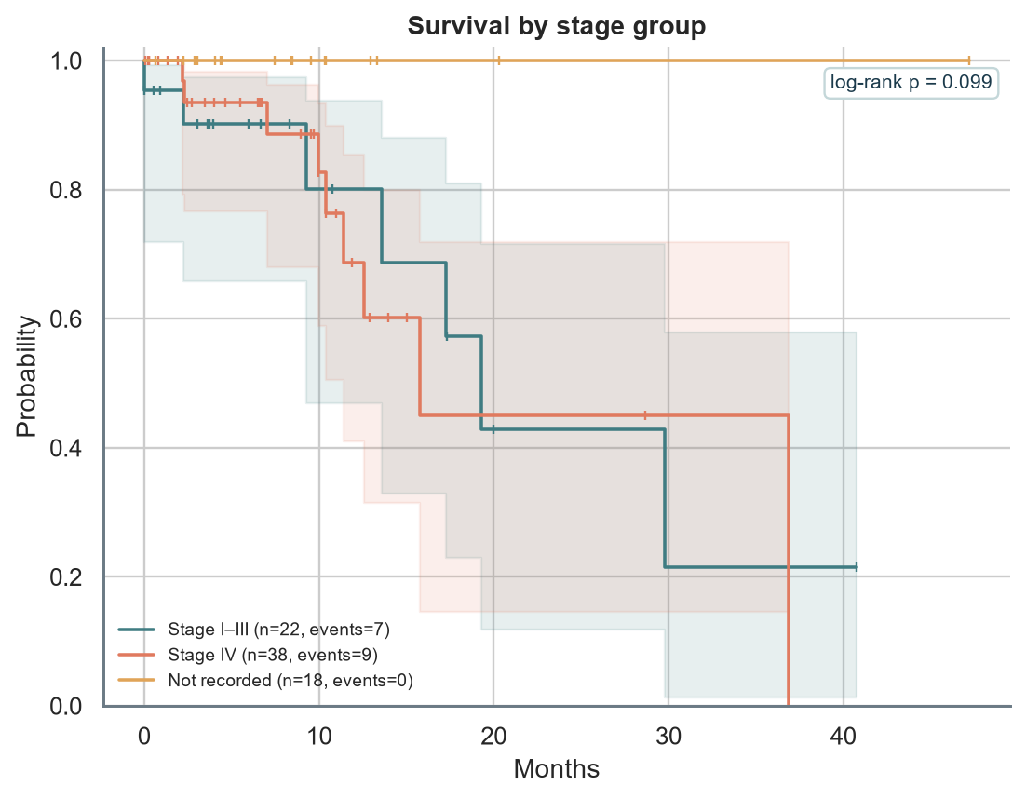
Figure 14. Survival by stage group (log-rank p = 0.10).
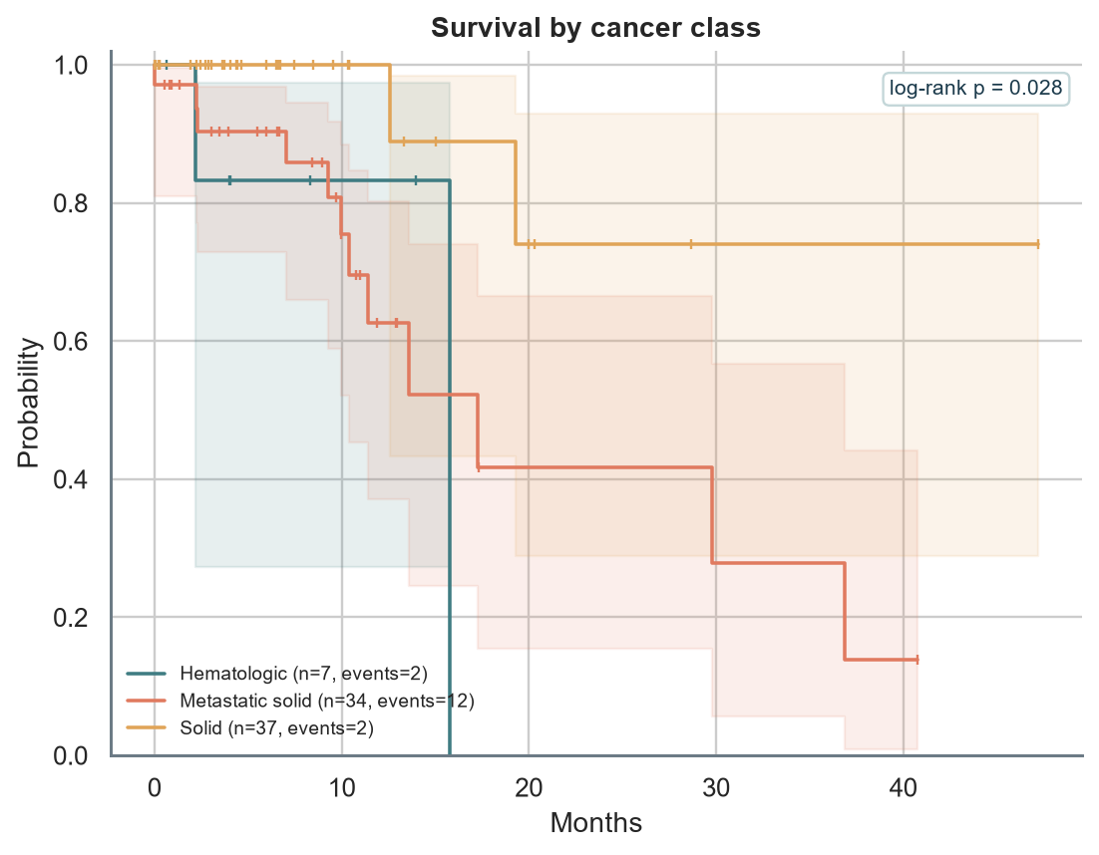
Figure 15. Survival by cancer class (log-rank p = 0.03).
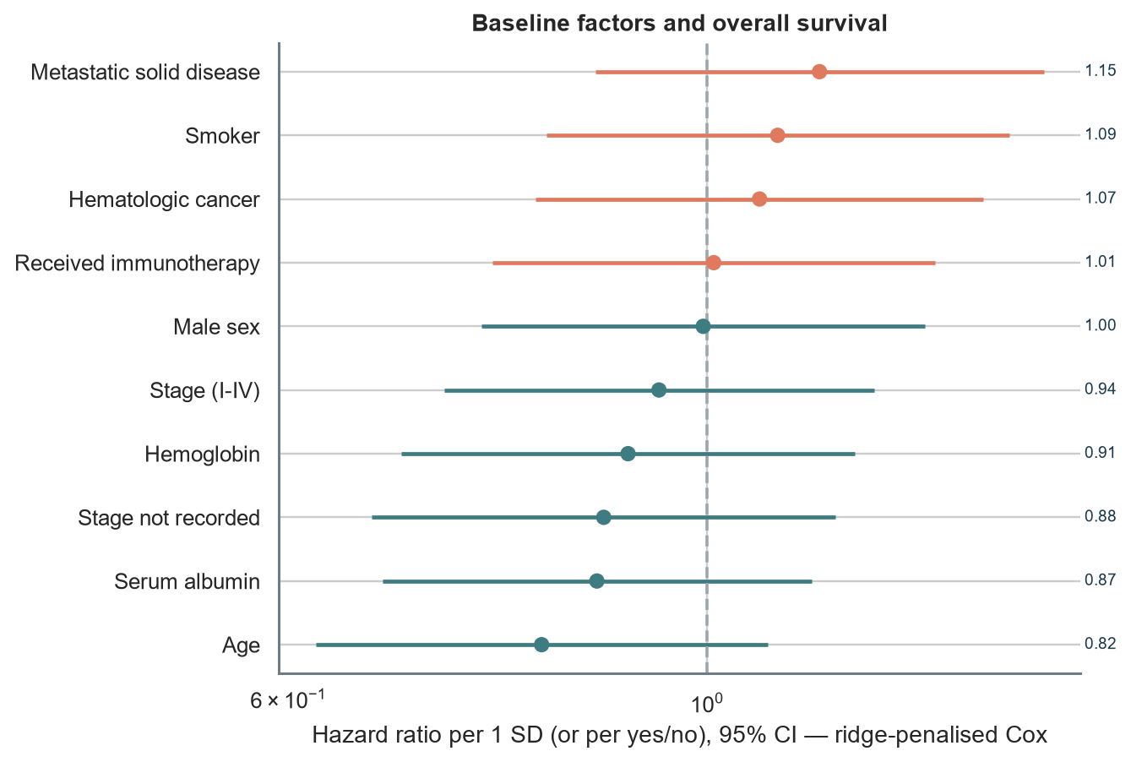
Figure 16. Hazard ratios from the penalised Cox model.
How to read it: Dots right of the dashed line mean higher hazard of death per standard deviation (or for 'yes'); bars that cross 1 are not distinguishable from no effect.
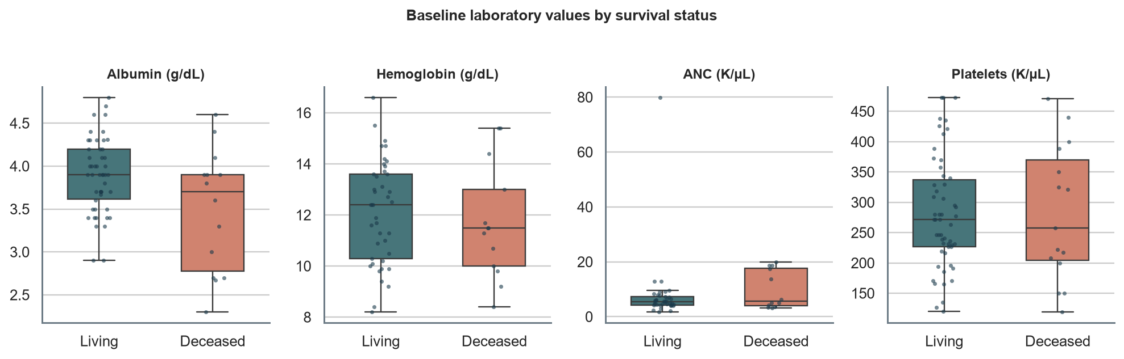
Figure 17. Baseline laboratory values by survival status.
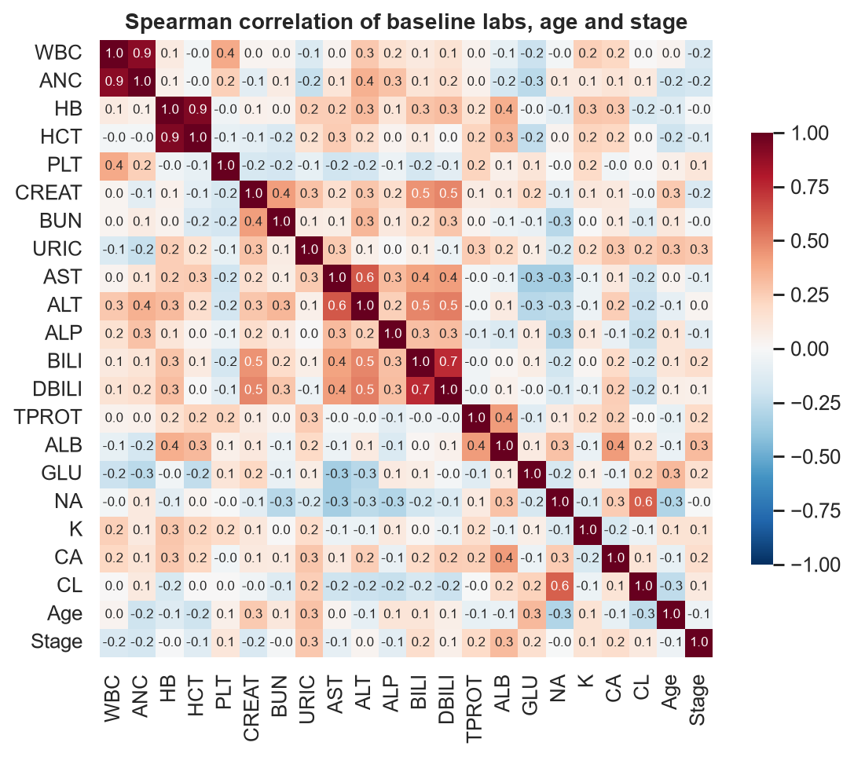
Figure 18. Correlation between labs, age and stage.

6. AI prediction layer
The layer is built for a small cohort: ridge-penalised Cox models for survival and progression, a transparent biomarker-prior plus regularised logistic model for immunotherapy response, rule-based precision-therapy and trial matching, and a similar-patient lookup. All models use baseline information only.
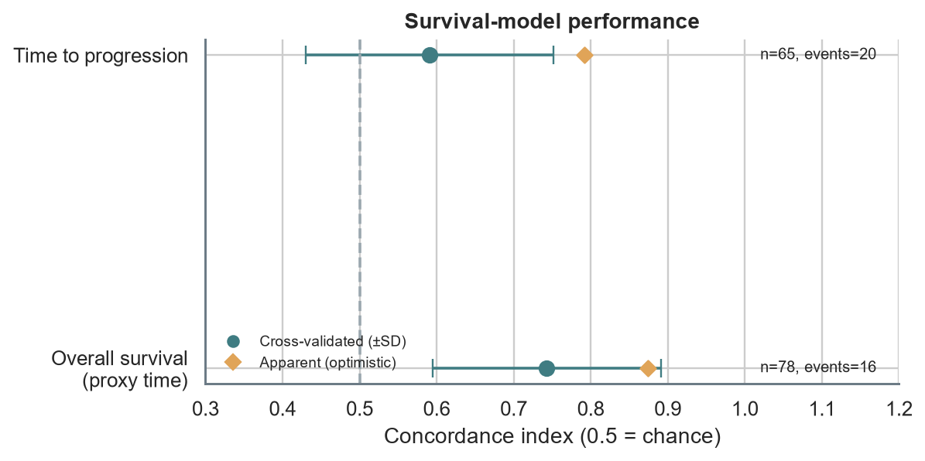
Figure 19. Cross-validated vs apparent concordance for the two time-to-event models.
How to read it: Dots show repeated 5-fold cross-validation (honest estimate); diamonds show performance on the training data (optimistic). A value of 0.5 equals chance.
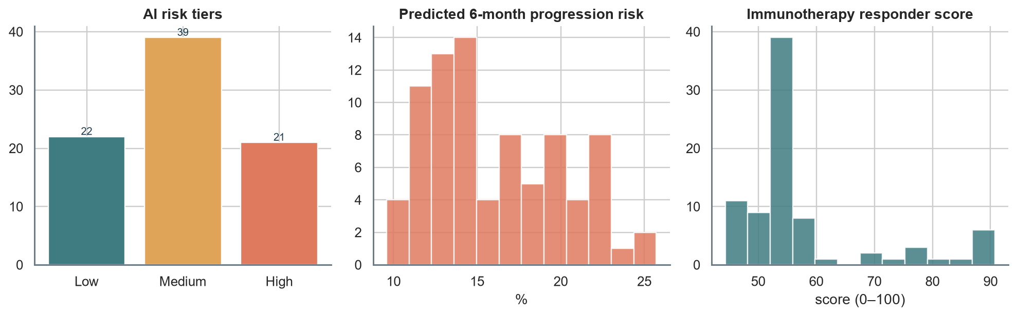
Figure 20. Distribution of AI risk tiers, progression risk and responder score.
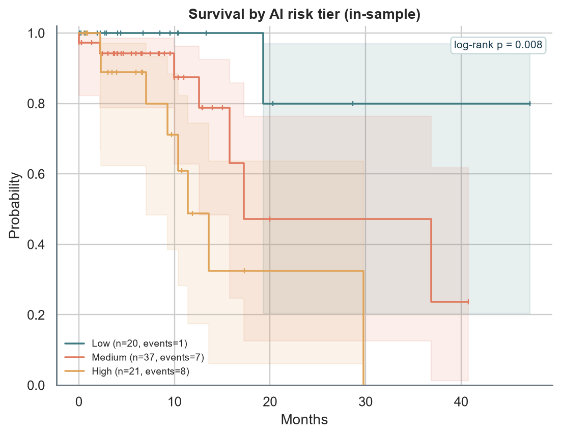
Figure 21. Survival separated by AI risk tier (log-rank p = 0.008; in-sample, therefore optimistic).
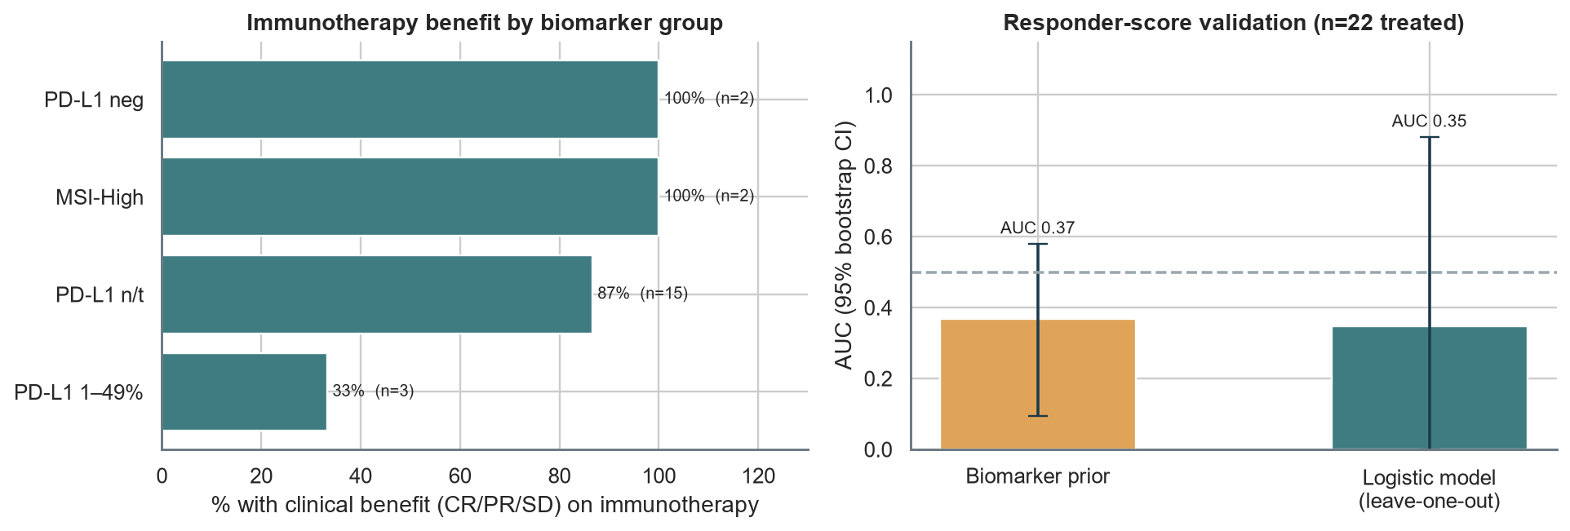
Figure 22. Immunotherapy benefit by biomarker group and responder-score validation.
Table 3. Ten highest-risk living patients (watch-list).
Patient | Site | Stage | 6-mo progression risk | Composite risk | Responder score
SAM081 | Lung | I | 25% | 94 | 90
SAM061 | Hepatobiliary | III | 23% | 90 | 90
SAM065 | Prostate | III | 22% | 90 | 49
SAM060 | Lung | III | 22% | 87 | 56
SAM077 | Colorectal | II | 19% | 82 | 91
SAM055 | Bone & Soft tissue | IV | 20% | 81 | 55
SAM058 | Lung | III | 22% | 80 | 90
SAM063 | Head & Neck | III | 22% | 78 | 59
SAM037 | Colorectal | IV | 16% | 77 | 48
SAM047 | Breast | IV | 19% | 73 | 55

Precision therapy matching
Biomarker-to-therapy associations are drawn from a curated illustrative knowledge base and matched at gene level. Treat as candidates for tumour-board discussion.
Table 4. Candidate therapies by biomarker (verify against OncoKB / NCCN before use).
Biomarker | Candidate therapies (verify) | Patients | Site-appropriate
PD-L1 positive | Checkpoint inhibitor (site-specific; CPS/TPS cut-offs vary) | 11 | 11
MSI-H | Pembrolizumab, Nivolumab +/- Ipilimumab, Dostarlimab | 7 | 7
KRAS | Sotorasib / Adagrasib (only if KRAS G12C) | 3 | 2
TMB-H | Pembrolizumab | 2 | 2
HER2 | Trastuzumab, Pertuzumab, Trastuzumab deruxtecan | 2 | 2
KIT | Imatinib | 1 | 0
PDGFRA | Imatinib / Avapritinib (D842V) | 1 | 0

Clinical trial matching
62 living patients match at least one placeholder trial on site, stage, age and biomarker rules. In production, trials are pulled live from ClinicalTrials.gov / CTRI.
Table 5. Placeholder trials ranked by number of matching patients.
Trial (placeholder) | Title | Matching patients
SAMPLE-009 | Supportive care / quality-of-life study, advanced cancer | 62
SAMPLE-007 | Novel agents in relapsed/refractory myeloma or lymphoma | 9
SAMPLE-006 | First-line therapy, metastatic colorectal cancer | 5
SAMPLE-004 | Immunotherapy for MSI-high / TMB-high tumours (any site) | 4
SAMPLE-001 | Checkpoint inhibitor + chemo, advanced lung cancer | 2
SAMPLE-003 | HER2-directed therapy, HER2-positive solid tumours | 1

7. Synthesis and recommendations
- Capture the missing outcome fields. Add death date, last-contact date and a structured RECIST response. This single change would convert the proxy outcomes into true survival and response endpoints.
- Expand molecular testing. Only 13 patients have gene-level results; broader panel testing would raise the number of patients with an actionable match.
- Use the risk tiers for triage, not prognosis. Prioritise high-tier patients for review while collecting more events to firm up the models.
- Validate the responder score prospectively. Record PD-L1 %, MSI and TMB before every immunotherapy start so benefit can be modelled properly.
- Verify automated extraction. Spot-check stage, response and gene calls against source text for a random 20 patients; record accuracy in the methods appendix.

Appendix: methods and definitions
Term | Definition
Active patient | Overall survival status = Living
Deceased | Overall survival status = Deceased; 'Not known' is treated as censored
High-risk (rule) | Living and (stage IV, M1 or imaging progression)
High-risk (AI) | Top third of composite risk (mean of survival and progression risk percentiles)
Survival time (proxy) | First dated treatment/imaging entry to last dated entry
Progression | Imaging text describing progression, new lesions or relapse (negations excluded)
Responder score | 50% biomarker prior (PD-L1, MSI-H, TMB-H, hot tumour, albumin) + 50% regularised logistic model
Validation | Repeated 5-fold CV (Cox); leave-one-out AUC with bootstrap CI (responder score)

